 | Project information
 | CALL FOR PROPOSALS |  | 1
 | MIS-ETC: |  | 517
 | PRIORITY AXIS: |  | 1 Economic and Social Development
 | MEASURE: |  | 1.1 Support for local/regional economic and social infrastructure
 | PROJECT TITLE: |  | Valorizing the tourism potential from Clisura Dunarii – building the attraction point and the Information and Tourism Promoting Center in the Pojejana village area
 | ACRONYM: |  | ATTRACT
 | DURATION: |  | 23.12.2010 – 22.12.2012
 | IPA FUNDS CONTRACTED: |  | 677.275,75
 | TOTAL FUNDS CONTRACTED: |  | 796.795,00
 | ABSORBTION RATE (%): |  | 84,84
 | PROJECT OBJECTIVE(S): |  | Stimulating the transformation of tourism into a major sector of the cross-border economy in the Pojejena-Veliko Gradiste area, by promoting the historical, cultural and natural values of the area.  Increase the impact of the authentic local values, from the cross-border area, by building a center for cross-border tourism information and promoting and equipping it with modern facilities.  Increase local attractiveness by establishing a tourism point of attraction in the form of a multifunction scene (for festivals, shows and contests), an alley for promenade along the Danube, a playground for children, a terrain for outdoor activities.  Educate local tourism entrepreneurs to use historical, natural and social heritage in order to promote the tourist area Clisura Dunãrii.  Promote the tourism values of both Romanian and Serbian sides, by realizing several materials and integrated software applications and by implementing joint promotional activities.
 | SHORT DESCRIPTION OF THE PROJECT: |  | The cross-border area between Romania and Serbia, along the border of the Danube between Pojejena (Romania) and Kladovo (Serbia) is characterized by a richness of natural and multicultural values but also by important differences in development. The rural communities need a rapid improvement in infrastructure and the business environment. The Romanian border area known as Clisura Dunarii is relatively isolated and low developed compared with the Serbian border. At the same time, an important biodiversity capital is present in Clisura Dunarii and also a multicultural and multi-ethnic environment.  The project included the construction of a tourism point of attraction in the form of a multifunctional stage (for festivals, shows and contests), a promenade alley along the Danube, a playground for children, a terrain for outdoor activities. All of these were intended to contribute as a support for different traditional or new events. A festival of folklore and local traditions was designed and organised during the implementation of the project.  Another important part consisted of the building of the Information and Promotion Center, the procurement of modern logistics and also the production of promotion and information materials to be distributed in the Center, and also the development of integrated software applications. All of these were intended to improve the information possibilities, and to implement joint actions included in an integrated tourism offer.
 | DEGREE OF ACHIEVEMENT OF INDICATORS: |  | Indicator value provisioned in the contract Present indicator value % 6= (5)/(3)*100  Output indicators (1) UM (2) Quantity (3) UM (4) Quantity (5)  Improved physical infrastructure in the border area  Improved capacity and cross-border contacts of SMEs  Result indicators  New or improved cross-border tourism products, joint marketing approaches/activities or joint tourism information services developed Number of new or improved cross-border tourism products, marketing activities or information services 4 Number of new or improved cross-border tourism products, marketing activities or information services 4 100  New or improved cross-border tourism services and increased SME’s capacity Number of activities, actions, initiatives focusing on promoting tourism in the border area and on promoting SME’s activity. 2 Number of activities, actions, initiatives focusing on promoting tourism in the border area and on promoting SME’s activity. 2 100  Project indicators  Promoting support creating Number of posters 100 Number of posters 100 100  Number of brochures 1000 Number of brochures 1000 100  Number of tourism guides 1000 Number of tourism guides 1000 100  Number of multimedia files 20 Number of multimedia files 20 100  Number of soft application 1 Number of soft application 1 100  Number of distributed promoting materials 1000 Number of distributed promoting materials 1000 100  Increasing of the tourism activity in cross-border area Number of visitor of the Center 2000 Number of visitor of the Center 2000 100  Number of visitor of attraction point 2500 Number of visitor of attraction point 2500 100  Increasing the cross-border tourism opportunities Number of tourists using the integrated offers 1000 Number of tourists using the integrated offers 1000 100  Number of tourism offers included 20 Number of tourism offers included 20 100  Developing the tourism infrastructure in the cross-border area Number of Information and Promoting Center 1 Number of Information and Promoting Center 1 100  Number of attraction points 1 Number of attraction points 1 100
 | RESULTS ACHIEVED: |  | The quality of tourism services and also the number of tourists were increased;  The specific values of the cross-border area were promoted during the organized activities and at the information center;  The Center of Information and Tourism Promotion was built and equipped and the Attraction point was built and equipped;  Promotional materials and software applications were created;  Thematic exhibition of photography was organized;  A study regarding the project impact on the local community was developed;  Training session for tourism entrepreneurs was implemented;  A joint Pojejena – Veliko Gradiste tourism offer was developed;  The first edition of the Festival Pojejena-Veliko Gradiste was realized.
Partnership information
 |  |  |  | COUNTRY | COUNTY/DISTRICT | BUDGET(EURO) | CONTACT DETAILS
LEAD PARTNER: |  | Pojejena Local Council |  | Romania | Caras-Severin | 767.134,00 | Pojejena, Com. Pojejena, nr. 277  Tel. 040- 255-544344
PARTNER 2: |  | Association for Tourism Veliko-Gradiste |  | Serbia | Braničevo | 29.661,00 | Veliko-Gradiste, 17 Pinkum  Tel. +38112662276

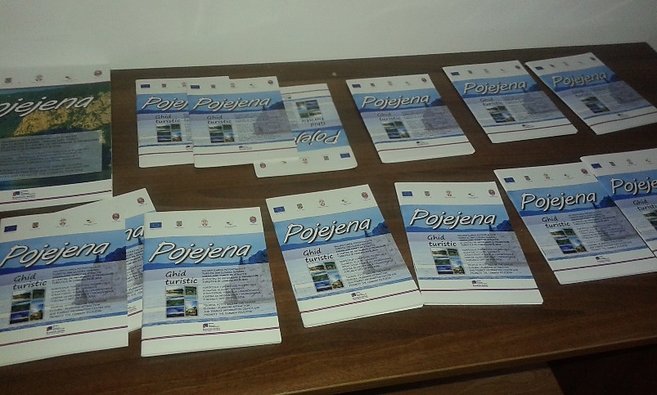
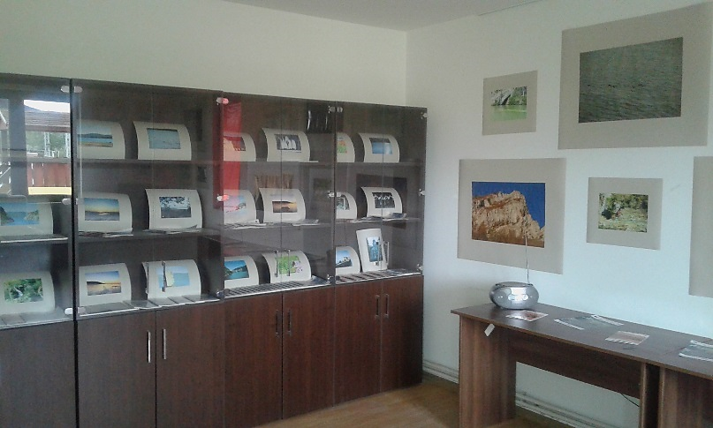
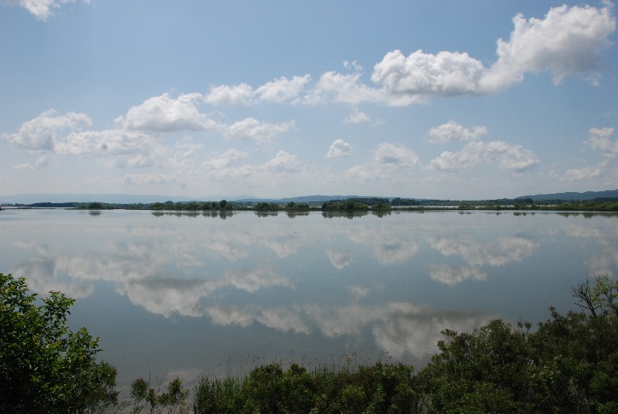
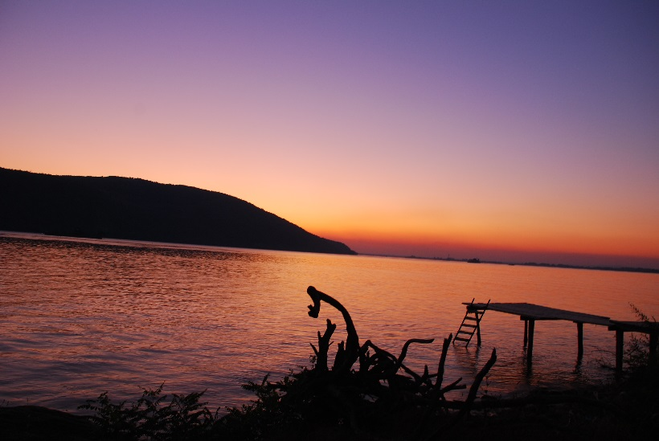
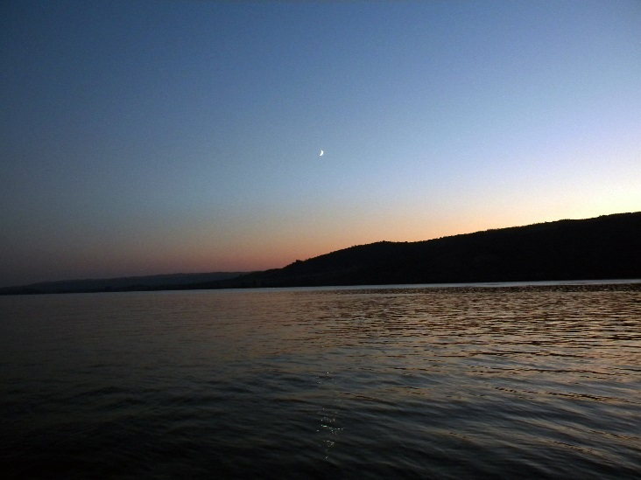
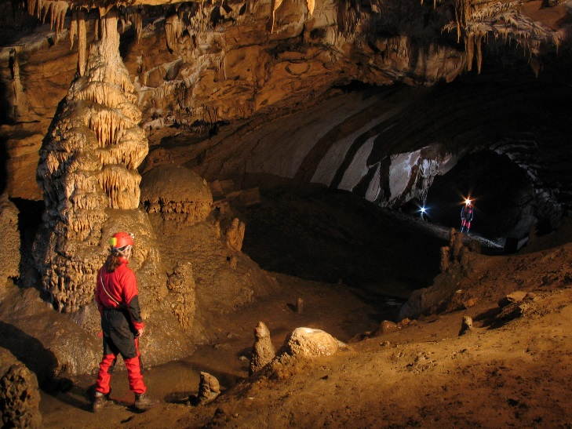

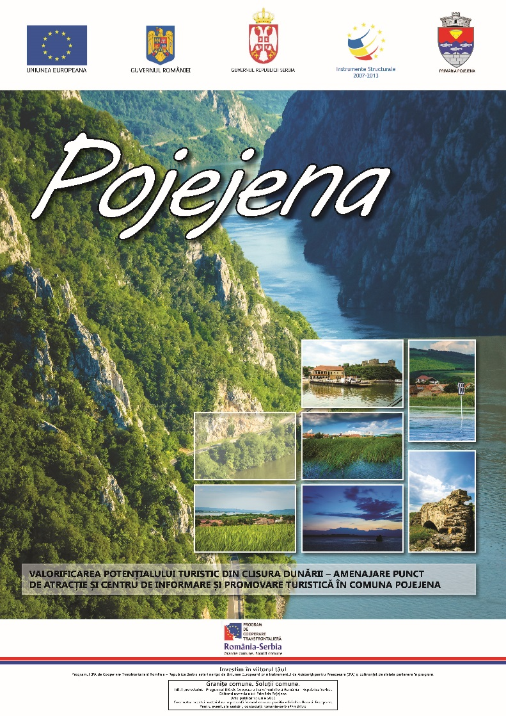
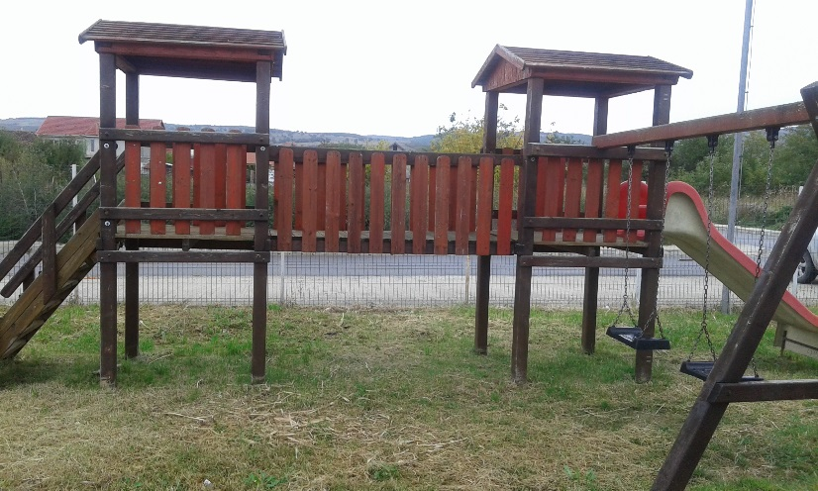
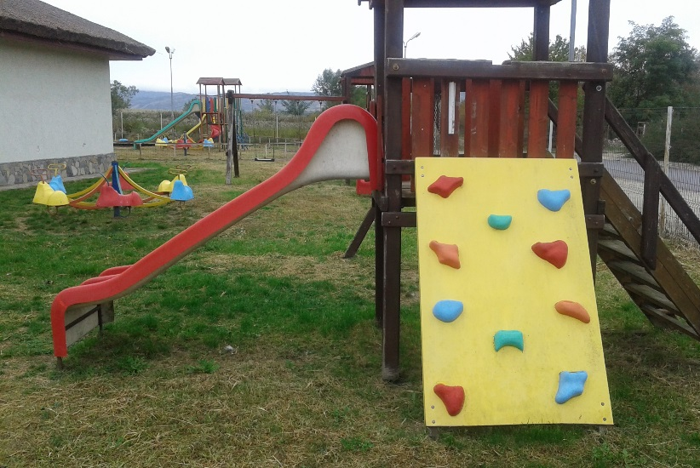

the implementation period (including extensions)
total funds spent/total funds contracted *100
indicators and level of achievement against targets set

