Project information
CALL FOR PROPOSALS |  | 1
MIS-ETC: |  | 512
PRIORITY AXIS: |  | 1 Economic and Social Development
MEASURE: |  | 1.1 Support for local/regional economic and social infrastructure
PROJECT TITLE: |  | Increasing the degree of mobility in order to develop economical and touristic exchange in the cross-border area Pojejena-Kladovo
ACRONYM: |  | PORT
DURATION: |  | 25.12.2010 – 24.06.2012
IPA FUNDS CONTRACTED: |  | 866.490,00 €
TOTAL FUNDS CONTRACTED: |  | 1.019.400,00 €
ABSORBTION RATE (%): |  | 74,97%
PROJECT OBJECTIVE(S): | The project aimed to obtain a balanced economic and social development for Pojejena-Kladovo cross-border area, through partnership activities for stimulating economic exchanges between Romanian and Serbian communities and by promoting cultural, historical and natural values in the framework of tourism sector development.  Intensifying the economic trades between the Pojejena and Kladovo areas, by creating the infrastructure required for the fluvial transportation, in the Pojejena village.  Stimulating the inter-regional and cross-border cooperation by promoting the touristic values found on both sides of the Danube, as a main mean of economic and social development.  Increasing the importance of tourism and its efficiency in the cross-border area of the Danube, by developing an integrated touristic offer and a common Romanian-Serbian activity program.

SHORT DESCRIPTION OF THE PROJECT: | The project aimed to develop the tourism infrastructure through the construction of a touristic port in Pojejena and procurement of a catamaran for 50 passengers in order to have an integrate tourism offers/package for the main attractions of Danube between Kladovo (Serbia) and Pojejena (Romania).

DEGREE OF ACHIEVEMENT OF INDICATORS: | Indicator value provisioned in the contract Present indicator value % 6= (5)/(3)*100  Output indicators (1) UM (2) Quantity (3) UM (4) Quantity (5)  Improved physical infrastructure in the border area  Result indicators  New or improved cross-border transport links and logistics capacity in the border area Number of activities, actions, initiatives creating new or improving existing transport links or tackling logistics capacity. 1 Number of activities, actions, initiatives creating new or improving existing transport links or tackling logistics capacity. 1 100%  New or improved cross-border tourism products, joint marketing approaches/activities or joint tourism information services developed Number of new or improved cross-border tourism products, marketing activities or information services 3 Number of new or improved cross-border tourism products, marketing activities or information services 3 100%  New or improved cross-border tourism services and increased SME’s capacity Number of activities, actions, initiatives focusing on promoting tourism in the border area and on promoting SME’s activity. 1 Number of activities, actions, initiatives focusing on promoting tourism in the border area and on promoting SME’s activity. 1 100%  Output indicators (1) UM (2) Quantity (3) UM (4) Quantity (5) % 6= (5)/(3)*100  Project indicators  Created fluvial transport infrastructure between Pojejena and Kladovo Number of created ports 1 Number of created ports 1 100%  New purchased transport means Number of ships 1 Number of ships 1 100%  Capacity of the transport ships Number of passengers 50 Number of passengers 50 100%  Surface of the port m² 12.000 m² 12.000 100%  Increasing of the tourist number in Pojejena Percentage of increasing 30% Percentage of increasing 30% 100%  Increasing of the tourist number in Kladovo Percentage of increasing 15% Percentage of increasing 15% 100%

RESULTS ACHIEVED: | Increasing the connectivity of the Romanian and Serbian communities.  Increasing the flux of tourists and the efficiency of the tourism sector.  Number of created harbors- 1 piece.  Number of purchased ships- 1 piece.  Promotional materials.  One tourism case study.  One training session for entrepreneurs.  One integrated tourism offer.
FILM OF THE PROJECT | https://www.youtube.com/watch?v=DRxZnCdRRwI

Partnership information
 |  | COUNTRY | COUNTY/DISTRICT | BUDGET(EURO) | CONTACT DETAILS
LEAD PARTNER: | Caras-Severin County Council | Romania | Caras-Severin | 968.159,00 | Resita,  P-ta 1 Decembrie 1918 no. 1  Tel. 0255 211420
PARTNER 2: | Pojejena Local Council | Romania | Caras-Severin | 25.817,00 | Pojejena, no. 277  Tel. 040- 255-544344
PARTNER 3: | Municipality of Kladovo | Serbia | Borski | 25.424,00 | Kladovo, Kralja Aleksandra 35  Tel. +381 19 808 066

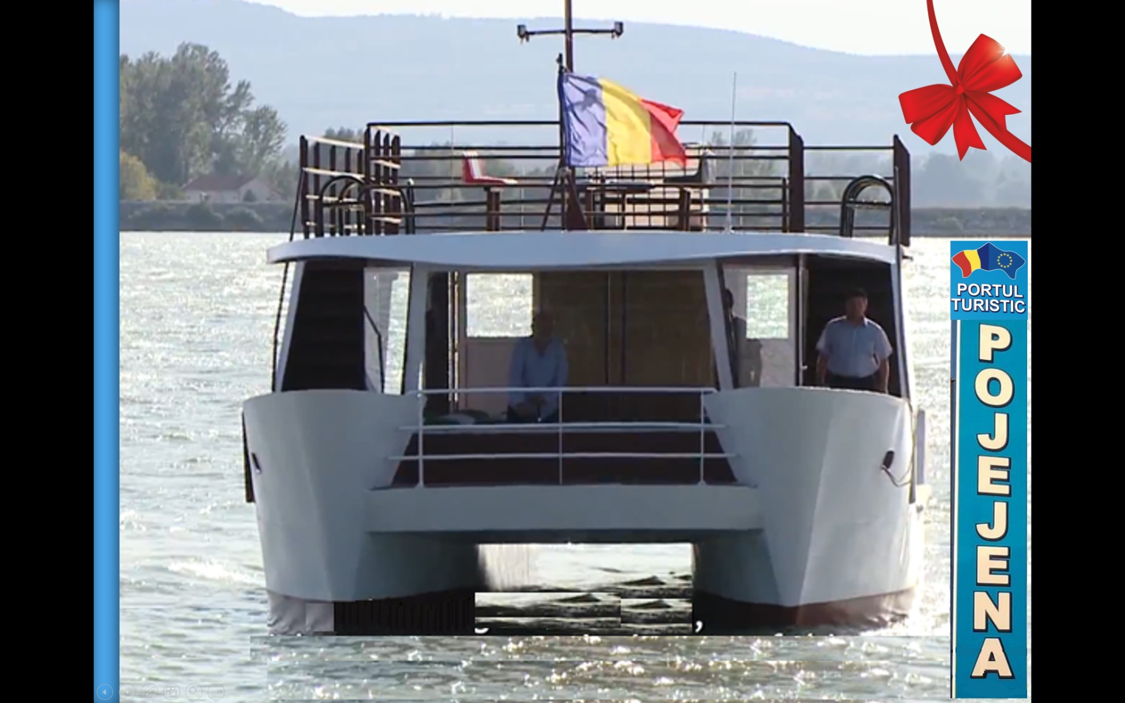
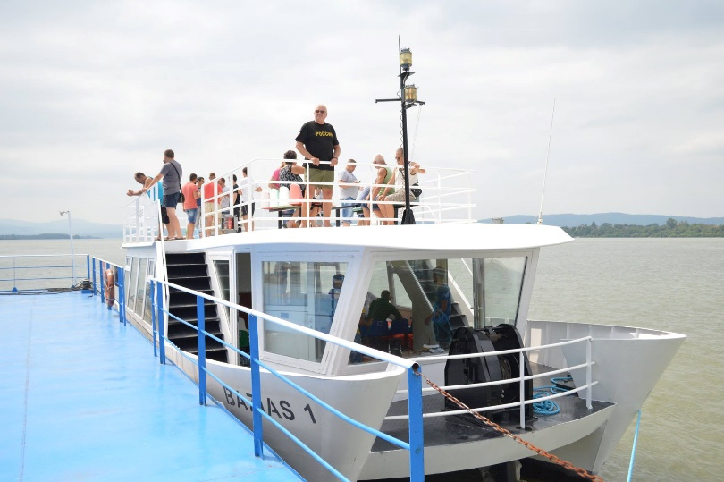
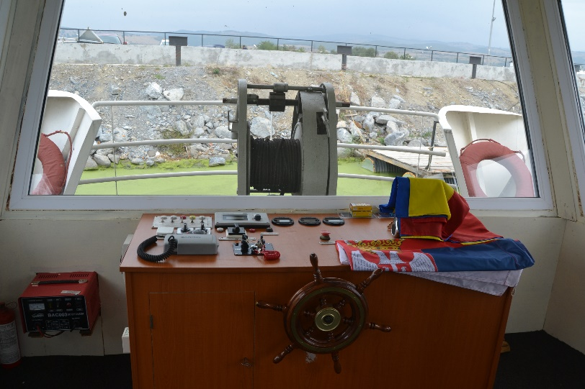

the implementation period (including extensions)
total funds spent/total funds contracted *100
indicators and level of achievement against targets set

