 | Project information
 | CALL FOR PROPOSALS |  | 1
 | MIS-ETC: |  | 507
 | PRIORITY AXIS: |  | 1
 | MEASURE: |  | 1.4
 | PROJECT TITLE: |  | Cross-border initiative for research and development activities, (and) cooperation between economy and scientific educational institutions, in Serbian and Romanian historical Banat, as contribution to competitiveness improvement and regional identity, according to EU standards
 | ACRONYM: |  | Banatian entrepreneurship tradition – appliance of new experiences, ideas and knowledge
 | DURATION: |  | 25.12.2010 – 24.12.2011
 | IPA FUNDS CONTRACTED: |  | 252.990,60
 | TOTAL FUNDS CONTRACTED: |  | 297.636,00
 | ABSORBTION RATE (%): |  | 90,05
 | PROJECT OBJECTIVE(S): |  | Forming, systematization and updating the database relevant for the economic activity supported by the Chambers of Commerce from the cross-border region and “Ioan Slavici” Foundation for Culture and Education University from Timisoara.  Sustaining development and research activities in the business field in the region.  Scientific and expert understanding of the position and potential of the region and offering cross-border support.  Strengthening the regional business identity within regional bonds.  Supporting innovation in business.
 | SHORT DESCRIPTION OF THE PROJECT: |  | In order to support research and development activities and innovation in the border area, the project partners founded a cross-border development support centre. The head office of the Centre is located in Pančevo, with an office also functioning in Timisoara. The Centre supported research and development activities in the business field, increasing competitive abilities of the economic players in the cross-border region. The Centre also strengthened connections and business activities, promotion of business possibilities, support and affirmation of innovation and technology transfer in the cross-border region.  Through existing fair activities, the chambers organized specific expert consultations concerning the possibilities of regional economic collaboration, competitiveness and innovation in the Banat region economy. Some of the subjects discussed were: the possibility of labour force mobility in the cross-border Banat region, standardization and certification of production in the EU, regional connections and clusters in the development of cross border economy and so on. At regional economic fairs taking place in Pančevo and Timisoara, special regional cross-border presentation pavilions were set up, as well as partner meetings (partnerships) and acquainting with examples of good practice. The Centre organized a conference on the subject of the perspectives of the regional connection within the historical Banat from Romania and Serbia.  In cooperation with local associations of entrepreneurs, an economy club with the objectives of closer connection among regional entrepreneurs and strengthening informal bonds and economy contact was organized.
 | DEGREE OF ACHIEVEMENT OF INDICATORS: |  | Indicator value provisioned in the contract Present indicator value % 6= (5)/(3)*100  Output indicators (1) UM (2) Quantity (3) UM (4) Quantity (5)  Improved capacity and cross-border contacts of SMEs and in the R&D  People in labour force with qualifications received/improved from joint training  Result indicators  Increased importance of R&D/Innovation in the border area Number of activities, actions, initiatives focusing on promoting the importance of or dealing directly with R&D/Innovation 3 Number of activities, actions, initiatives focusing on promoting the importance of or dealing directly with R&D/Innovation 3 100  New or improved cross-border tourism services and increased SME’s capacity Number of activities, actions, initiatives focusing on promoting tourism in the border area and on promoting SME’s activity. 6 Number of activities, actions, initiatives focusing on promoting tourism in the border area and on promoting SME’s activity. 6 100  New or improved cross-border tourism products, joint marketing approaches/activities or joint tourism information services developed Number of new or improved cross-border tourism products, marketing activities or information services 5 Number of new or improved cross-border tourism products, marketing activities or information services 5 100  Project indicators  Institutionalization of the research and development support with the objective of boosting economy activities Number of institutions which support development 1 Number of institutions which support development 1 100  Improved regional identity and better quality information database Regional database 1 Regional database 1 100  A higher level of knowledge of the local economy tendencies Scientific conference, research 2 Scientific conference, research 2 100  Improved advertising activities and entrepreneurship promotion Fairs 2 Fairs 2 100  Boosting cross border economy contacts Fairs, partnerships, expert conferences 5 Fairs, partnerships, expert conferences 5 100  R&D linked to economy activities Scientific conference, consulting 3 Scientific conference, consulting 3 100  A higher level of innovation activities Number of participants in the activities 30 Number of participants in the activities 118 393
 | RESULTS ACHIEVED: |  | Improved infrastructure for using the scientific and research work for economic purposes.  Regional economy information database completed and improved.  Improved advertising activity and a stronger regional business identity.  Improved cross border business cooperation and economic contacts in Banat region.  Forming an informal support structure for the Chambers of Commerce in the cross-border region and the regional business and an infrastructure for innovation support in business.
Partnership information
 |  |  |  | COUNTRY | COUNTY/DISTRICT | BUDGET(EURO) | CONTACT DETAILS
LEAD PARTNER: |  | Regional Chamber of Commerce and Industry Pancevo |  | Serbia | South Banat | 206.259 | Pancevo, Zmaj Jovina 1a  Tel. +381 13 343 255
PARTNER 2: |  | Timişoara Chamber of Commerce, Industry and Agriculture |  | Romania | Timis | 49.930 | Timisoara, Piata Victoriei nr. 3  Tel. +40-256-497136
PARTNER 3: |  | “Ioan Slavici” Foundation for Culture and Education –University Timisoara |  | Romania | Timis | 13.792 | Timisoara, 144 Dr. A. Paunescu-Podeanu Street  Tel. +40256 213 108
PARTNER 4: |  | Regional Chamber of Commerce and Industry Kikinda |  | Serbia | North Banat | 13.630 | Kikinda, Trg srpskih dobrovoljaca 48  Tel. +381 (0)230 21080
PARTNER 5: |  | Regional Chamber of Economy Zrenjanin |  | Serbia | Central Banat | 14.025 | Zrenjanin, Kralja Petra I. 3/1  Tel. +381 23 535890

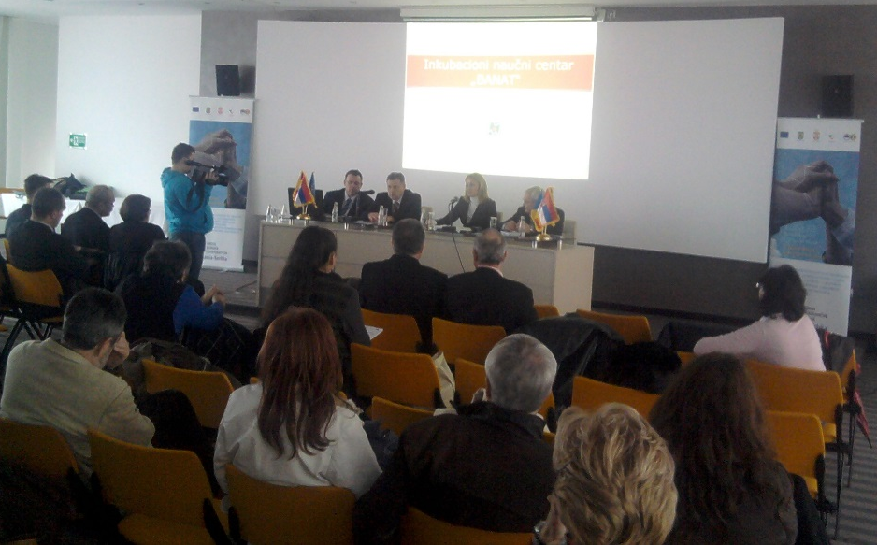
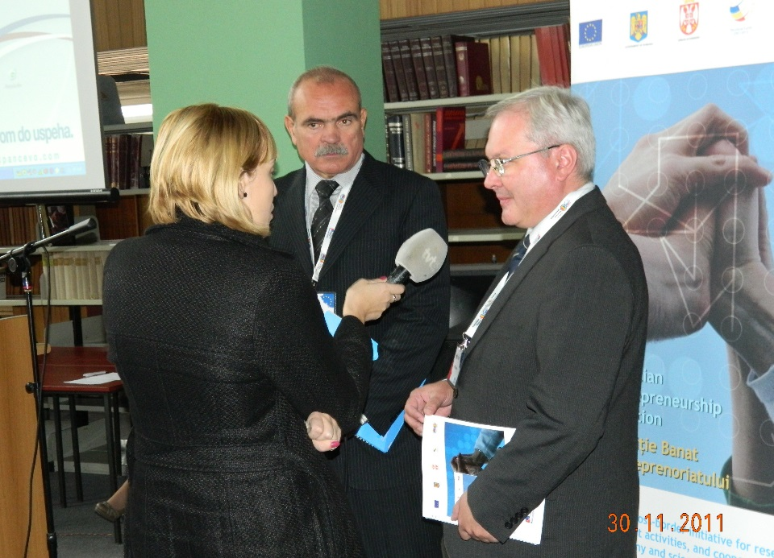

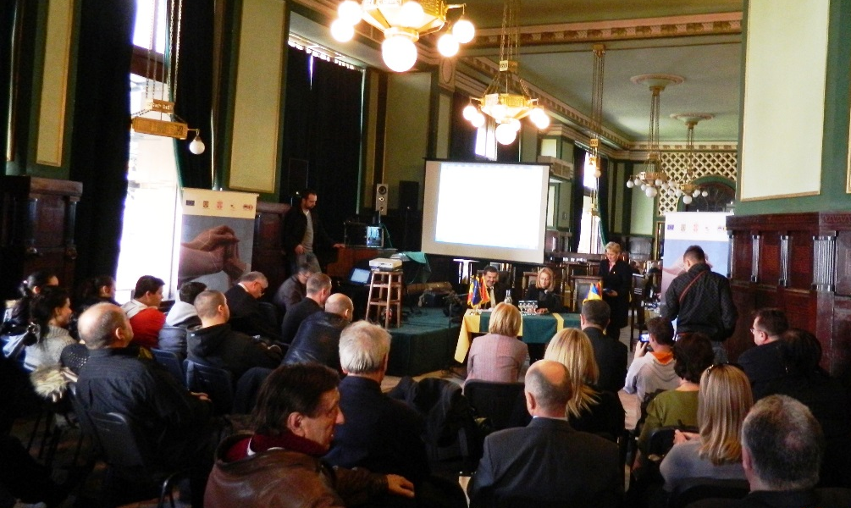

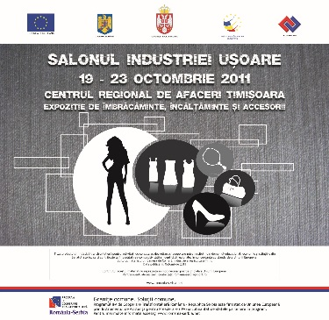

the implementation period (including extensions)
total funds spent/total funds contracted *100
indicators and level of achievement against targets set

