 | Project information
 | CALL FOR PROPOSALS |  | 1
 | MIS-ETC: |  | 476
 | PRIORITY AXIS: |  | 2 Environment and Emergency Preparedness
 | MEASURE: |  | 2.3 More effective systems and approaches to emergency preparedness
 | PROJECT TITLE: |  | Monitoring and Alarming System in Cases of Natural Disasters
 | ACRONYM: |  | MASD
 | DURATION: |  | 27.11.2010-26.05.2012
 | IPA FUNDS CONTRACTED: |  | 977.500,00
 | TOTAL FUNDS CONTRACTED: |  | 1.150.000,00
 | ABSORBTION RATE (%): |  | 91,41
 | PROJECT OBJECTIVE(S): |  | Setting up, by the project end, a monitoring and decision support system for emergency situations related to hydro-meteorological events, accidents at hydro-technical buildings and accidental spills.  Efficient alarming system by the acquisition and deployment of sirens, spread throughout the entire county (in the risk areas) that will be triggered by the monitoring and decision support system.  Stimulating the local awareness in case of risk related to water by creating and maintaining a local risk register.  Providing real time, easy to access information and updates for all the involved authorities and for the general public via a bilingual web portal.
 | SHORT DESCRIPTION OF THE PROJECT: |  | A system of monitoring and decision support for emergency situations related to hydro-meteorological events, accidents to hydro-technical buildings and accidental spills has been set up; Efficient alarming system by the acquisition and deployment of sirens, spread throughout the entire county (in the risk areas) that will be triggered by the monitoring and decision support system; Stimulating the local awareness in case of risk related to water by creating and maintaining a local risk register; Providing in real time easy access to information and updates for all the involved authorities and for the general public via a bilingual web portal.
 | DEGREE OF ACHIEVEMENT OF INDICATORS: |  | Indicator value provisioned in the contract Present indicator value % 6= (5)/(3)*100  Output indicators (1) UM (2) Quantity (3) UM (4) Quantity (5)  Increased institutional capacity and preparedness in reacting to situations of environmental emergency (e.g. flooding, bird flu)  Increased joint technical preparedness to situations of environmental emergency  Result indicators  Increased qualification of human resource in reacting to situations of environmental emergency Number of persons 80 Number of persons 80 105  Project indicators  Electronic sirens alarming system – new sirens installed unit 7 unit 7 100  SMS alerting system for the decision factors involved in emergency situations management unit 1 unit 1 100  Voice alerting system for the decision factors involved in emergency situations management unit 1 unit 1 100  System dealing with information and prevention for the general population unit 1 unit 1 100
 | RESULTS ACHIEVED: |  | Alarming system based on 7 electorinc sirens and a phone alarming system.  A web GIS system.  A portal for public information.  A tactical support system for intervention management.  Optimization of time and costs of intervention with help of stakeholders stocks of defense materials and logistics in case of floods or accidental spills.  A short video about the project is available at: https://www.youtube.com/watch?v=tAdNDSRfnEY
Partnership information
 |  |  |  | COUNTRY | COUNTY/DISTRICT | BUDGET(EURO) | CONTACT DETAILS
LEAD PARTNER: |  | Timis County Council |  | Romania | Timis | 1.150.000,00 | Timisoara, Bd. Revoluţiei din 1989, nr.17  Tel. +40-256-406 323
PARTNER 2: |  | Municipality of Vrsac |  | Serbia | South Banat | 0 | Vrsac, Trg Pobede 1  Tel. +381 (0) 13 800-501
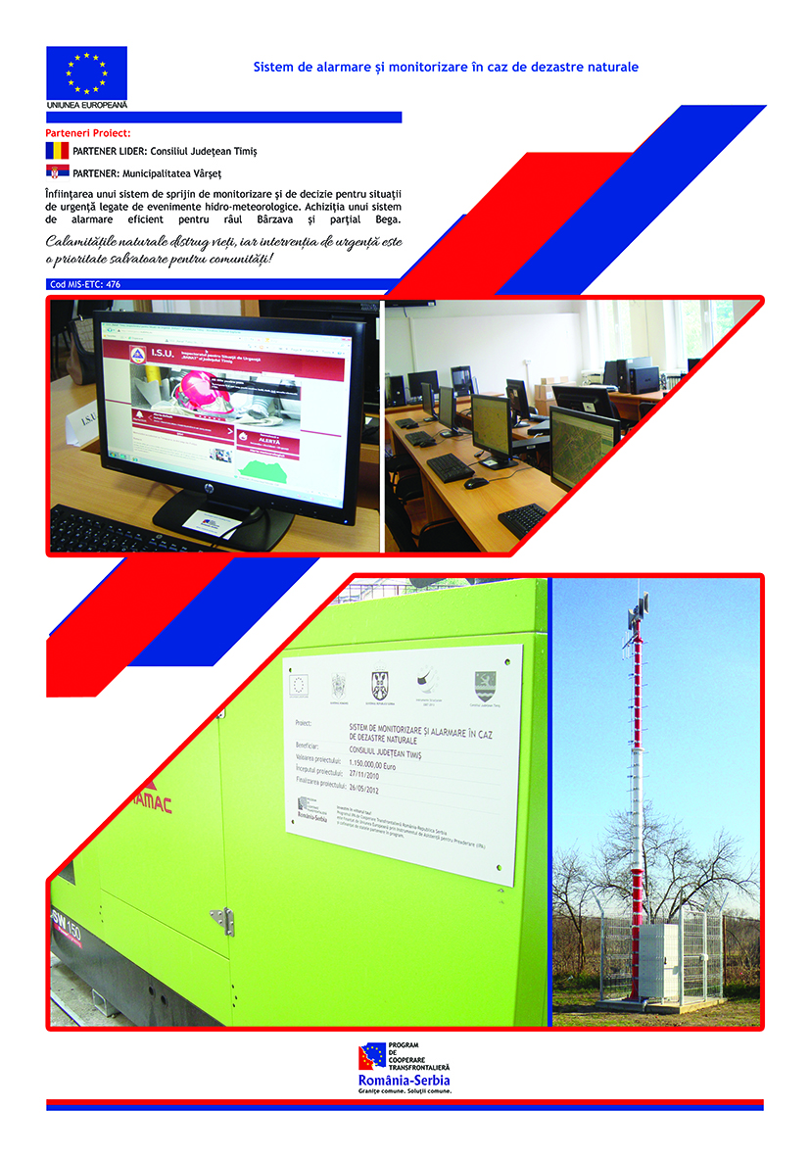

the implementation period (including extensions)
total funds spent/total funds contracted *100
indicators and level of achievement against targets set

