Project information

CALL FOR PROPOSALS | 1
MIS-ETC: | 471
PRIORITY AXIS: | 3 Promoting “people to people” exchanges
MEASURE: | 3.3 Increase educational, cultural and sporting exchange
PROJECT TITLE: | Identity, Common culture and tradition in the Romanian-Serbian Cross-border
ACRONYM: | Culture and tradition in the cross-border area
DURATION: | 02.11.2010-14.06.2012
IPA FUNDS CONTRACTED: | 139.247,00 €
TOTAL FUNDS CONTRACTED: | 163.820 €
ABSORBTION RATE (%): | 92,71 %
PROJECT OBJECTIVE(S): | Knowing, rediscovering and preserving the Romanian cultural and historic identity by the Romanians and the Serbians of Romanian ethnicity from the two sides of the Danube
SHORT DESCRIPTION OF THE PROJECT: | The knowledge, rediscovery and preservation of Romanian cultural and historical identity by Romanians and Romanian ethnicity on both sides of the Danube has been realized.

DEGREE OF ACHIEVEMENT OF INDICATORS: | Indicator value provisioned in the contract Present indicator value % 6= (5)/(3)*100  Output indicators (1) UM (2) Quantity (3) UM (4) Quantity (5)  Increased people-to-people exchange in the fields of education, culture and sports  Increased integration of the border communities and improved local services in the border area  Result indicators  Increased social and cultural integration of people in the border areas Number of participants benefiting from cross-border social and cultural events 200 Number of participants benefiting from cross-border social and cultural events 260 130%  Improved knowledge of culture, history, society, organisational and institutional structure, and language of the neighbouring country Number of participants gained knew knowledge in events promoting/profiling the neighbouring country 200 Number of participants gained knew knowledge in events promoting / profiling the neighbouring country 260 130%  Project indicators  Intensification of the cultural and educative exchanges among the Romanians and the Serbians of Romanian ethnicity from the two sides of the Danube for knowing and rediscovering the common cultural and historic identity. Number of persons participating to cross-border events for knowing and rediscovering the common cultural and historic identity. 195 Number of persons participating to cross-border events for knowing and rediscovering the common cultural and historic identity. 260 130%  Project indicators  Increasing the degree of information and awareness of the Romanians and the Serbians of Romanian ethnicity from the two sides of the Danube regarding the importance of culture and traditions through cultural and scientific manifestations. Number of cultural and scientific manifestations organized in cross-border area: symposia and exhibitions 4 Number of cultural and scientific manifestations organized in cross-border area: symposia and exhibitions 4 100%  Improving the knowledge and promotion of the identity and popular traditions specific to Romanians from the two sides of the Danube through the folkloric music shows. Number of shows organized in cross-border area 2 Number of shows organized in cross-border area 2 100%  Intensification of cultural and educative exchanges among young people from Mehedinti County and Borski District for knowing and preserving the traditions and traditional customs. Number of cultural and educative exchanges organized for young people 1 Number of cultural and educative exchanges organized for young people 1 100%
RESULTS ACHIEVED: | During the project implementation the partners succeed to develop the interest in the preservation and transmitting of the traditional costumes, traditions, customs, the spiritual and material heritage specific to the people living in the Romania-Serbia cross-border area.  The main local and regional actors were involved in cross-border cooperation activities. The popular ensembles’ repertoire was enriched with songs from the two sides of the Danube and members of the ensembles had the opportunity to experience new cultural exchanges.  The project raised the interest for visiting the historical and traditional places in the Borski District (Serbia) and in the Mehedinti County (Romania) and attracted new tourists in both regions. During the project implementation were organised 2 symposiums with 160 participants, 2 exhibitions, 1 summer school with 30 participants. Also were printed 2 photo albums distributed in 1200 pieces and were produced 2 video films distributed in 1200 hard copies.

Partnership information
 |  | COUNTRY | COUNTY/DISTRICT | BUDGET(EURO) | CONTACT DETAILS
LEAD PARTNER: | Episcopate of Severin and Strehaia | Romania | Drobeta Turnu Severin /Mehedinți | 163.820 | Drobeta Turnu Severin, 6 I. Gh. Bibicescu Street  Tel. 0040252333049
PARTNER 2: | National Council of Valach (Romanian) National Minority | Serbia | Bor/ Borski | 0 | Bor, 15 Bobijeva Street  Tel. +381604854900

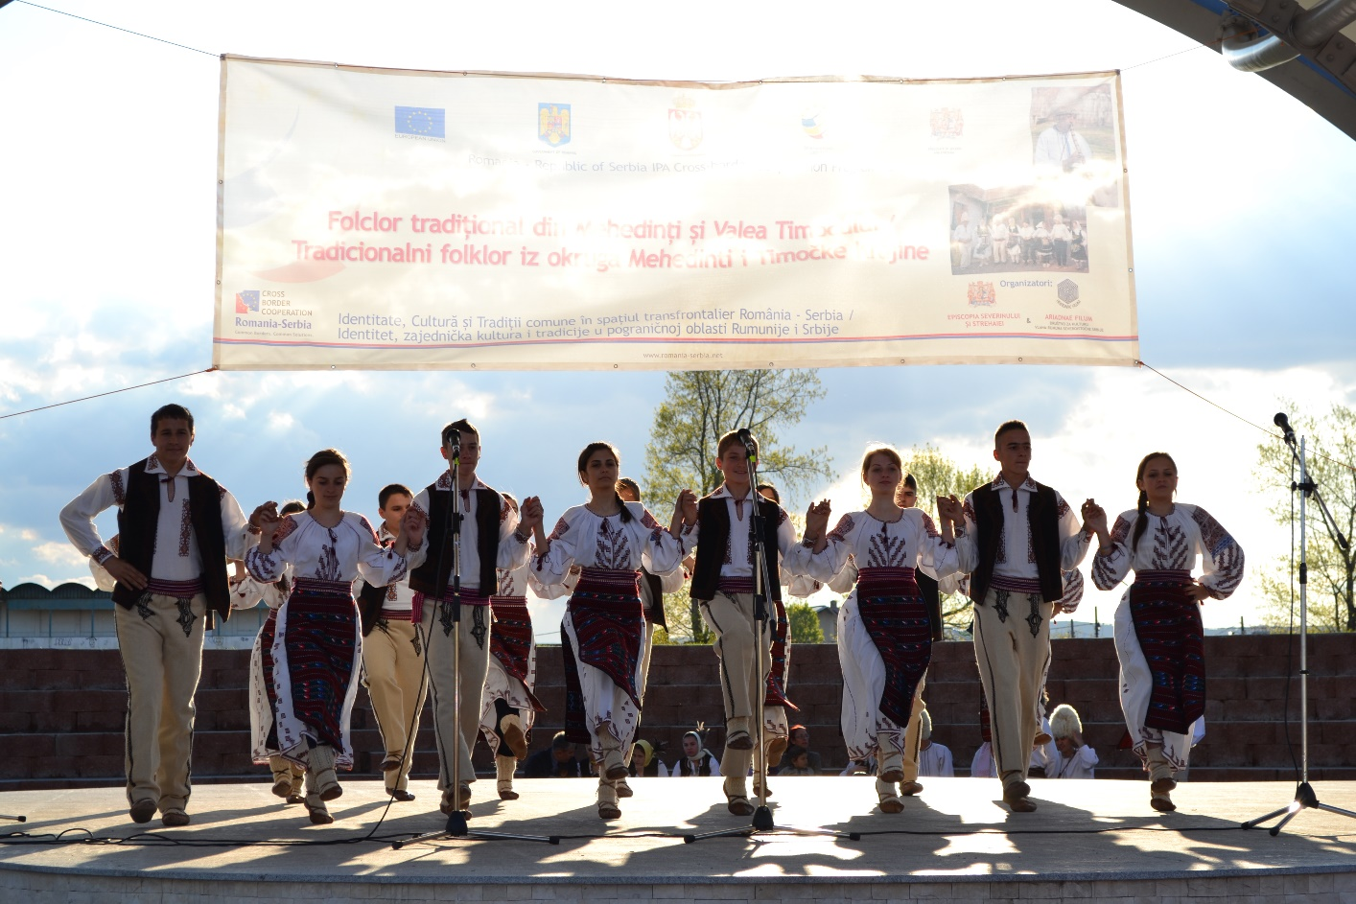

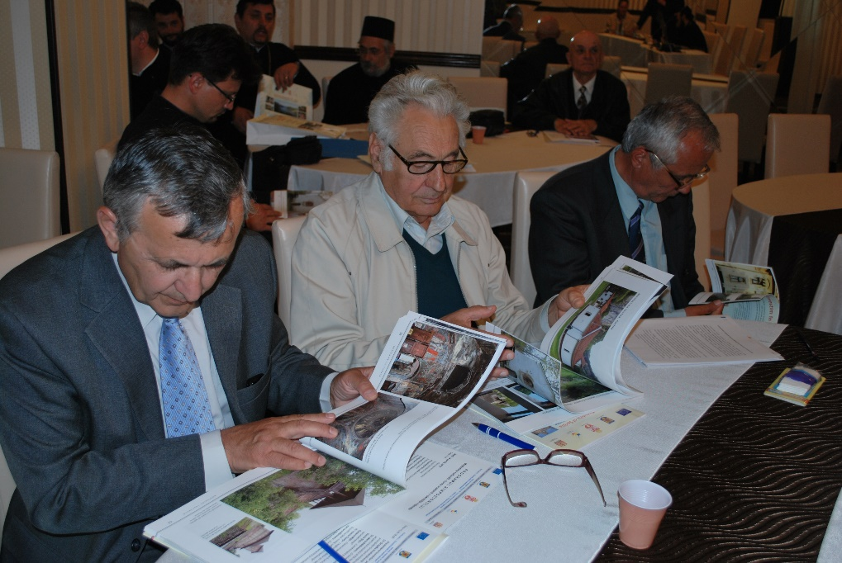
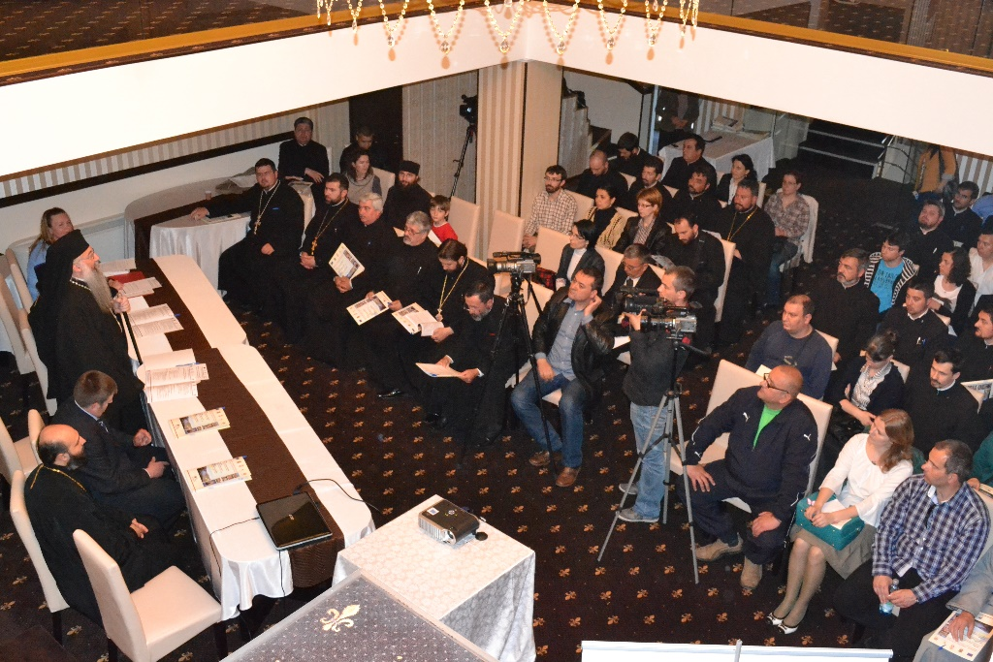
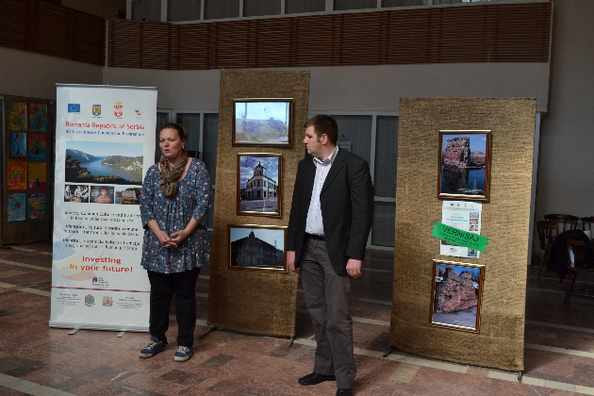
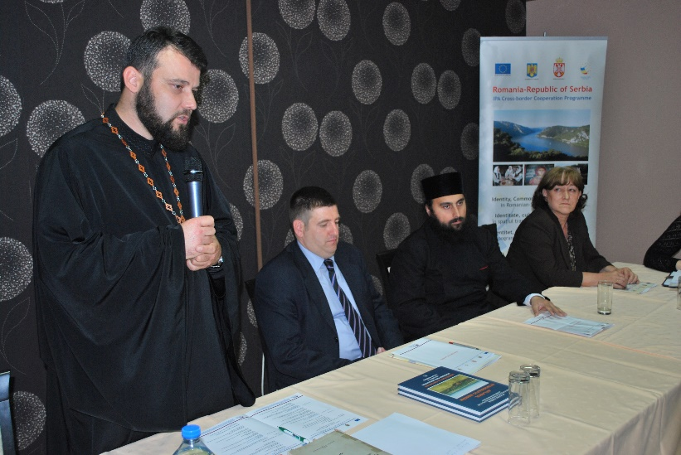

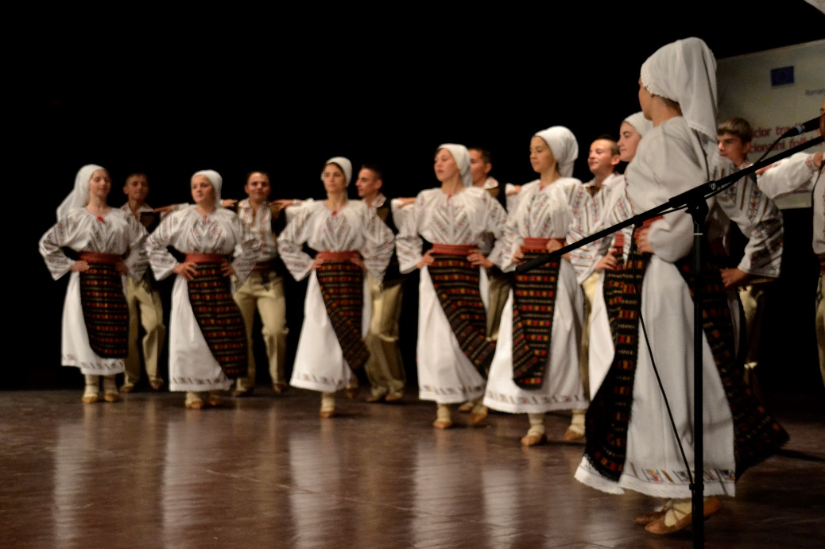
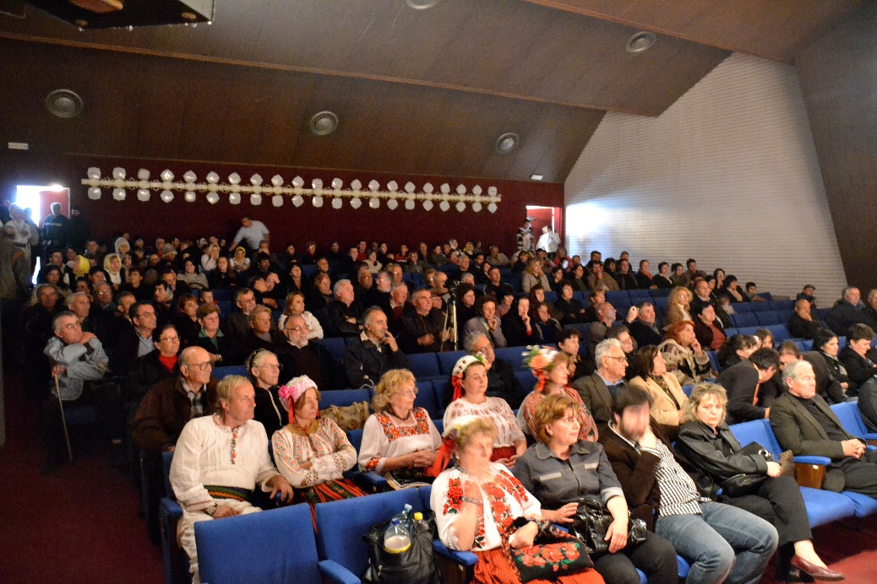
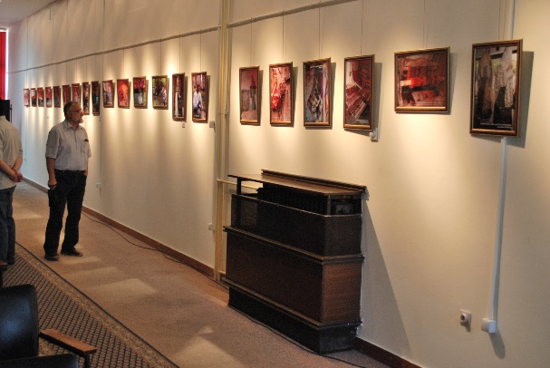
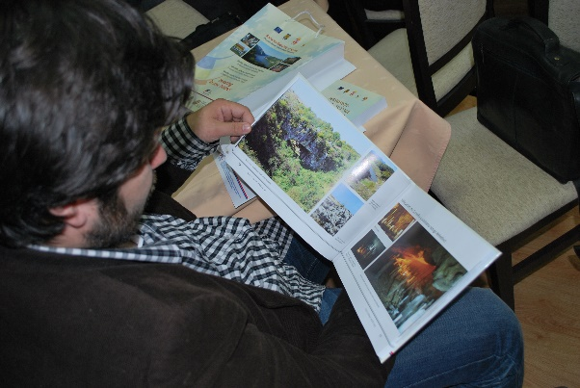

the implementation period (including extensions)
total funds spent/total funds contracted *100
indicators and level of achievement against targets set

