Project information
CALL FOR PROPOSALS |  | 1
MIS-ETC: |  | 444
PRIORITY AXIS: |  | 3 Promoting “people to people” exchanges
MEASURE: |  | 3.3 Increase educational, cultural and sporting exchange
PROJECT TITLE: |  | Learn best Agribusiness practices - Improve Banat Rural Prospects
DURATION: |  | 04.12.2010-03.12.2011
IPA FUNDS CONTRACTED: |  | 92.191,00 €
TOTAL FUNDS CONTRACTED: |  | 108.460,00 €
ABSORBTION RATE (%): |  | 74,97%
PROJECT OBJECTIVE(S): | To improve the rural economy and the exchange experiences between professionals. To improve the information, the knowledge and the management skills of young farmers and woman in the sector of livestock production. To develop new job opportunities for the unemployed people in the agricultural sector. To support creation of a “demonstration farm” for advanced dissemination of the good agricultural practices and increased household incomes
SHORT DESCRIPTION OF THE PROJECT: | The project facilitated the exchange of knowledge, education, good agricultural practice and the connection with the support services to sustain the sector’s viability. The implemented actions contributed to the objectives of the programme through farmer’s capacity building and education, related to the quality production, farm management, standards, marketing and access to information. All the activities allowed farmers to increase productivity, to become more competitive and to create jobs in the rural area of the Banat. The actions were based on a spectrum of practical education - training modules, exchange of best practices and information flow from both sides of the border, thus strengthening institutional support, relationships and creating base ground for viable cooperation.

DEGREE OF ACHIEVEMENT OF INDICATORS: | Indicator value provisioned in the contract Present indicator value % 6= (5)/(3)*100  Output indicators (1) UM (2) Quantity (3) UM (4) Quantity (5)  Increased people-to-people exchange in the fields of education, culture and sports  Result indicators  Increase people to people exchange in the field of education Number of professional conferences 1 Number of professional conferences 1 100%  Number of trained farmers 45 Number of trained farmers 92 204%  Number of trained women 15 Number of trained women 18 120%  Number of trained unemployed people 15 Number of trained unemployed people 17 113%  Project indicators  Improved cross border knowledge and business Number of participants at the conference 30 Number of participants at the conference 40 133%  Interactive database for 80 farms created Number of farmers in database 80 Number of farmers in database 80 100%  Forming of demo-training centre and demo fields for practical farmer trainings and dissemination of good production practice Training centre equipped 1 Training centre equipped 1 100%  Increased milk production/cow 7 Increased milk production/cow 7 100%  Education of young farmers, woman and unemployed people Number of seminars 38 Number of seminars 38 100%  Increased production and farm profitability Increased milk production/cow 800 Increased milk production/cow 850 106%  Number of printed materials material-pages 1500 material-pages 1700 113%

RESULTS ACHIEVED: | 1. Creation of an interactive database for 80 farms, from the area of Zrenjanin, Vršac and Novi Kneževac.  - Mapping of resources, selection of farms for interactive database and training was done. 80 farms populated in database.  - 2073 cows were included in the database and monitored.  2. Forming of demo-training centre and demo-fields for practical farmer trainings and dissemination of good production practice.  - 1 Demo training centre established in Stajicevo, with related equipment purchased.  - 7 Demo fields for practical training established both in Zrenjanin and Novi Kneževac.  - 38 Practical seminars were organized in the demo training centre.  3. Education of young farmers, woman and unemployed people.  - Dairy farmers, young farmers, women and unemployed people attended in total 40 seminars.  4. Increased incomes and farm profitability.  - Project management and monitoring of the project results were implemented, including written recommendations for improvement. Second monitoring of the project results were implemented and written recommendations for improvement and verification were implemented.  - Average milk production per cow increased to 850 litres.

Partnership information
 |  | COUNTRY | COUNTY/DISTRICT | BUDGET(EURO) | CONTACT DETAILS
LEAD PARTNER: | Educational Centre for Rural Development Zrenjanin | Serbia | Central Banat | 108.460,00 | Zrenjanin, Teplička 20  Tel. +381 23 515 911
PARTNER 2: | Centre for Rural Development Novi Kneževac | Serbia | North Banat | 0 | Novi Kneževac, Trg Moše Pijade 11  Tel. +381 230 82 715
PARTNER 3: | The Serbian-Romanian Development Centre | Romania | Timiş | 0 | Timişoara, Str. Maslinului nr.9, sc.A, ap.3  Tel. +40 256475397

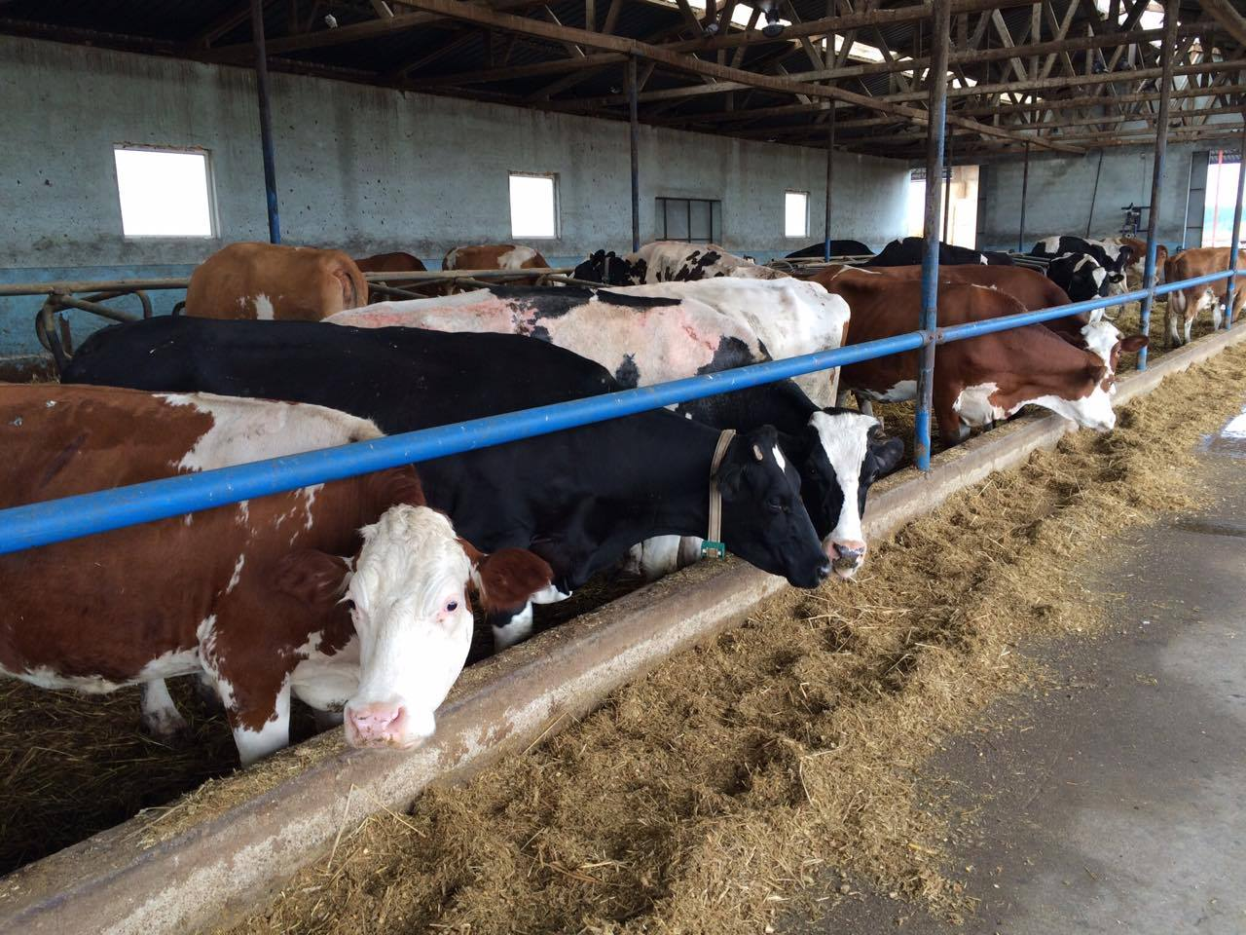
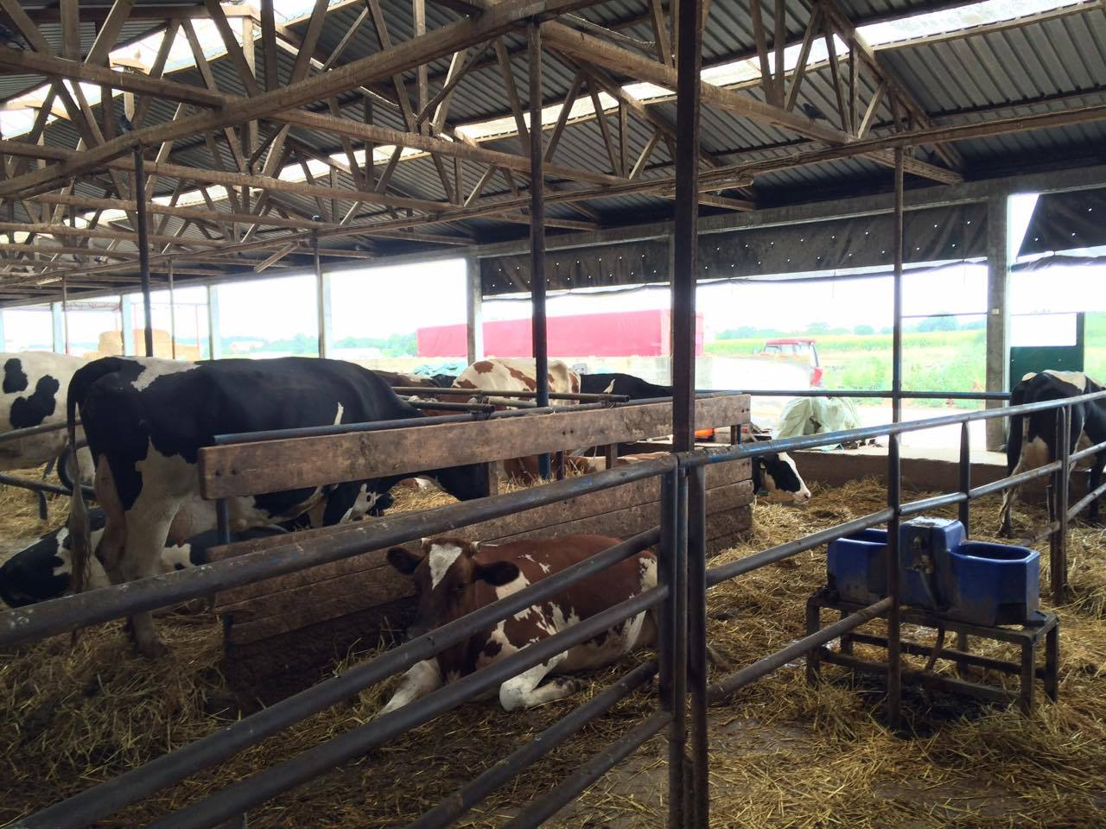

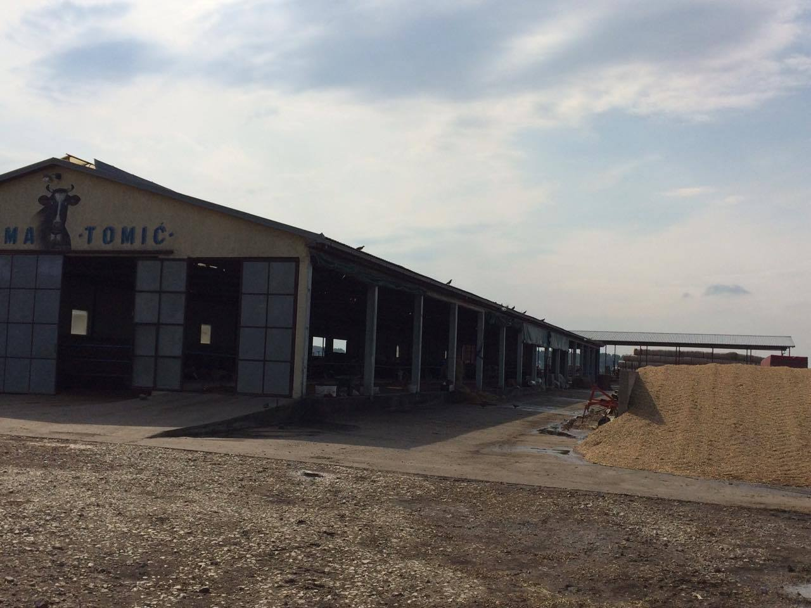
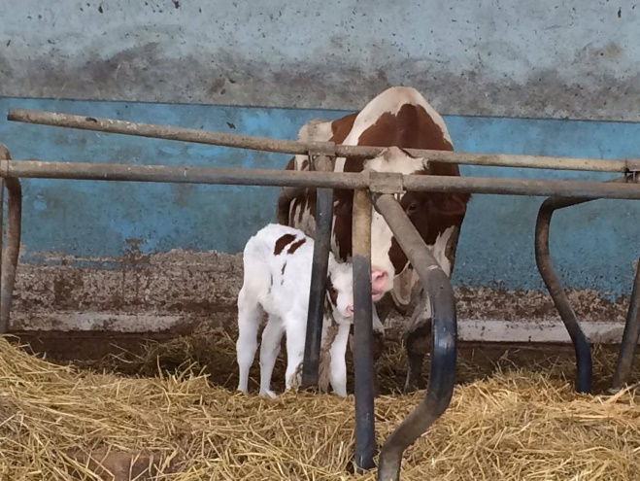
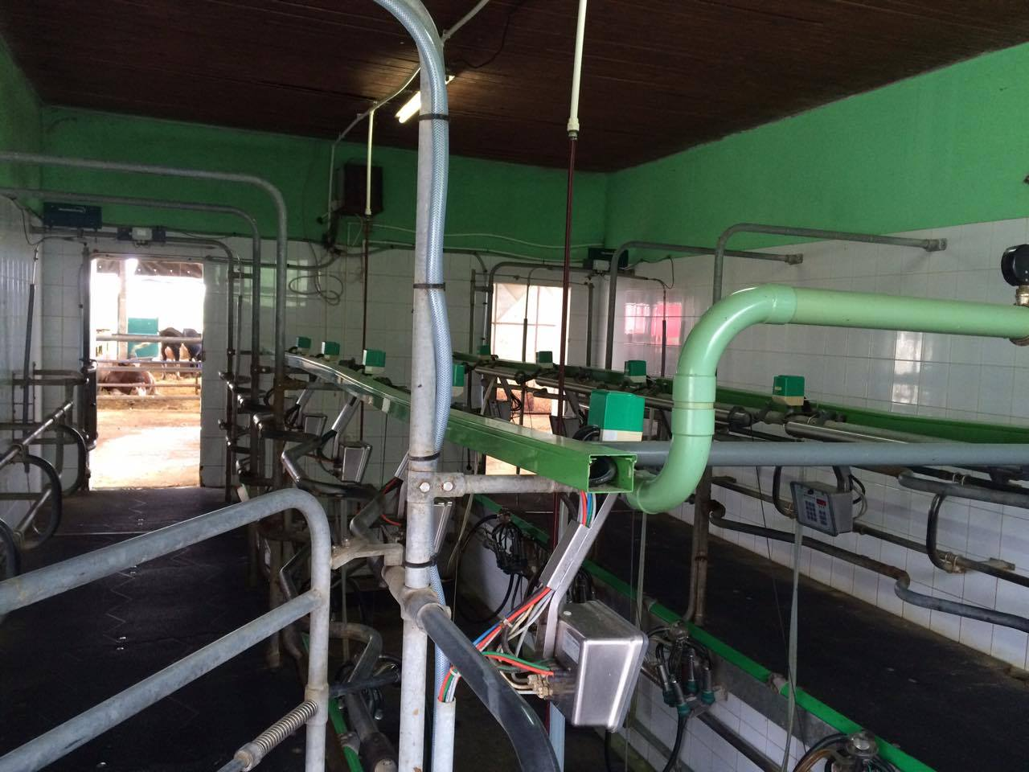

the implementation period (including extensions)
total funds spent/total funds contracted *100
indicators and level of achievement against targets set

