Project information
CALL FOR PROPOSALS | 1
MIS-ETC: | 432
PRIORITY AXIS: | 3 Promoting “people to people” exchanges
MEASURE: | 3.3 Increase educational, cultural and sporting exchange
PROJECT TITLE: | Cultural and linguistic interfaces – bridge between two nations
ACRONYM: | Intercultural dialogue
DURATION: | 14.12.2010 – 13.04.2012
IPA FUNDS CONTRACTED: | 119.222,28 €
TOTAL FUNDS CONTRACTED: | 140.261,50 €
ABSORBTION RATE (%): | 27,83%

PROJECT OBJECTIVE(S): | To develop, within 16 months from the start of the project, the capacities of common, active, durable and cross-border cooperation of the 11 local communities which belong to Banat-Ripensis microregion in Romania made up of Jimbolia town and the localities: Comloşu Mare, Lenauheim, Cărpiniş, Cenei, Uivar, Iecea Mare, Gottlob, Cehecea and Săcălaz and Kikinda town in Serbia.  To promote within 10 months, the traditions, the cultural and tourist resources in the 11 Romanian-Serbian local communities.  To develop, within 12 months, structures integrated in a common cross-border network of intercultural cooperation and dialogue.  To promote interpersonal relations and linguistic and cultural exchanges through the 7 common Romanian-Serbian actions within 16 months.

SHORT DESCRIPTION OF THE PROJECT: | Capacities for joint, active, sustainable and cross-border cooperation have been developed, the development of integrated structures in a cross-border cooperation network and intercultural dialogue to promote the traditions, cultural and tourist resources of the 11 Romanian-Serbian local communities belonging to the Banat-Ripensis micro-region in Romania and Serbia's Kikinda.

DEGREE OF ACHIEVEMENT OF INDICATORS: | Indicator value provisioned in the contract Present indicator value % 6= (5)/(3)*100  Output indicators (1) UM (2) Quantity (3) UM (4) Quantity (5)  Stronger civil society of the border area  Increased people-to-people exchange in the fields of education, culture and sports  Result indicators  Increased social and cultural integration of people in the border areas Number of participants benefiting from cross-border social and cultural events 100 Number of participants benefiting from cross-border social and cultural events 100 100  Improved knowledge of culture, history, society, organisational and institutional structure, and language of the neighbouring country Number of participants who gained new knowledge in events promoting/profiling the neighbouring country 40 Number of participants who gained new knowledge in events promoting/profiling the neighbouring country 40 100  Project indicators  Common workshops organised Number of workshops 4 Number of workshops 4 100  Cultural promoters attending the workshops Number of promoters attending 20 Number of promoters attending 20 100  Room equipped for trainings Number of rooms equipped 1 Number of rooms equipped 1 100  Language training courses organised Number of trainings 2 Number of trainings 2 100  Cultural promoters attending the language training courses Number of promoters attending 20 Number of promoters attending 20 100  Young persons attending the language training courses Number of young persons attending 20 Number of young persons attending 20 100  Number of young persons attending the creative ceramic camp Number of young persons attending 20 Number of young persons attending 20 100  Ceramic objects realised Number of objects 100 Number of objects 100 100  Housewives attending the workshop Number of housewives attending 20 Number of housewives attending 20 100  Teachers attending the workshop Number of teachers attending 20 Number of teachers attending 20 100  Workshops organized Number of workshops 2 Number of workshops 2 100  Organised concerts Number of concerts organised 2 Number of concerts organised 2 100  Participant bands Number of bands 2 Number of bands 2 100  Promotional leaflets Number of copies 2000 Number of copies 2000 100  Promotional posters Number of copies 50 Number of copies 50 100  Seminars organised to promote and disseminate Number of seminars organised to promote and disseminate 1 Number of seminars organised to promote and disseminate 1 100  People attending the seminar Number of people attending the seminar 100 Number of people attending the seminar 100 100  Promotional exhibitions organised Number of promotional exhibitions organised 1 Number of promotional exhibitions organised 1 100  Tourist and cultural guide Number of copies 2000 Number of copies 100  The brochure “Like at Mama’s – traditional culinary recipes from Romanian and Serbian Banat” Number of copies 2000 Number of copies 2000 100  Brochures to promote the project Number of copies 2000 Number of copies 2000 100  Press releases Number of press releases 2 Number of press releases 2 100  Media publication Number of publications 4 Number of publications 4 100  Site publication of the project brochure Number of publications 2 Number of publications 2 100  Invitations to seminar Number of copies 120 Number of copies 120 100  Promotional posters Number of copies 50 Number of copies 50 100
RESULTS ACHIEVED: | The organisational capacity of the two partners aiming at the management of cross-border partnerships was developed. Meetings of the project team resulted in the establishment of a network of good relationships. Established cooperation, good communication and timely flow of information lead to the successful implementation of planned activities.  The training room for the Romanian language course was successfully equipped with video projector, screen, flipchart, laptop, printer and air conditioning. The lead partner provided its room for free in order to organize the Serbian language course. The language trainings were delivered by 2 trainers who used interactive and communicative teaching methods. 40 participants graduated the Romanian and Serbian language training courses.  20 young persons (10 RO, 10 SE) took part in the camp. At least 5 objects were realised by each participant (a total of minimum 100 objects realised). 10 young people from Kikinda participated in the camp and 50 objects were made by young people from Kikinda.  The culinary traditions of the two countries were promoted on each side of the border. 20 housewives over 40 years old, from Serbia and Romania took part in the workshop. Through this activity the participants created a framework for cross-border cooperation through the promotion of experience exchange and culinary traditions in the two countries. The housewives from Serbia and Romania promoted the culinary recipes.  20 teachers visited the cultural sights of the 11 localities involved. The activity consisted of two visits, one in Romania and one in Serbia. 10 teachers from Serbia visited Romania. They took part in an exercise of direct learning, individual learning, completed by the institutional one and the group learning. After the visit, the participants took part in a seminar on this theme organized in Romania.  Two rock concerts were organized during the implementation of the project - “Communication through music” - The goal of the action was to promote cultural and artistic exchange, to involve and encourage the participants to organize similar events in the future.

Partnership information
 |  | COUNTRY | COUNTY/DISTRICT | BUDGET(EURO) | CONTACT DETAILS
LEAD PARTNER: | Banat-Ripensis Microregional Association for the Development of Localities | Romania | Timis | 119.009,50 | Jimbolia, Tudor Vladimirescu 81  Tel. +4 0256 302563
PARTNER 2: | House of Youth Kikinda | Serbia | Severno-Banatski | 21.252,00 | Kikinda, Trg srpskih dobrovoljaca 23  Tel. 00381 230 22 544

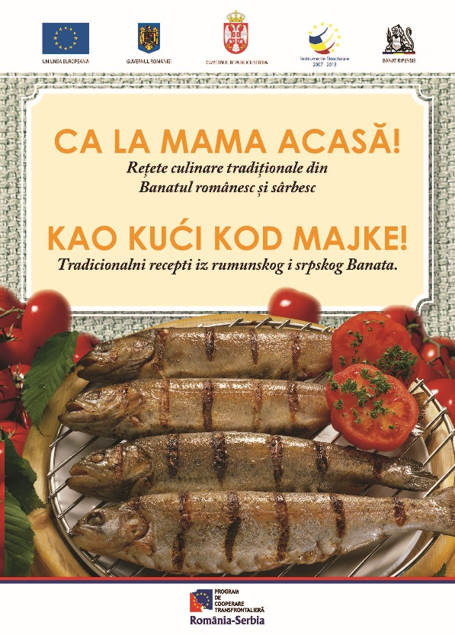
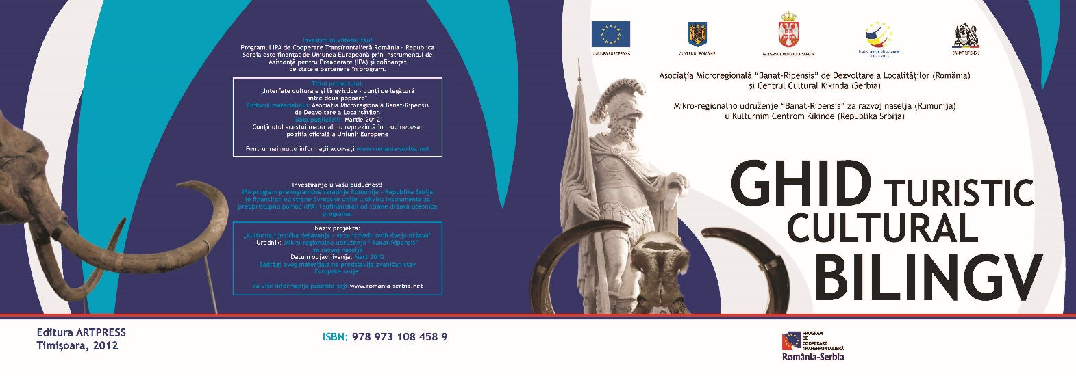
Bilingual cultural guide
Recipe book

the implementation period (including extensions)
total funds spent/total funds contracted *100
indicators and level of achievement against targets set

