Project information
CALL FOR PROPOSALS |  | 1
MIS-ETC: |  | 430
PRIORITY AXIS: |  | 3 Promoting “people to people” exchanges
MEASURE: |  | 3.3 Increase educational, cultural and sporting exchange
PROJECT TITLE: |  | Caraș and Nera Valley – Communication channels, civilization roads
ACRONYM:
DURATION: |  | 17.12.2010 – 16.06.2012
IPA FUNDS CONTRACTED: |  | 121.567,00 €
TOTAL FUNDS CONTRACTED: |  | 143.020,00 €
ABSORBTION RATE (%): |  | 79,19%
PROJECT OBJECTIVE(S): | The general objective of the project was to promote the common cultural heritage of the Romanian-Serbian cross-border area and performing a documentation work in order to print 4 albums and 1 book about the history, the archaeological patrimony, the traditional economic activities, the folk costumes heritage and the birds living along the Valea Carasului and Valea Nerei, from their river springs to the Danube.
SHORT DESCRIPTION OF THE PROJECT: | The project promoted the natural and the cultural legacy, including traditional costumes and the water mills patrimony through promotional activities sustained in educational, cultural, ethnological and scientific research institutions through conferences, photo and video expositions. The book and the albums created through the project covered not only the traditional costumes or the water mills from the Caras River valley, but also the archaeology patrimony, the history of the valleys and the natural habitats of the local eco-system.

DEGREE OF ACHIEVEMENT OF INDICATORS: | Indicator value provisioned in the contract Present indicator value % 6= (5)/(3)*100  Output indicators (1) UM (2) Quantity (3) UM (4) Quantity (5)  Increased people-to-people exchange in the fields of education, culture and sports Number 1 Number 1 100%  Result indicators  Improved knowledge of culture, history, society, organisational and institutional structure, and language of the neighbouring country Number of participants 50 scientists 25 students Number of participants 50 scientists 25 students 100%  Increased social and cultural integration of people in the border areas Number of participants 50 scientists 25 students 22 local administration Number of participants 50 scientists 25 students 22 local administration 100%  Project indicators  Improving promotion of Caras Severin County specific touristic sites No of albums 4 No of albums 4 100%  Increased the Caras Severin image promotion outside the borders No of international events 2 No of international events 2 100%

RESULTS ACHIEVED: | The overall objective of the project was to promote the common cultural heritage of the cross-border region, from Valea Carasului (Valley) and Valea Nerei (Valley).  The project has capitalized the common history of the Romanian and Serbian communities that lived along the two great rivers, identifying ancient human settlements (from prehistory to the Middle Ages), presenting old folk costumes, water mills and species of birds that live in this area.  Based on the realized researches, within the project has been published 1 book regarding „The archaeological repertoire of the Caraş and Nerei valleys” and 4 albums about „The popular costumes from Valea Carasului and Valea Nerei”, „The water mill in Banat”, „The birds from Valea Carasului and Valea Nerei” and the „Banat Mountain Museum in cross-border projects.” The books benefitted from 3 launching events, both Romania and Serbia, in Timisoara, Vršac and Resita.  The project has been addressed to specialists, from museums and universities, but equally to students, local public administrations and inhabitants of these regions, contributing to the knowledge of local economy, traditions and history.

Partnership information
 |  | COUNTRY | COUNTY/DISTRICT | BUDGET(EURO) | CONTACT DETAILS
LEAD PARTNER: | Mountain Banat’s Museum | Romania | Caras Severin | 143.020,00 | Resita, 10 Republicii blvd  Tel. 0255/231469
PARTNER 2: | City Museum of Vršac | Serbia | South Banat | 0 | Vrsac, Feliksa Milekera 19  Tel. +013 822 569

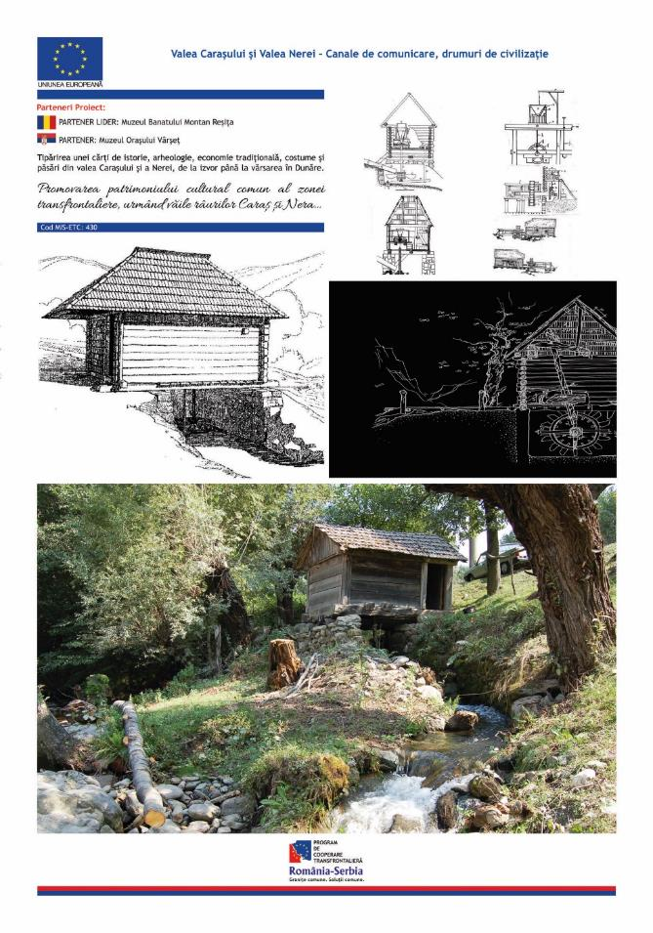
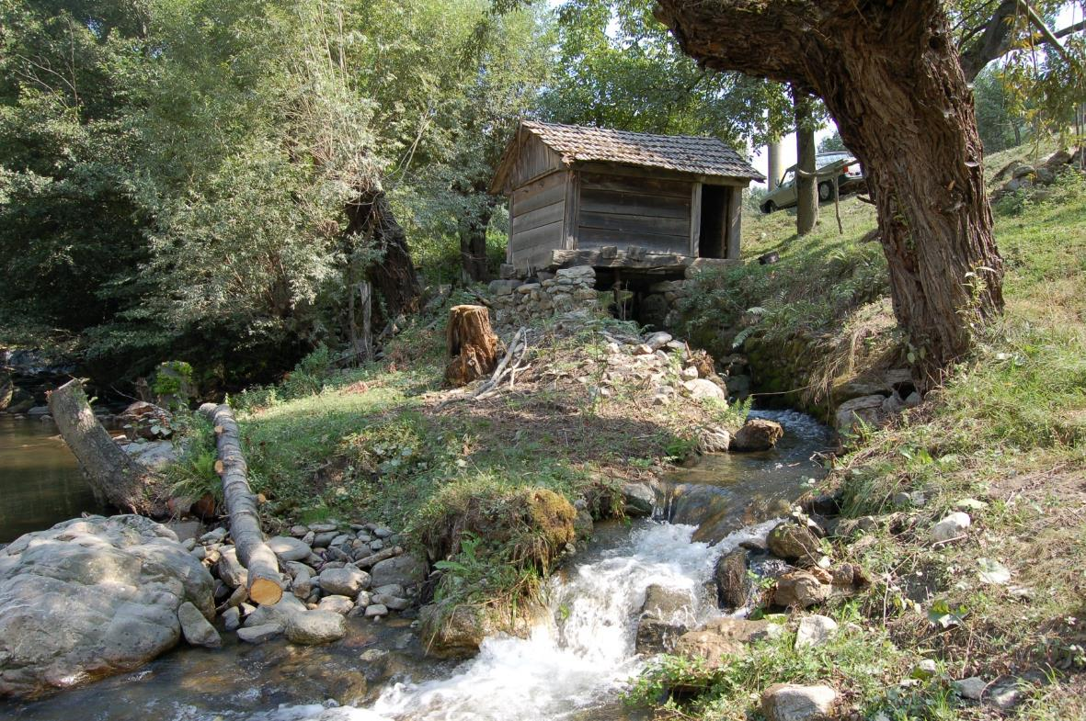

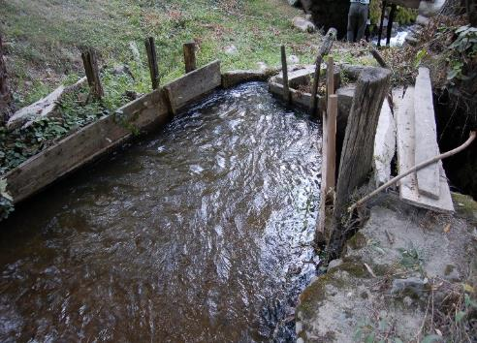
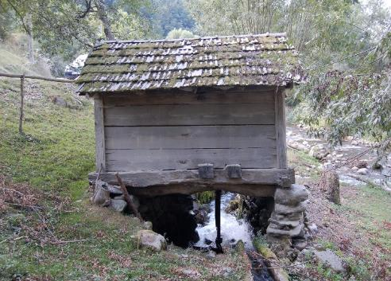
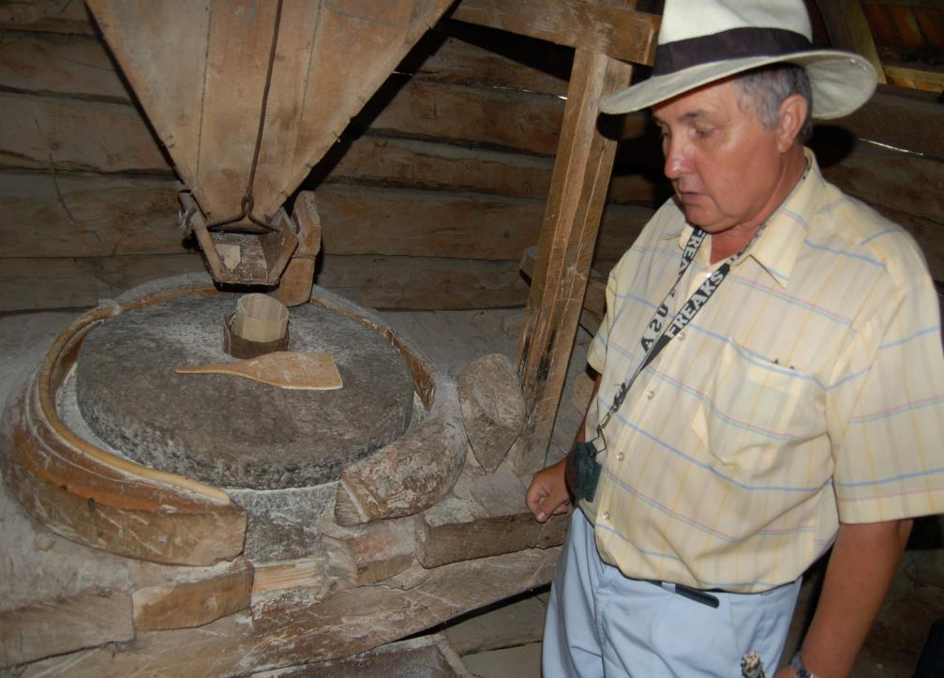

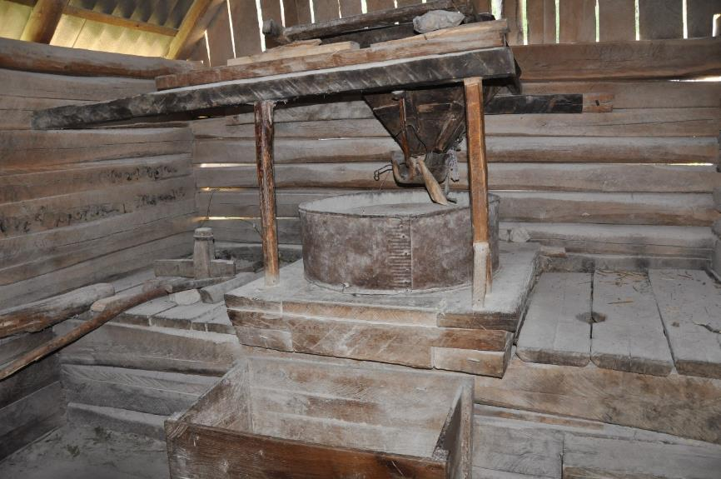
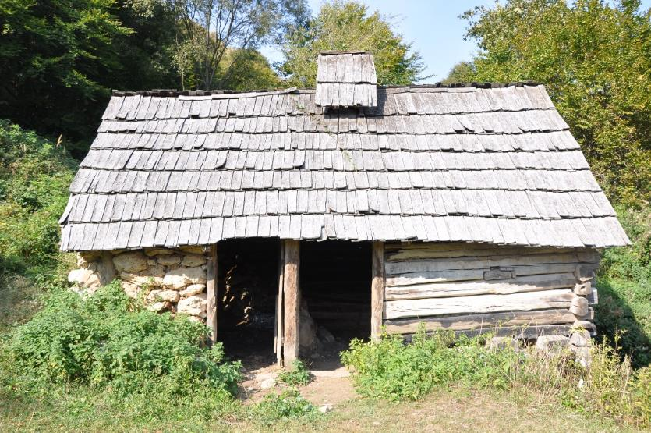

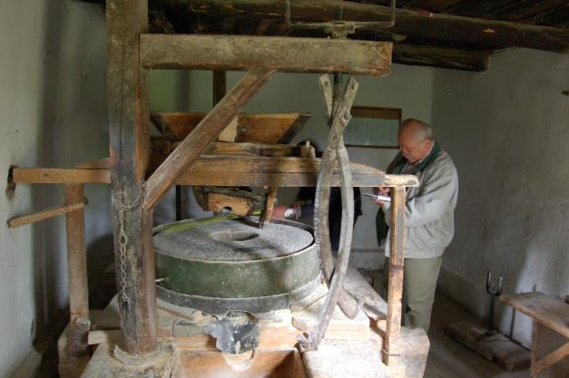
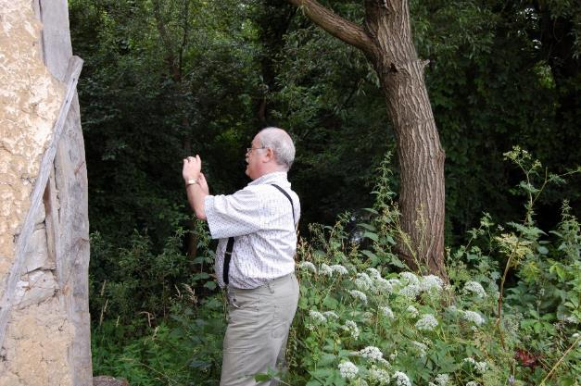
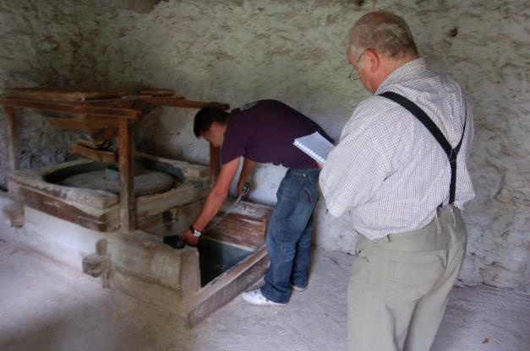
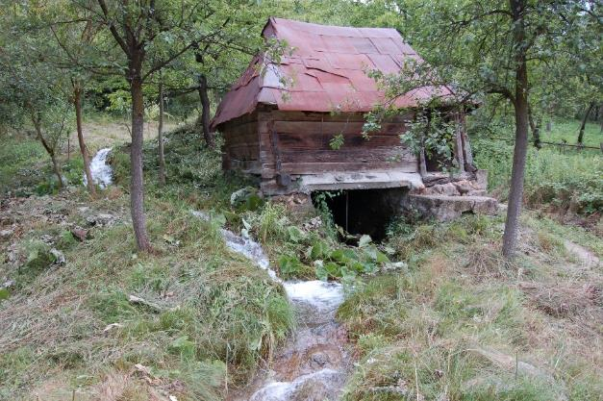

the implementation period (including extensions)
total funds spent/total funds contracted *100
indicators and level of achievement against targets set

