Project information
CALL FOR PROPOSALS | 1
MIS-ETC: | 423
PRIORITY AXIS: | 1 Economic and Social Development
MEASURE: | 1.2 Develop the tourism sector, including the strengthening of the regional identity of the border region as a tourist destination
PROJECT TITLE: | Home of Longevity for Cultural Treasury of Banat - establishment of Regional Cultural Centre for Banat Heritage - "Konkordia"
ACRONYM:
DURATION: | 01.12.2010-31.07.2012
IPA FUNDS CONTRACTED: | 849.936,25
TOTAL FUNDS CONTRACTED: | 999.925,00
ABSORBTION RATE (%): | 86,80
PROJECT OBJECTIVE(S): | - Contribution to the preservation of the cultural heritage and cultural diversity of Banat and its inclusion into European cultural streams,  - Creation of condition for preservation of cultural-historic heritage of Serbian and Romanian Banat,  - Establishment of Regional Centre for Cultural Heritage of Banat region,  - Encouraging of intersectional activities
SHORT DESCRIPTION OF THE PROJECT: | During the implementation of the project, various activities took place in order to obtain quality cross-border results. The museum building in Vršac, Serbia named “Konkordia” was renovated, cultural heritage experts from Serbia and Romania has several meetings in order to establish the Regional Centre for Cultural Heritage and ensure that it is equipped accordingly, several events were organized with the aim of initiating intersectional cooperation and promoting the results of the project. Today, the Centre represents a revived touristic attraction in the Banat region and a hub for events and exhibitions that enhance cooperation beyond borders.  Target Groups:  Banat population, experts from Banat region etc.
DEGREE OF ACHIEVEMENT OF INDICATORS: | Indicator value provisioned in the contract Present indicator value % 6= (5)/(3)*100  Output indicators (1) UM (2) Quantity (3) UM (4) Quantity (5)  Improved physical infrastructure in the border area Building 1 Building 1 100%  People in labor force with qualification received/improved from joint training activities 2 2 100%  Result indicators  New or improved cross-border tourism product: “Konkordia” Building Building 1 Building 1.00 100%  Joint tourism information service developed: Content for promotional material-information on “Konkordia” as revived touristic attraction Document Text 1 Document Text 1.00 100%  Project indicators  Reports Reports 10 Reports 10 100%  Act on Establishment of the Regional Centre for Cultural Heritage in Banat Document 1 Document 1 100%  Official registration of the Regional Centre for Cultural Heritage in Banat Number of registration document 1 Document 1 100%  Programme documents of the Regional Centre for Cultural Heritage in Banat Document 2 Document 2 100%  Information material and publication on Regional Centre for Cultural Heritage (museum guest book, website, publication) Number of visitors signed the guest book 3000 Number of visitors signed the guest book 3000 100%  Website 1 Website 1.0 100%  Publication 300 Publication 300 100%  Memorandum of Cooperation between Regional Centre for Cultural Heritage of Banat region and relevant intersectional institutions Number of MoC 7 Number of MoC 7 100%
RESULTS ACHIEVED, INCLUDING PHOTOS: | More on the results of the project may be found by accessing:  Project presentation movie: https://www.youtube.com/watch?v=GkIBe8VVsjs  1. “Konkordia” building from Serbia was rehabilitated.  2. Regional Centre for Cultural Heritage of Banat region was set up:  The Regional Conference “Research, Preservation and Presentation of Banat Heritage: Current State and Long-term Strategy” held from 17th to 19th November 2011 in Vršac, Serbia marked the beginning of the Centre’s promotion and start of the intersectional and regional cooperation. At the Conference, a discussion was organized and a Working Body of the Conference formed. As a result of that discussion, the Working Body of the Conference has drawn major conclusions that were also published in the Proceedings. Those conclusions served as guidelines of Regional Centre’s strategy, its objectives and function.  The Regional Centre’s strategy and Working plan was written. Act on Establishment of the Regional Centre was made, as its official registration as a part of the City Museum Vrsac. The City Museum Vrsac and Regional Centre for Banat Heritage signed 7 memorandums of cooperation with Serbian and Romanian heritage institutions.  The team members developed a logo of the future Regional centre that will be presented as a Roman goddess of harmony “Concordia”, symbolizing partnership of the two countries.  3. Banat population (from Serbia and Romania) informed on “Konkordia” project: First information of the commencement on “Konkordia” building reconstruction and establishment of the Regional Centre for Banat Heritage, was the press conference organized in March 2011. Later on, throughout the Project, team members and Municipality officials gave numerous interviews to the press informing on the progress.  The leaflet, informing Banat, Vojvodina and Serbian population about the project, its goals and importance was prepared and printed. The website of the Regional centre was made and will be continually developed and updated: http://banatheritage.com/english/  The Final Conventions also drew attention of the media and it was broadcasted on several TV stations. Exhibition “Cold Arms”, that marked the official beginning of the Regional’s Centre joint cross-border projects, opened in the newly reconstructed building “Konkordia” and was visited by many Vrsac and other Serbian citizens and guests from Romanian Banat.  4. “Konkordia” – a revived tourist attraction of the Banat region: One of the Project aims was to develop a cultural tourism strategy and raise awareness of the population of the heritage values and possible solutions for sustainable development through the heritage presentation. Therefore, the Project Team had analysed the current state of the tourist offer in the Vrsac area. Also, it researched cultural tourism developments and offers in the Region, as well as in the other European countries. Romanian Project Team Partners shared their experience and gave valuable suggestions.  The team established contacts with the local tourist offices in the Banat region. They had shown great interest in in developing a cultural tourism strategy in cooperation. Such response in the initial stage of the project gave the necessary amount of feedback, enabling the project team to make comprehensive workshop material.  Being in a regular contact with the local tourism representatives, the team had been gathering information regarding the problems, but also requirements and interest of tourists visiting the area. One of the project aims was to develop cultural tourism strategy and raise awareness of the population of the heritage values and possible solutions for sustainable development through the heritage presentation.  The “Creation of Cultural Tourism Strategy in Banat Region” workshop was held on three occasions. Representatives of the cultural institutions as well as all citizens were informed of prospects for cultural tourism development. The team presented experiences and good examples from other Europeans countries. Also, the project team promoted cooperation with other cultural institutions in Vrsac and reach agreement on joint planning of activities.  Strategy on Cultural Tourism Development was a part of the Regional Centre’s Strategy, as one of its functions was Cultural Tourism, seen as a way not only to promote heritage but also to educate and raise awareness of the heritage values among the population. It was also a way to sustainable develop both the Centre and the region.  To promote Banat Heritage, the Project team also prepared and printed a brochure on cultural tourism – “Vrsac for Beginners” in Serbian, Romanian and English. It contains basic information on culture, museums, monuments and history of Vrsac and its region. Due to the fact that “Konkordia” building is protected by the State, has significant architectural value (built in 1847) and has been restored in compliance with all contemporary criteria but also in compliance with the original constructing manner, it was included into the touristic Banat offer. The brochure was distributed at the Tourism Office of Serbia, and Tourism Office of Belgrade and in Timisoara, Romania.  Also, a short cultural tourism commercial was filmed that presents heritage of the Vrsac and its region. It was broadcasted at the national TV - RTS and official Vojvodina province TV – RTV. The commercial was posted on the web site of the Regional Centre.  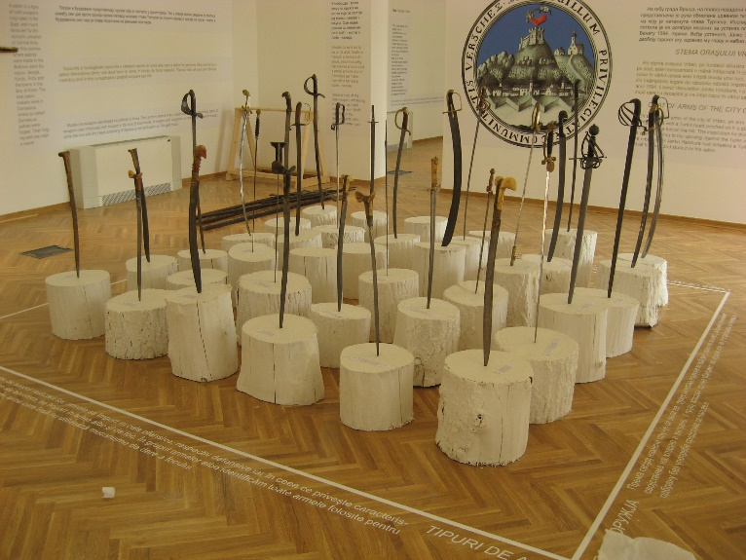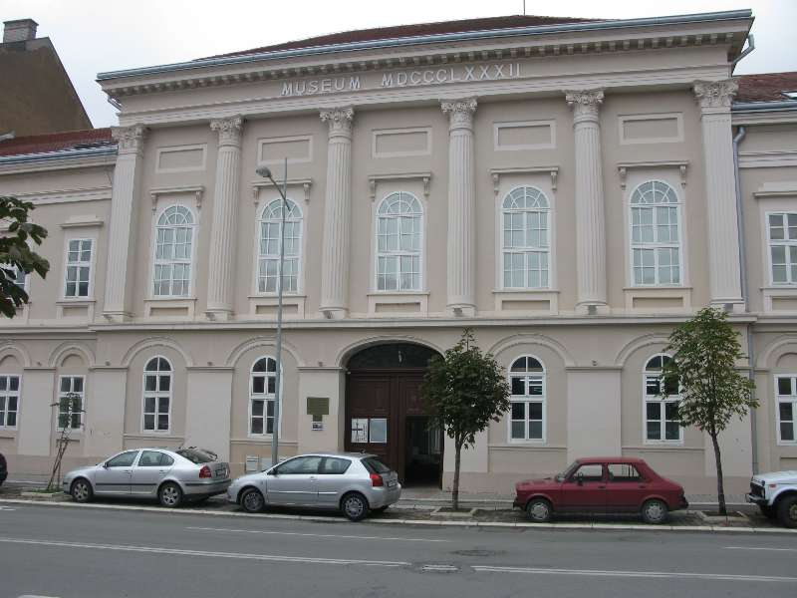

Partnership information
 |  | COUNTRY | COUNTY/DISTRICT | BUDGET(EURO) | CONTACT DETAILS
LEAD PARTNER: | Municipality of Vrsac | Serbia | Južno Banatski | 999.925 | Vrsac, Pobede no. 1  Tel. +381 (0) 13 800-501
PARTNER 2: | Banat Museum Timişoara | Romania | Timiş | 0 | Timişoara, Piaţa Huniade no. 1  Tel. +040256491339

the implementation period (including extensions)
total funds spent/total funds contracted *100
indicators and level of achievement against targets set

