Project information
CALL FOR PROPOSALS | 1
MIS-ETC: | 410
PRIORITY AXIS: | 2. Environment and Emergency Preparedness
MEASURE: | 2.1 Improve systems and approaches to address cross-border environmental challenges, protection and management
PROJECT TITLE: | Monitoring and control of the invasive biological pollutant - Ambrosia artemisifolia L. (spp.).  „STOP AMBROSIA!”
ACRONYM: | STOP AMBROSIA
DURATION: | 01.01.2011 – 31.12.2011
IPA FUNDS CONTRACTED: | 578.792,20 €
TOTAL FUNDS CONTRACTED: | 680.932,00 €
ABSORBTION RATE (%): | 59,92%

PROJECT OBJECTIVE(S): | - Joint works for ambrosia control in the Romanian-Serbian cross-border area;  - Implementation of integrated cross-border control system of ambrosia;  - Improvement of technical capacity of the cross-border monitoring of ambrosia.  - Increasing the public awareness in the field of the problems caused by ambrosia biological pollution.  - Establishing and equipping the Ambrosia Monitoring Centres.  - Promotion and implementation of the EU policy in the field of environment.

SHORT DESCRIPTION OF THE PROJECT: | Ecosystems can be disturbed by the presence of invading and colonizing species. The invasive plant is the one that multiplies, to the disadvantage of other local plant species, due to a favourable natural or anthropic ecological factor. Studies the invasive species are particularly complex because of their interdisciplinary character, thus requiring knowledge of ecology, botany, biocenology etc. Studies on invasive species are currently the subject of new research directions that have led to the emergence of a new branch of ecology, namely the ecology of invasion.  The European Environment Agency has produced a list of the 163 most damaging invasive alien species that threaten ecosystems in Europe. Since 1950, there is added at least one other species every year, and there is no sign that the rate would fall.  The „STOP AMBROSIA!” project is a common effort of the Romanian-Serbian communities from Timisoara and Pancevo to reduce the invasive biological pollutant produced by the ambrosia plant species. Diminishing the Ambrosia plants density, the pollen quantity and the number of Ambrosia seeds produced yearly in the Romanian-Serbian cross-border area was possible because of the chemical and the mechanical control actions.  Those three specific indicators are interdependent, a technical fact highlighted in the speciality literature and confirmed by our own data obtained in our trial plots and in laboratory studies.

DEGREE OF ACHIEVEMENT OF INDICATORS: | Indicator value provisioned in the contract Present indicator value % 6= (5)/(3)*100  Output indicators (1) UM (2) Quantity (3) UM (4) Quantity (5)  Increased the cross-border cooperation in the environment protection field Number of professionals educated 40 Number of professionals educated 112 280%  Improved technical capacity of the cross-border monitoring of pollution Number of ambrosia monitoring centres equipped 2 Number of ambrosia monitoring centres equipped 2 100%  Increase public awareness in the field of environment protection Number of participants gained new knowledge about ambrosia pollution 220 Number of participants gained new knowledge about ambrosia pollution 435 198  Increased expertise and exchange of experience in the field of environment protection Number of events (conferences, workshops and other promotional activities) 15 Number of events (conferences, workshops and other promotional activities) 18 120  Project indicators  Diminishing of the ambrosia plants density in the cross-border area % <10% % <17,02% 170%  The diminishing of the pollen quantity in the air of the target area % <10% % <11,31% 113%  Reducing the number of ambrosia seeds produced per year % <10% % <21,46% 214%

RESULTS ACHIEVED: | RESULT INDICATOR 1: Increased the Romanian-Serbian cross-border cooperation in the environment protection field. During the project implementation, a laboratory was equipment for mechanical and chemical ambrosia control activities. The mechanical and chemical control of ambrosia was made several times and these actions lead to a decrease of the pollen concentration per air volume and thus a decrease in the number of allergy cases caused by the ambrosia pollen.  RESULT INDICATOR 2: Improved technical capacity to monitor the Ambrosia cross-border pollution, with the help of the Ambrosia monitoring center.  RESULT INDICATOR 3: The most effective way for the ambrosia control is considered by the worldwide specialists to be the wide public awareness, an indicator completely achieved within the project because of the complex approach of the implementation of the activities.  RESULT INDICATOR 4: Increasing the expertise and exchange of experience in the field of environment protection had a great relevance for the successful control of Ambrosia artemisifolia plant, because we share the experience at different professional levels. In this way our team members have organized different events, conferences, workshops, roundtables, project results presentation at professional fairs and press-conference for media representatives.  During the „STOP AMBROSIA!” project, the specific indicators achieved were the following:  - Decrease the Ambrosia plants density in the Romanian-Serbian cross-border area;  - Diminishing of the pollen quantity in the air of the Romanian-Serbian cross-border area;  - Reducing the number of Ambrosia seeds produced per year;  - Establishing and equipping the Ambrosia Monitoring Centre;  - Increase public awareness in the field of the problems caused by ambrosia pollution.

Partnership information
 |  | COUNTRY | COUNTY/DISTRICT | BUDGET(EURO) | CONTACT DETAILS
LEAD PARTNER: | City of Panćevo | Serbia | South Banat District | 259.816 | Pancevo, Trg Kralja Petra I 2-4  Tel. +381 13 344 455
PARTNER 2: | Banat’s University of Agricultural Sciences and Veterinary Medicine from Timisoara | Romania | Timis County | 261.596 | Timişoara, Calea Aradului 119  Tel. 004-0256-494023
PARTNER 3: | Public utility company - Higijena | Serbia | South Banat District | 141.640 | Pancevo, Cara Lazara 57  Tel. +381 13 327 000
PARTNER 4: | The “Tamis” Institute Pančevo | Serbia | South Banat District | 17.880 | Pancevo, Novoseljanski put 33  Tel. + 381 13 313 092

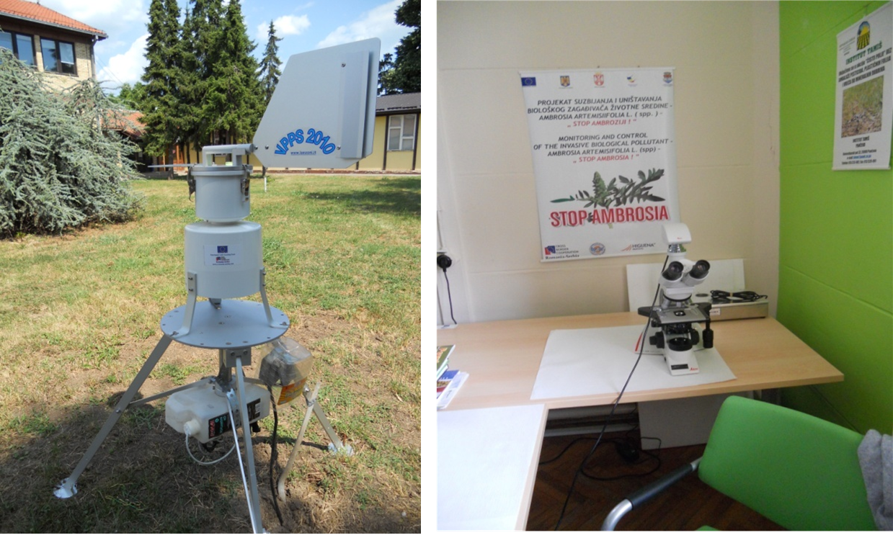

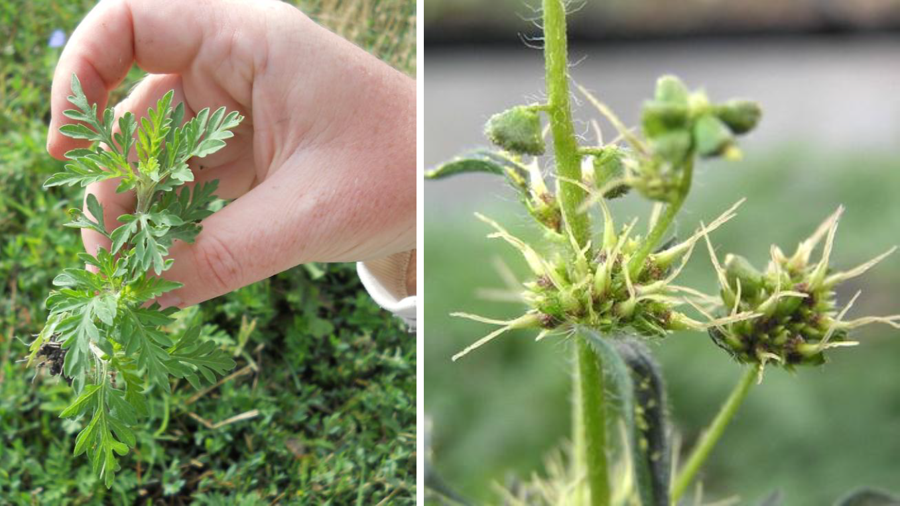

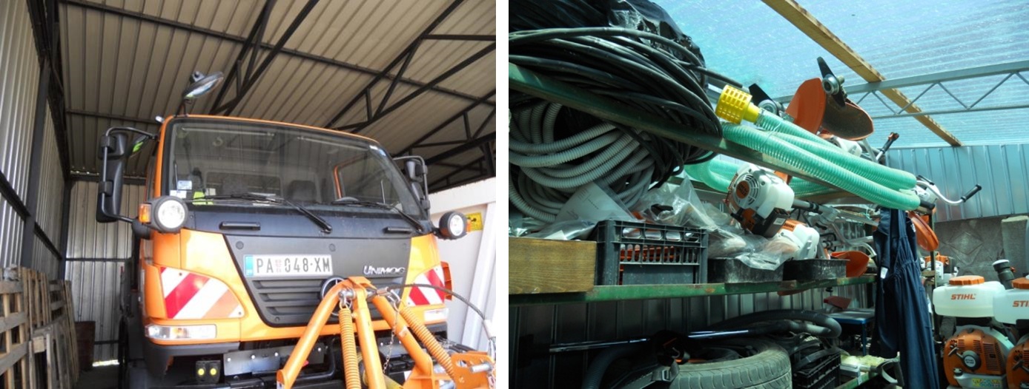

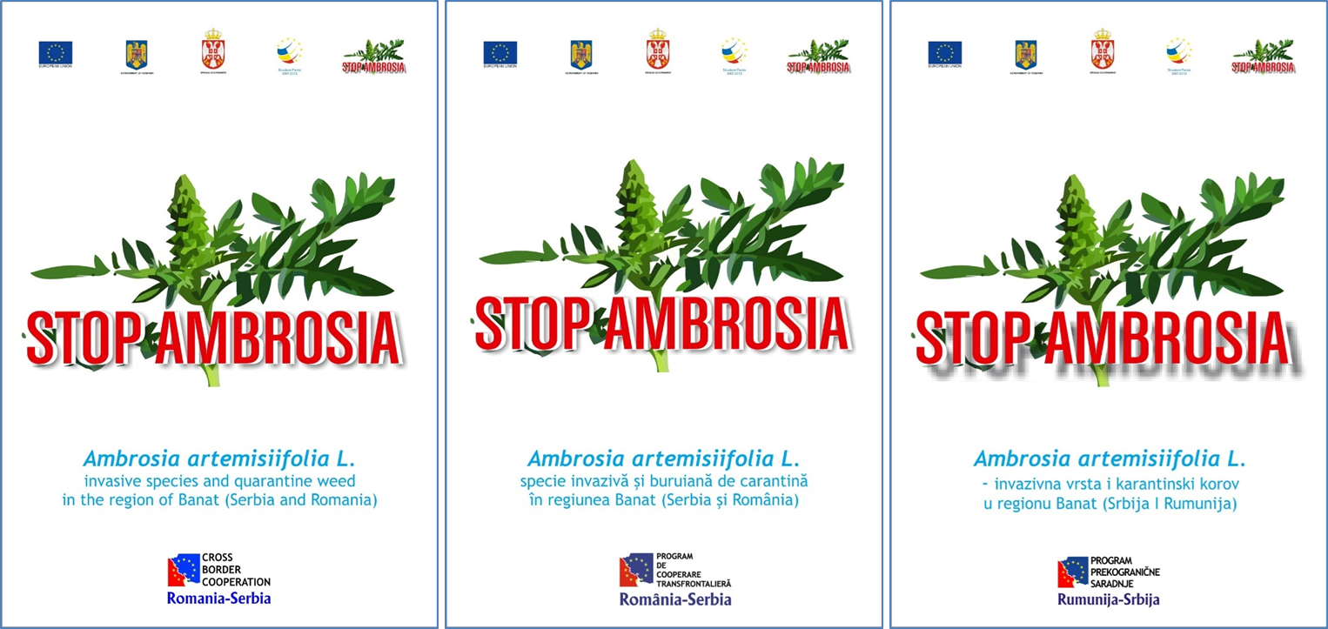

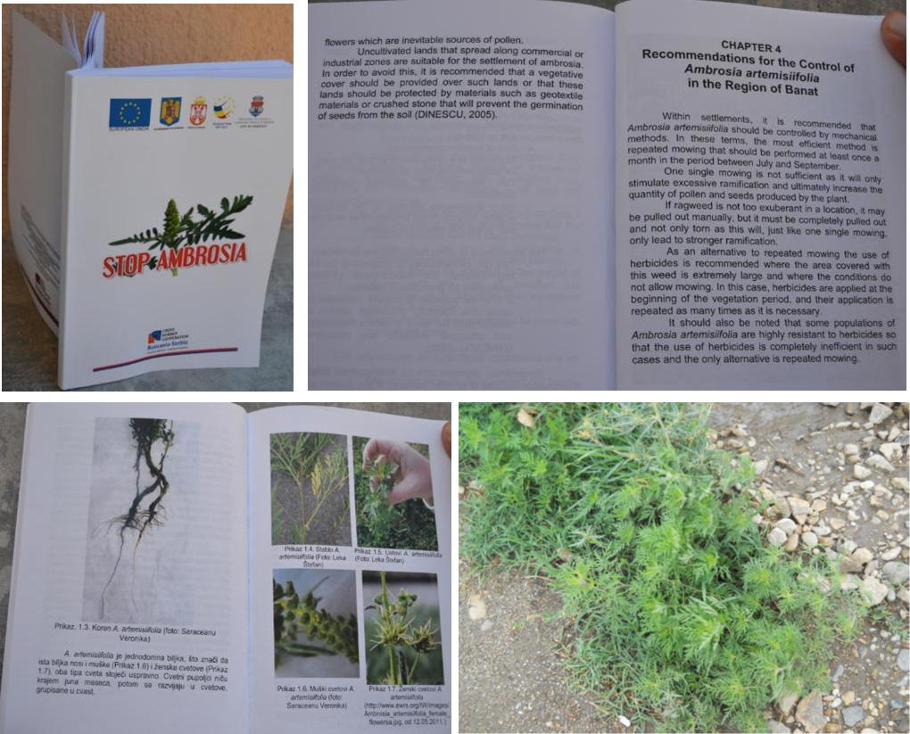

the implementation period (including extensions)
total funds spent/total funds contracted *100
indicators and level of achievement against targets set

