Project information
CALL FOR PROPOSALS | 1
MIS-ETC: | 409
PRIORITY AXIS: | 1 Economic and Social Development
MEASURE: | 1.3 Promote SME development
PROJECT TITLE: | Centre for increasing competitiveness of SME in border region
ACRONYM: | Competitiveness Centre
DURATION: | 29.12.2010 – 28.12.2011
IPA FUNDS CONTRACTED: | 324.150,90 €
TOTAL FUNDS CONTRACTED: | 381.354,00 €
ABSORBTION RATE (%): | 58,49%

PROJECT OBJECTIVE(S): | - Strengthening the Economic Development of the Romanian-Serbian Cross-border Region through enabling SME’s to adopt appropriate knowledge and technologies.  - To establish a Center for Increasing Competitiveness of SME’s in order to enable SME owners to introduce new approach in business management.  - Creation opportunities for SMS’s from the Border Region to access quality labour market offer.

SHORT DESCRIPTION OF THE PROJECT: | Due to generally poor opportunities for economic development in past two decades, SME’s from the border region of Romania and Serbia were unable to invest in new knowledge, skills and technologies which resulted in lower competitiveness level, especially related to strong EU Companies. Trainings, study tours, exchange sessions organized within the project created a favourable environment for the cross-border SME’s to increase their opportunities to sell their products on targeted EU Market. Also, the SME’s learned to manage their actions in accordance with the EU standards. The organized trainings had the following themes: Training for CMC machines functioning, Training for English Language, Training for Romanian Language, Workshop for establishing of SME, Workshop for marketing of SME, Workshop for management of SME, Training for computer literacy and Workshop for Insurance.
DEGREE OF ACHIEVEMENT OF INDICATORS: | Indicator Indicator value provisioned in the contract Present indicator value % 6= (5)/(3)*100  Output indicators (1) UM (2) Quantity (3) UM (4) Quantity (5)  Output indicators  Improved capacity and cross border contracts of SMEs in the sector of research and development.  People within the labour force with acquired/improved from the joint activities of trainings.  Result indicators  New and improved services of the cross-border tourism and increased capacity of SMEs By connecting SMEs from both sides of the border, greater possibilities have been opened of using tourist services in border region. Opening of the Representative Office of Romanian and Serbian companies in both countries, higher number of overnight stays will be accomplished in hotels, more tourist destinations, museums, galleries, monasteries visited, and thus tourist companies will be interconnected. By implementing the project, cooperation has already been established in wood-processing industries. Talks were held regarding cooperation in waffle industry between “Monte Banato” from Resita and “Petru” from Požarevac. The increased capacity of SMEs acquired through trainings  Project indicators Estimated / predicted Realised  Centres for increasing of SME competitiveness in border region and SME Info Office established No. of centres (Požarevac) 1 No. of centres (Požarevac) 1 100%  No. of offices (Resita) 1 No. of offices (Resita) 1 100%  Predicted trainings and workshops conducted No. of trainings 309 No. of trainings 328 106,14%  No. of participants 2350 No. of participants 3173 135,02%  Study tour conducted No. of study tours 1 No. of study tours 1 100%  Practice in companies conducted No. of participants 35 No. of participants 35 100%  Project visibility No. of promotion activities 15 No. of promotion activities 35 233,33%  Bank Fair organized and conducted No. of fairs 1 No. of fairs 1 100%
RESULTS ACHIEVED: | 1 Competitiveness Centres opened and 1 SME Info Office established.  Trainings, workshops and Info-Days:  328 trainings and workshops with 3173 participants (215 trainings, 112 workshops, 1 Info Day).  - 30 workshops held for SME establishing, with 397 participants, out of whom there were 252 women, or 63,47%.  - 30 workshops held for SME marketing, with 397 participants, out of whom there were 252 women, or 63,47%.  - 30 workshops held for SME management, with 397 participants, out of whom there were 252 women, or 63,47%.  Romanian partner conducted 12 workshops with 145 participants.  - 105 conducted on Computer Literacy with 1405 participants out of whom there were 1010 women or 71,78%.  - Info Franchise Day held, with 106 participants out of whom there were 78 women or 73,58%.  - 10 trainings held on the English language, with 20 participants, out of whom there were 16 80%.  - 10 trainings held on the Romanian language, with 25 participants, out of whom there were 18 women or 72%.  - 10 workshops held on Insurance, with 128 participants, out of whom there were 95 women or 71,25%.  - Trainings organized and held for Romanian and Serbian groups, 10 trainings (5 trainings for Romanian group in Požarevac, Serbia, and 5 trainings for Serbian group in Romania).  - Trainings conducted on CNC machines, with 54 participants, out of whom there were 8 women or 14,81%.  - Practice in companies, with 54 participants, out of whom there were 8 women or 14,41% (“Goša FSO” and “Metech” companies and “Eftimie Murgu” University).  - Study Tour organized. 20 persons took part in the Study Tour  - Bank Fair held, with participation of 9 banks.

Partnership information
 |  | COUNTRY | COUNTY/DISTRICT | BUDGET(EURO) | CONTACT DETAILS
LEAD PARTNER: | Regional Chamber of Commerce Pozarevac | Serbia | Branicevo | 196.504,00 | Pozarevac, Bosanska 31  Tel. +381 12 556 800
PARTNER 2: | ACTIVITY Foundation for human resources and sustainable development | Romania | Caras-Severin | 82.050,00 | Resita, Street Pandurilor No.13  Tel. 0040 255 220607
PARTNER 3: | High Technical School of Professional Studies Požarevac | Serbia | Branicevo | 102.800,00 | Požarevac, Street Nemanjina No.2  Tel. +381 12 531-667

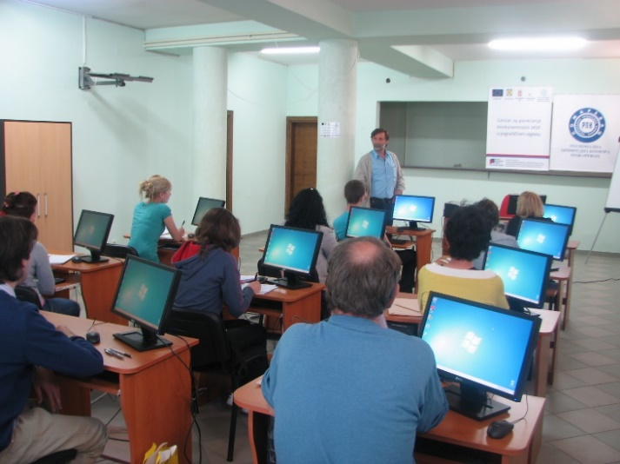
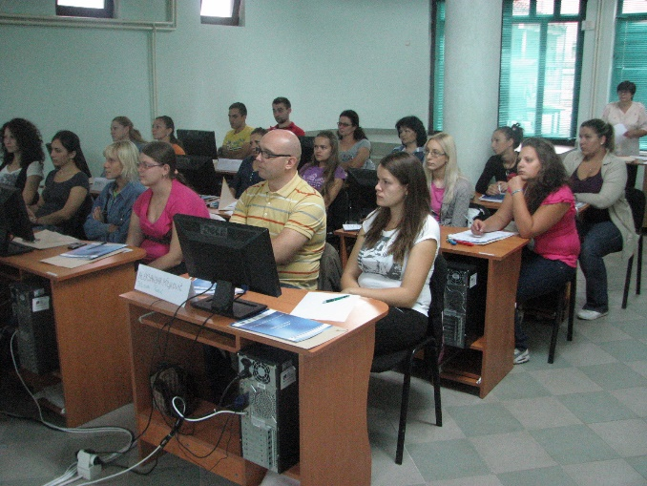
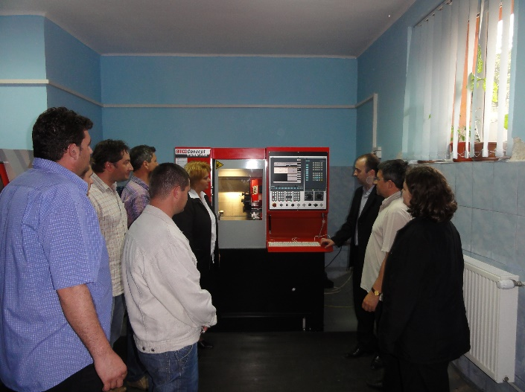

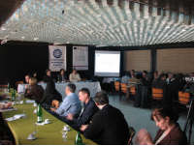
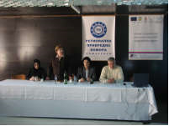
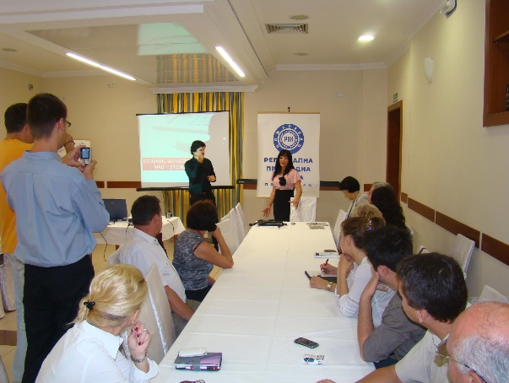
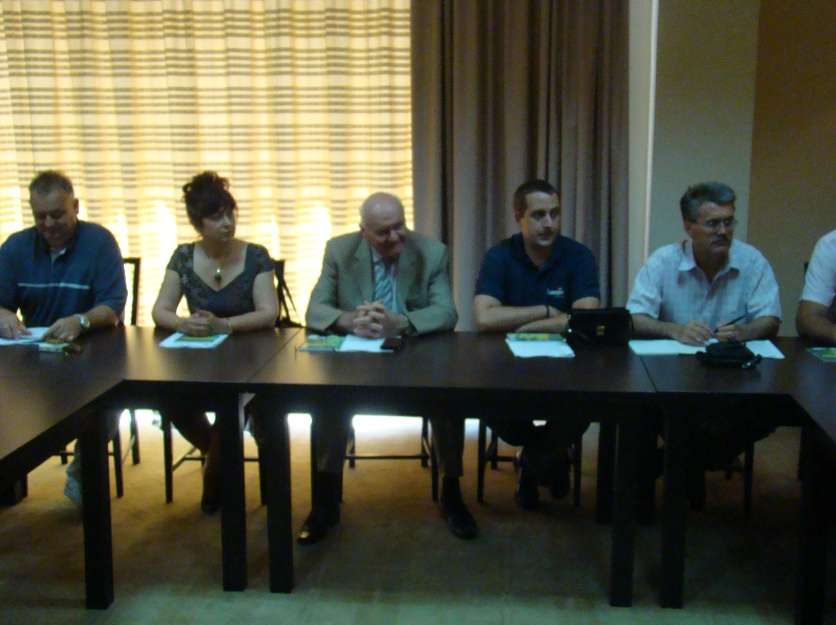
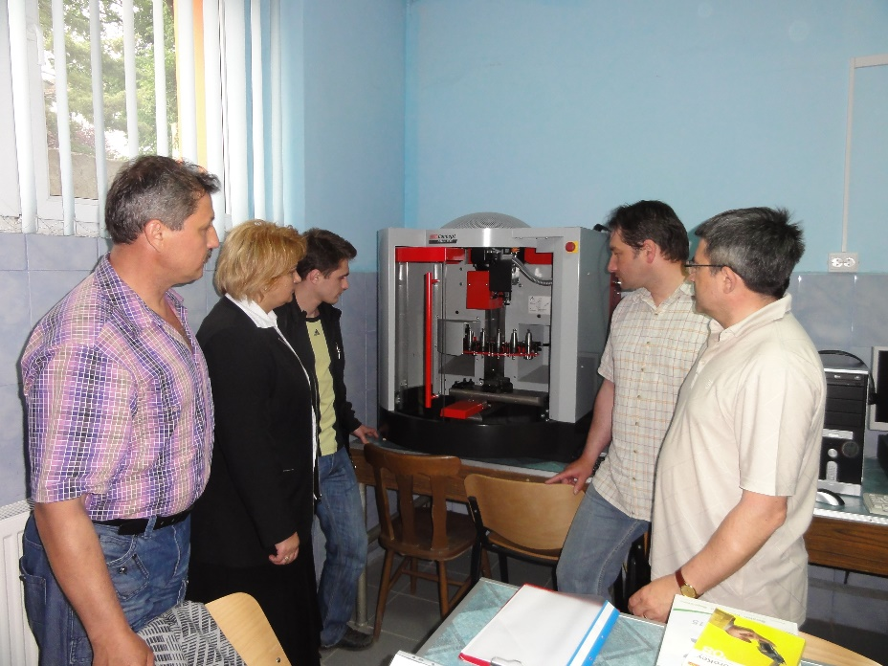

the implementation period (including extensions)
total funds spent/total funds contracted *100
indicators and level of achievement against targets set

