|  |  |  |  |  |  |  |  |  |
| --- | --- | --- | --- | --- | --- | --- | --- | --- |
| **Project information** | | | | | | | | |
|  | | |  | | | | | |
| CALL FOR PROPOSALS | | | 1 | | | | | |
| MIS-ETC: | | | 407 | | | | | |
| PRIORITY AXIS: | | | 3 Promoting “people to people” exchanges | | | | | |
| MEASURE: | | | 3.3 Increase educational, cultural and sporting exchange | | | | | |
| PROJECT TITLE: | | | **FOUNDING OF BANAT TENNIS ASSOCIATION** | | | | | |
| ACRONYM: | | | BTA | | | | | |
| DURATION[1]: | | | 17.12.2010 – 16.03.2012 | | | | | |
| IPA FUNDS CONTRACTED: | | | 165.805,25 € | | | | | |
| TOTAL FUNDS CONTRACTED: | | | 195.065,00 € | | | | | |
| ABSORBTION RATE (%)[2]: | | | 76,16 % | | | | | |
| PROJECT OBJECTIVE(S): | | | **The project contributed to:**   * the improvement of the mental and physical health of participants through tennis. * the promotion of sport as social function and developing of best practice * making the logical extension with “Tennis connecting People” project financed under the Neighbourhood Programme Romania-Republic of Serbia. | | | | | |
| SHORT DESCRIPTION OF THE PROJECT: | | | The project aimed at contributing to a harmonious and integral cross-border development in the field of tennis, in order to improve the quality of everyday life and promote sport as a social function. The Banat Tennis Associations were formed in Romania and in Serbia. Sports Club Tivoli Timisoara, along with Tennis Klub Dinamo Pancevo in Serbia have organized matches between children, juniors and adult. New groups from Tivoli school and Dinamo Pancevo dedicated to children between the ages of 4 and 7 were set up. | | | | | |
| DEGREE OF ACHIEVEMENT OF INDICATORS[3]: | | | |  |  |  |  |  |  | | --- | --- | --- | --- | --- | --- | |  | **Indicator value provisioned in the contract** | | **Present indicator value** | | **%**  **6= (5)/(3)*100** | | **Output indicators**  **(1)** | **UM**  **(2)** | **Quantity**  **(3)** | **UM**  **(4)** | **Quantity**  **(5)** |  | | Stronger civil society of the border area | Number | 1 | Number | 1 | 100 | | Increased people to people exchange in field of sports | Number | 1 | Number | 1 | 100 | | Increased integration of the border communities and improved local services in the border area | Number | 1 | Number | 1 | 100 | | **Result indicators** | | | | | | | Increased people to people exchange in field of sports in the border area | Number of people participating | 120 | Number of people participating | 120 | 100 | | Banat Tennis Association | Number of Associations | 2 | Number of Associations | 2 | 100 | | Increased cooperation of the border communication and improved local services in the border area | Number of cross border events | 4 | Number of cross border events | 4 | 100 | | Improved knowledge of sport, culture, history, institutions and language of the neighbouring country | Number of participants gained new knowledge | 120 | Number of participants gained new knowledge | 120 | 100 | | **Project indicators** | | | | | | | Improve the knowledge of participants by learning to work as a team while taking part in Project | Number of participants involved | 120 | Number of participants involved | 120 | 100 | | Gain new tool and strategies for generating positive self-esteem as well as managing fear and self doubt. | Number of participants involved | 150 | Number of participants involved | 150 | 100 | | Learn and find out what it means to represent your country through sport | Number of participants involved | 130 | Number of participants involved | 130 | 100 | | Increase number of people who take part in sport activities | Number of participants involved | 150 | Number of participants involved | 150 | 100 | | | | | | |
| RESULTS ACHIEVED: | | Increased people-to-people exchange in the fields of sports.  Increased number of tennis players in the border region.  Founding of “Banat Tennis Association” in Serbia and Romania.  The contract on future cooperation between the two newly founded Tennis Associations from Romania and Serbia was signed. This contract enabled cooperation in all sports and educational aspects regarding Banat tennis. The two Tennis schools for beginners were finalized. The number of children who passed basic tennis school reached 30 young players in Romania and 60 young players in Serbia. Various events between participants on both sides of the border took place during the period implementation and after. Final Conference took place on 7th March 2012 and gathered all registered Tennis Clubs in Banat region in Romania. Representatives from Timisoara, Lugoj and Drobeta Turnu-Severin tennis clubs took part in this event. On the Serbian side, the Founding Assembly and Final Conference took place on 25 February and gathered all registered Tennis Clubs in Banat region in Serbia. Representatives from Kikinda, Mol, Zrenjanin, Vrsac, Pancevo, Novi Knezevac and Kovacica tennis clubs took part in this event.  Team members gave interviews to TVT89 that were broadcasted during evening news regarding the final conference and founding assembly. Team members gave interviews to TV Pancevo that were broadcasted during evening news regarding the final conference and founding assembly. | | | | | | |
| **Partnership information** | |  | | | | | | |
|  | |  | | | COUNTRY | COUNTY/DISTRICT | BUDGET(EURO) | CONTACT DETAILS |
| LEAD PARTNER: | | Sport Club Tivoli | | | Romania | Timis | 97.400 | Timisoara, Aleea Ghirodei 36  Tel. 0040 722 605380 |
| PARTNER 2: | | Tennis Club Dinamo Pancevo | | | Serbia | South Banat | 97.665 | Pancevo, Masarikova 1-a  Tel. 00381 64 701 2425 |

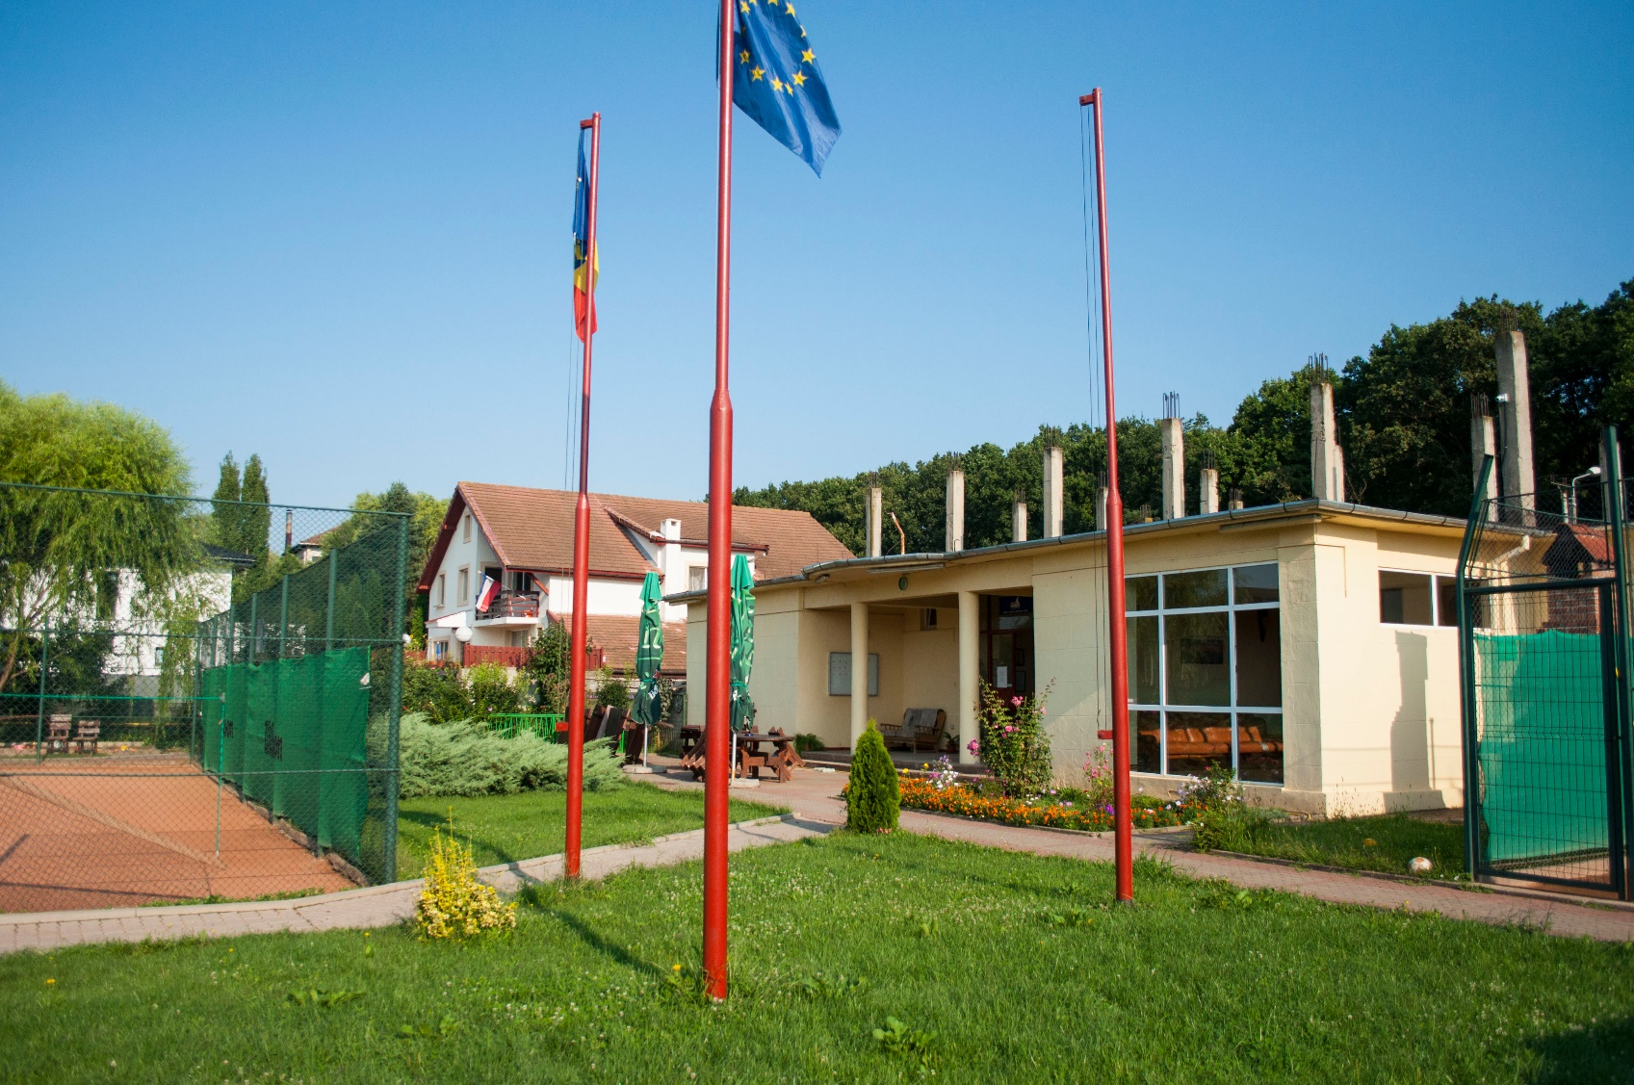



1. the implementation period (including extensions)
2. total funds spent/total funds contracted *100
3. indicators and level of achievement against targets set