Project information
CALL FOR PROPOSALS | 1
MIS-ETC: | 404
PRIORITY AXIS: | 1 Economic and Social Development
MEASURE: | 1.1 Support for local/regional economic and social infrastructure
PROJECT TITLE: | REGIONAL CENTER OF VITREO-RETINAL SURGERY AND OPHTHALMO-ONCOLOGY
ACRONYM: | R.C.V.R.S.O.
DURATION: | 10.12.2010 – 09.04.2012
IPA FUNDS CONTRACTED: | 572.959,50 €
TOTAL FUNDS CONTRACTED: | 674.070 €
ABSORBTION RATE (%): | 88,37 %
PROJECT OBJECTIVE(S): | Support of cooperation among Romanian-Serbian public health services.  Health services modernization.  Improvement of the quality of life for the communities of the border area.  Prevention of blindness caused by vitreoretinal diseases.  Reduction of mortality caused by intraocular cancer.  Training and instruction of the Romanian and Serbian oncologists and ophthalmologists.
SHORT DESCRIPTION OF THE PROJECT: | A regional center for vitreoretinal surgery and oncology ophthalmology in the region has been created and this has improved the public health services in the cross-border area; by medical (screening, examination and treatment) activities, surgical activities, instructional activities.

DEGREE OF ACHIEVEMENT OF INDICATORS: | Indicator value provisioned in the contract Present indicator value % 6= (5)/(3)*100  Output indicators (1) UM (2) Quantity (3) UM (4) Quantity (5)  Improved physical infrastructure in the border area number 1 number 1 100  Improved capacity and cross-border contacts of SMEs and in the R&D number 1 number 1 100  People in labour force with qualifications received/improved from joint training activities number 1 number 1 100  Increased importance of R&D/Innovation in the border area number 1 number 1 100  Result indicators  Number of treated patients with acute and chronic ocular vitreoretinal diseases and with intraocular malignant tumours Number of patients 200 patients / year Number of patients 119 patients /3 month 476 patients / year 238  Number of trained medical specialists in oncology and ophthalmology, Romanian and Serbian, from the public institutions involved Number of doctors 20 doctors / year Number of doctors 20 100  Number of centres with new medical infrastructure Number of centres 1 centre / project Number of centres 1 100  Project indicators  Visual acuity improvement Visual acuity (VA) 0.05 ->0.5 Visual acuity (VA) 0.05 ->0.5 100  Life expectancy improvement Years of life 1 ->7 Years of life 1 ->7 100

RESULTS ACHIEVED, INCLUDING PHOTOS: | Within this project, funded by the European Union and the partner states under the first call for proposals of the Romania - Republic of Serbia IPA Cross-Border Cooperation Program, the Municipal Emergency Clinical Hospital Timisoara inaugurated the "Regional Centre of Vitreoretinal Surgery and Ophthalmo-Oncology" in Timisoara.  The center of vitreoretinal and ocular surgery is addressed to patients with ocular diseases with disabling potential (retinal detachment, vitreous hemorrhage, proliferative diabetic retinopathy, etc.). The center offers to access to the latest therapeutic technologies for the patients from the Romanian-Serbian cross-border area.  Until its inauguration, this type of ocular medical illness could not be resolved regionally and the majority of the project activities involved Serbian specialists, being carried out both in Romania and Serbia.  Results:  - Reducing the degree of vision loss caused by ocular vitreoretinal diseases.  - Reducing the number of persons with premature death caused by intraocular malignant tumours (eye cancer).  - Establishing in our cross-border region, for the first time in the medical history of the region, a regional centre for vitreoretinal diseases and ophthalmo-oncology.  - Increasing the professional level of the Romanian and Serbian medical specialists.  - Screening and examination of ophthalmological and oncological pathology in over 2,000 patients from cross-border area.  - Organising 1 seminar in Timisoara with Romanian and Serbian specialists, including joint surgical activities and live surgical sessions;  - Implementation of the practical medical training activity with 20 targeted specialists;  - Implementation of surgical treatment procedures after the procurement of medical equipment, including the participation of specialists and Serbian patients in these actions;
Video link: | https://www.youtube.com/watch?v=13nMGIP2MlU

Partnership information
 |  | COUNTRY | COUNTY/DISTRICT | BUDGET(EURO) | CONTACT DETAILS
LEAD PARTNER: | EMERGENCY CLINICAL MUNICIPAL HOSPITAL TIMISOARA | Romania | Timis | 674.070 | TIMISOARA, Str. Hector Nr.1  Tel. 0040-256-221553
PARTNER 2: | MUNICIPALITY OF ZRENJANIN | Serbia | Srednje-Banatski | 0 | ZRENJANIN, Trg slobode 10  Tel. +381-23-566.567

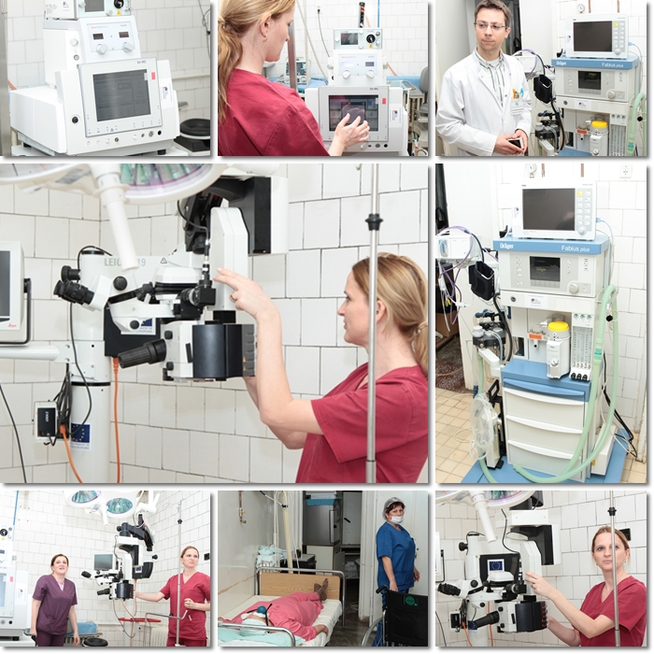

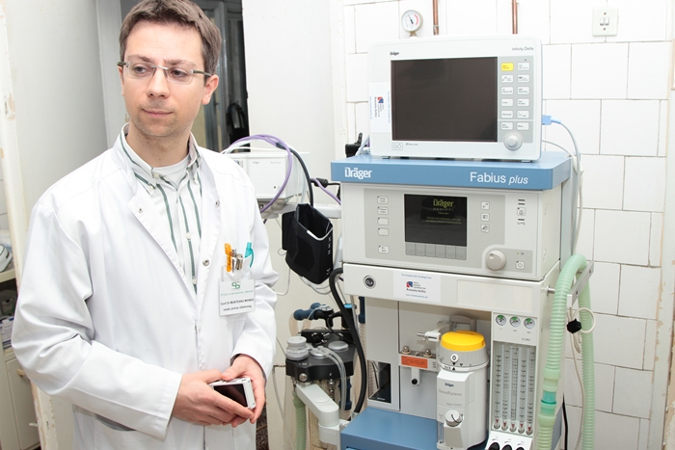
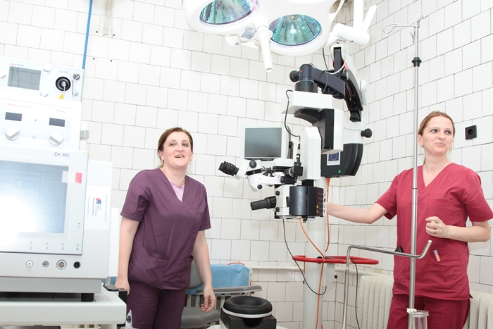

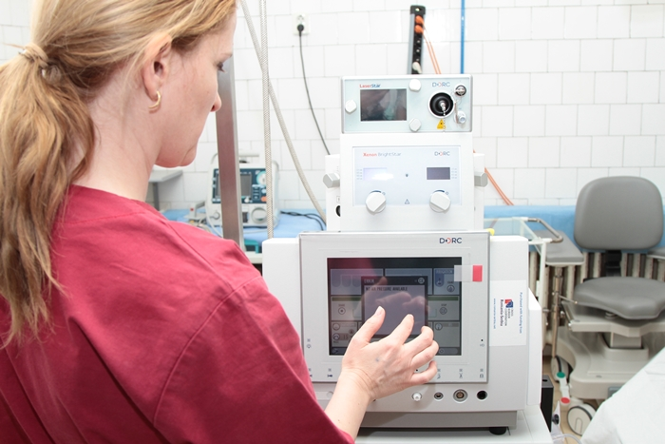
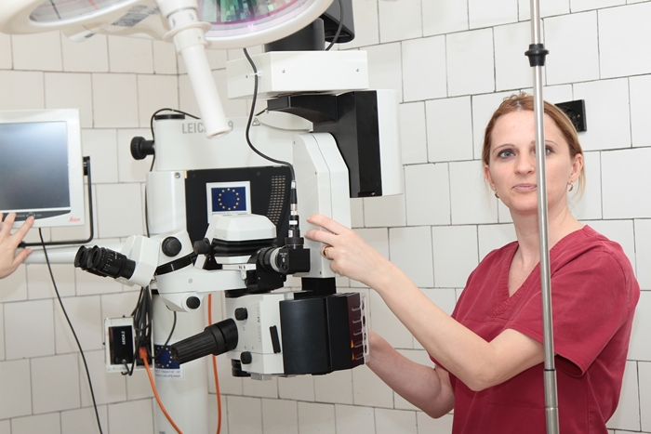
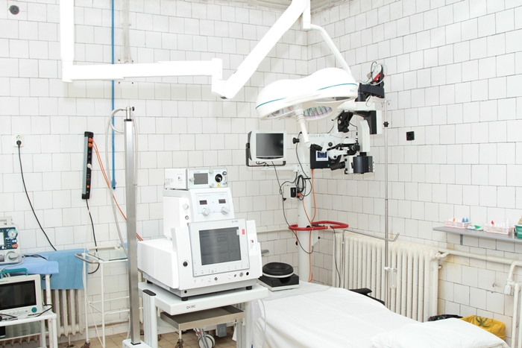

the implementation period (including extensions)
total funds spent/total funds contracted *100
indicators and level of achievement against targets set

