Project information
CALL FOR PROPOSALS | 1
MIS-ETC: | 393
PRIORITY AXIS: | 1 Economic and Social Development
MEASURE: | 1.2 Develop the tourism sector, including the strengthening of the regional identity of the border region as a tourist destination
PROJECT TITLE: | Modernisation and preservation of Water Castle
ACRONYM:
DURATION: | 16.12.2010 – 15.06.2012
IPA FUNDS CONTRACTED: | 812.328,85 €
TOTAL FUNDS CONTRACTED: | 955.681,00 €
ABSORBTION RATE (%): | 90,30%
PROJECT OBJECTIVE(S): | The general objective of the project is to achieve on the basis of joint cross-border projects and common actions by Romanian and Serbian stakeholders a more balanced and sustainable socio-economic development of the Romanian-Serbian border area.  The specific objectives of the project are: Increasing the overall competitiveness of the economy in the border area and improvement of the quality of life for the communities of the border area
SHORT DESCRIPTION OF THE PROJECT: | The Water Castle in Drobeta Turnu Severin was inaugurated in 1914 and provided water to the town’s residents until 1980. With EU-funding the castle was reborn in 2012 and is now quenching a thirst for culture through its modern exhibition rooms and literary spaces. Tourist numbers have risen sharply and a great deal of investment has come into the area as a result of the renovation. Moreover, the Water Castle is the now an iconic symbol of Dr.Tr. Severin City
DEGREE OF ACHIEVEMENT OF INDICATORS: | Indicator value provisioned in the contract Present indicator value % 6= (5)/(3)*100  Output indicators (1) UM (2) Quantity (3) UM (4) Quantity (5)  improving physical infrastructure in the border area  improved cross-border tourism products  activities improved tourism marketing common border  Result indicators  improved cross-border tourism products Pieces 1500 brochures, 5000 postcards, 2 panels, 10 pictures, 210 souvenirs Pieces 1500 brochures, 5000 postcards, 2 panels, 10 pictures, 210 souvenirs 100%  activities improved tourism marketing common border events 3 seminars events 3 seminars 100%  Project indicators  Increase the number of tourists number 2000 number 3780 189%
RESULTS ACHIEVED, INCLUDING PHOTOS:  Project selected to be part of the European Year of Cultural Heritage 2018 | “The Modernisation and Preservation of Water Castle” is a project implemented by the Drobeta Turnu Severin Town Hall (Romania) in partnership with Negotin Municipality (Republic of Serbia), being financed by the European Union with € 955.681 under the Romania – Republic of Serbia IPA Cross-border Cooperation Programme.  The rehabilitation of the Water Castle from Drobeta Turnu Severin in Romania, using the IPA financial support from the European Union, involved a lot of hard work from all sides of the border. The result is amazing, together we succeeded to regenerate an architectural heritage icon of the Romanian-Serbian border area and give it back to the community. Today, the castle attracts tourists and locals, offering numerous cultural events and an unforgettable view that extends over the Danube, in Serbia.  The Water Castle from Drobeta Turnu Severin has been inaugurated in 1914 and provided water to the town from the Danube until 1980. After a century of life, the Water Castle was reborn from its dust and it now receives new tasks from the local community which will contribute to the touristic promotion of the town through a new Info-point.  Because of its importance in the community life, its central location and its distinguished architectural characteristics, the local community embraced the Water Castle as the most important symbol of the town. The Water Castel satisfies the thirst for culture of the community through the adaptation, modernisation and transformation of the technological spaces into cultural spaces. Expositional spaces, a museum space, a recreational area including a coffee and tea room and a belvedere area in the tower pinnacle were opened.
Project website: | https://www.primariadrobeta.ro/water-castle/
Project presentation movie: | https://www.youtube.com/watch?v=n_-DdJQPMfw

Partnership information
 |  | COUNTRY | COUNTY/DISTRICT | BUDGET(EURO) | CONTACT DETAILS
LEAD PARTNER: | Drobeta Turnu Severin City Hall | Romania | Mehedinti | 955.681,00 | Drobeta Turnu Severin, 2 Maresal Averescu Street  Tel. 0040252314379
PARTNER 2: | Negotin City Hall | Serbia | Bor | 0 | Negotin, Trg Stevana Mokranjca 1  Tel. + 381 19 544 000
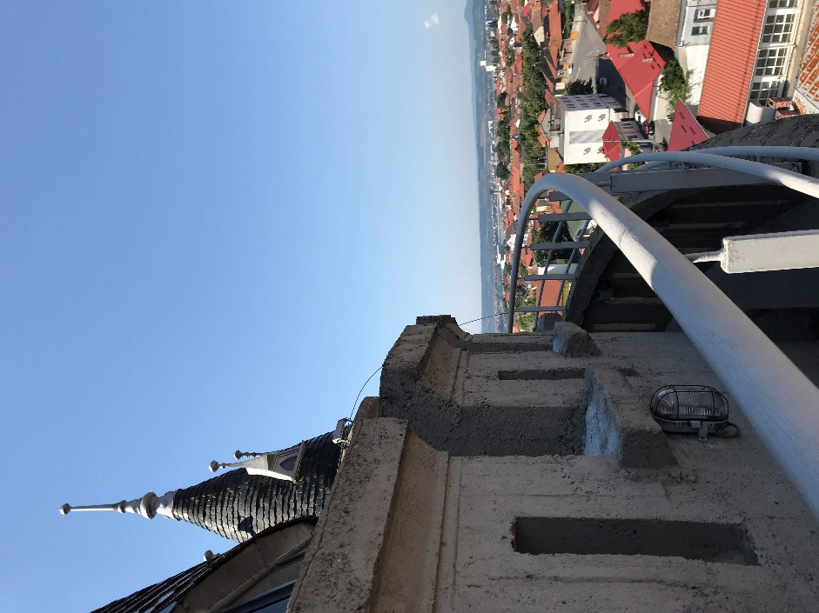
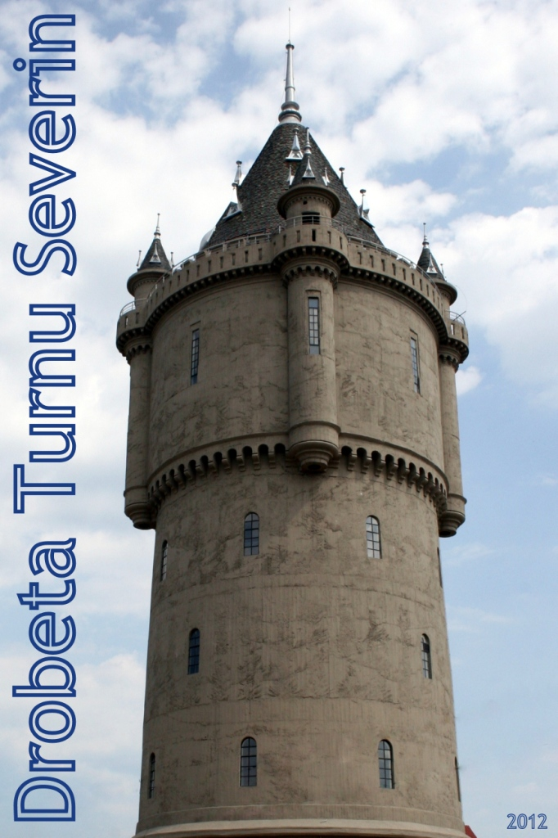
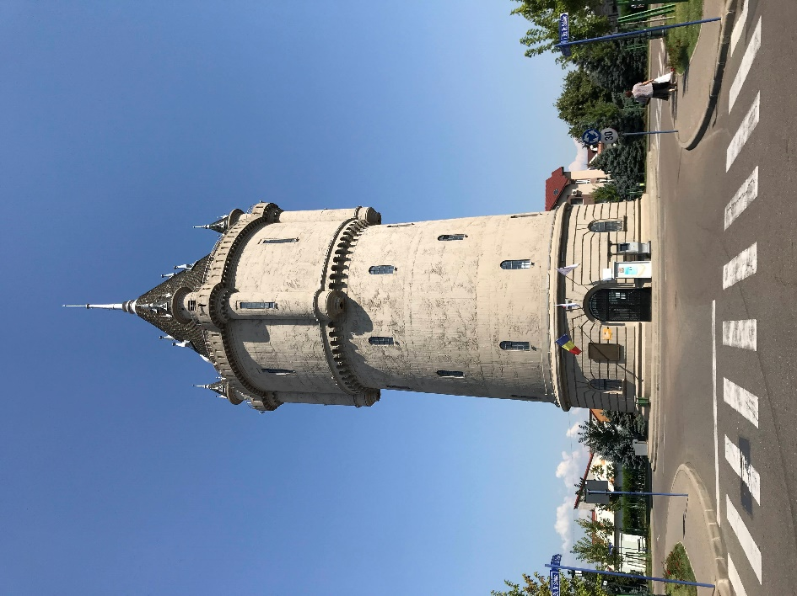

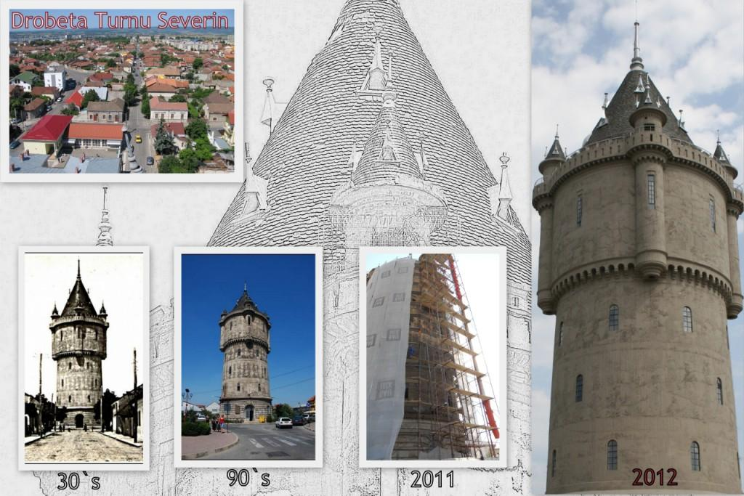
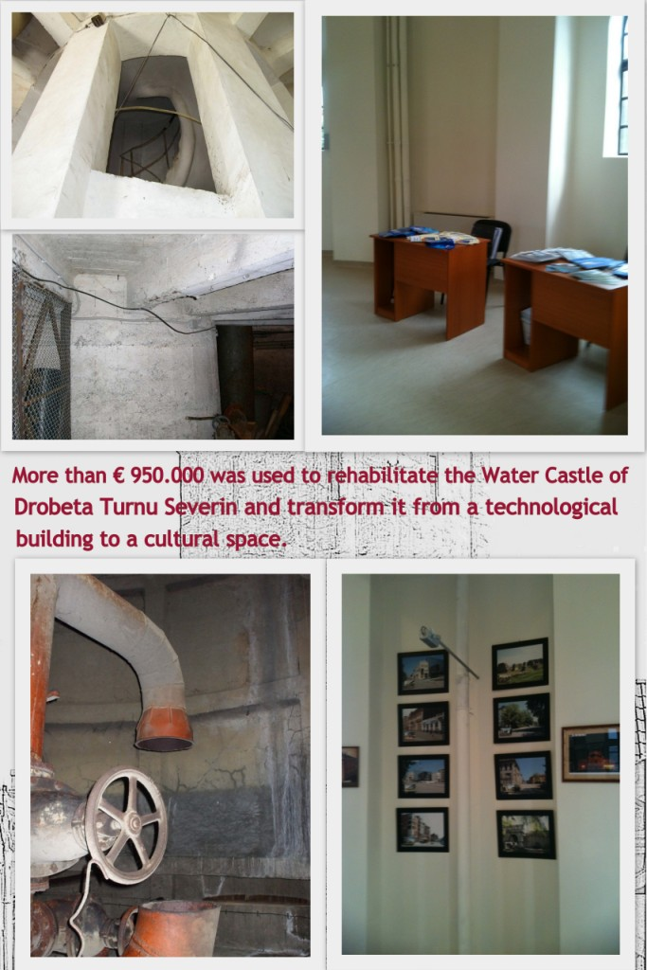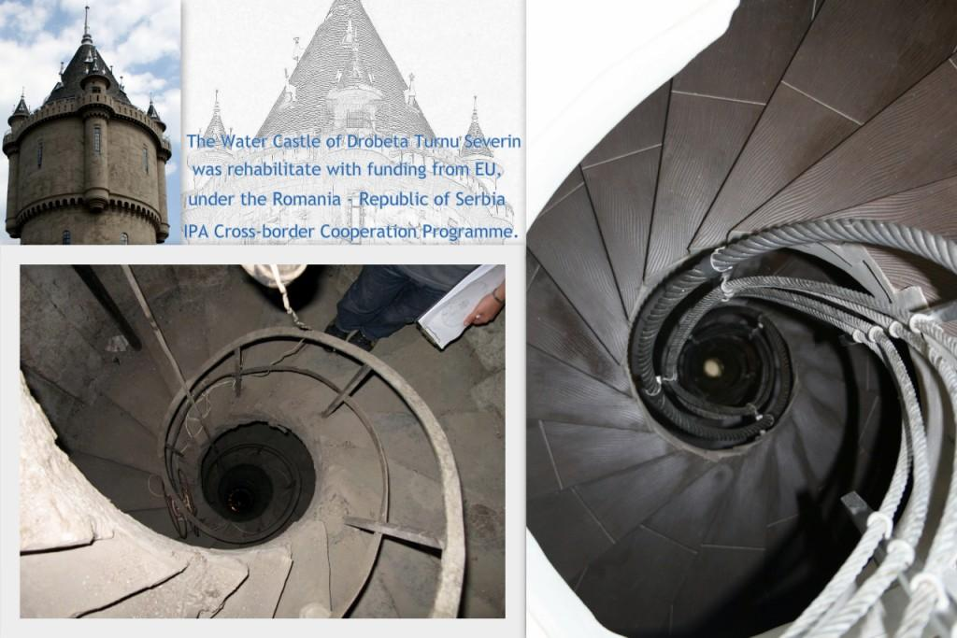

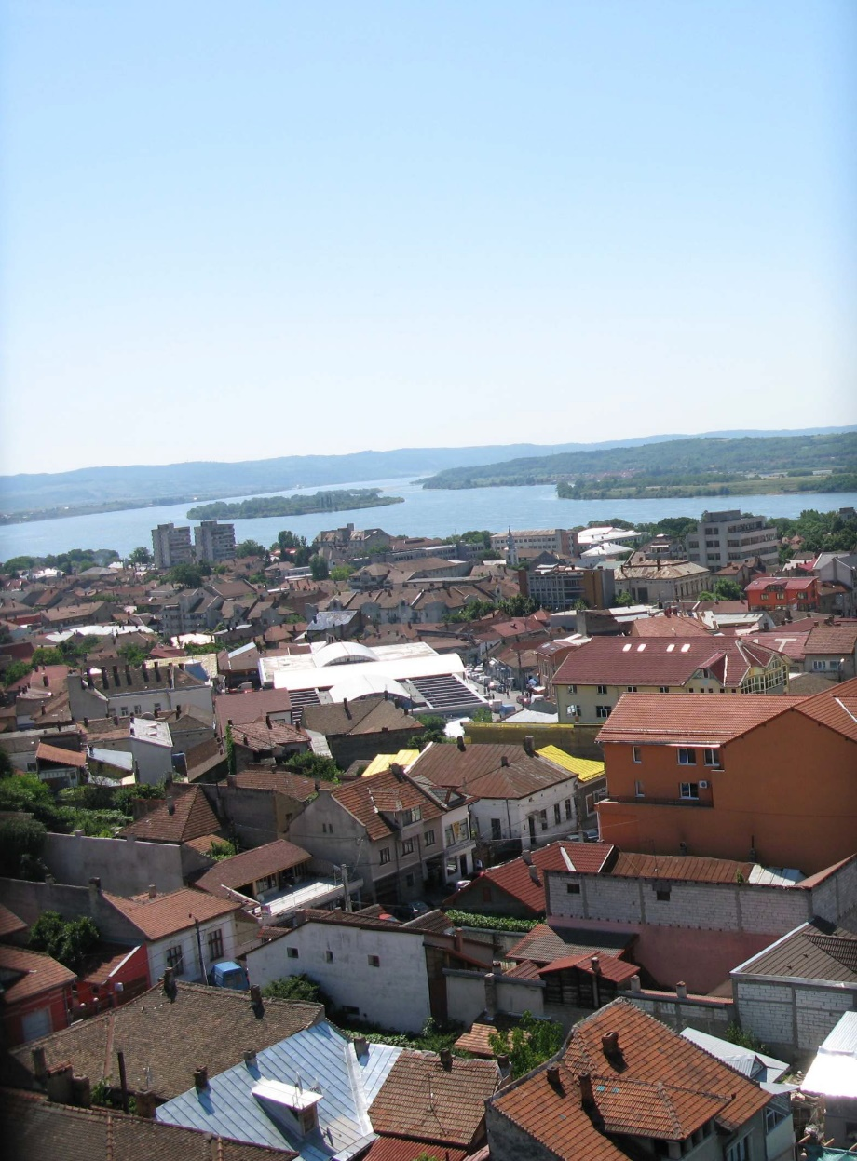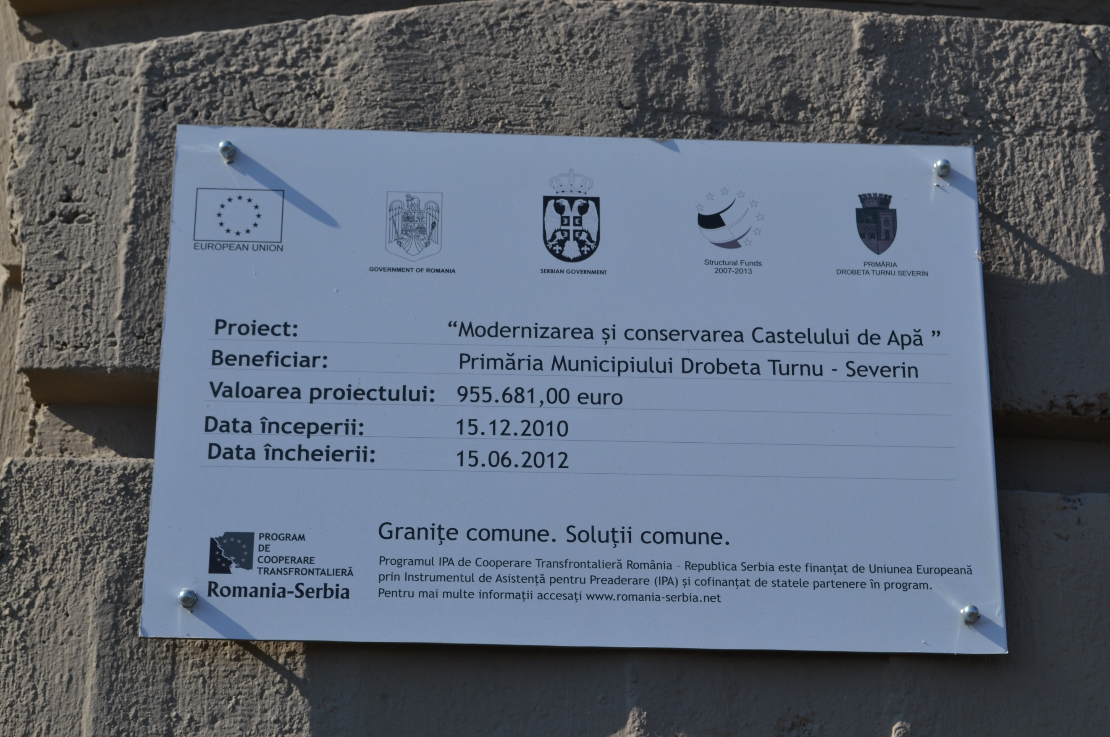

the implementation period (including extensions)
total funds spent/total funds contracted *100
indicators and level of achievement against targets set

