|  |  |
| --- | --- |
| **Project information** | |
|  |  |
| CALL FOR PROPOSALS | 1 |
| MIS-ETC: | 392 |
| PRIORITY AXIS: | 1 Economic and Social Development |
| MEASURE: | 1.2 Develop the tourism sector, including the strengthening of the regional identity of the border region as a tourist destination |
| PROJECT TITLE: | Creation and promotion of the tourist route with Roman specific Via Danubii including the rehabilitation of the physical infrastructure "Roman Street" |
| ACRONYM: |  |
| DURATION[1]: | 04.11.2010-03.05.2012 |
| IPA FUNDS CONTRACTED: | 999.371,90 € |
| TOTAL FUNDS CONTRACTED: | 1.175.731,65 € |
| ABSORBTION RATE (%)[2]: | 54,11 % |
| PROJECT OBJECTIVE(S): | Increase the attractiveness of Băile Herculane (Romania) – Veliko Gradište (Serbia) cross-border region as a tourist destination.  Improve the competitiveness in the Băile Herculane – Veliko Gradište region by increasing the number of tourists by 5% within 17 months due to the creation of the Via Danubii cross-border touristic route.  Improve the access to 8 specifically Roman tourist attractions on the cross-border thematic route Via Danubii „The Roman Street” local public physical infrastructure from Băile Herculane resort. Diverse cross-border products and services from Băile Herculane - Veliko Gradište border region due to the creation of 7 new economic agents in the field of tourism. |
| SHORT DESCRIPTION OF THE PROJECT: | Confronted with a decrease of the number of tourists in the area, the partnership, started in 2006 after the official twining of the 2 cities, decided on using the opportunity presented by the Programme to implement several measures that led to the improvement of the current situation. The implementation of the *Via Danubii* project stimulated global economic competitiveness growth in the border region by adding value to the economic activities for 400 different economic agents. The rehabilitation of 955 m of local physical infrastructure,creation of a new tourism product and effective border region marketing enabled interconnection and attractiveness growth, including economic competitiveness growth in the cross-border region targeted by the project. |
| DEGREE OF ACHIEVEMENT OF INDICATORS[3]: | |  |  |  |  |  |  |  | | --- | --- | --- | --- | --- | --- | --- | |  | Indicator value provisioned in the contract | | | Present indicator value | | %  6= (5)/(3)* 100 | | Output indicators  (1) | UM  (2) | | Quantity  (3) | UM  (4) | Quantity  (5) |  | | *Improvement of the physical infrastructure in the border area* is achieved through*:*   1. rehabilitation and improvement of 955 m of the „Roman Street”, a local road from Băile Herculane resort, and 2. rehabilitation of 250 m2 of green spaces and 2560 m2 of promenades, essential parts of the departure point on the Via Danubii Roman-thematic route. | | | | | | | | *Achieved/Improved skills of labour force at the end of common professional training courses is* achieved by means of:  1. common professional training for 4 tourist cross-border guides within the Regional Tourist Information Centre from Veliko Gradište, Serbia and in 2 info points from Viminacium, Kostolac, Serbia and Băile Herculane, Romania. | | number | 4 | number | 4 | 100% | | **Result indicators** | | | | | | | | New cross-border tourist products, new or improved approaches/activities of common cross-border tourist marketing or the common tourist information services created | Number of new cross-border tourist products | | 1 | Number of new cross-border tourist products | 1 | 100 | | Number of  new activities of cross-border tourist marketing | | 2 | Number of  new activities of cross-border tourist marketing | 2 | 100 | | Number of new cross-border tourist information services | | 1 | Number of new cross-border tourist information services | 1 | 100 | | Improved cross-border  transport connections | Number of improvement activities of the existing transport connections | | 1 | Number of improvement activities of the existing transport connections | 1 | 100 | | New or improved cross-border tourism services and the development of the SMEs ability to develop cross-border tourism | Number of activities, actions, initiatives centred on tourism promotion in the border area | | 2 | Number of activities, actions, initiatives centred on tourism promotion in the border area | 2 |  | | **Project indicators** | | | | | | | | Joint regional strategy on the sustainable development and promotion of tourism based on common Roman characteristics of the Danube Cross-Border region | Number of Strategy | | 1 | Number of Strategy | 1 | 100 | | Study and development of brand VIA DANUBII for improved visibility and attractiveness of tourism in the region | Developed brand, registration of trade mark | | 1 | Developed brand, registration of trade mark | 1 | 100 | | Established regional coordination centre VIA DANUBII for promotion of Roman tourism | Centre established, centre office and info points equipped | | 1 | Centre established, centre office and info points equipped | 1 | 100 | | Professional training of certain persons in the tourism field | Number of persons trained as tourist guides | | 4 | Number of persons trained as tourist guides | 4 | 100 | | Rehabilitation of the Roman Street road of Băile Herculane resort. | Square meters road | | 955 m | Square meters road | 955 m | 100 | | Rehabilitation of the side walk corresponding to the rehabilitated road infrastructure. | Surface of the proposed area | | 2560 m2 | Surface of the proposed area | 2560 m2 | 100 | | Rehabilitation and preservation of tourist interest points along the Roman Street route from Băile Herculane | Number of rehabilitated tourist objectives | | 4 | Number of rehabilitated tourist objectives | 4 | 100 | | Landscaping the green spaces areas, reported to the background of the resort rehabilitated road | Surface of the proposed area | | 250 m2 | Surface of the proposed area | 250 m2 | 100 | | Creating the Roman atmosphere by Roman decorative art works | Number of works and of urban furniture items | | 64 | Number of works and of urban furniture items | 64 | 100 | | Sanitation, rehabilitation and protection of the physical and natural environment | Number of environment protection actions | | 4 | Number of environment protection actions | 4 | 100 | | Promotional material | Promotional material | | 1 website,  500 flyers, 1,500 leaflets, 1,000 maps;  2,000 promotional items (souvenirs);  1 promotional film, 1 promotional TV spot and 750 CDs | Promotional material | 1 website,  500 flyers, 1,500 leaflets, 1,000 maps;  2,000 promotional items (souvenirs);  1 promotional film, 1 promotional TV spot and 750 CDs | 100 | | Dissemination and promotional activities | Advertisements broadcasted or published, presence list | | 12 adverts in media;  at least 6 broadcastings of tv spot;  3 promotional events;  3 roman days organized | Advertisements broadcasted or published, presence list | 12 adverts in media;  at least 6 broadcastings of tv spot;  3 promotional events;  3 roman days organized | 100 | | Increasing the tourist number in the Băile Herculane (Romania) – Veliko Gradište (Serbia) cross-border area with almost 5% | Local/county statistical data | | 80000 -> 84000 | Local/county statistical data | 80000 -> 106.657 | 666 | | The establishment of new economic agents that provide tourist products and services in the Băile Herculane – Veliko Gradište cross-border area | Local/county statistical data/Trade Register Office | | 116 -> 123 | Local/county statistical data/Trade Register Office | 116 -> 123 | 100 | | Creation of new jobs during the project's period | Number of employment contracts | | 3 | Number of employment contracts | 4 | 133 | |
|  |  |
| RESULTS ACHIEVED, INCLUDING PHOTOS: | **1. Rehabilitation of „The Roman Street” public physical infrastructure implies the rehabilitation of:**  - 955 m of road  - 870 m of road gutters  - 2560 m2 of Roman -like pavements  - 65 m2 of parking places  - 250 m2 of green spaces, as well as the sanitation of:  - 2500 m2 of retaining wall  - 955 m of guard rail to Cerna River  - 3000 m2 of green spaces  **2. Landscaping in comparison with the rehabilitated road background :**  - 12 benches  - 10 trash bins  - 10 tables  - 5 Roman-like statues  - 5 bas-reliefs  - 2 access gates  - 8 environmental lighting devices  - 6 little metal pillars  **3. Rehabilitation of 4 tourist sights dating from the Dacia Ripensis Roman period**  **4. Creation of the specifically Roman –themed route Via Danubii at cross-border level:**  - at least 212 km  - crosses at least 16 towns and villages  - 14 Roman vestiges  **5. Promotion of tourist potential in the cross-border region by creation of:**  - 1 Regional centre for cross-border tourist information  - 2 tourist information local points,  -professional training of 4 tourist guides  - 3 studies/strategic documents  - 5000 promotion materials  - 1 site |
|  |  |

|  |  |  |  |  |  |
| --- | --- | --- | --- | --- | --- |
| **Partnership information** |  | | | | |
|  |  | COUNTRY | COUNTY/DISTRICT | BUDGET(EURO) | CONTACT DETAILS |
| LEAD PARTNER: | **Baile Herculane Local Council** | Romania | Caras Severin | 1047.126,39 | Băile Herculane, Str. Mihai Eminescu, no.10  Tel. +4 0255 560 775 |
| PARTNER 2: | **Municipality of Veliko Gradiste** | Serbia | Branicevo | 128.605,26 | Veliko Gradiste, Zitni trg 1  Tel. +381 12 662 120 |

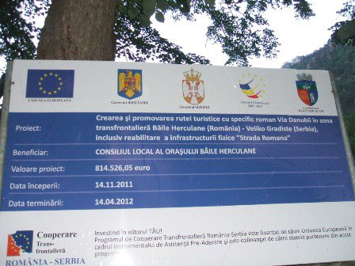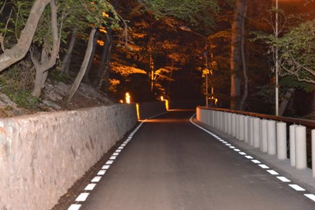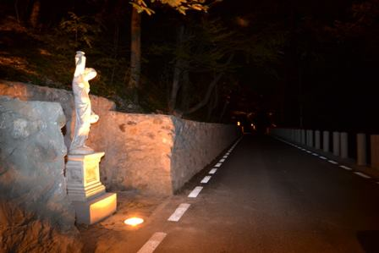

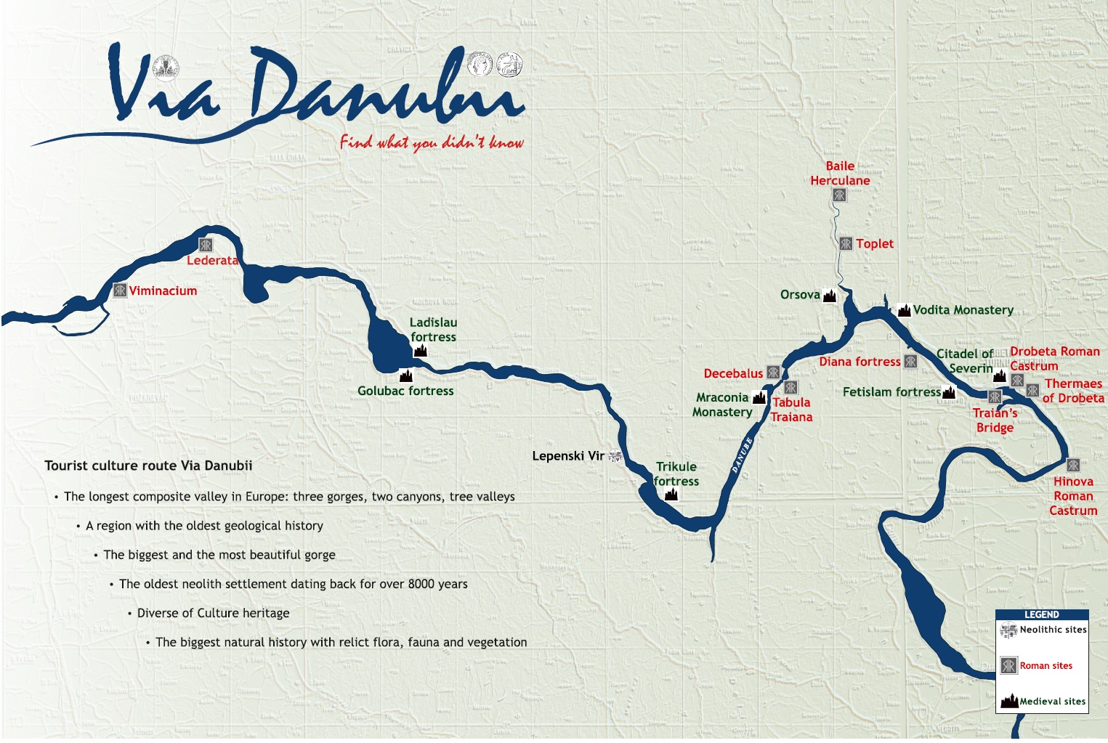







  

1. the implementation period (including extensions)
2. total funds spent/total funds contracted *100
3. indicators and level of achievement against targets set