Project information
CALL FOR PROPOSALS | 1
MIS-ETC: | 386
PRIORITY AXIS: | 1 - Economic & Social Development
MEASURE: | 1.1 - Support for local/regional economic and social infrastructure
PROJECT TITLE: | Development Of Cross-Border Telediagnostic And Teleconsultation Network In Health Institutions
ACRONYM: | TELEDIAG
DURATION: | 31.12.2010 – 30.02.2012
IPA FUNDS CONTRACTED: | 976.014,20 €
TOTAL FUNDS CONTRACTED: | 1.148.252 €
ABSORBTION RATE (%): | 90,58 %
PROJECT OBJECTIVE(S): | With funding from the Romania – Republic of Serbia IPA Cross-border Cooperation Programme, the doctors from the General Hospital Vršac (Republic of Serbia), County Emergency Hospital Reșița (Romania) and the Health Centre Žitište (Republic of Serbia) collaborate through a unique telemedical system in both countries which allows the doctors to perform cross-border medical investigations without being face-to-face with the patients, by using secured e-information and e-communication to provide long-distance healthcare.  Project objectives:  - Increase the quality of health care in the border area by developing and establishing a modern and sustainable cross-border system of communication among different level health institutions.  - Provide basis for new research and development as well as analytical and statistical processing of data by creating new databases in the region.  - Overcoming the border as a perceived “division” by promoting cross-border cooperation and creating synergies in health care  - Enabling remote consultations and treatment for patients regardless of their geographical location, allow constant access to medical experts, reduce reaction time and decrease the possibility for errors concerning loss of data and such  - Rehabilitation of project partner institutions and modernization of health units within the network for the purpose of effective and high-quality network operation.  - Reduce cost and increase economic benefits for peripheral and border regions
SHORT DESCRIPTION OF THE PROJECT: | One of the 4 projects selected by the EU Commission to be presented as a good project example during the Annual Meeting of the Managing Authorities (Brussel, 19-20 May 2014) and finalist of the Regio Stars Awards 2015, which honour Europe's most inspirational and innovative regional projects supported by EU Cohesion Policy Funds. An independent RegioStars Awards Jury, led by MEP Lambert Van Nistelrooij as Jury President, selected 17 finalists from 143 entries on the basis of four key criteria: innovation, impact, sustainability and partnership.  A cross-border telediagnostic and teleconsultation network was created between 14 health units from the cross-border region, network which is being administrated by the tree partners from the project. The telemedical system created by this project can be considered a first step in creating a network without limitations in regards of connecting into larger networks in the world. By using e-information and e-communication to provide over-the-distance health care, limiting factors like physical distance and time was eliminated.  Each health unit included in the network has installed a software for telemedicine and additionally each project partner procured specialized equipment. General Hospital Vršac - analogous X-ray device, CR system, laser printer for “dry development” of digital images, high quality and middle quality ultrasound, laparoscopic equipment, hysteroscopy equipment, Colonoscopy equipment; County Emergency Hospital Resita - Laparoscopic equipment, Hysteroscopy equipment, Gastroscopy equipment, Microscope for pathological anatomy, High quality Ultrasound, Digital retina camera, Ophthalmology Intraoperator microscope, Ultrasound - MRI intraoperator and CR system for mammography and analogous X-ray machine; Health Centre Žitište - upgraded the system for the existing X-ray device.
DEGREE OF ACHIEVEMENT OF INDICATORS: | Indicator Indicator value provisioned in the contract Present indicator value % 6= (5)/(3)*100  Output indicators (1) UM (2) Quantity (3) UM (4) Quantity (5)  Improved capacity and cross-border contacts of SMEs and in the R&D sector Number 1 Number 1 100%  People in labour force with qualifications received/improved from joint training activities Number 1 Number 1 100%  Result indicators  Increased importance of R&D/Innovation in the border area Number of activities, actions, initiatives focusing on promoting the importance of or dealing directly with R&D/Innovation - 2 workshops organized for training of health care and IT personnel, - 1 innovative cross-border network - Min. 14 new databases Number of activities, actions, initiatives focusing on promoting the importance of or dealing directly with R&D/Innovation - 2 workshops organized for training of health care and IT personnel, - 1 innovative cross-border network - 14 new databases 100%  Project indicators  Implemented multilingual software for image transmission among health units with new databases pcs 14 pcs 14 100%  Creation of a multilingual manual for system operation pcs 500 pcs 500 100%  Number of health care and IT personnel receiving training people 40 people 40 100%  Modernization of health care units within the network / number of new equipment purchased pcs 20 pcs 20 100%  Number of new cross-border partnerships between health institutions pcs 14 pcs 14 100%  Number of new joint planning teams for system operation and management pcs 1 pcs 1 100%  Number of new digital diagnosis databases pcs 14 pcs 14 100%  Number of patients receiving improved health services provided by the network people Min. 150.000 people 150.000 100%  Area covered by the new tele diagnostic and teleconsultation network km2 9.839 km² km2 9.836 km² 100%
RESULTS ACHIEVED, INCLUDING PHOTOS: | ”The Development of Cross-border Telediagnostic and Teleconsultation Network in Health Institutions” project allowed equipping the health institutions with top of the line medical instruments and equipment which will reduce the cost of the medical act through the following services:  - Tele-diagnostics - enables a remote-based physician to diagnose a patient;  - Tele-radiology – transferring radiological data for interpretation and/or consultation;  - Tele-pathology – used to make patho-histological diagnoses;  - Tele-consultation – enables a remote access to the information stored in databases or by direct communication with medical specialists;  - Tele-concilium – enables several medical experts from different locations to communicate at the same time;  - Tele-education and tele-training - training medical staff.  The created network is a one-of-a-kind innovation in the region and similar cross-border partnerships have not been accomplished yet and may be a first step in creating a network without limitations allowing the connection into larger medical networks in the EU or all around the world. As a clear example, during the project implementation, additionally to the 3 partner institutions, another 7 Serbian and 4 Romanian medical units were selected to join the network
Project presentation movie: | https://www.youtube.com/watch?v=CeddfoJWFX8

Partnership information
 |  | COUNTRY | COUNTY/DISTRICT | BUDGET(EURO) | CONTACT DETAILS
LEAD PARTNER: | General Hospital Vrsac | Serbia | South Banat | 590.737 | Vrsac, Abraševićeva bb  Tel. + 381 13 839 838
PARTNER 2: | County Emergency Hospital Resita | Romania | Caras-Severin | 511.322 | Resita, str. Fagarasului nr.18  Tel. + 40 255 227 830
PARTNER 3: | Health Center Zitiste | Serbia | Central Banat | 46.193 | Žitište, Ivo Lole Ribar 16  Tel. + 381 23 822 010
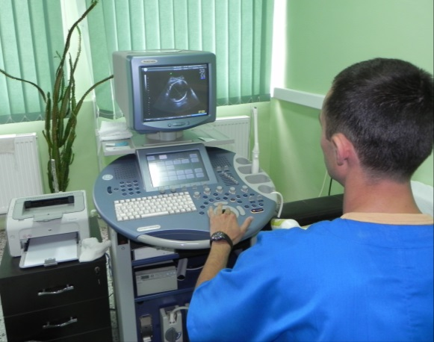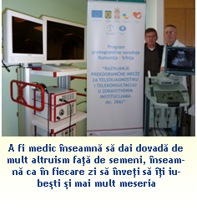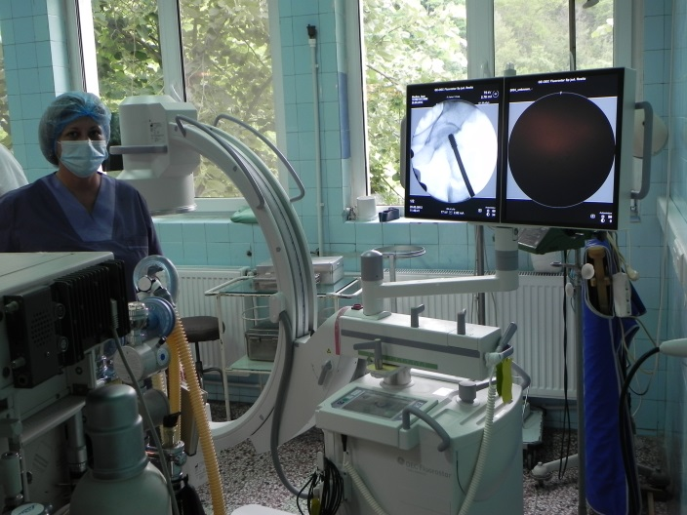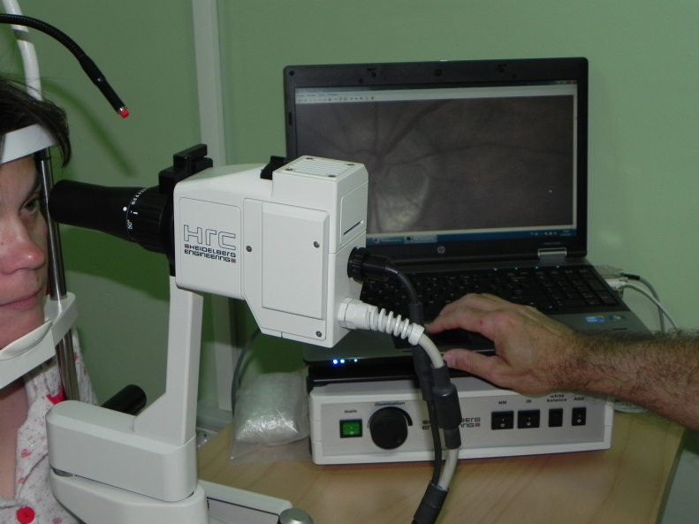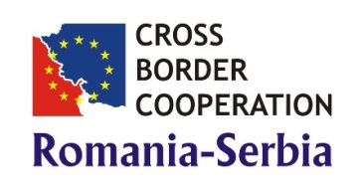

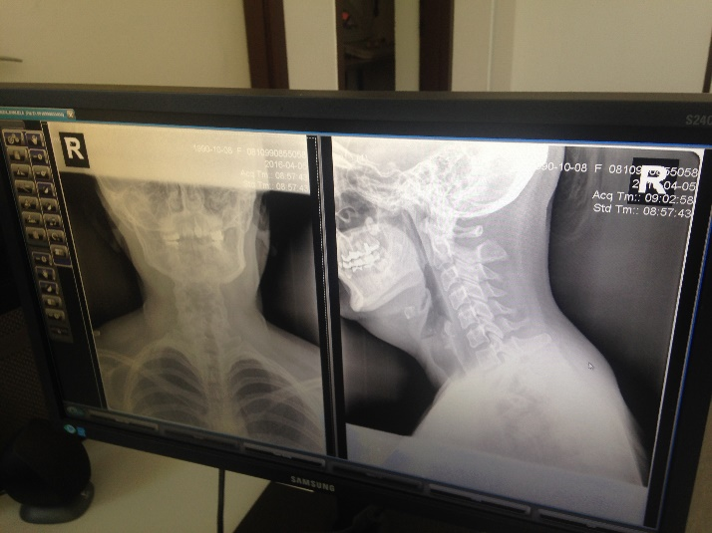
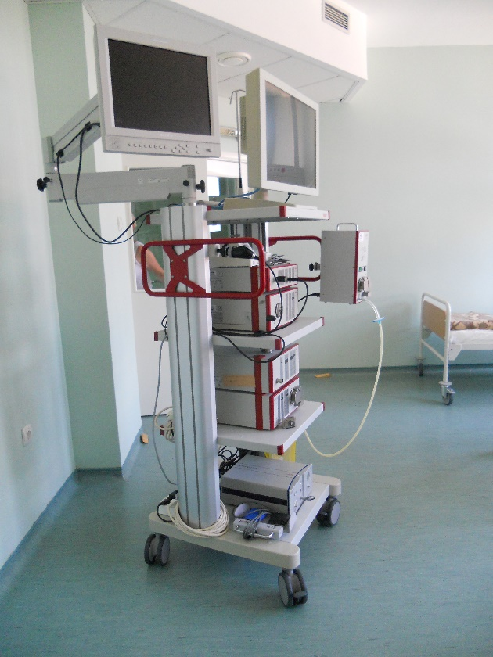

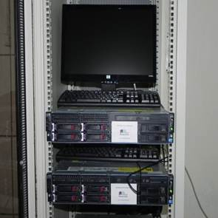
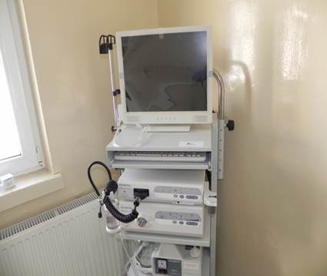
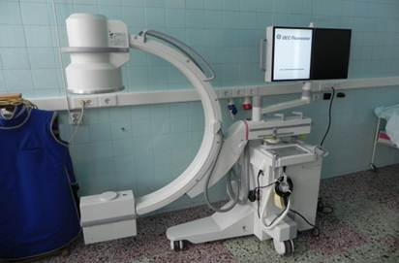
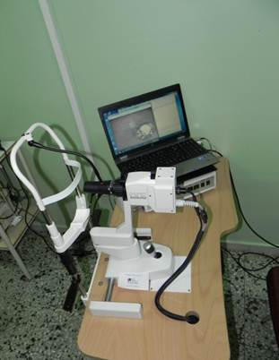
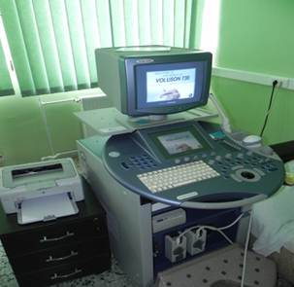
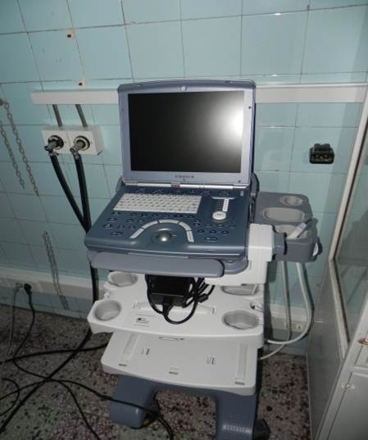
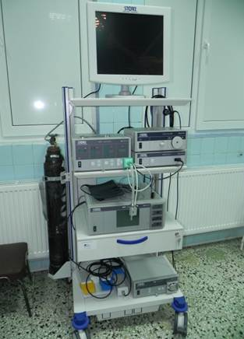

the implementation period (including extensions)
total funds spent/total funds contracted *100
indicators and level of achievement against targets set

