Project information
CALL FOR PROPOSALS | 1
MIS-ETC: | 383
PRIORITY AXIS: | 3 Promoting “people to people” exchanges
MEASURE: | 3.3 Increase educational, cultural and sporting exchange
PROJECT TITLE: | BORDERS SET US APART, CULTURE LINKS US
ACRONYM: | BSUACLU
DURATION: | 01.01.2011 – 30.06.2012
IPA FUNDS CONTRACTED: | 177.768,15 €
TOTAL FUNDS CONTRACTED: | 209.139 €
ABSORBTION RATE (%): | 95,66 %
PROJECT OBJECTIVE(S): | Intensification of the cultural and sporting exchanges in the border aria between Romania and Serbia, by initiating common activities as cultural events and sport competitions to improve the local communities contact.  Developing the necessary resources for creating the premises of a better communication between border regions.  Increase public awareness level for cross border cooperation in cultural and sports field.  Develop cultural cooperation in the Romanian-Serbian border area by promoting common cultural heritage of cross border area
SHORT DESCRIPTION OF THE PROJECT: | The project "Borders Set Us Apart, Culture Link Us," came as a natural continuation of the cooperation between the two project partners in organizing cultural and sporting events.  The project created the premises for improving local communities contact in the Romanian – Serbian border. Through the project the situation of the direct and indirect beneficiaries has been improved, materials and more extensive documentation for a better knowledge and mutual understanding have been created, folk and religious traditions of the region of Banat, on both sides of the border has been preserved and literature, naive art, sportive competition in the area have been promoted.
DEGREE OF ACHIEVEMENT OF INDICATORS: | Indicator value provisioned in the contract Present indicator value % 6= (5)/(3)*100  Output indicators (1) UM (2) Quantity (3) UM (4) Quantity (5)  Increased people-to-people exchange in the fields of education, culture and sports  Result indicators  Increased social and cultural integration of people in the border areas Number of participants benefiting from cross border social and cultural events 1020 Number of participants benefiting from cross border social and cultural events 1020 100  Improved knowledge of culture, history, society, organizational and institutional structure, and language of the neighbouring country Number of participants gained knew knowledge in events promoting the neighbouring country 520 Number of participants gained knew knowledge in events promoting the neighbouring country 520 100  Project indicators  1) stronger logistic capacity of the Applicant The type and numbers of equipment, goods and office supplies 3263 The type and numbers of equipment, goods and office supplies 3263 100  2) increased instruction level of the participants at the events organized during project implementation. Number of participants 520 Number of participants 520 100  3) increased public awareness level of the cross-border cooperation Number of beneficiaries 1020 Number of beneficiaries 1020 100  4) edited DVD with a documentary dedicated to Generations festival Number of DVDs 500 Number of DVDs 500 100  5) edited Collection with most interesting works from the camp "Stefan Naciu" creation and communication field Number of collections 150 Number of collections 150 100  6) edited volume of poetry from "Light Bridges" literary meeting Number of volumes 200 Number of volumes 200 100  7) edited CD with the best told jokes from this section of the meeting the "Light Bridges" literary meeting Number of CDs 200 Number of CDs 200 100  8) edited illustrated brochure dedicated to the festival "Hello! Here Semenic" folk music festival Number of brochures 250 Number of brochures 250 100  9) edited DVD dedicated to the festival "Hello! Here Semenic" folk music festival Number of DVDs 200 Number of DVDs 200 100  10) edited CD with traditional songs “doine” the "Nostalgia Sings" traditional music festival Number of CDs 300 Number of CDs 300 100  11) edited illustrated brochure the "Poetic Miniatures" symposium and exhibition Number of brochures 150 Number of brochures 150 100  12) edited a religious poetry volume for the “The Annunciation" festival Number of volumes 150 Number of volumes 150 100  13) edited a CD with religious music for the “The Annunciation" festival Number of CDs 200 Number of CDs 200 100  14) editing a photo album from the exhibition “Soul on Canvas” Number of photo albums 200 Number of photo albums 200 100  15) edited the volume “Istoria doinelor” as the result of the linguistic study Number of volumes 150 Number of volumes 150 100  16) the constructed website dedicated to the project Number of websites 1 Number of websites 1 100
RESULTS ACHIEVED, INCLUDING PHOTOS: | - increasing of the instruction level of the participants at the events organized during project implementation.  - increasing of the public awareness level of the cross-border cooperation  - editing a DVD with a documentary dedicated to Generations festival  - editing one Collection with most interesting works from the camp "Stefan Naciu" creation and communication field  - editing a volume of poetry from "Light Bridges" literary meeting  - editing a CD with the best told jokes from this section of the meeting the "Light Bridges" literary meeting  - editing a illustrated brochure dedicated to the festival "Hello! Here Semenic" folk music festival  - editing a DVD dedicated to the festival "Hello! Here Semenic" folk music festival  - editing a CD with traditional songs “doine” the "Nostalgia Sings" traditional music festival  - editing illustrated brochure, the "Poetic Miniatures" symposium and exhibition  - editing a religious poetry volume for the “The Annunciation" festival  - editing a CD with religious music for the “The Annunciation" festival  - editing a photo album from the exhibition “Soul on Canvas”  - editing the volume “Istoria doinelor” as the result of the linguistic study

Partnership information
 |  | COUNTRY | COUNTY/DISTRICT | BUDGET(EURO) | CONTACT DETAILS
LEAD PARTNER: | SEMENIC RADIO ASSOCIATION | Romania | CARAŞ-SEVERIN | 209.139 | REŞIŢA, Petru Maior Str., No 71  Tel. 0040 255 206 055
PARTNER 2: | LITERARY ARTISTIC SOCIETY "TIBISCUS" | Serbia | JUZNO BANATSKI | 0 | UZDIN, Tudor Vladimirescu Str., No. 176 B  Tel. 0038113763262

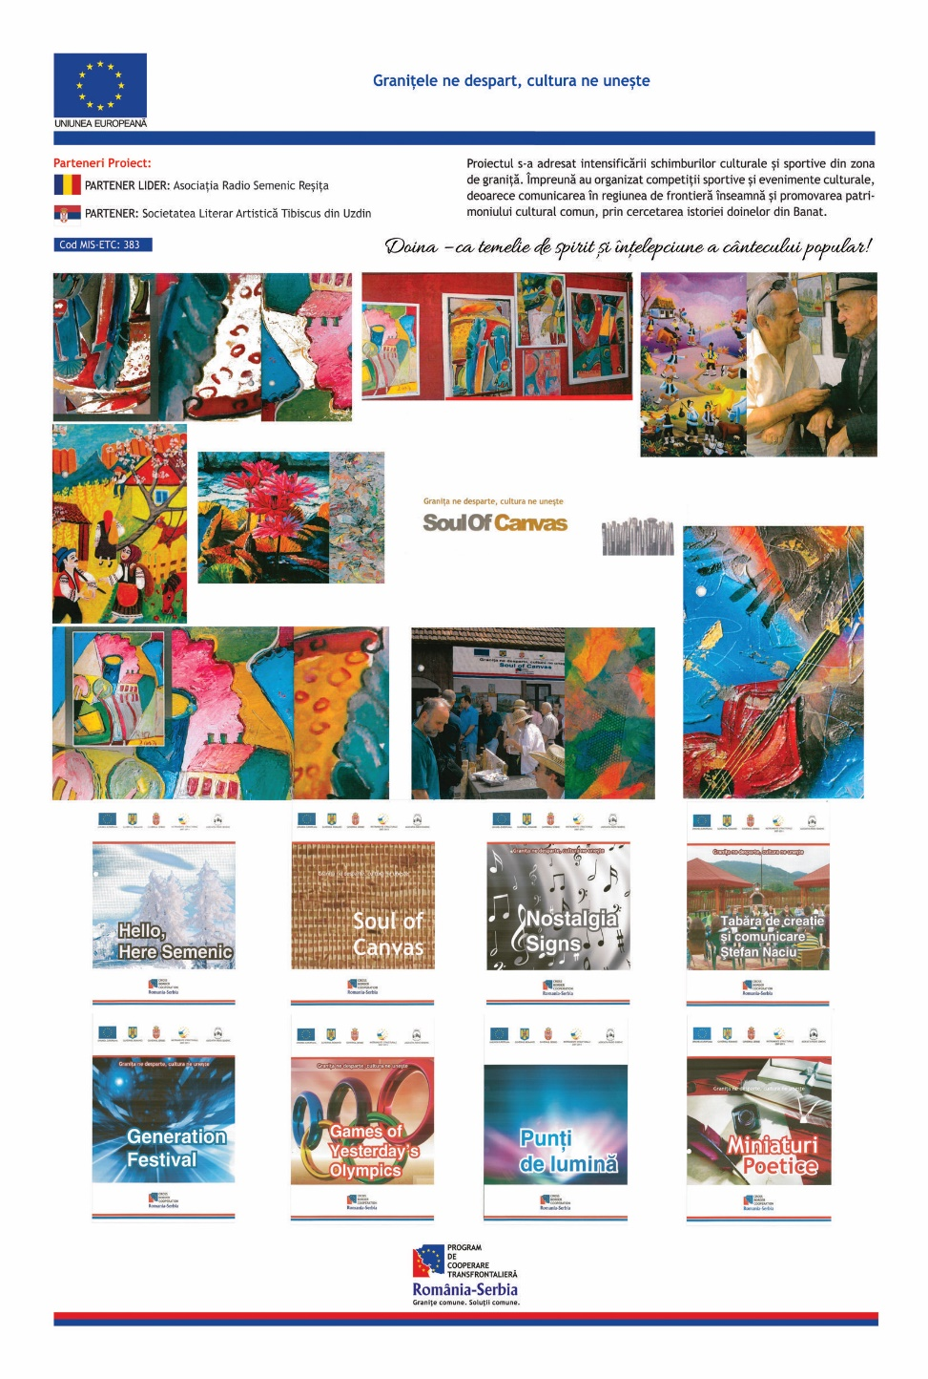

the implementation period (including extensions)
total funds spent/total funds contracted *100
indicators and level of achievement against targets set

