Project information
CALL FOR PROPOSALS | 1
MIS-ETC: | 371
PRIORITY AXIS: | 3 Promoting “people to people” exchanges
MEASURE: | 3.4 Enhance social and cultural integration of border areas
PROJECT TITLE: | Cross-border initiatives for social insertion of disadvantaged groups
ACRONYM:
DURATION: | 08.02.2011 – 07.06.2012
IPA FUNDS CONTRACTED: | 170.354,45€
TOTAL FUNDS CONTRACTED: | 200.417 €
ABSORBTION RATE (%): | 68,42 %
PROJECT OBJECTIVE(S): | Improve the quality of life for the populations from Timis County and Ada Municipality, by increasing social solidarity in the border region.  Increase the knowledge and social skills of ethnic minorities and socially and economically disadvantaged groups in the border area.  Improve the perception of the general population in the border area about cultural and ethnic diversity, social solidarity and anti-discriminatory practices
SHORT DESCRIPTION OF THE PROJECT: | It has increased the knowledge and skills of ethnic minorities and socially and economically disadvantaged groups in the border area through informative and educational sessions, work-shops with public servants, the Anti-discrimination camp for children. Improving the perception of the general population in the border area on cultural and ethnic diversity, social solidarity and anti-discriminatory practices was also achieved through the implementation of the Common Cross-Border Strategy for Anti-Discrimination.
DEGREE OF ACHIEVEMENT OF INDICATORS: | Indicator value provisioned in the contract Present indicator value % 6= (5)/(3)*100  Output indicators (1) UM (2) Quantity (3) UM (4) Quantity (5)  Stronger civil society of the border area number 1 number 1 100  Increased integration of the border communities and improved local services in the border area number 1 number 1 100  Result indicators  Increased social and cultural integration of people in the border areas Number of participants benefiting from cross-border social and cultural events 294 Number of participants benefiting from cross-border social and cultural events 327 111  Improved quality of life and increased attractiveness of the border communities as a living place Number of activities improving other local living conditions 50 Number of activities improving other local living conditions 63 126  Project indicators  Increased knowledge and social skills of ethnic minorities and socially and economically disadvantaged groups in the border area Number of educational and informative sessions for ethnic minorities and socially and economically disadvantaged families with children in Romania and Serbia 18 Number of educational and informative sessions for ethnic minorities and socially and economically disadvantaged families with children in Romania and Serbia 24 133  Number of participants at the educational and informative sessions in Romania and Serbia 120 Number of participants at the educational and informative sessions in Romania and Serbia 130 108  Number of publications on social rights of vulnerable groups 1 Number of publications on social rights of vulnerable groups 1 100  Number of group visits to the Public Institutions in Serbia 2 Number of group visits to the Public Institutions in Serbia 3 150  Number of participants at the groups visits 32 Number of participants at the groups visits 32 100  Improved perception of the general population in the border area about cultural and ethnic diversity, social solidarity and anti-discriminatory practices Number of work-shops with the public servants in Serbia 4 Number of work-shops with the public servants in Serbia 4 100  Number of public servants participating in the work-shops 40 Number of public servants participating in the work-shops 52 130  Number of publications on anti-discrimination topics 1 Number of publications on anti-discrimination topics 1 100  Number of thematic camp organized 1 Number of thematic camp organized 1 100  Number of beneficiaries at the thematic camp 36 Number of beneficiaries at the thematic camp 36 100  Number of common work-shops for the representatives of the NGO’s and public institutions in Romania and Serbia 4 Number of common work-shops for the representatives of the NGO’s and public institutions in Romania and Serbia 4 100  Number of beneficiaries participating to the common work-shops 32 Number of beneficiaries participating to the common work-shops 32 100  Number of Common Cross-border Strategies for Anti-Discrimination elaborated 1 Number of Common Cross-border Strategies for Anti-Discrimination elaborated 1 100
RESULTS ACHIEVED, INCLUDING PHOTOS: | By increasing social solidarity in the border region, it was improved the quality of life for the populations from Timis County and Ada Municipality. Increased knowledge and social skills of ethnic minorities and socially and economically disadvantaged groups in the border area:  - 18 educational sessions for ethnic minorities and socially and economically disadvantaged families with children in Romania; 49 participants;  - 6 informative sessions for ethnic minorities and socially and economically disadvantaged families with children in Serbia; 81 participants;  - 1 Handbook of rights for disadvantaged in Serbia; 200 copies distributed;  2 group visits to the Public Institutions in Serbia; 32 participants;  Improved perception of the general population in the border area about cultural and ethnic diversity, social solidarity and anti-discriminatory practices:  - 4 work-shops with the public servants in Serbia; 52 participants;  - 24 educational sessions for school children in Romania 107 participants;  - One anti-discrimination photo album in Romania; 40 works published; 40 participants; 200 copies;  - One anti-discrimination camp in Romania; 36 beneficiaries participating (30 children and 6 teachers)  - Two common work-shops for the representatives of the NGO’s and public institutions in Romania 32 representatives participating;  - Two common work-shops for the representatives of the NGO’s and public institutions in Serbia 32 representatives participating;  - One Common Cross-border Strategy for Anti-Discrimination elaborated.
 | Project presentation movie: https://www.youtube.com/watch?v=vKUrOBtShyM

Partnership information
 |  | COUNTRY | COUNTY/DISTRICT | BUDGET(EURO) | CONTACT DETAILS
LEAD PARTNER: | Bethany Social Services Foundation | Romania | Timis | 135.047 | Timisoara, Fagaras, No. 16th A  Tel. 0040256499431
PARTNER 2: | Association of citizens Duga | Serbia | Severno Banatski | 65.370 | Ada, Vuka Karadzica 20  Tel. +381 24 851 138

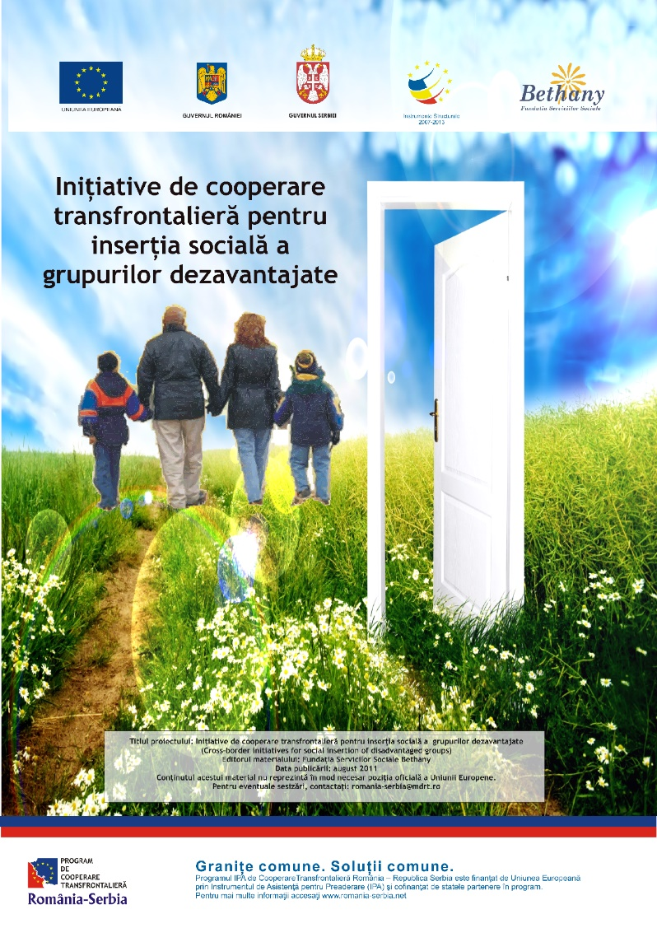

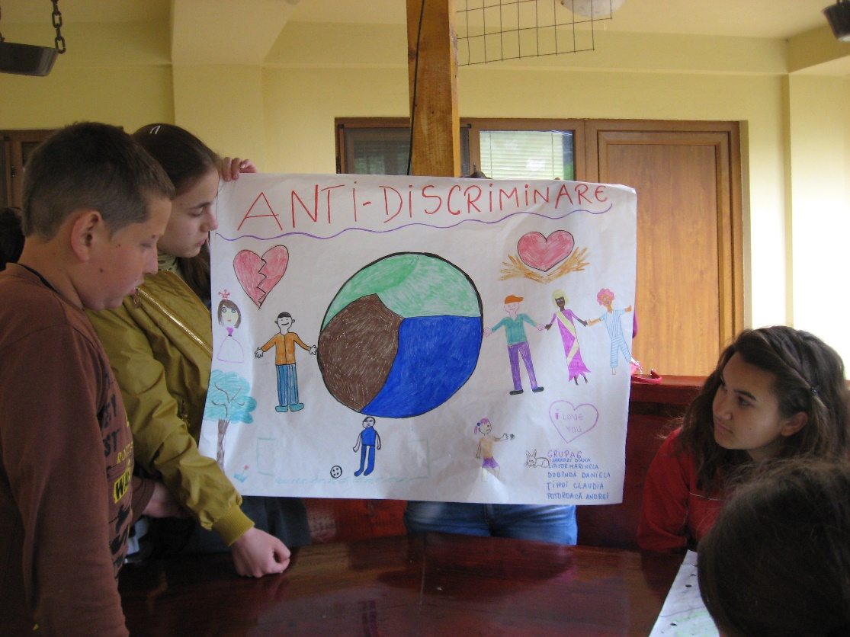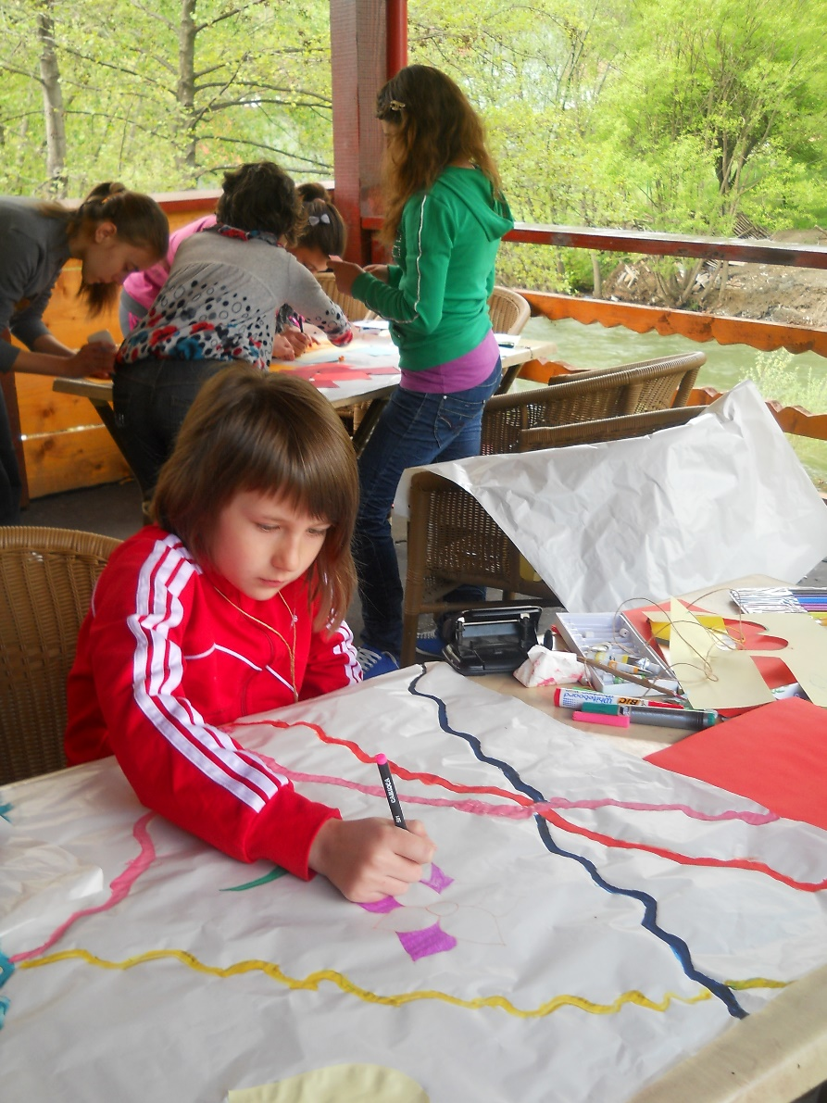
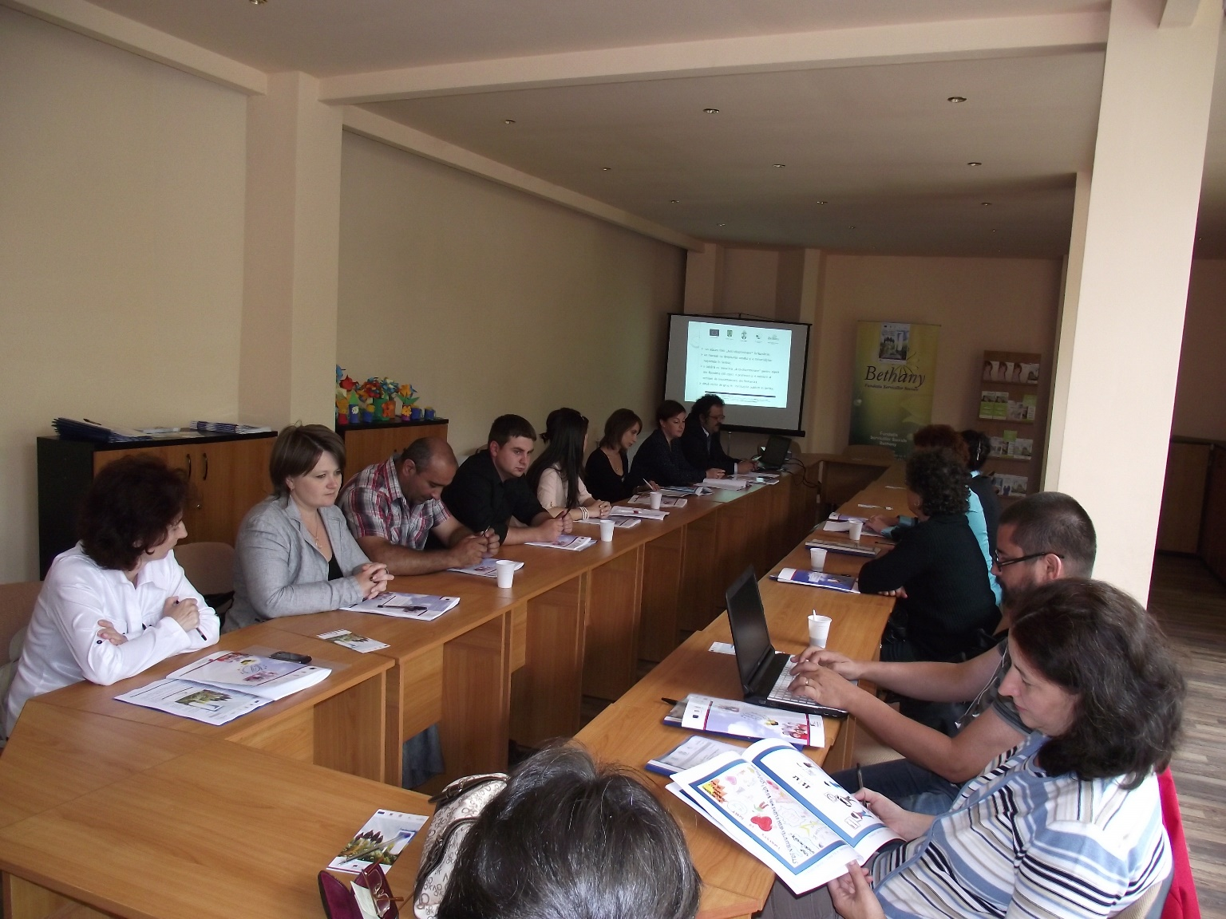

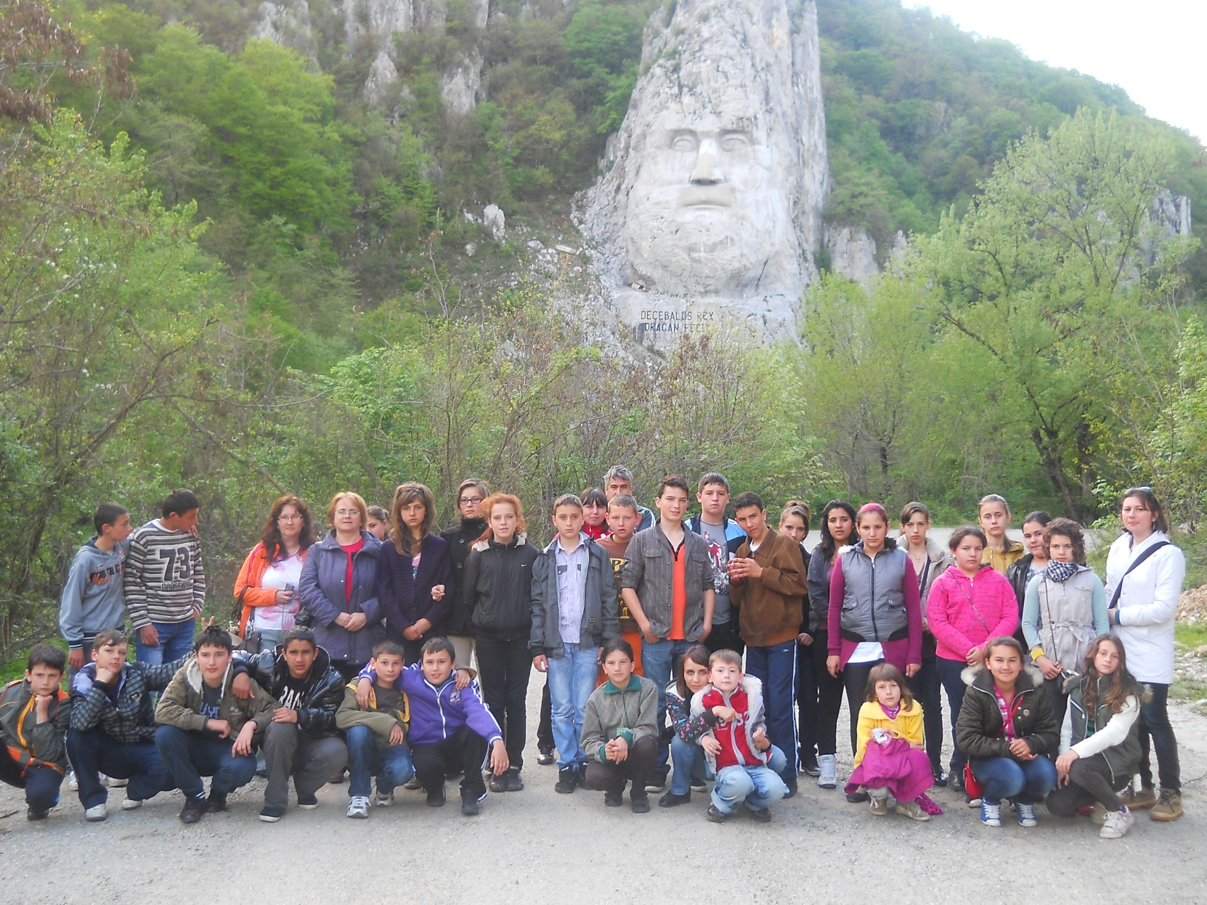

the implementation period (including any extensions) will be filed in, for example 01.01.2015 – 01.01.2017
total funds spent/total funds contracted *100
indicators and level of achievement against targets set

