Project information
CALL FOR PROPOSALS | 1
e-MS Code: | RORS-92
PRIORITY AXIS: | 4 Attractiveness for sustainable tourism
OBJECTIVE: | 4.2 Capacity building initiatives for the improvement of quality and innovation of tourism services and products
PROJECT TITLE: | Cultural connection in purpose of touristic attractiveness strengthening of the Region
ACRONYM: | Culture has no boundaries
DURATION: | 23.12.2017 – 22.06.2019 (18 Months)
Interreg-IPA  FUNDS CONTRACTED: | €426.753,55
TOTAL FUNDS CONTRACTED: | €502.063,00
ABSORPTION RATE (%): | 89,71%
PROJECT OBJECTIVE(S): | To increase the quality of cultural tourism in cross-border area.  To extend the capacities for cultural presentation of the region.  To promote cultural differences and similarities of the neighbouring districts.
SHORT DESCRIPTION OF THE PROJECT: | The Programme area has magnificent potential for tourism. It has a cultural heritage of significance to both communities, including important monuments, sites, traditional events, and manifestations, and they needed to be brought forward. The project represented an excellent opportunity for cross-border partners to promote the region's emerging tourism sector and attract a broader audience in a renewal of interest in their common cultures and historical assets. Emphasising strong cultural and historical links stimulated regional integrity and favoured tourism on both sides of the border. Setting foundations for organising annual cultural events created a network of cultural associations and institutions from both sides. The organisation of multicultural festivals provided the necessary boost to the local associations and all interested entities in the tourism sector.
DEGREE OF ACHIEVEMENT OF INDICATORS: | 20 Cross border cooperation structures/ initiatives supported in the field of tourism. 120%
ACHIEVED RESULTS: | 4 new cultural festivals were organized.  2 new exhibitions of handicrafts, traditional food and honey products were organized.  1 cultural-sports manifestation was organized.  1 webpage dedicated to the project was added: https://culturehasnoborders.pozarevac.rs/

Partnership information
 |  | COUNTRY | COUNTY/DISTRICT | BUDGET(EURO) | CONTACT DETAILS
LEAD PARTNER: | City of Pozarevac | SERBIA | Branicevski | 273.082,00 | 2 Drinska, 12000, Pozarevac  dtufegdzic@pozarevac.rs
PARTNER 2: | Municipality of Anina | ROMANIA | Timis | 228.981,00 | 49 Sfanta Varvara, 325100, Anina  inteu.anina@yahoo.com

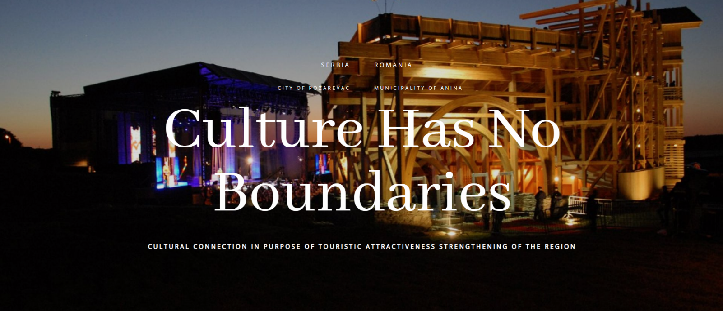
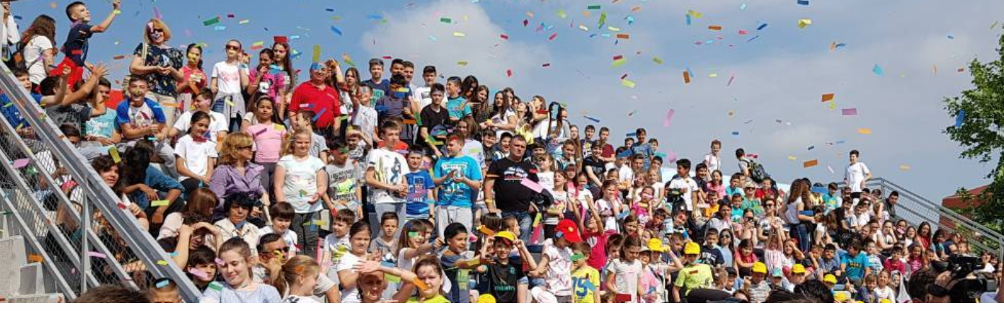

the implementation period (including extensions)
total funds spent/total funds contracted *100
indicators and level of achievement against targets set

