Project information
CALL FOR PROPOSALS | 1
e-MS Code: | RORS-9
PRIORITY AXIS: | 1 Employment promotion and basic services strengthening for an inclusive growth
OBJECTIVE: | 1.2 Health and social infrastructure
PROJECT TITLE: | Improved health care in neurology and psychiatry – longer life
ACRONYM: | IHC
DURATION: | 24.05.2017 – 23.05.2019 (24 Months)
Interreg-IPA  FUNDS CONTRACTED: | €1.384.713,75
TOTAL FUNDS CONTRACTED: | €1.629.075,00
ABSORBTION RATE (%): | 99,12%
PROJECT OBJECTIVE(S): | Creating conditions for timely preventive action in situations of psychiatric and neurological diseases that cause death and / or long-term incapacity for work in the border region Romania – Serbia.  Providing quality Health Care through revitalization and equipping of Hospital facilities in the border region.  Establishing continuous cooperation among Health Care institutions in the border region.
SHORT DESCRIPTION OF THE PROJECT: | Atherosclerosis as a leading cause of Stroke, and Stroke as a one of the most common causes of death and work incapacity, were recognized by the EU health bodies. Several protocols, strategies and projects initiated and financed by the EU Commission and other EU bodies, prove the necessity of joint efforts on the successful diagnostic, treatment and above all prevention of these neurological diseases.  At the same time, initiatives for introducing cross-border health care were present in EU since the late 90ties, by the development of a legal framework to enable cross-border care for citizens.  Due to the prevention and timely reaction on Stroke, many lives could be saved, and the ability to work quickly restored. This was the main challenge of this project which was jointly solved by involving experts from both sides of the border.  The main results of the project were the purchasing and utilization of the necessary equipment in all three partner institutions, as well as the development of scientific documents, new protocols and techniques for reliable, non-invasive and inexpensive diagnosis that could be included in a battery of tests for the early screening of vascular cognitive impairment, the prevention, especially in rural areas, by using the Mobile Prevention Diagnostic System, the Cooperation e-health platform supported with newly purchased equipment.  The cross-border project team, composed of neurology and psychiatry experts from both countries were involved in all stages of the project, backed by a well-equipped laboratory of cervical-cerebral Doppler ultrasonography. Cervical and cerebral echo-Doppler evaluations were performed. The team used advanced equipment (brain CT, brain MRI) allowing the thorough investigation of ischemic stroke patients. This equipment was selected in order to ensure the improvement of the team`s performance in the cervical and cerebral Doppler ultrasonography field.
DEGREE OF ACHIEVEMENT OF INDICATORS: | 18.028 Citizens involved in project activities in social health care services – 150%  4 Investments in health care and social services infrastructure – 100%  303.994,00 Population covered by improved health services- 136%  312.192,00 Number of participants in projects promoting gender equality, equal opportunities and social inclusion across borders – 147%
RESULTS ACHIEVED: | Revitalization of the facilities of Neurological Department of “Sveti Luka” Hospital from Smederevo  Three health care institutions equipped with:  1 CT scanner  1 Set of material for isolation  1 Passenger car  1 Additional CT scanner workstation  2 sets of MPD equipment  3 Ultrasound system sets  1 EMG  1 EEG  3 sets of IT equipment  12 Round table implemented in Timisoara, Vrsac and Smederevo  Printed 500 copies of the book “Vascular cognitive impairment”  1 Cooperation e-health platform  1300 mobile team’s visits  6 scientific articles published and 5 protocols signed

Promo video about the project: https://www.youtube.com/watch?v=WzKAIo6llCo&fbclid=IwAR1j5vutEy4I5RH8pzLlXWHP1HFb3CiC6Cnr9PnjAQrVCrWL2vxdoTLdZHM

Partnership information
 |  | COUNTRY | COUNTY/DISTRICT | BUDGET(EURO) | CONTACT DETAILS
LEAD PARTNER: | Special Hospital for Psychiatric Diseases “Dr Slavoljub Bakalović”, | Serbia | South Banat | 650.265,00 | Podvršanska no.13,  26300 Vršac  tel. +381 13 833 225  mail: npbvrsac@gmail.com
PARTNER 2: | “Victor Babes” University of Medicine and Pharmacy Timisoara | Romania | Timis | 238.035,00 | 2A Eftimie Murgu Square, 300041, Timisoara  Tel: +40 256 293 389  E-mail: rectorat@umft.ro
PARTNER 3: | General Hospital “Sveti Luka” Smederevo | Serbia | Podunavski | 740.775,00 | 51 Kneza Mihajla, 11300 Smederevo  Tel: 0038163304602  E-mail: nedadjordjevic66@yahoo.com

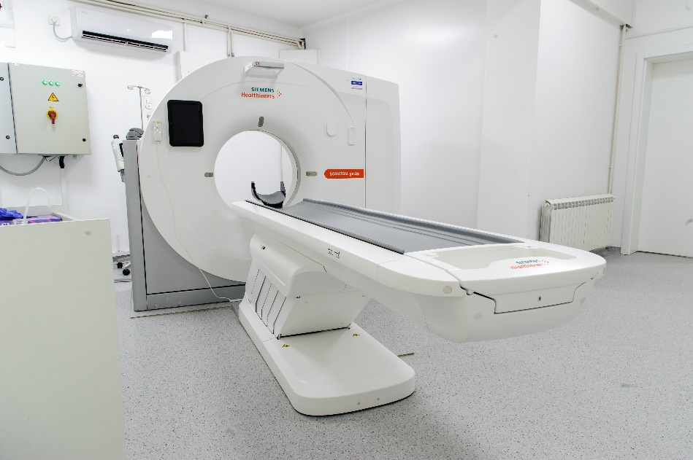
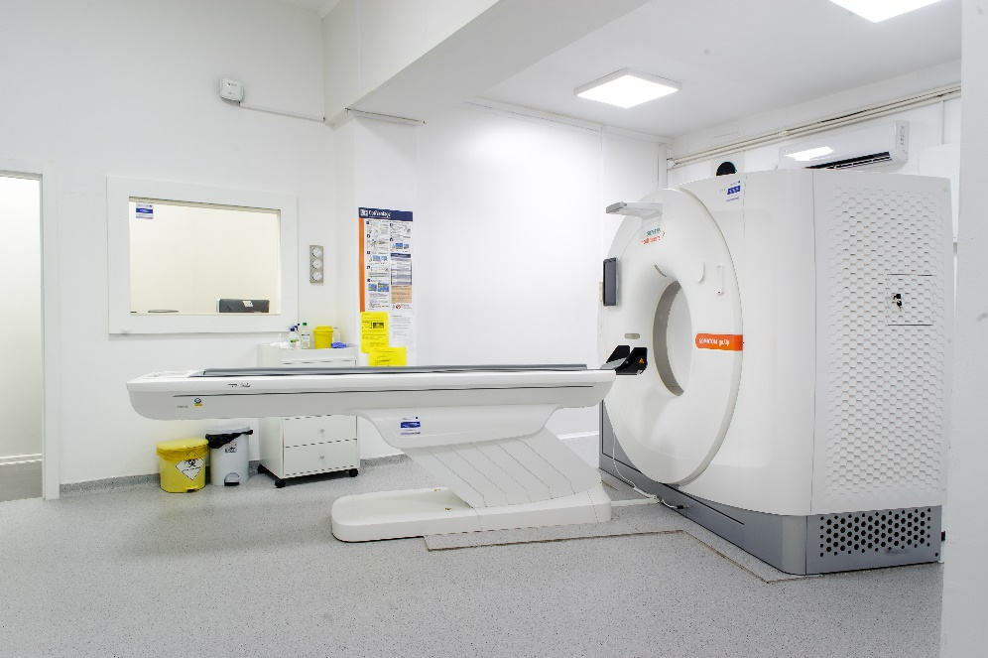

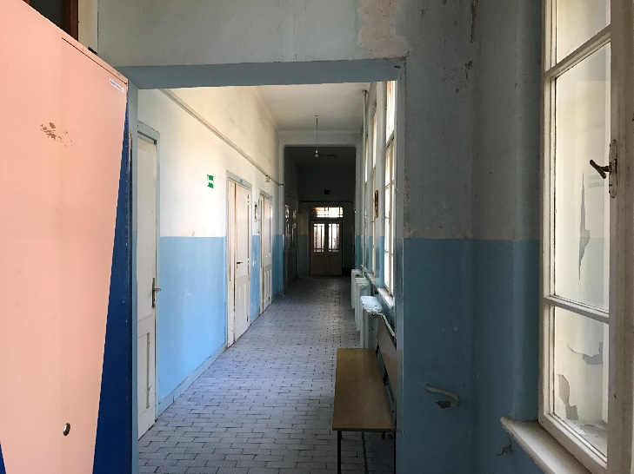
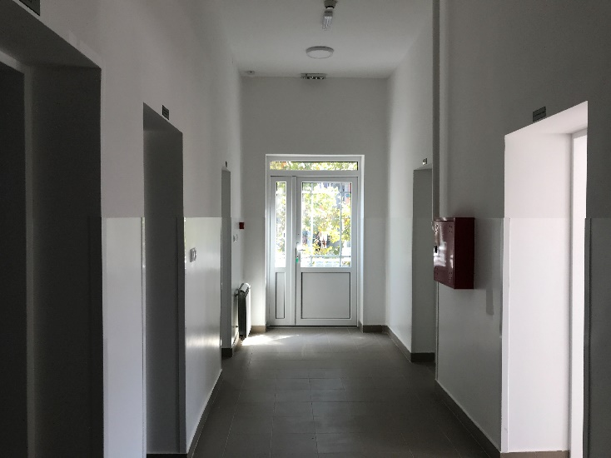
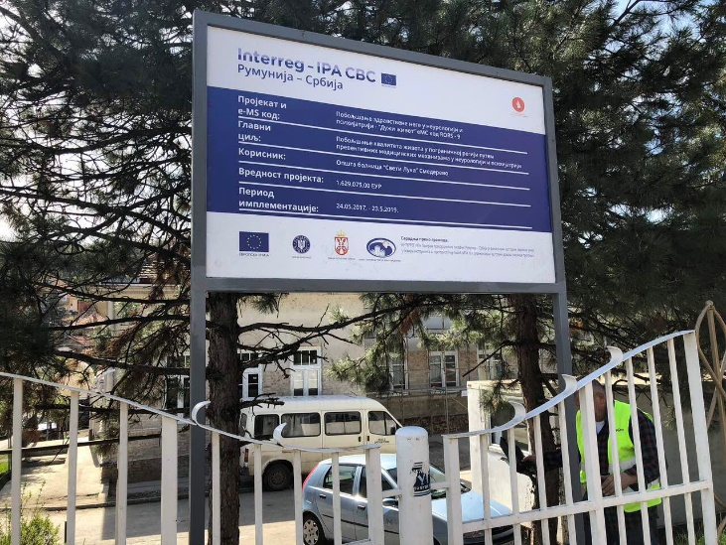
Before
After

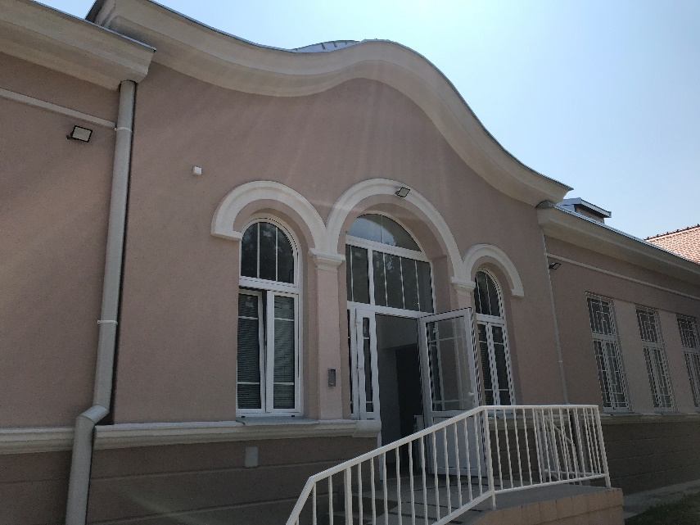
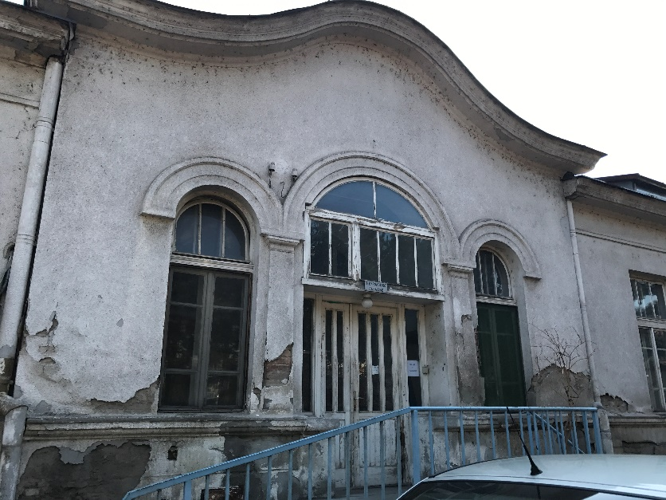
After
Before

the implementation period (including extensions)
total funds spent/total funds contracted *100
indicators and level of achievement against targets set

