Project information
CALL FOR PROPOSALS | 1
e-MS Code: | RORS-5
PRIORITY AXIS: | 1 Employment promotion and basic services strengthening for an inclusive growth
OBJECTIVE: | 1.1 Employment and labour mobility
PROJECT TITLE: | Labour Mobility Network in the Cross-border Area
ACRONYM: | LaborNet
DURATION: | 16.05.2017 – 15.08.2018 (15 Months)
Interreg-IPA  FUNDS CONTRACTED: | €145.555,28
TOTAL FUNDS CONTRACTED: | €171.241,52
ABSORBTION RATE (%): | 84,31 %
PROJECT OBJECTIVE(S): | Development and implementation of language learning for unemployed persons, at least half from endangered groups for whom it is harder to find employment.  Promotion of joint initiatives and cooperation between institutions in the border area.  Creation of info-points in the main centres (Timisoara, Kikinda) which will provide information about job opportunities.
SHORT DESCRIPTION OF THE PROJECT: | The strategic goal of the project was to achieve, on the basis of joint and common cross-border actions by Romanian and Serbian stakeholders, an innovative, more balanced and sustainable socio-economic development of the Romanian-Serbian cross-border area - by increasing the competitiveness of the economy in the cross-border area, providing support for better preparedness for people to find new jobs in the cross-border area - support for economic diversification, with contribution to labour and employers` migrations in the project target area. The level of acquired education and skills of the unemployed is still one of the factors that contribute to long-term unemployment. The chances for the unemployed to find employment depend on significant investments into skills that are relevant on the market.  Cross-border-language-knowing manpower needs were expressed, although language knowledge of unemployed persons in the project target area rarely includes both - Romanian and Serbian. The idea about the need of common Romanian/Serbian language knowledges, in the aim of efficient job-seeking and employment in the cross-border area, was based on expressed needs, when employers from Timis County and western Romania were seeking workers in Serbia, in the cross-border area. Searched labour profiles were construction workers - electricians, plumbers, engineers; IT technicians; etc. With foreign languages knowledge (Serbian, Romanian, English, etc.), knowledge of Romanian/Serbian labour market and labour law regulations, with centralized approach (using Internet technologies & services) to labour economy factors in the border area, unemployed persons gained knowledge, skills and tools for job seeking and applying, thus contributing to labour and employers migrations and overall economy competitiveness in the project`s target area.
DEGREE OF ACHIEVEMENT OF INDICATORS: | 6 cross-border cooperation structures supported in the field of labour market - 100%  60 disadvantaged persons involved in projects activities – 100%  326 participants in projects` activities promoting gender equality, equal opportunities and social inclusion across borders – 100%
RESULTS ACHIEVED: | 2 Labour-fair events.  2 Info-points creations.  200 participants at Info-classes in high schools.  60 participants at Info trainings for unemployed persons.  60 participants at training for Romanian language.

Partnership information
 |  | COUNTRY | COUNTY/DISTRICT | BUDGET(EURO) | CONTACT DETAILS
LEAD PARTNER: | Regional Chamber of Commerce and Industry Kikinda | Serbia | Northern Banat | 71.599,50 | 48 Trg srpskih dobrovoljaca, Kikinda, 23300, Serbia  tibor.horvat@pks.rs
PARTNER 2: | Timis Chamber of Commerce, Industry and Agriculture | Romania | Timis | 81.010,65 | 3 Piata Victoriei, 300030, Timisoara, Romania  office@cciat.ro
PARTNER 3: | City of Kikinda | Serbia | Northern Banat | 18.631,37 | 12 Trg srpskih dobrovoljaca, Kikinda, 23300, Serbia  sasa.tanackov@kikinda.org.rs

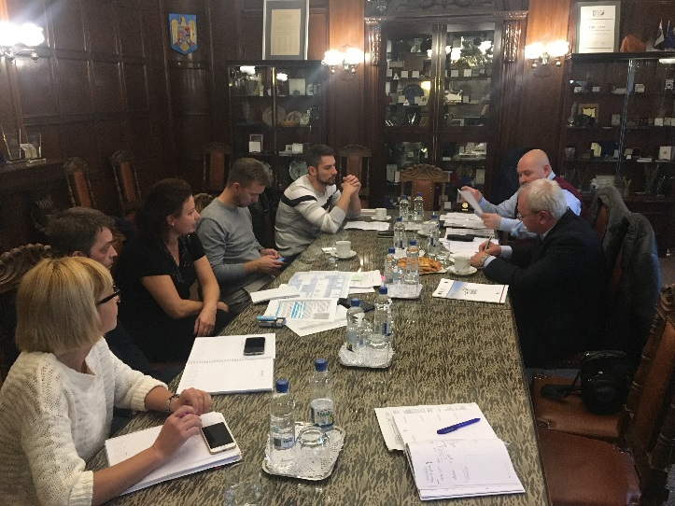
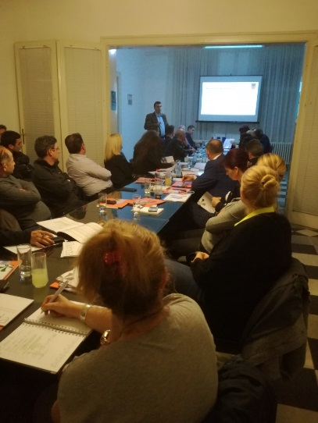
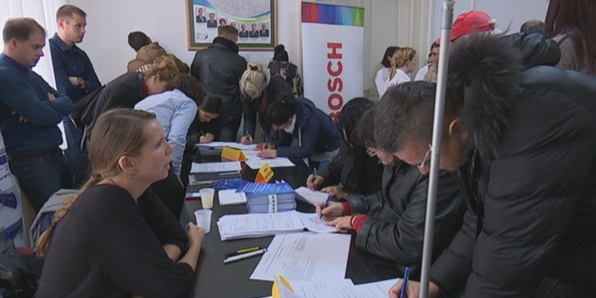

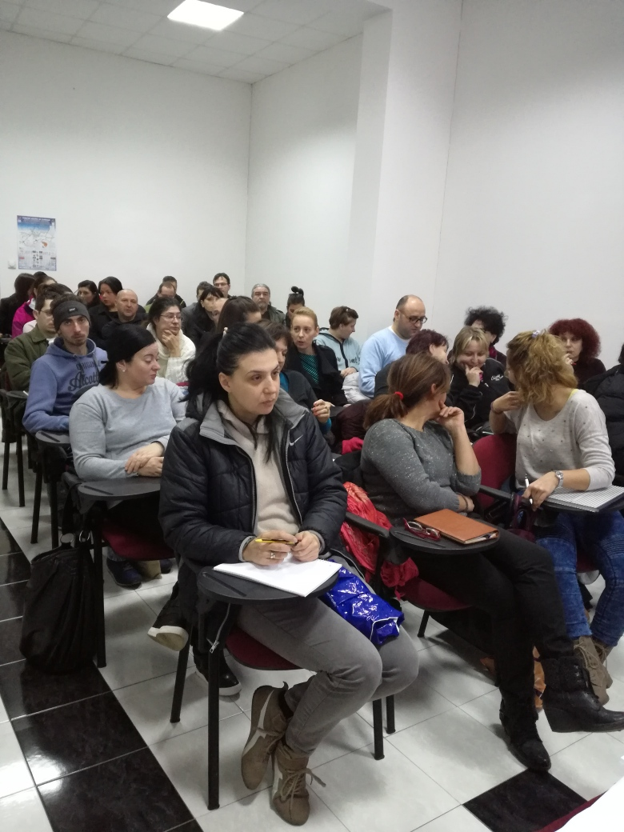
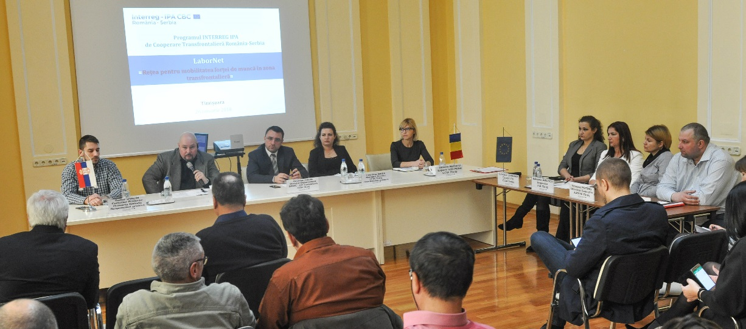

the implementation period (including extensions)
total funds spent/total funds contracted *100
indicators and level of achievement against targets set

