Project information
CALL FOR PROPOSALS | 2
e-MS Code: | RORS-498
PRIORITY AXIS: | 1 Employment promotion and services for an inclusive growth
OBJECTIVE: | 1.2 Health and social infrastructure
PROJECT TITLE: | Improvement of the Neoplazic pathology management through the development and implementation of cross border medical excellence center
ACRONYM: | NEO-PAT-MAN
DURATION: | 09.07.2019 – 08.06.2022 (35 Months)
Interreg-IPA  FUNDS CONTRACTED: | €761.881,73
TOTAL FUNDS CONTRACTED: | €896.331,45
ABSORPTION RATE (%): | 98,98%
PROJECT OBJECTIVE(S): | Citizens involved in project activities in cultural, social healthcare services.  Cross border cooperation structures supported in the field of labour market.  Investment in health care and social services infrastructure.
SHORT DESCRIPTION OF THE PROJECT: | The project developed and implemented centres of excellence in complementary and synergistic medicine in Timisoara and Požarevac to develop the infrastructure and human resources at the level of performance and competitiveness of EU hospitals. Considering the high incidence and mortality of colorectal and breast cancers in the cross-border area, adopting modern screening tests that allow genetic risk analysis was necessary. To assess the evolution/prognosis and the administration of the high precision-oriented treatment in breast cancer, the anatomopathology services of the modernised specialised units benefited from the respective endowment analysis by immnunohistochemical techniques. A molecular gene prediction test is recommended in patients where anatomopathogenic diagnosis shows a limiting situation where it is not clear whether chemotherapy is or is not indicated.  The activities of the project included enrolling patients in the study and DNA isolation from blood, tissue and paraffin-embedded samples (Romanian partner trained personnel from Serbia to isolate DNA manually). Samples processed in Serbia throughout the project were kept cold and were sent monthly for analysis in Romania.  Genetic diagnostic tests were performed for patients: for breast cancer, the following genes were analysed: BRCA1/ BRCA2 in all patients enrolled in the study, and in case of inconclusive immunohistochemical diagnosis (performed by the RS partner), the genes Her / Neu, ER, PR were analysed.  The following genes were analysed by sequencing for colorectal cancers: KRAS, BRAF, NRAS and PTEN. Also, Activity 3.4 will screen for genes of interest BRCA1 / BRCA2, KRAS, BRAF, NRAS and PTEN.  Acquisition of the equipment leads to improved population access from the cross-border area to correct and refined diagnosis and to the administration of optimal medication. Setting a precision treatment personalised to each patient's molecular status reduced the costs of cross-border healthcare providers in the long run.  A total of 700 patients were enrolled in the study, of which more than 50% were women, about 50% of all patients had low incomes, and approximately 25% were Rroma population.
ACHIEVEMENT OF INDICATORS: | 774 Clinically and paraclinical diagnosed Patients  707 Patient analysis bulletin  6 Work protocols  10 Courses materials  1 Molecular analysis guide in medical diagnosis  6 List of beneficiary volunteers  50 Workshop for student  209 Courses for doctors  774 Biological samples collected  1 Health facility equipped in Timisoara, Romania  1 Health facility equipped in Požarevac, Republic of Serbia  860 Leaflets/brochures distributed  288 Trained students
RESULTS ACHIEVED: | 1504 Citizens involved in project activities in cultural, social health care services – 123.99%  259 Cross border cooperation structures supported in the field of labour market – 323.75%  776 Investment in health care and social services infrastructure – 110.55%  860 Joint actions targeting vulnerable groups (youth, women, disabled, ethnic minorities) established for the prevention of early school leaving, for cultural inclusion – 215.00%  288 Number of participants in projects promoting gender equality, equal opportunities and social inclusion across borders – 144.00%

Partnership information
 |  | COUNTRY | COUNTY/DISTRICT | BUDGET(EURO) | CONTACT DETAILS
LEAD PARTNER: | County Emergency Hospital „Pius Brinzeu” Timisoara | ROMANIA | Timis | 487.797,45 | Bd. Liviu Rebreanu no. 156, 300723, Timisoara  judetean@hosptm.ro
PARTNER 2: | General Hospital Požarevac | SERBIA | Branicevski | 408.534,00 | 135 Ratstva Jedinstva, 12000 Požarevac  bolpo@ptt.rs

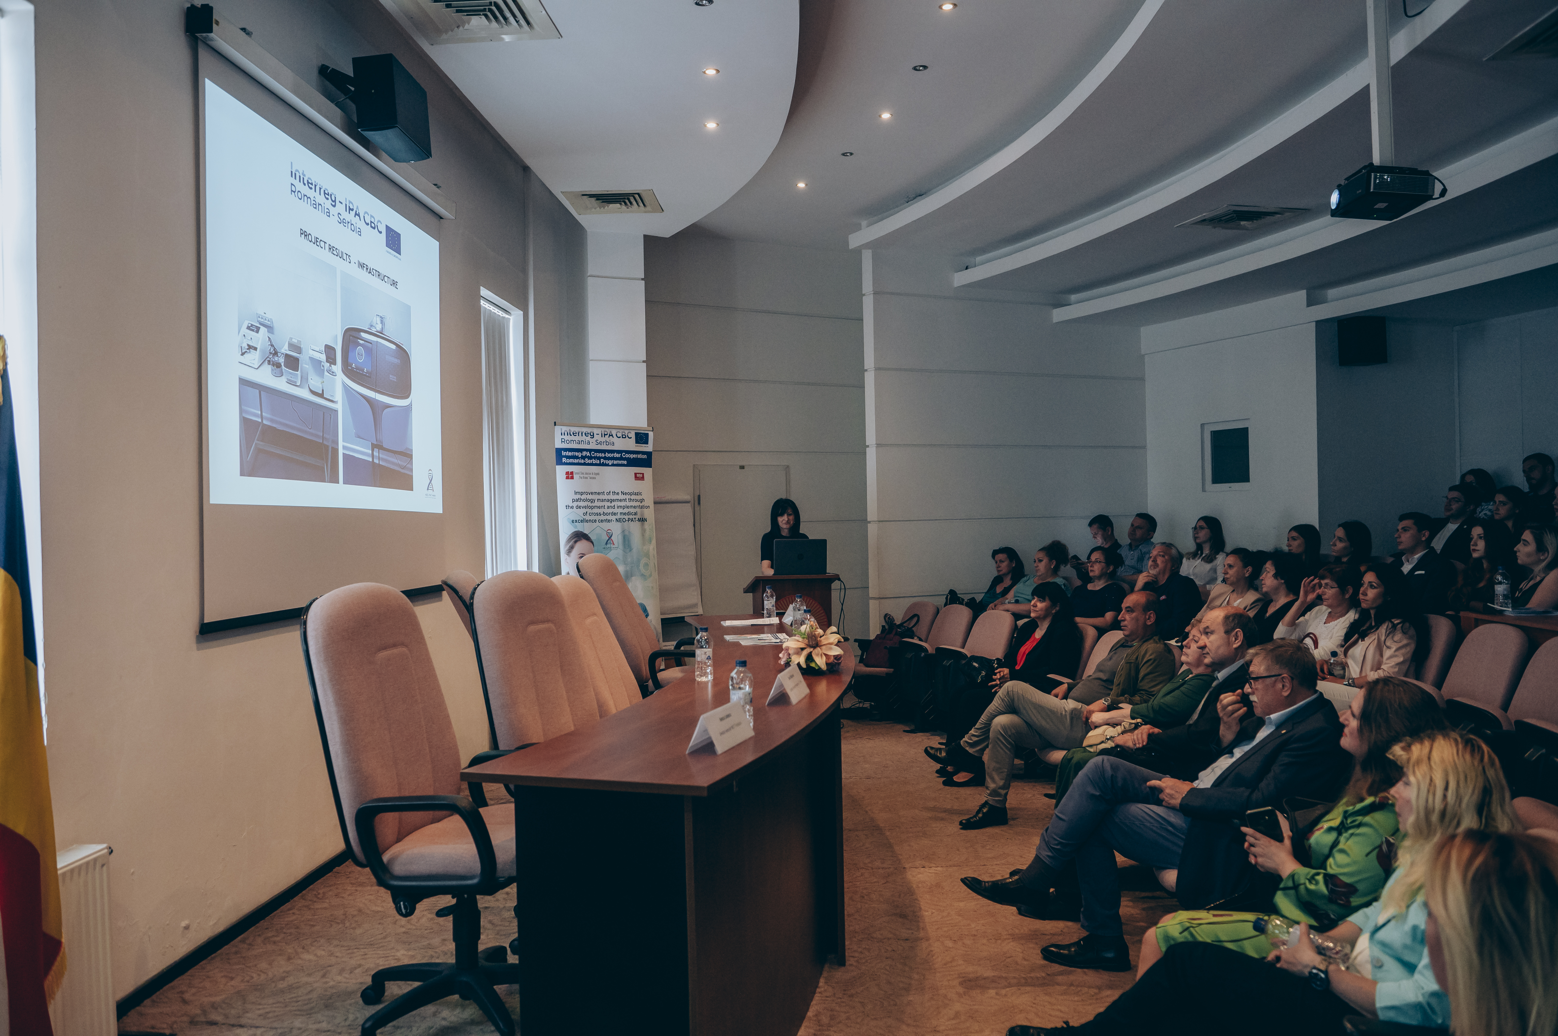
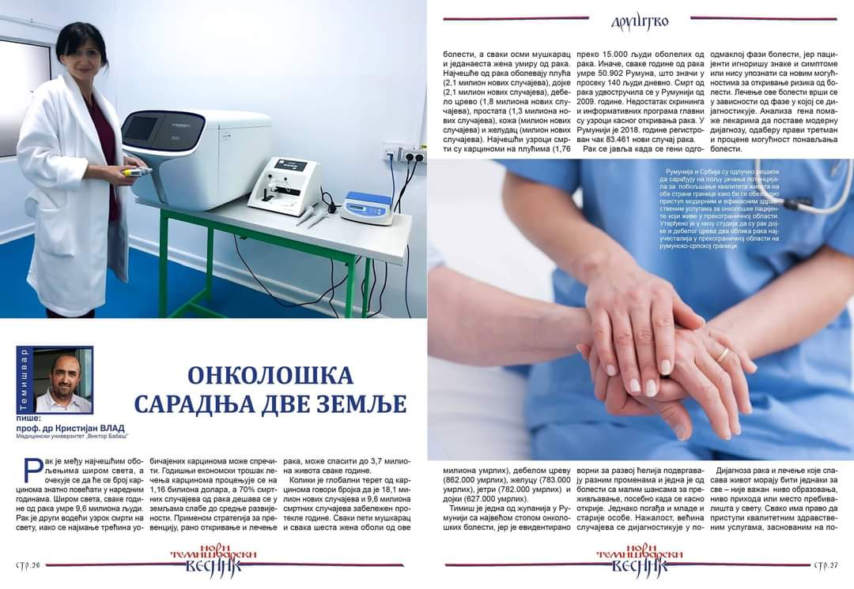
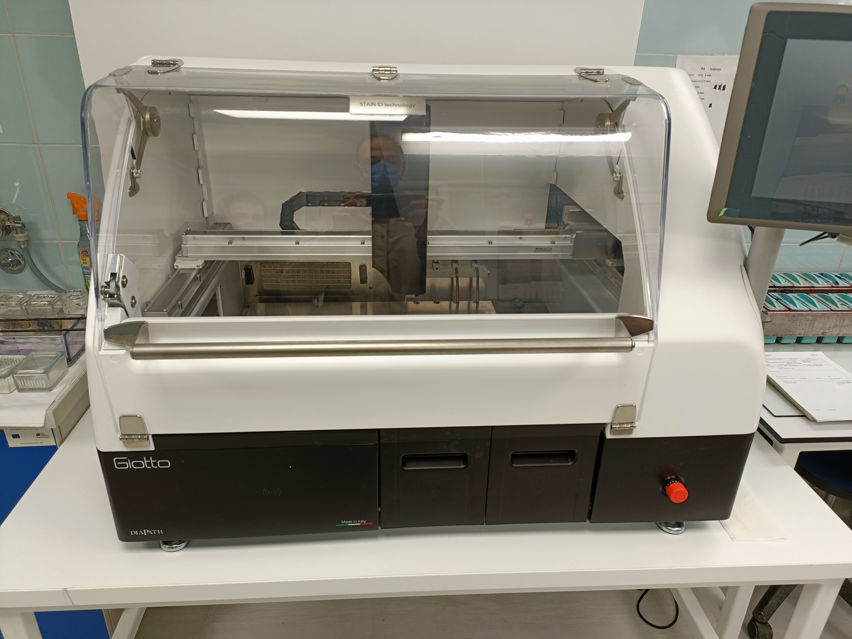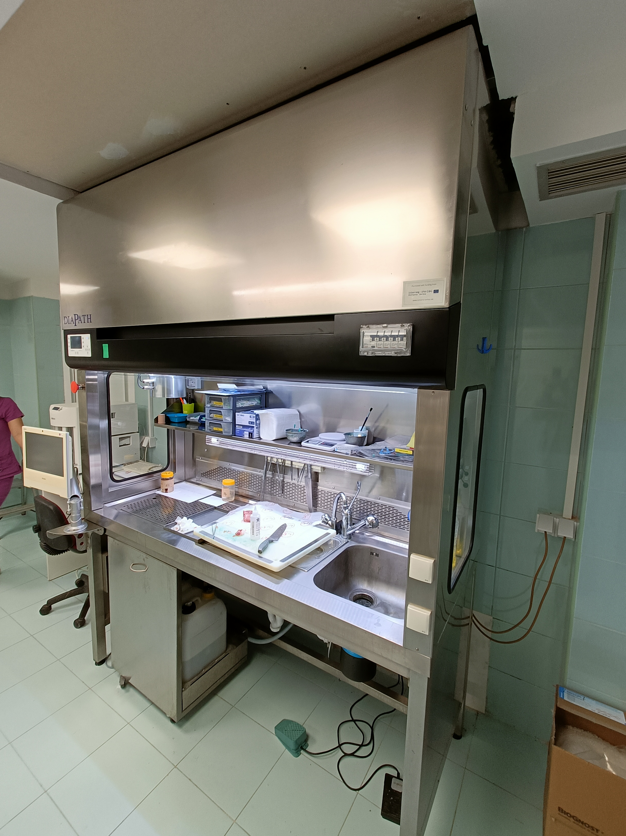

the implementation period (including extensions)
total funds spent/total funds contracted *100

