Project information
CALL FOR PROPOSALS | 2
e-MS Code: | RORS-481
PRIORITY AXIS: | 3 Sustainable mobility and accessibility
OBJECTIVE: | 3.1 Mobility and transport infrastructure and services
PROJECT TITLE: | Improvement of Banat Connectivity 2
ACRONYM: | IBC2
DURATION: | 01.08.2019 – 31.07.2021 (24 months)
Interreg-IPA  FUNDS CONTRACTED: | €972.418,78
TOTAL FUNDS CONTRACTED: | €1.144 022,12
ABSORPTION RATE (%): | 98,39
PROJECT OBJECTIVE(S): | The project's overall objective is the convergence of people, communities, and economic actors of the border area to create a sound basis for balanced economic and social development, assuring optimal development opportunities for both countries.  This cross-border region has recognized the importance of road networks to achieve social and economic cohesion, even regional development and high-quality mobility service.  We are strengthening economic ties between border regions to intensify the pace of sustainable economic development based on the shared social and cultural coherence between people and communities.  We are raising awareness of preserving the environment by using renewable energy sources for sustainable community development.
SHORT DESCRIPTION OF THE PROJECT: | Road networks that do not meet modern standards affect the connections between places and regions and their economic development. The roads are the main channel for the transportation of cargo and passengers. Moreover, they play an essential role in improving the socio-economic standards of the region. The project partners identified the need to improve the road network in the border region, especially at and near border crossing points like Nakovo-Lunca, as a solution for social and economic development.  In the previous joint project, IBC, with the same partners, we did the technical documentation to reconstruct roads leading to the border crossings from both sides. The current project was a logical continuation aiming to put the technical documentation to good use. Therefore, we rehabilitated roads, we installed solar illumination and we continued to prepare technical documentation for future improvements in the field of transport and mobility infrastructure in the area.
DEGREE OF ACHIEVEMENT OF INDICATORS: | 1 study related to the implementation of selected projects or the realisation of actions in the field of transport and mobility infrastructure.  3670 investments in transport and utilities infrastructure, including improvement, enhancement of existing infrastructure.  1360 participants to information/ training/ awareness raising initiatives in the field of transport and public utilities.  500 joint initiatives on improvements of public transport and intermodal connections.
RESULTS ACHIEVED: | 1 prepared Technical documentation for Rehabilitation of the streets adjacent to the national road 59C in Jimbolia. (100%)  1.590 meters of rehabilitated of the streets adjacent to the national road 59C in Jimbolia. (100%)  1.800 meters of rehabilitated road no. 15 I-B section: Kikinda – Nakovo. (100%)  280 solar illumination installed, with video surveillance. (100%)  25 participants acquired knowledge about the new possibilities for improvement of cross-border economic cooperation at cross-border events. (125%)  64 participants were informed and recognized the initiative for new connections established through the transport sector. (128%)  199 participants were informed through training and strengthening the participation in the transport sector. (166%)  72 participants become familiar with the new possibilities in the field of transport and raising awareness about the importance of the initiative for further joint development. (144%)  1000 participants in events that raised awareness on the importance of preserving the environment through exploring explanations for the basic, frequently used biological and ecological terms, and the terms that are directly related to the issue of preserving the environment. (100%)  500 booklets provided to interested business representatives to provide timely, accurate and key information regarding the conditions of economic launch in Romania and Serbia. (100%)

Partnership information
 |  | COUNTRY | COUNTY/DISTRICT | BUDGET(EURO) | CONTACT DETAILS
LEAD PARTNER: | PE “Roads of Serbia” | Serbia | Northern Banat | 427.793,87 | 282 Kralja Aleksandra bvd, Belgrad, 11000, Serbia  office@putevi-srbije.rs
PARTNER 2: | Municipality of Jimbolia | Romania | Timis | 332.841,75 | 81 T. Vladimirescu street, Jimbolia, 305400, Romania
PARTNER 3: | Municipality of Kikinda | Serbia | Northern Banat | 316.816,50 | 12 Trg srpskih dobrovoljaca street, Kikinda 23300, Serbia
PARTNER 4: | Regional Agency for Socio – Economic Development – Banat Ltd - RDA Banat | Serbia | Northern Banat | 66.570,00 | 1 Čarnojevićeva street, Zrenjanin, 23000, Serbia

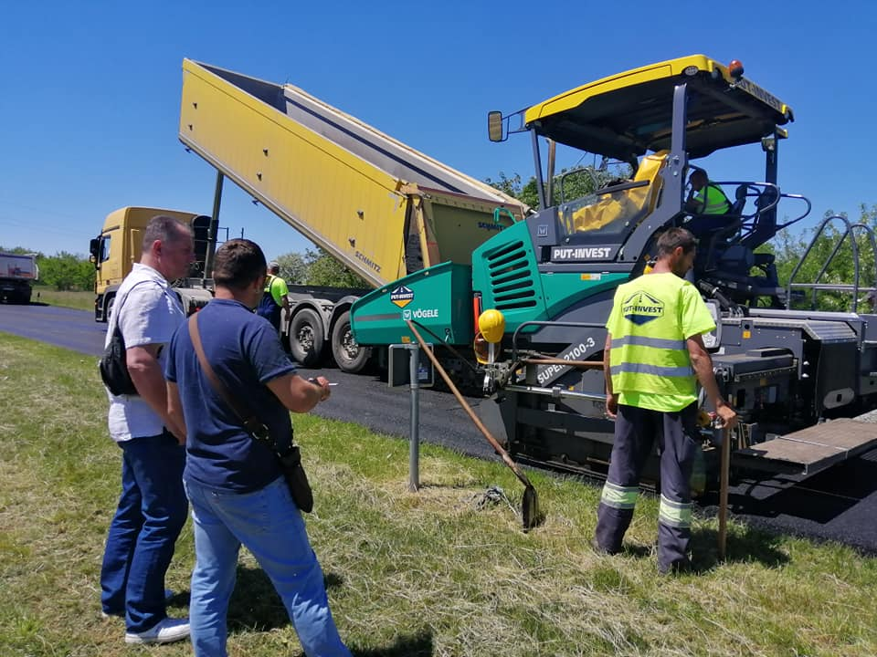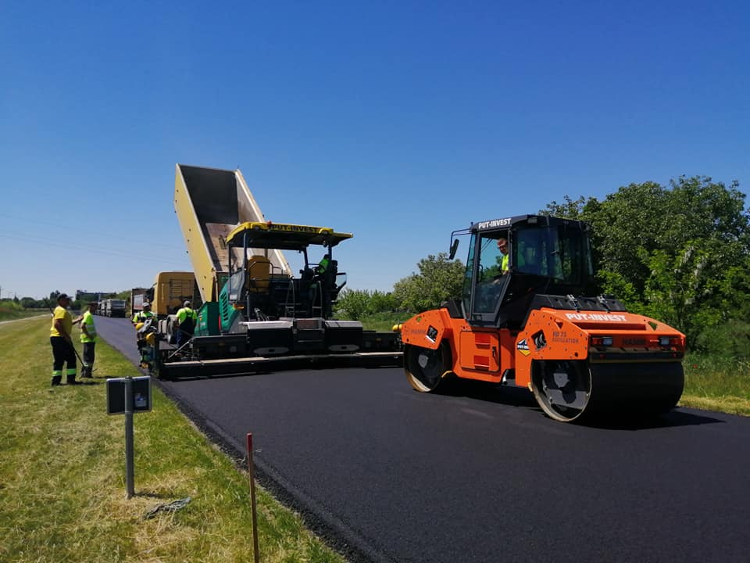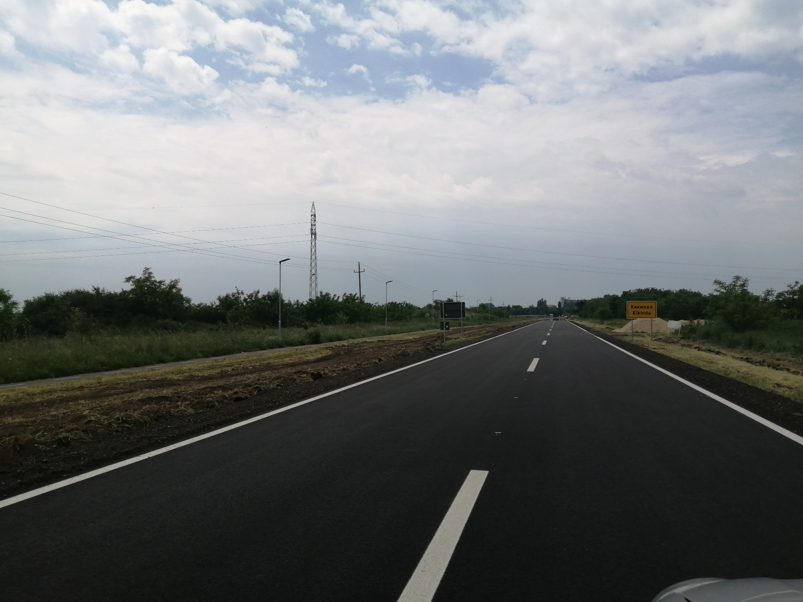
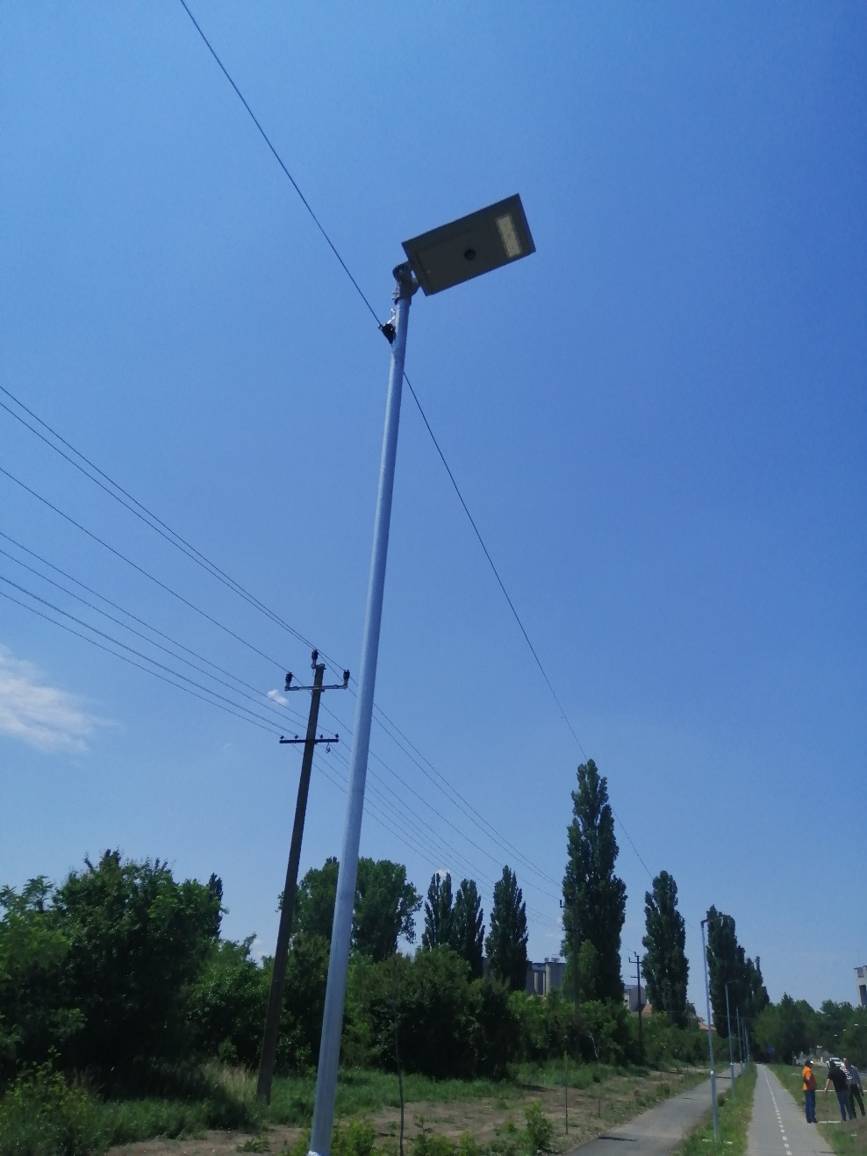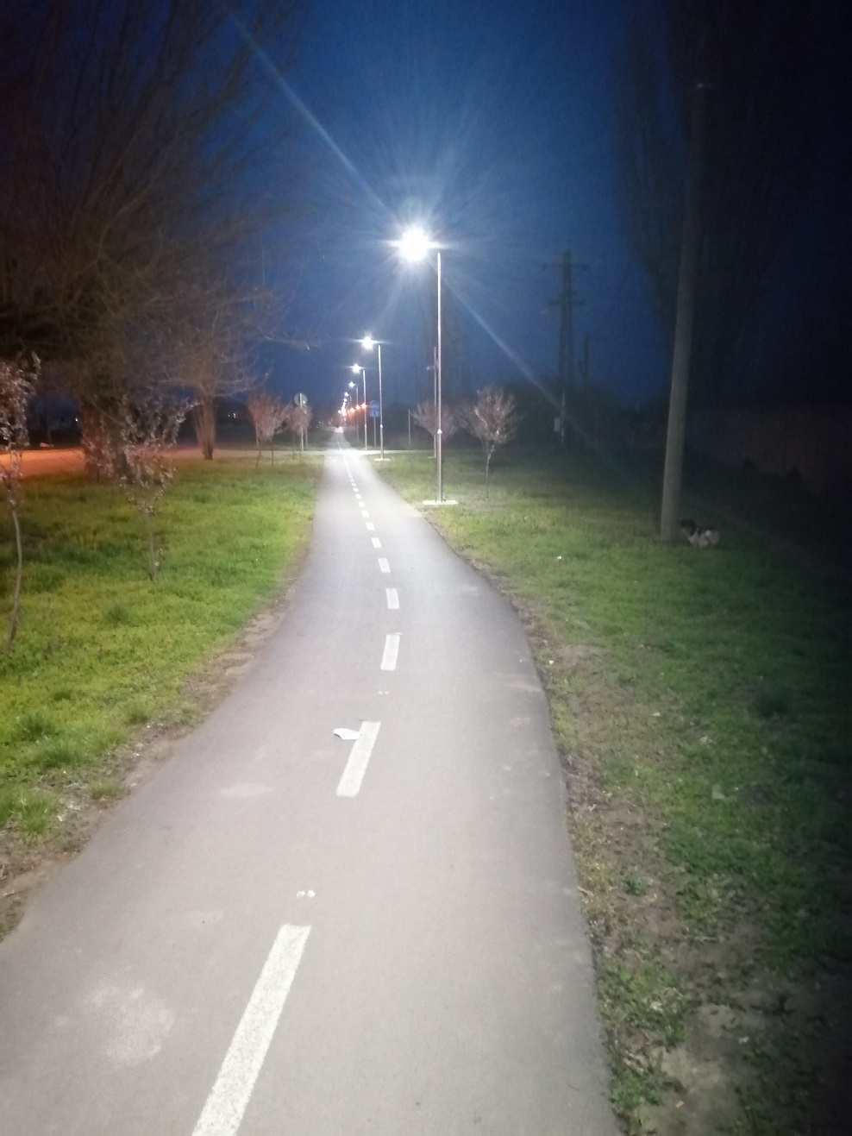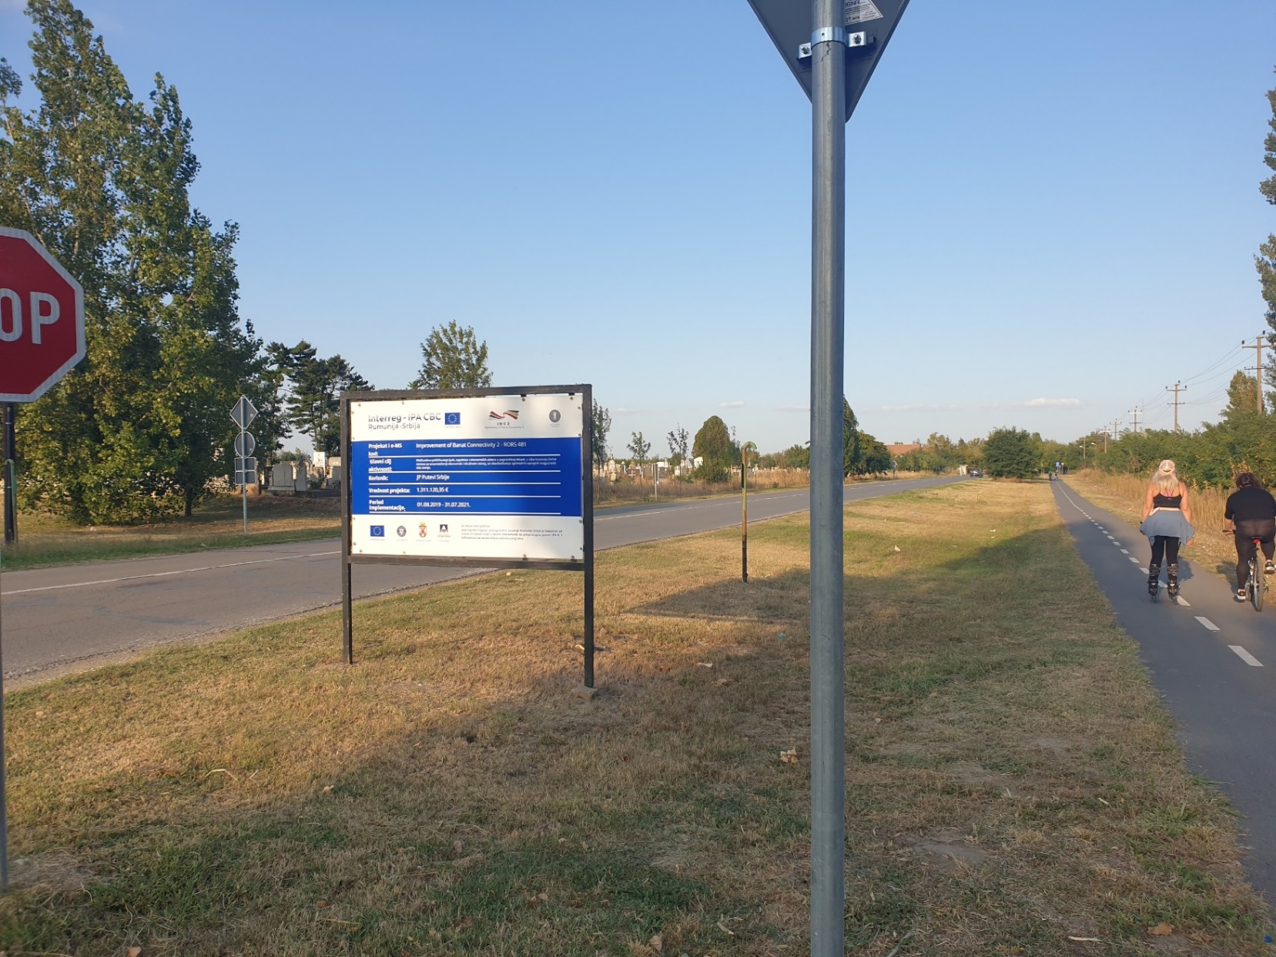

the implementation period (including extensions)
total funds spent/total funds contracted *100
indicators and level of achievement against targets set

