Project information
CALL FOR PROPOSALS | 2
e-MS Code: | RORS-467
PRIORITY AXIS: | 1 Employment promotion and services for an inclusive growth
OBJECTIVE: | 1.2 Health and social infrastructure
PROJECT TITLE: | Medical Infrastructure for the Development of Excellence Surgical Services in the Cross-border Area
ACRONYM: | MEDICARE
DURATION: | 26.07.2019 – 23.02.2023 (42 Months and 29 days, including a suspension of 6 months)
Interreg-IPA  FUNDS CONTRACTED: | € 997.215,42
TOTAL FUNDS CONTRACTED: | € 1.173.194,62
ABSORPTION RATE (%): | 98,20 %
PROJECT OBJECTIVE(S): | - developing infrastructure in healthcare;  - increasing the quality of surgery services in the region by providing access to training courses for the Romanian-Serbian cross-border specialists;  - performing screening procedures for the Romanian-Serbian cross-border population aiming to identify pathologies in the early stages of their development;  - performing a minimum of 100 arthroscopy surgeries,  - increasing the population's medical training level by providing free training courses;  - developing the existing network of specialists in surgery (with already 1600 members) by attracting new members (specialists) and consolidating the current collaborations.
SHORT DESCRIPTION OF THE PROJECT: | The building of the Pius Branzeu Center in Timisoara, Romania, was modernized by constructing one additional floor and reconfiguring the existing floors. Medical university students and also specialists use the facility for training.  Training courses were provided for more than 180 specialists during the implementation period. Beyond the implementation period, the Center will offer training courses for 480 specialists annually.  The number of beneficiaries of screening procedures reached 10.000 persons.  Arthroscopy surgeries were never performed before in Smederevo due to the lack of adequate equipment. During the implementation period, over 100 patients benefited from such surgeries (free of charge).  The number of beneficiaries from the training courses reached over 5.000 persons.  The network of specialists in surgery will serve as a tool for exchanging good practices in the medical field. Apart from the 1600 members that are already members of the Center's network, the project targets a merge with the network of specialists in surgery created through projects RORS - 8 and RORS - 11.
DEGREE OF ACHIEVEMENT OF INDICATORS: | 15.330 Citizens were involved in project activities in cultural, social health care services. (109,70%)  1 Investment in health care and social services infrastructure was performed. (100%)  4.748 Disadvantaged persons were involved in projects activities. (237,40%)
RESULTS ACHIEVED: | 261 Practical training services for medical personnel were performed.(145%)  10.000 Screening services were performed. (100%)  140 High quality surgical services were performed. (140%)  5.000 Medical education services were performed. (127,06%)  63 Practical stages for surgeons were completed. (126%)  1 The "Pius Branzeu" healthcare infrastructure was developed. (100%)  2.000 Screening services were provided. (100%)

Partnership information
 |  | COUNTRY | COUNTY/DISTRICT | BUDGET(EURO) | CONTACT DETAILS
LEAD PARTNER: | "Victor Babes" University of Medicine and Pharmacy Timisoara | ROMÂNIA | Timis | 926.606,23 | 2A Piata Eftimie Murgu, 300041, Timisoara,  rectorat@umft.ro
PARTNER 2: | General Hospital "Sveti Luka" Smederevo | SERBIA | Podunavski | 246.588,39 | 51 Kneza Mihajla, 11300, Smederevo,  nedadjordjevic66@yahoo.com

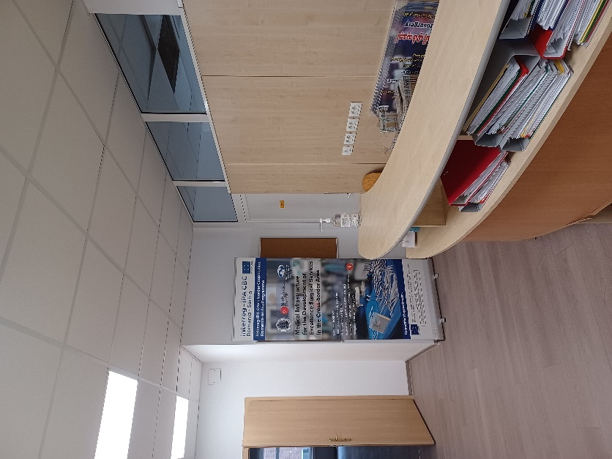
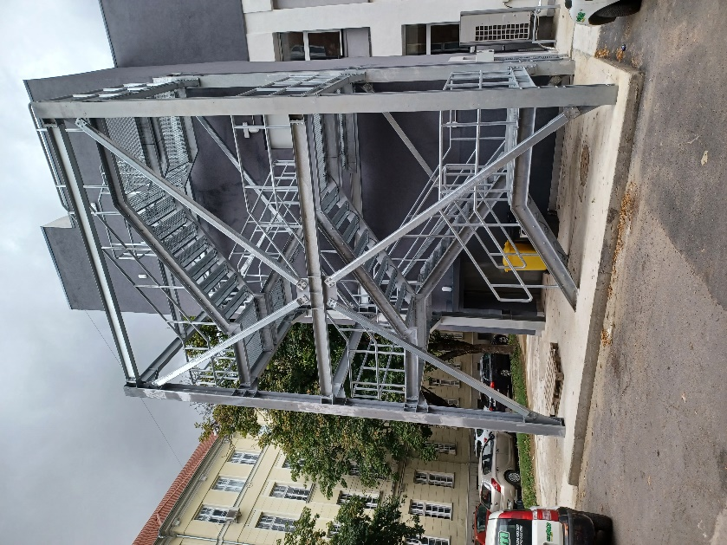
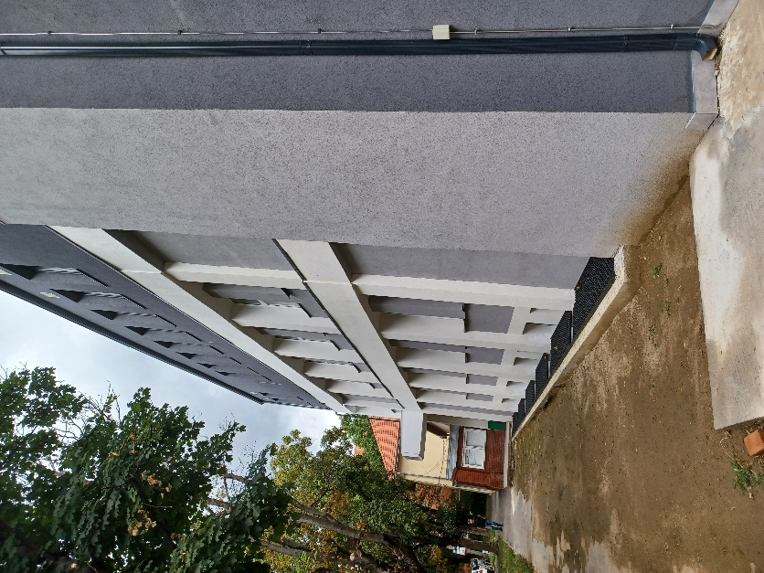

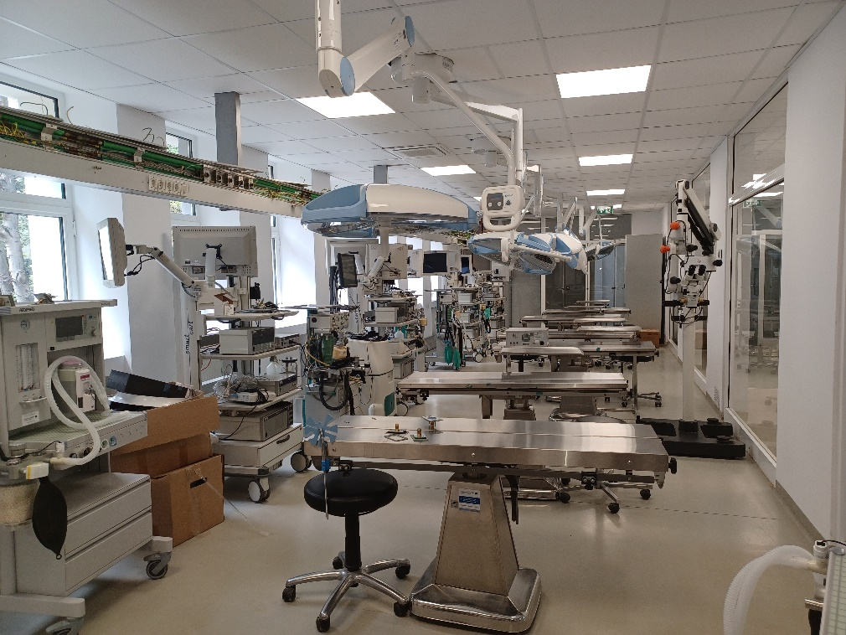
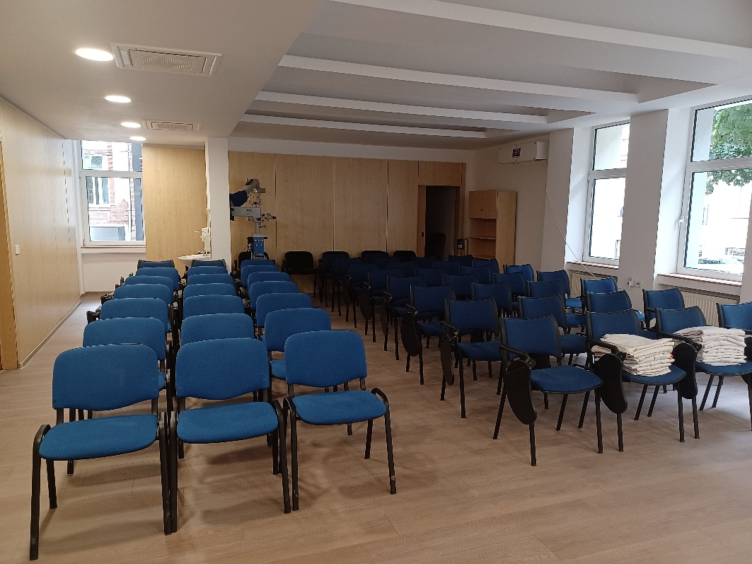
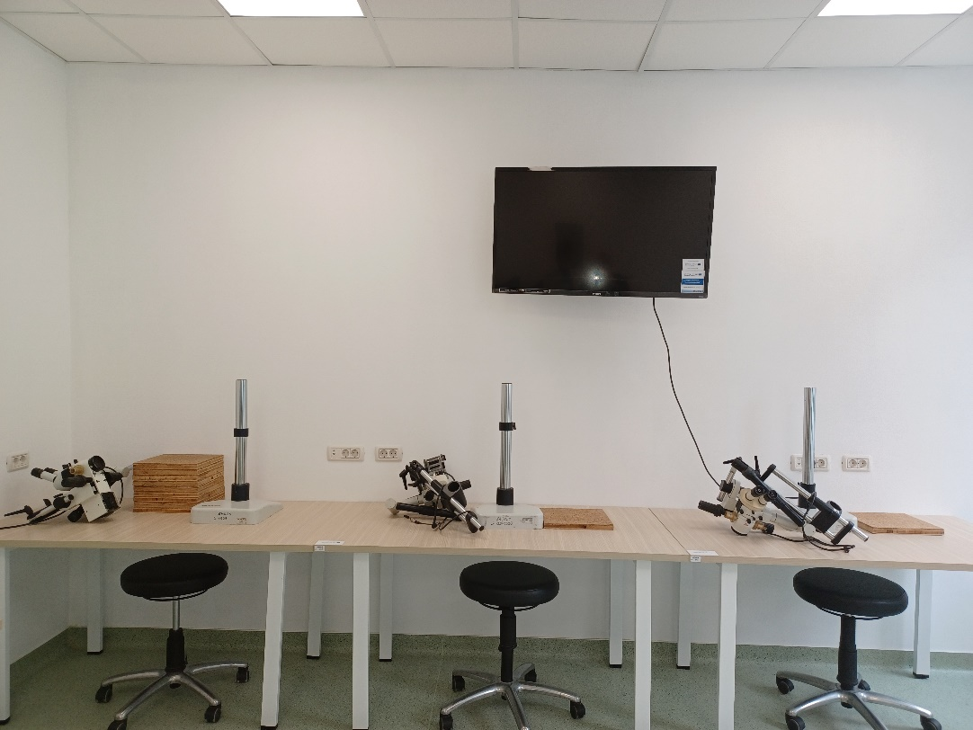

the implementation period (including extensions)
total funds spent/total funds contracted *100

