Project information
CALL FOR PROPOSALS | 2
e-MS Code: | RORS-462
PRIORITY AXIS: | 2 Environmental protection and risk management
OBJECTIVE: | 2.1 Environmental protection and sustainable use of natural resources
PROJECT TITLE: | Academic environmental protection studies on surface water quality in significant cross-border nature reservations Djerdap / Iron Gate national park and Carska Bara special nature reserve, with population awareness raising workshops.
ACRONYM: | AEPS
DURATION: | 21.08.2019 – 13.02.2021 (17 Months 24 Days)
Interreg-IPA  FUNDS CONTRACTED: | €532.932,26
TOTAL FUNDS CONTRACTED: | €626.979,15
ABSORPTION RATE (%): | 86,32 %
PROJECT OBJECTIVE(S): | Evaluation of current environmental situation in the cross border "sister" Danube banks nature reservation Djerdap (Serbia) and national parks Iron Gate (Romania). Surface water quality was evaluated from both countries' Danube and Danube tributaries.  Another objective was to raise the awareness of young generations on both sides of the border on the immediate need to protect the region's remarkable natural heritage and increase local society's awareness of the advantages of sustainable use of natural resources and environmental protection.  We also aimed to develop the research infrastructure of the University Politehnica Timisoara and the Technical Faculty in Bor with state-of-the-art analytical equipment for environmental analysis to increase their research capabilities to assure their goals for the future: significant contribution to the education of the next generation of experts.
SHORT DESCRIPTION OF THE PROJECT: | The most important challenge of the project was to raise the awareness of society on the need for natural heritage protection and conservation. The scientific state-of-the-art tools for surface water quality monitoring in cross-border areas were bought and they were put to good use by the future scientists through case studies and onsite measurements.
DEGREE OF ACHIEVEMENT OF INDICATORS: | Infrastructure, equipment built/ installed/ modernized in the field of cross border services for environmental protection. 100%  Participants to project initiatives and events for information and awareness rising. 142,70%  Studies in the field of environmental protection and emergency management. (technical and scientific studies, researches in the relevant fields). 100%
RESULTS ACHIEVED: | 2 Equipment acquisitions performed. 100%  2000 participants in awareness raising campaigns. 142,70%  3 Studies on surface water quality in cross-border protected areas. 100%
Partnership information
 |  | COUNTRY | COUNTY/DISTRICT | BUDGET(EURO) | CONTACT DETAILS
LEAD PARTNER: | University Politehnica Timisoara | Romania | Timis | 299.250,00 | Victoriei square, no 2, Timisoara  Tel: +40725890929  E-mail: ioan.laza@upt.ro
PARTNER 2: | University of Belgrade, Technical Faculty in Bor | Serbia | Borski | 223.366,50 | Vojske Jugoslavije, no. 12, Bor  Tel: +381 64 614 7337  E-mail: mtrumic@tfbor.bg.ac.rs
PARTNER 3: | Pro-Mehedinti Association | Romania | Mehedinti | 71.688,75 | Decebal Street 40, no. A1, Ap.35, Drobeta Turnu Severin  Tel: +40252311126  E-mail: promehedinti@gmail.com
PARTNER 4: | Citizen’s Association “Village” – Movement for Rural Development Zlot | Serbia | Borski | 32.673,90 | Pere Radovanovica, no. 1, Zlot  Tel: +381 64 168 3697  E-mail: villagebor@gmail.com

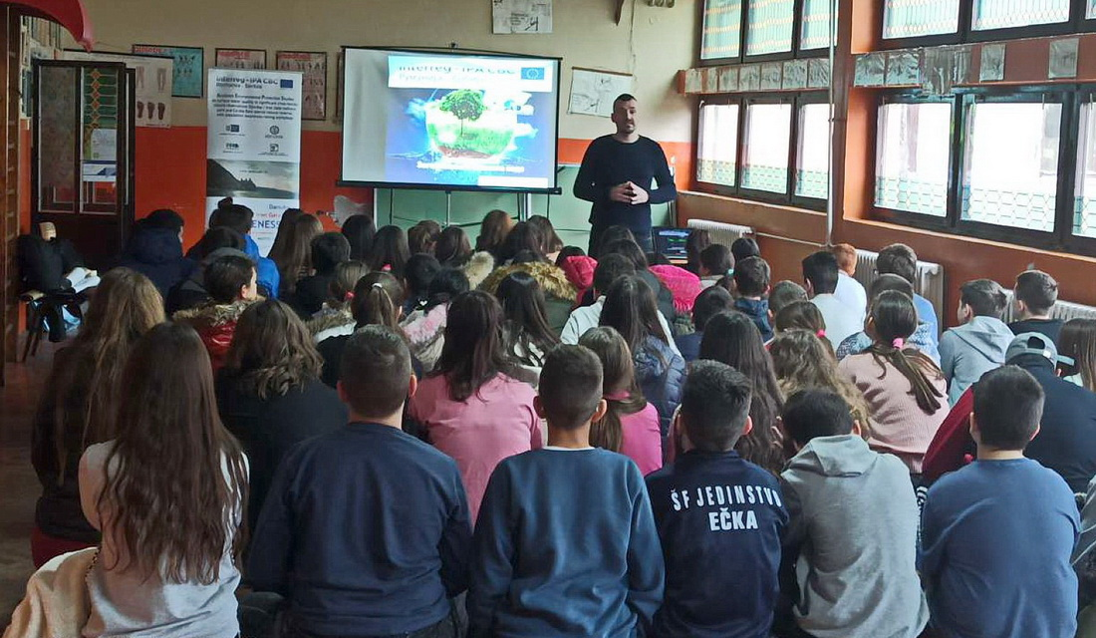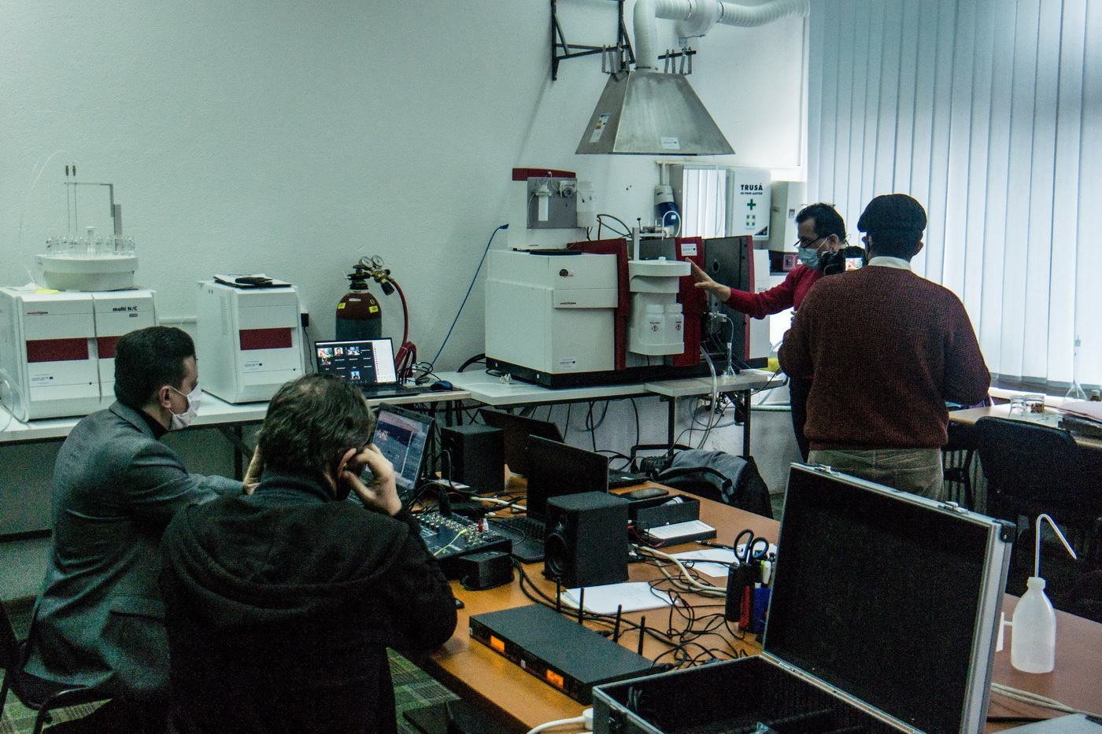

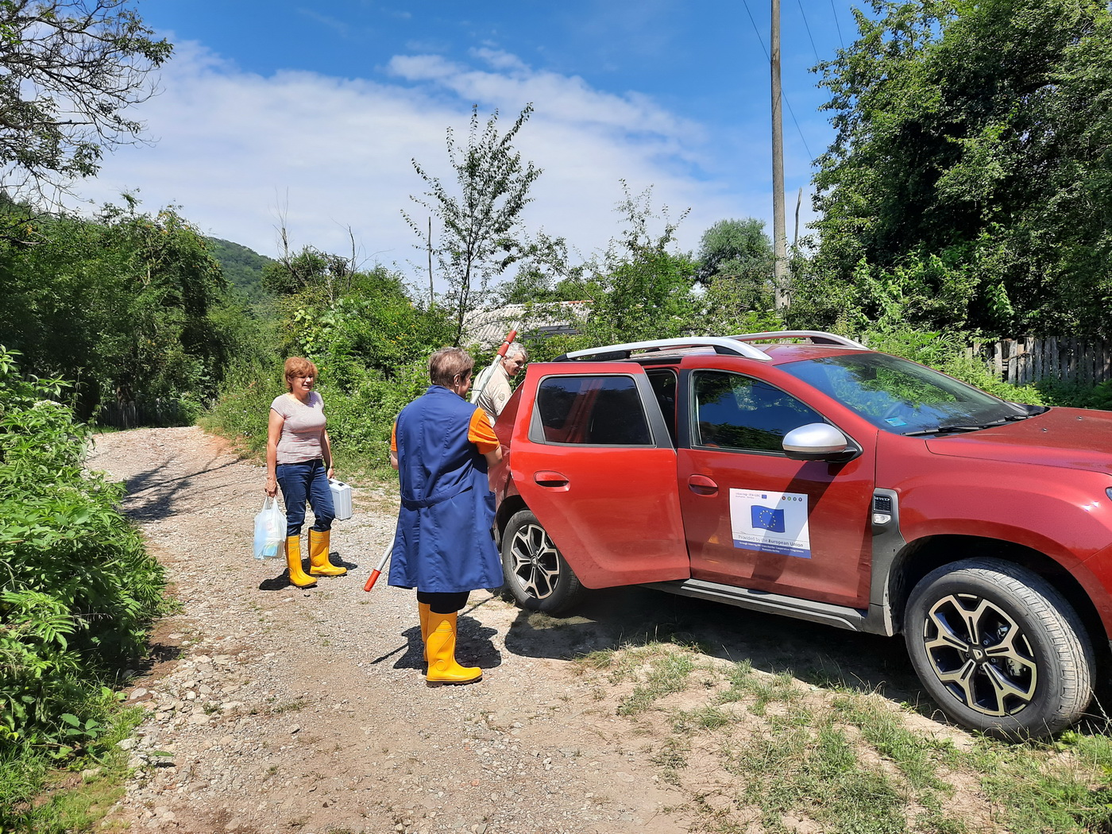

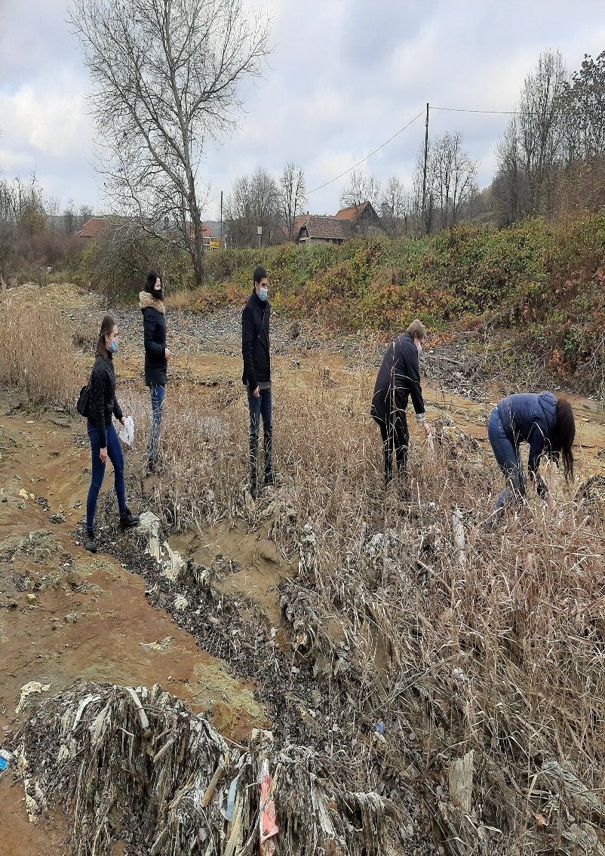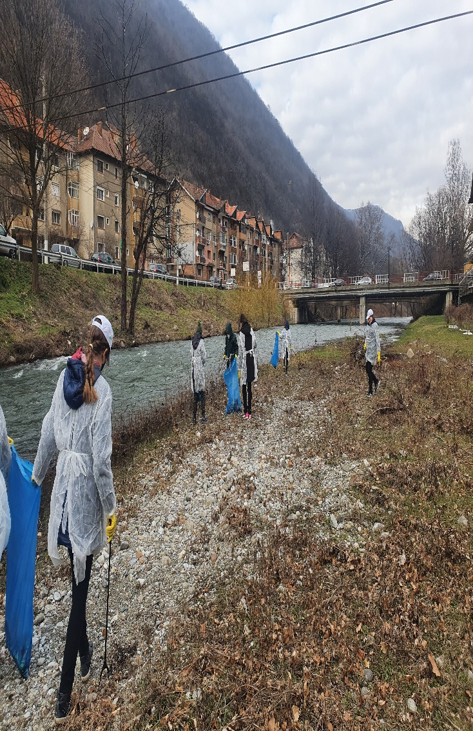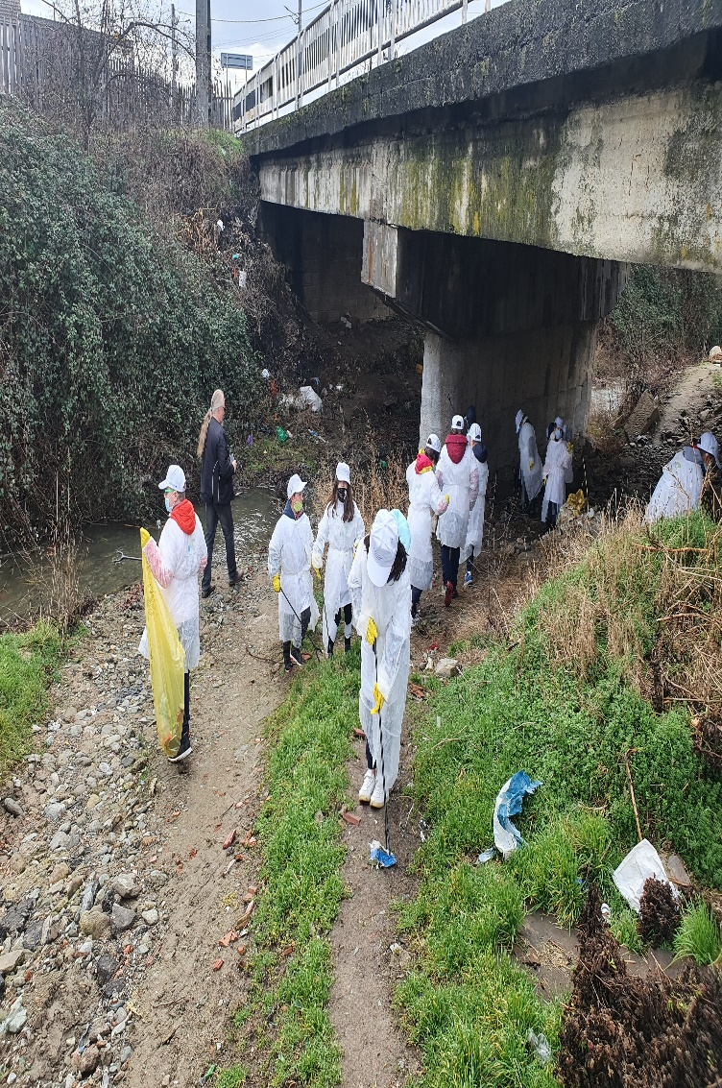

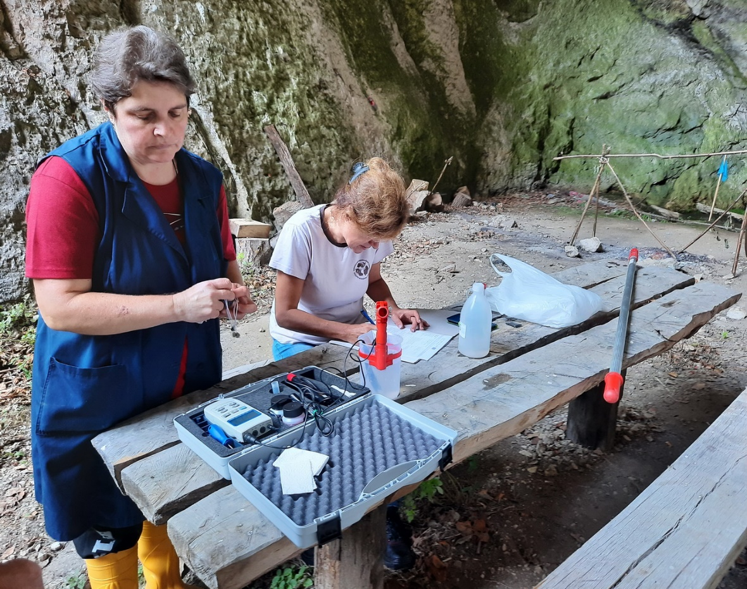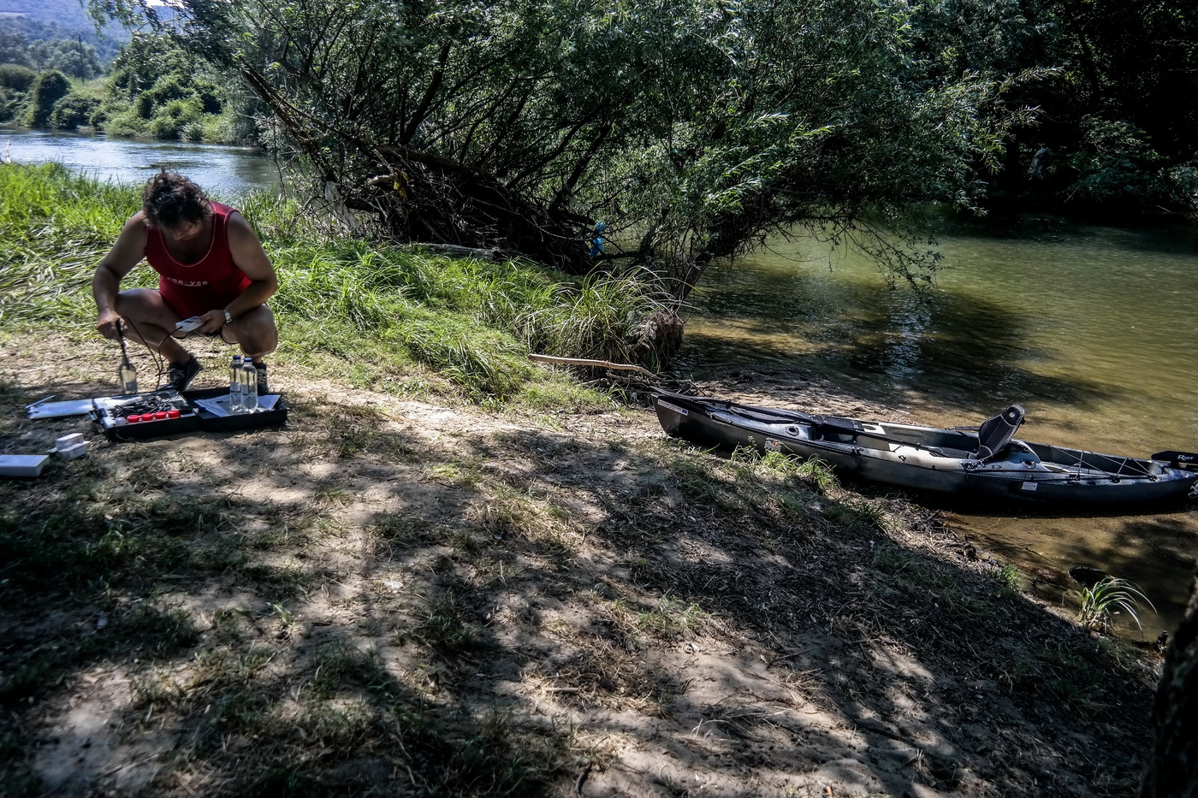

the implementation period (including extensions)
total funds spent/total funds contracted *100
indicators and level of achievement against targets set

