Project information
CALL FOR PROPOSALS | 2
e-MS Code: | RORS 451
PRIORITY AXIS: | 3 Sustainable mobility and accessibility
OBJECTIVE: | 3.2 Public utilities infrastructure
PROJECT TITLE: | Implementation of a joint waste water management strategy in the Danube hydrological basin
ACRONYM: | WasteWater II
DURATION: | 22.10.2019-21.10.2021 (24 Months)
Interreg-IPA  FUNDS CONTRACTED: | € 843.116,42
TOTAL FUNDS CONTRACTED: | € 991.901,69
ABSORPTION RATE (%): | 97.36%
PROJECT OBJECTIVE(S): | Creation of modern and efficient sewer system in Dumbravita and Golubac.  Cooperation and knowledge exchange between technical staff.  Awareness raising campaign.
SHORT DESCRIPTION OF THE PROJECT: | The partners implemented in the years 2015-2016 the project “Joint strategy for wastewater management in the area of Danube hydrological basin”, financed through the previous Romania-Serbia IPA Programme. In that first project, the partners developed the complete technical documentation to realise the sewer system in both localities covering 47 km for Dumbravita Commune and 55 km for Golubac Municipality. In this new project, the partners built on the previous experience and constructed a part of the system, indirectly improving the quality of the water reservoir in the Danube hydrologic system. Dumbravita Commune made a sewer system that included streets previously not connected to the sewer network. The municipality of Golubac built a secondary sewer network. Besides the construction work, both partners organised awareness-raising campaigns about the importance of water protection and reducing water consumption. During the project, employees working with issues of water and sewers from Romania and Serbia cooperated. The project partners helped them identify best practices, exchange knowledge, and transfer the best practices identified.
DEGREE OF ACHIEVEMENT OF INDICATORS: | - Sewer system in Dumbravita – 100%  - Establishment of cross-border cooperation system – 100%  1 Sewer system in Golubac – 100%  470 people benefiting from the awareness raising campaign – 100%
RESULTS ACHIEVED: | 2 Cross border cooperation structures supported in the field of transport and public utilities – 100%  1 Investment realized in transport and utilities infrastructure, including improvement, enhancement of existing infrastructure – 100%  470 Participants to information/ training/ awareness raising initiatives in the field of transport and public utilities – 100%

Partnership information
 |  | COUNTRY | COUNTY/DISTRICT | BUDGET(EURO) | CONTACT DETAILS
LEAD PARTNER: | Dumbravita Commune | Romania | Timis | 514.524,34 | Petofi Sandor Street, no. 31, Dumbravita, 307160  primdumb@yahoo.com
PARTNER 2: | Municipality of Golubac | Serbia | Branicevski | 477.377,35 | Cara Lazara Street, no. 15, Golubac, 12223  office@golubac.org.rs

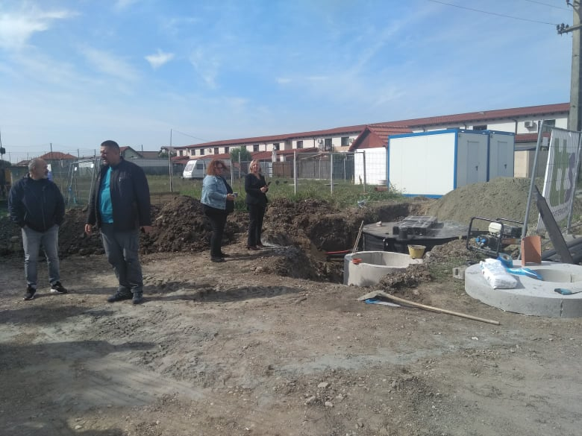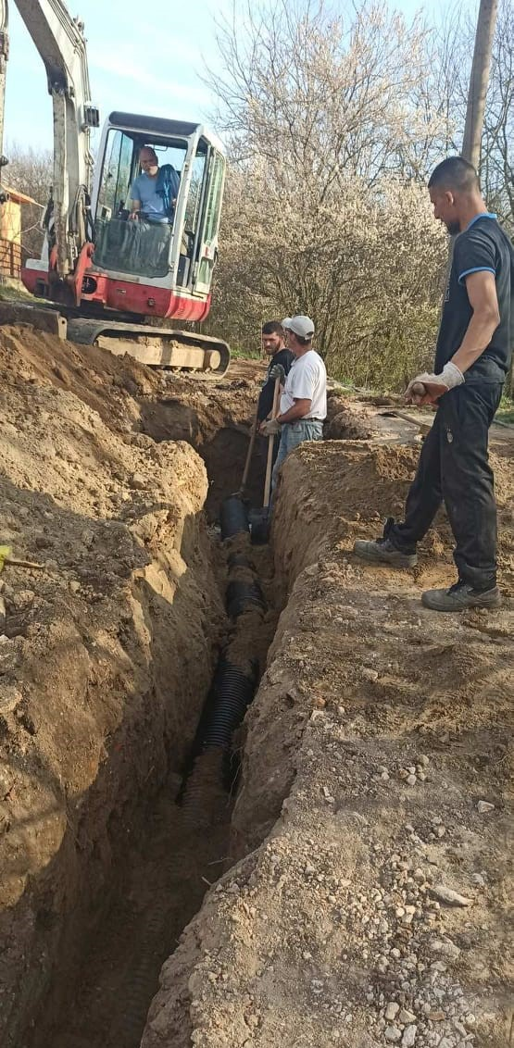

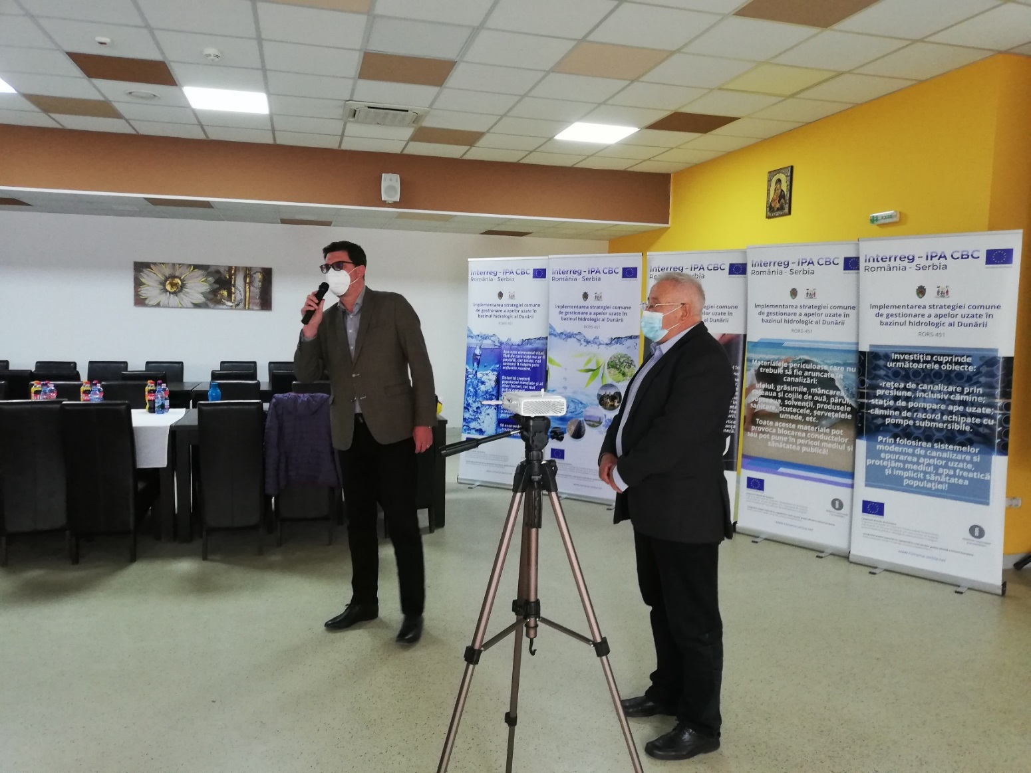
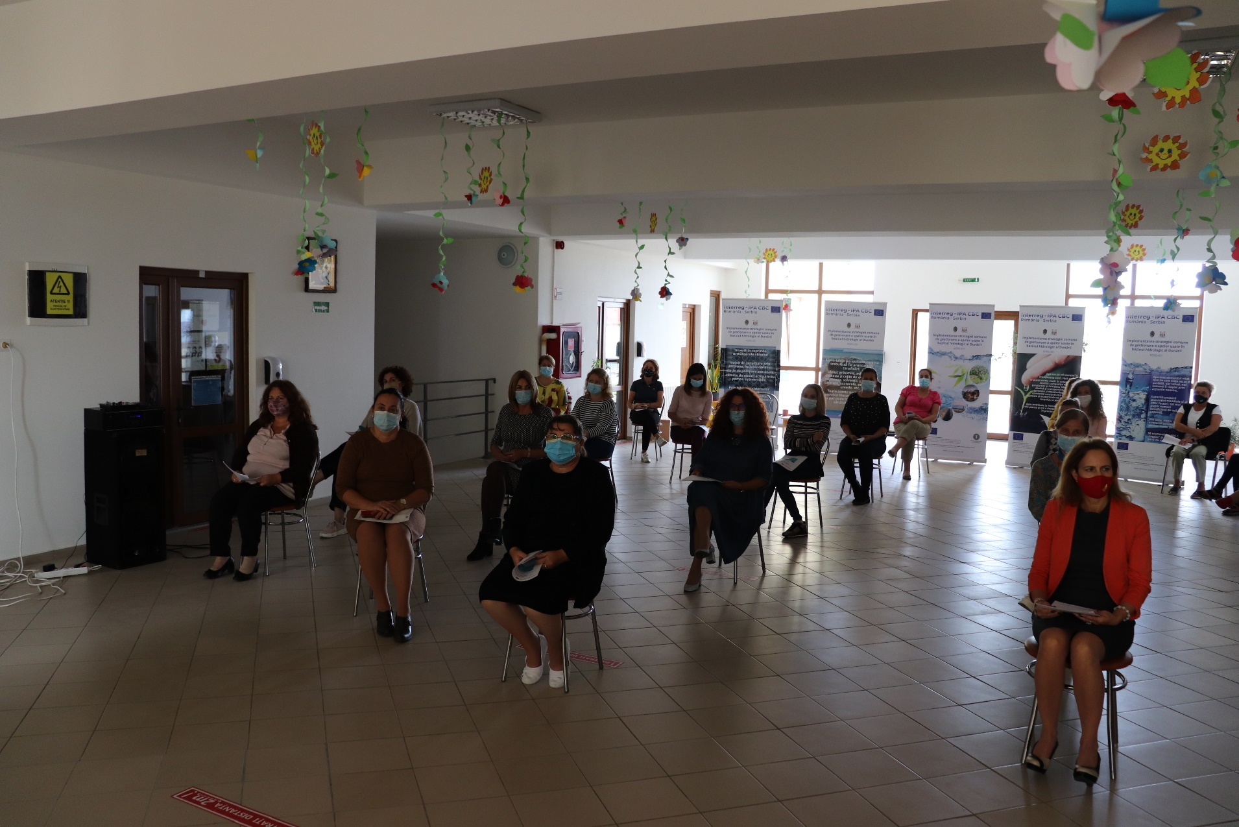
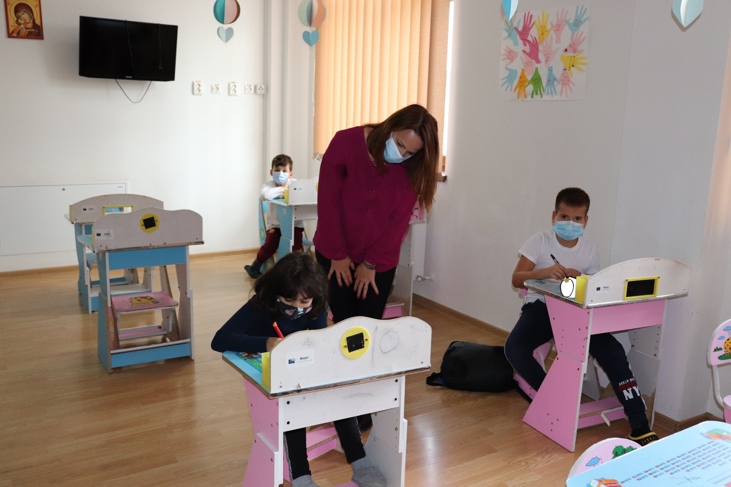

the implementation period (including extensions)
total funds spent/total funds contracted *100

