Project information
CALL FOR PROPOSALS | 2
e-MS Code: | RORS-439
PRIORITY AXIS: | 1 Employment promotion and services for an inclusive growth
OBJECTIVE: | 1.2 Health and social infrastructure
PROJECT TITLE: | Common support on the life path in the cross-border area
ACRONYM: | CaSTLE
DURATION: | 27.04.2021 – 26.10.2022 (18 months)
Interreg-IPA  FUNDS CONTRACTED: | €287.662,38
TOTAL FUNDS CONTRACTED: | €338.426,34
ABSORPTION RATE (%): | 80.77%
PROJECT OBJECTIVE(S): | The “Common support on the life path in the cross-border area” project objective was to promote the development and increase the availability of social security networks in local communities’ border areas to prevent the isolation of elderly and disabled persons and hold back their dependence on institutional care.
SHORT DESCRIPTION OF THE PROJECT: | Life expectancy at birth rose rapidly in Europe during the last century due to several factors, including reductions in infant mortality, rising living standards, better education, and advances in healthcare and medicine. The official Eurostat statistics reveal that life expectancy has risen, on average, by more than two years per decade since the 1960s. The aging of the population in terms of medical, social, and economic progress is a kind of victory. However, aging challenges existing social support systems and affects almost all areas of life.  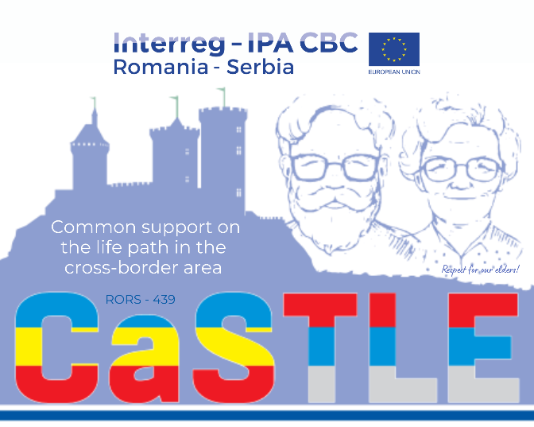  The elderly population and members of vulnerable groups, especially in rural areas, have difficulties accessing the services, systems of social protection, and their rights in institutions of this system.  Serbian and Romanian partners from Žitište, Săcălaz and Sečanj aimed at preventing social isolation and developing capacity for old and disabled persons and their inclusion in the social life of the community.  News about the project can be accessed on the “I Love Zrenjanin” news site: https://bit.ly/3sXfvh0
DEGREE OF ACHIEVEMENT OF INDICATORS: | 564 participants in projects promoting gender equality, equal opportunities and social inclusion across borders – 102,55%  84 investments in health care and social services infrastructure (equipment, construction materials etc.) – 116.67%  37 citizens involved in project activities in cultural, social health care services – 100%
RESULTS ACHIEVED: | 3 accredited trainings for geriatric caregivers organized.  1 research performed for mapping services of social protection at the local level.  2 associations for geriatric caregivers formed.  22 daily clubs renovated.  27 engagements of unemployed persons achieved.  2 protocols of cooperation put into place.  2 round tables organized.  3 project conferences organized.  2 encounters of geriatric caregivers and users of services organized.  2 vehicles for transport of elderly and disabled persons procured.

Partnership information
 |  | COUNTRY | COUNTY/DISTRICT | BUDGET(EURO) | CONTACT DETAILS
LEAD PARTNER: | Municipality of Zitiste | SERBIA | Central Banat | 133.393,89 | 15, Cara Dusana, 23210, Zitiste  opstina.zitiste@gmail.com
PARTNER 2: | Sacalaz Territorial Administrative Unit | ROMANIA | Timis | 69.926,85 | 368, Main Street, 307370, Sacalaz
PARTNER 3: | Municipality of Secanj | SERBIA | Central Banat | 135.105,60 | 57, Vožda Karađorđa, 23240, Secanj

the implementation period (including extensions)
total funds spent/total funds contracted *100
indicators and level of achievement against targets set

