Project information
CALL FOR PROPOSALS | 2
e-MS Code: | RORS-434
PRIORITY AXIS: | 1 Employment promotion and services for an inclusive growth
OBJECTIVE: | 1.2 Health and social infrastructure
PROJECT TITLE: | For Unique New Education Design
ACRONYM: | FUN-ED
DURATION: | 23.04.2021 – 21.04.2023 (23 months and 30 days)
Interreg-IPA  FUNDS CONTRACTED: | €529.574,05
TOTAL FUNDS CONTRACTED: | €623.028,31
ABSORPTION RATE (%): | 94%
PROJECT OBJECTIVE(S): | Improved quality of education and health by implementing innovative, high-quality services in education and health, making it available in the cross-border area through interregional models jointly developed in accordance with EU and local values.  The project builds a link between theory and practice between two countries.
SHORT DESCRIPTION OF THE PROJECT: | The primary challenges of the project were: insufficient or complete lack of competences-based education together with a lack of materials, equipment and know-how on how to organize a modern, transnational and long-lasting model of education, i.e. lack of a model that is adaptable and that can be upgraded to contemporary educational trends and that responds to the needs of the labour market through the implementation of the lifelong learning method.  The project partners have organized and established Methodology development centers in Zrenjanin, a Methodology research center in Vrsac, and a Methodology research center in Resita. They created new education and health curriculum models and methodology for early education, they organized workshops, courses and trainings for children, students and teachers and published research studies on topics related to education.
DEGREE OF ACHIEVEMENT OF INDICATORS: | 760 citizens involved in project activities in cultural, social health care services. 100%  2 methodology research centres established. 100%  8 methodology development centres established. 100%
RESULTS ACHIEVED: | Organization and setup of Methodology development centres in Zrenjanin with 7 sub centres (MDCZ). 100%  Organization and setup of Methodology research centre Vrsac (MRCV). 100%  Organization and setup of Methodology research centre Resita (MRCR). 100%  Creation of new education and health curriculum models and methodology for early children education (primary education). 100%  Implementation of workshops, courses and trainings for children, students and teachers: 600 teachers, 1500 students, 700 primary education children, 1000 parents. 100%  Exchange of good practice between educational institutions in Serbia and Romania. 100%  Research studies published. 100%  More information can be found by accessing: https://funed.rs/en/

Partnership information
 |  | COUNTRY | COUNTY/DISTRICT | BUDGET(EURO) | CONTACT DETAILS
LEAD PARTNER: | Preschool Institute Zrenjanin | SERBIA | Central Banat | 346.482,57 | 3a, Karadžićeva, 23000, Zrenjanin project.zr023@gmail.com
PARTNER 2: | Preschool Teacher Training College "Mihailo Palov" Vrsac | SERBIA | South Banat | 176.081,74 | 1, Omladinski trg, 26300, Vrsac
PARTNER 3: | Kreativ Research Association - Center of Media Studies and Social Research | ROMANIA | Caras-Severin | 79.464,00 | 232, Illovat, 327290, Ocna de Fier
PARTNER 4: | Daria – a Smile of a Child Organization | ROMANIA | Timis | 21.000,00 | No.23, Bl.15, Apt.7, Intrarea Lugojului, 300135, Timisoara

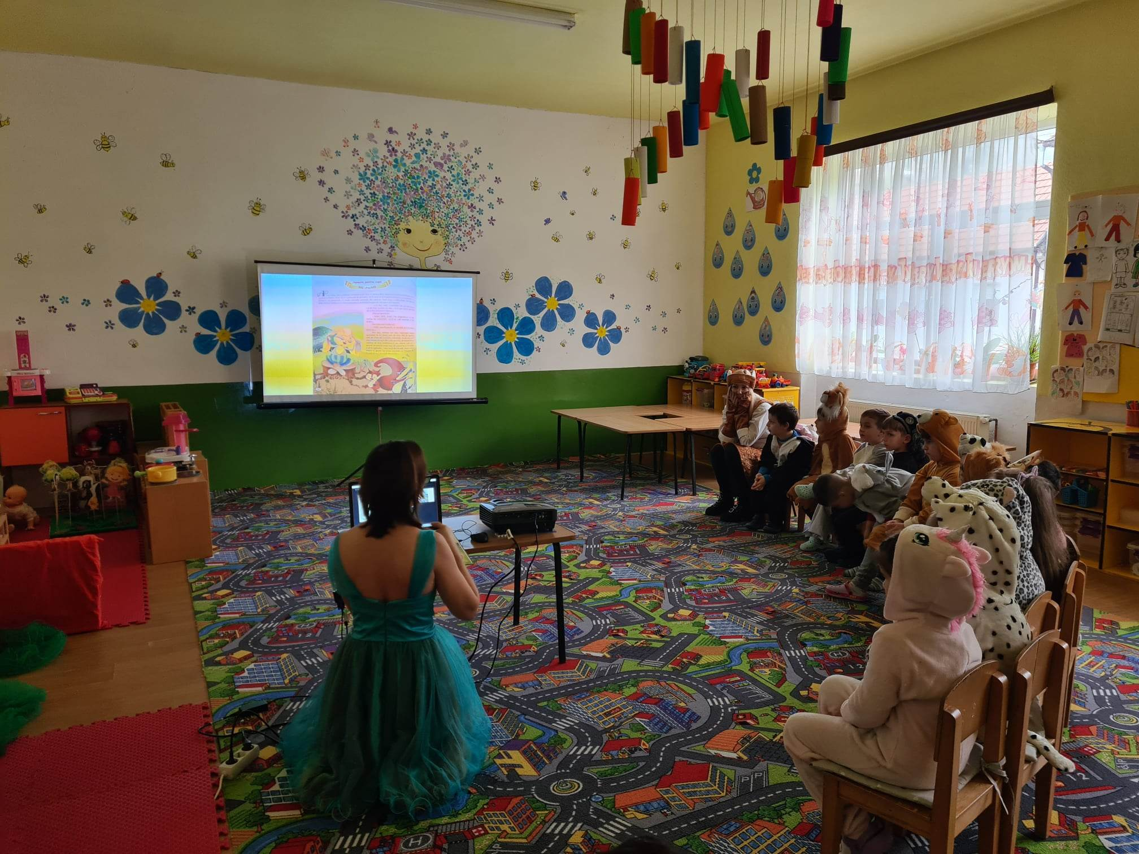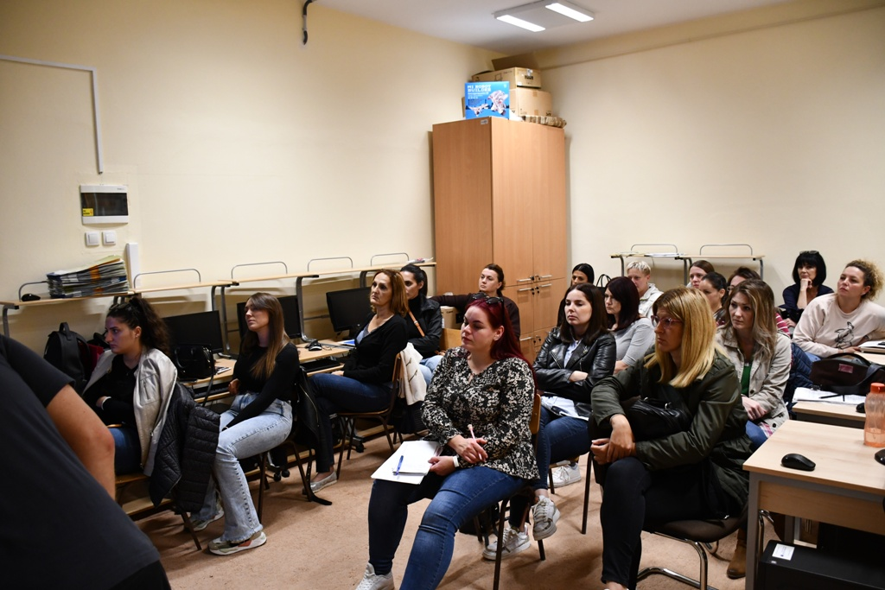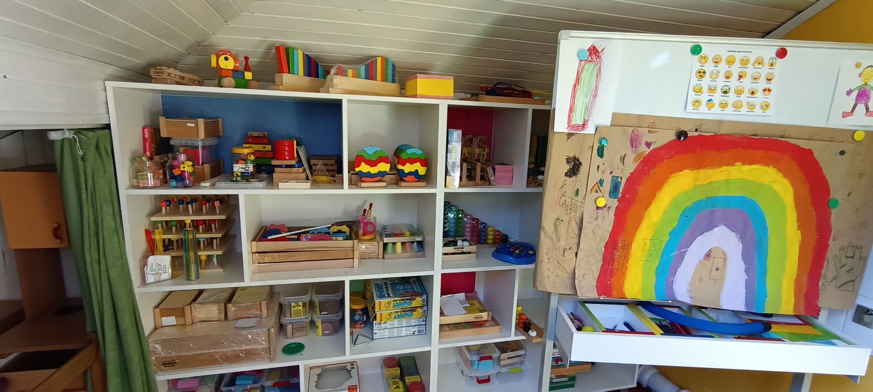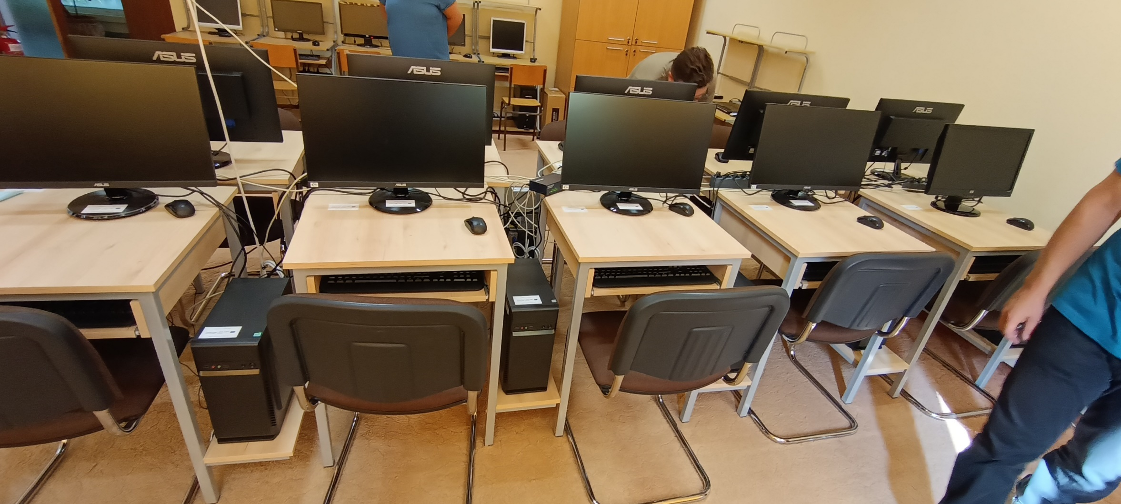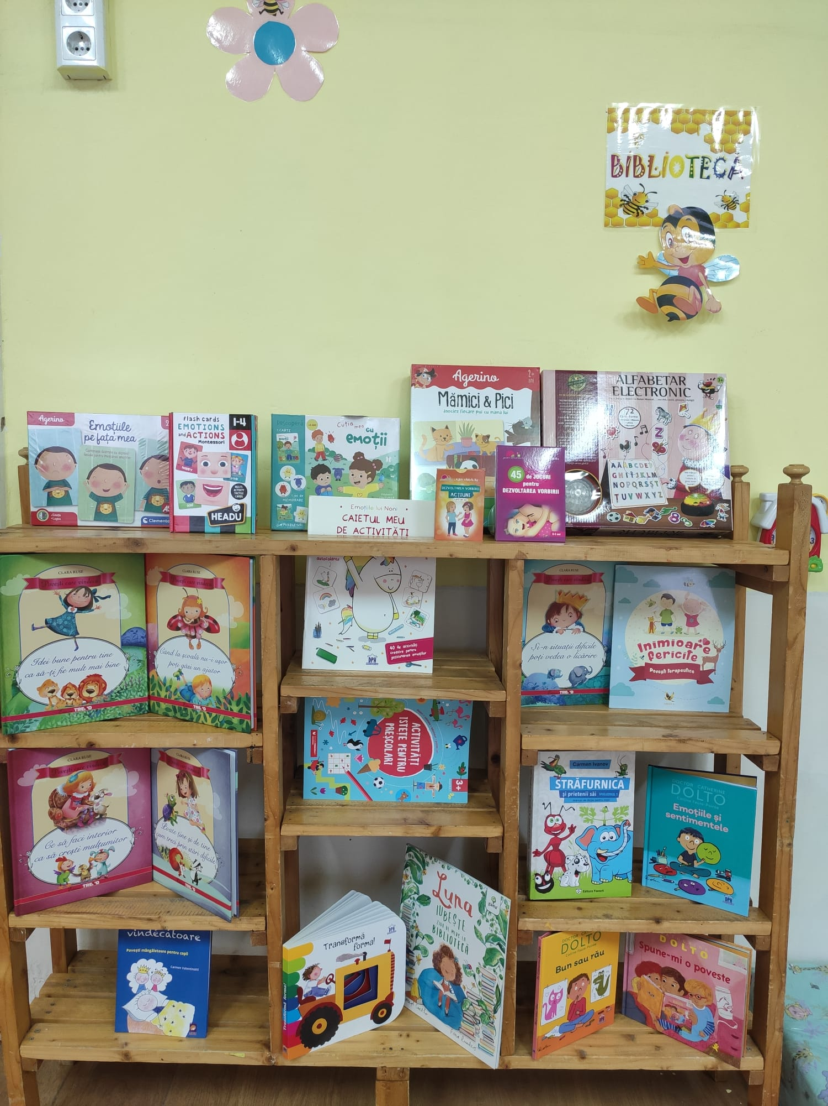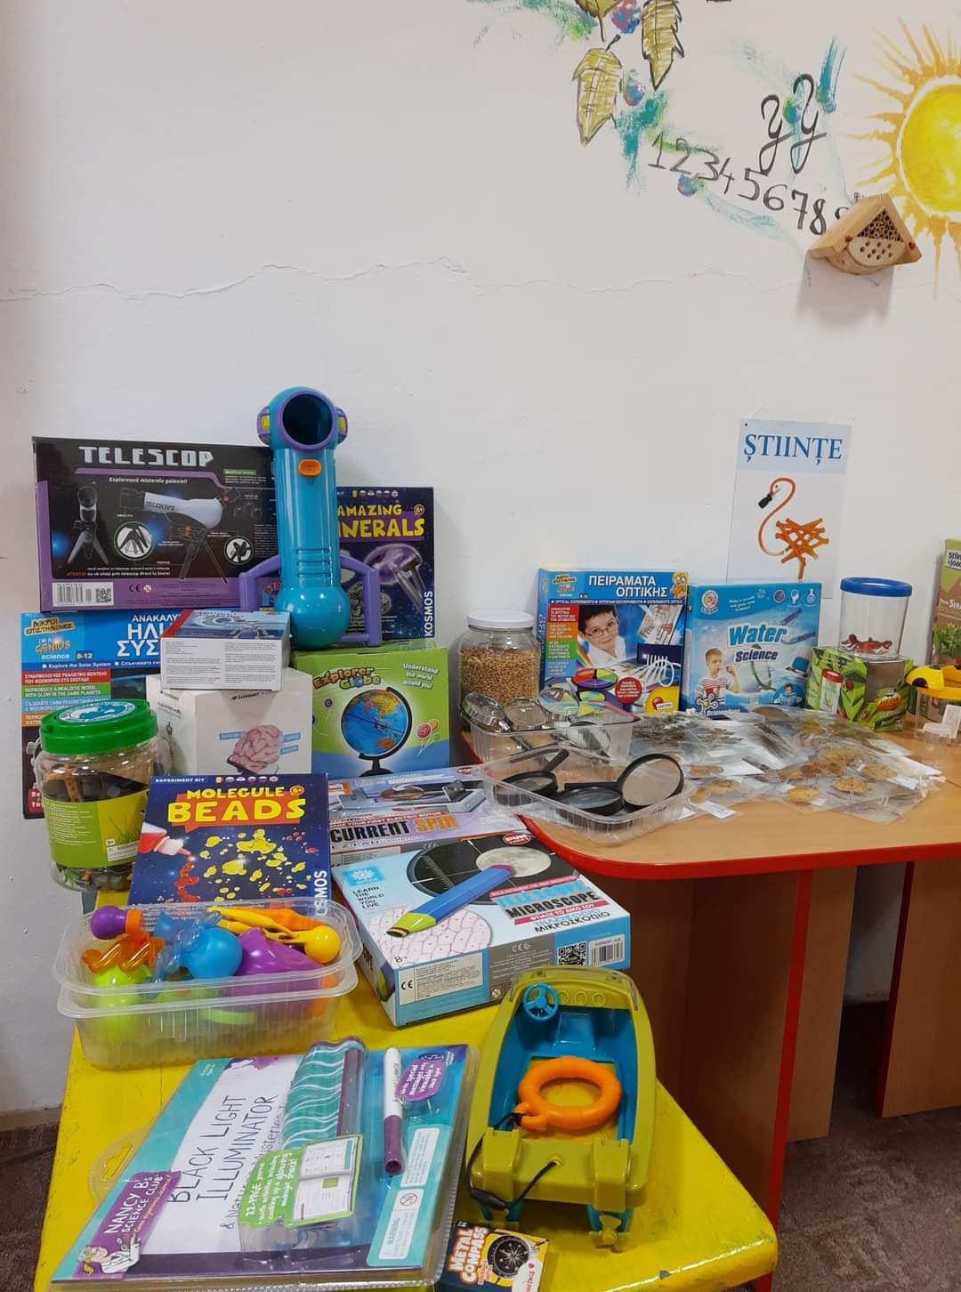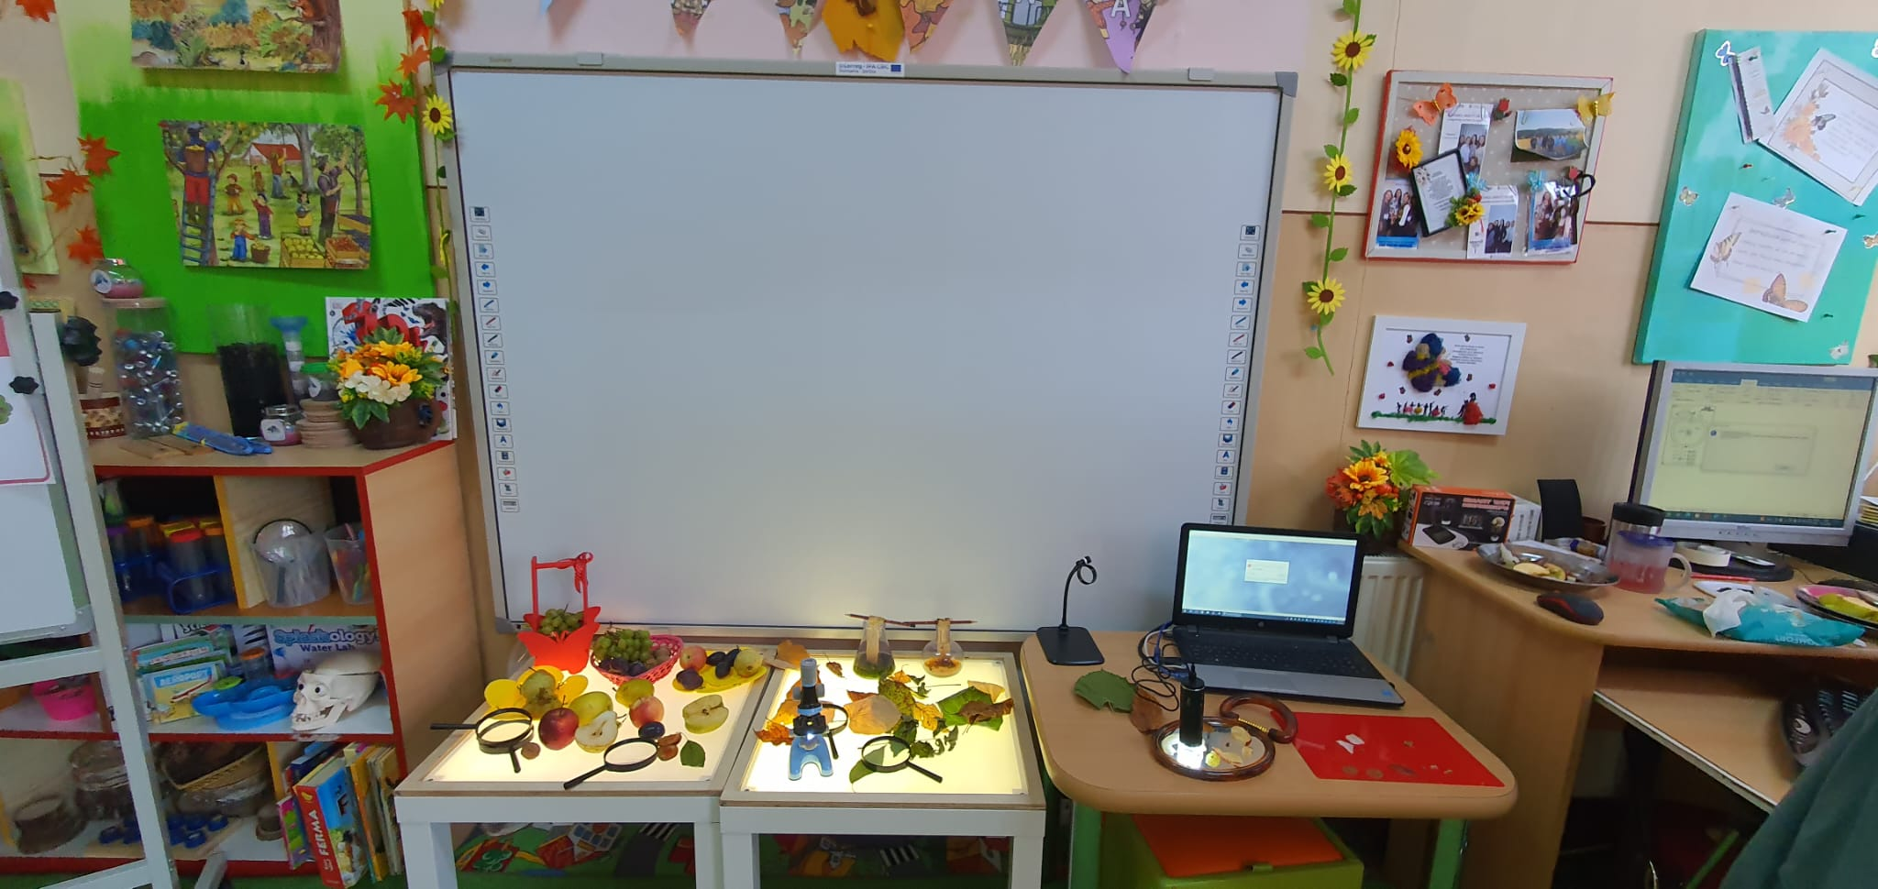

the implementation period (including extensions)
total funds spent/total funds contracted *100

