Project information
CALL FOR PROPOSALS | 2
e-MS Code: | RORS-414
PRIORITY AXIS: | 1 Employment promotion and services for an inclusive growth
OBJECTIVE: | 1.3 Social and cultural inclusion
PROJECT TITLE: | Cross-Border Local Action Groups (LAGs) Cooperation
ACRONYM: | CBC LAGs
DURATION: | 06.04.2023 – 31.12.2023 (8 Month 26 Days)
Interreg-IPA  FUNDS CONTRACTED: | €366.987,81
TOTAL FUNDS CONTRACTED: | €431.750,37
ABSORPTION RATE (%): | 89%
PROJECT OBJECTIVE(S): | Prepared Serbian LAGs (Local Action Groups) for maximizing impact, performance and innovation for IPA Rural Development Programme through sharing Romanian LAGs’ practical experience and knowledge on EU LEADER approach to rural development with fellow Serbian LAG initiatives.
SHORT DESCRIPTION OF THE PROJECT: | The project contributed to addressing key issues of rural development which are characteristic of the regions on both sides of the border and which benefited from joint cross-border action in relation to key areas such as (inter alia) cultural and social integration in marginalized rural areas, agriculture, inclusive growth, rural tourism development.  The LEADER methodology was designed to support local businesses, farmers, foresters, community groups, those involved in tourism and a range of rural enterprises. The members of the LAG are local self-governments, civil organizations and private businesses from local territories.
DEGREE OF ACHIEVEMENT OF INDICATORS: | 1 Study elaborated: Potential support structures. 100%  1 Study elaborated: LAGs of Timis, Caras-Severin and Mehedinti. 100%  1 Policy Paper elaborated. 100%  1 Study elaborated: LEADER/CLLD and the EU LAGs Cross-Border Cooperation. 100%  1 LAGs Needs assessments elaborated. 100%  18 Non-financial Support (NFS) Plans elaborated. 100%  18 Financial plans elaborated. 100%  12 Pitches for Venture Philanthropy elaborated. 100%  12 Cross-border Pitching session organized. 100%  18 Operational programs of LAGs elaborated. 100%  1 Cross-Border Network established. 100%
RESULTS ACHIEVED: | 1. Increased capacities of LAGs from Serbia for IPARD LEADER Measure implementation. 100%  2. Experience and knowledge transferred from more advanced Romanian LAGs to Serbian LAGs. 100%  3. Established cross-border Romania-Serbia Network of Local Action Groups, for continuous cooperation and experience exchange for inclusive growth and social integration in rural areas. 100%  4. Supported and accelerated creation of at least 12 non-profit projects and actions in targeted area, regarding culture, social integration, environment protection, social entrepreneurship and innovation, relevant for rural marginalized areas. 100%  Project results contributed to both of PA1-RI3 programme result indicators:  - Population experiencing lively cultural life in a cross-border setting. 100%  - Population, especially in marginal areas, accessing various opportunities for cultural and social activities, permanently offered in joint initiatives across the border. 100%

Partnership information
 |  | COUNTRY | COUNTY/DISTRICT | BUDGET(EURO) | CONTACT DETAILS
LEAD PARTNER: | Udruženje građana Leader+ Banatski Karlovac | SERBIA | South Banat | 240.800,00 | Nemanjina Street, no. 58/1 26320, Banatski Karlovac policy@leader.org.rs
PARTNER 2: | Euroland Banat Assciation | ROMANIA | Caras-Severin | 190.950,37 | Al. Galati, 4/3/6, 320137, Resita
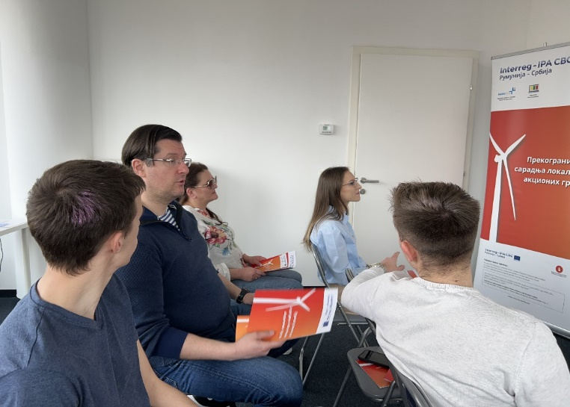
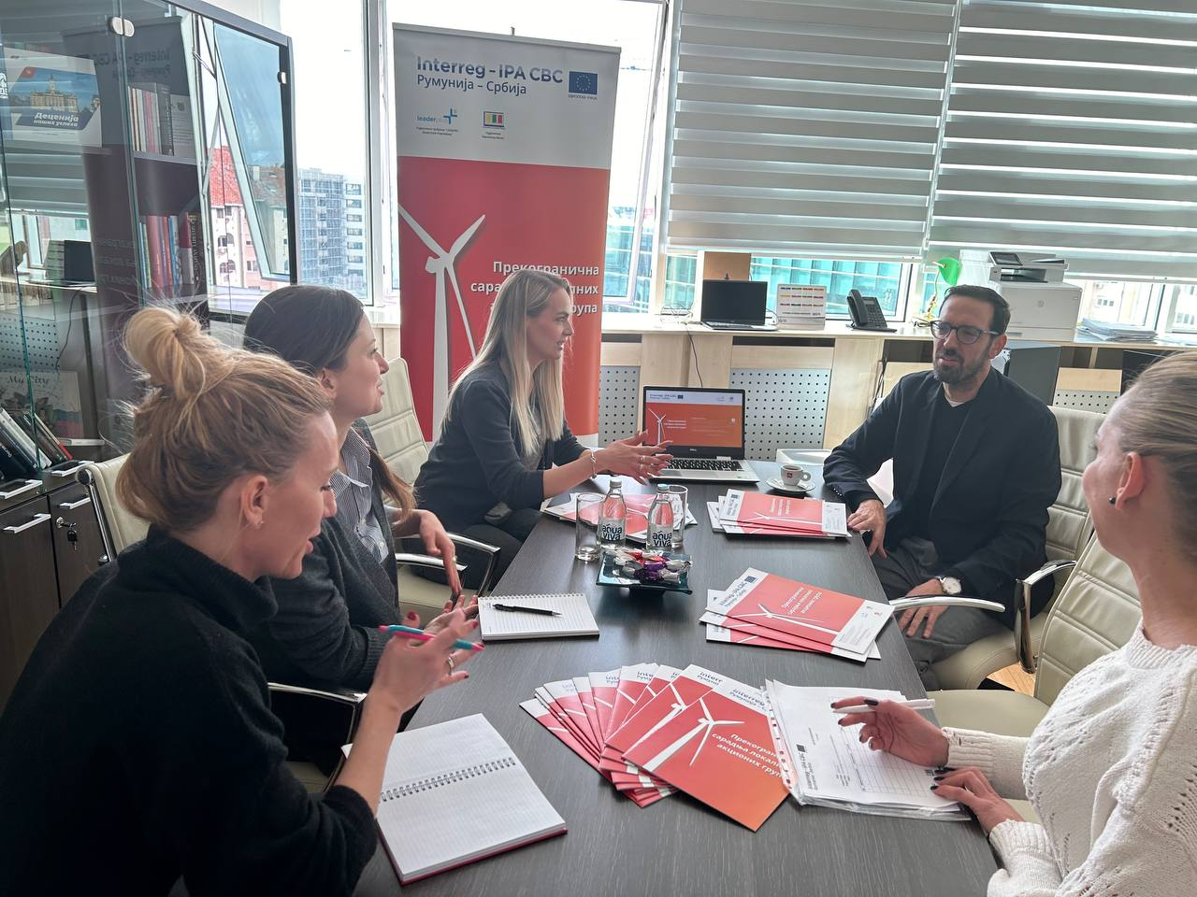
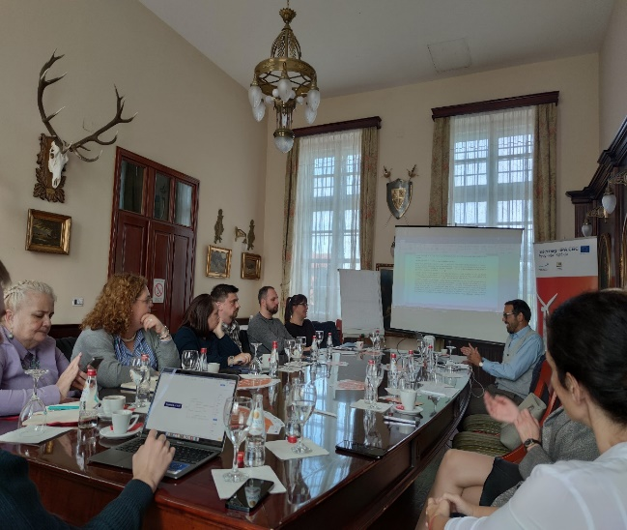
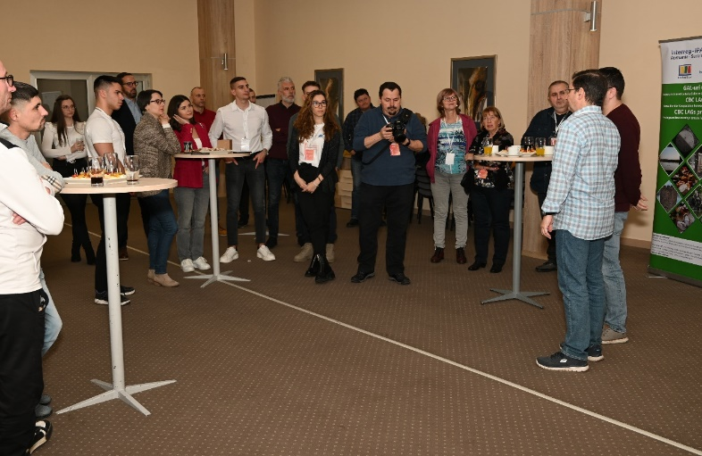

the implementation period (including extensions)
total funds spent/total funds contracted *100

