Project information
CALL FOR PROPOSALS | 2
e-MS Code: | RORS-406
PRIORITY AXIS: | 1 Employment promotion and services for an inclusive growth
OBJECTIVE: | 1.1 Employment and labour mobility
PROJECT TITLE: | e-Support services for career and vocational counseling of youth entering to the labor market
ACRONYM: | e-SSCVC
DURATION: | 03.04.2021 – 02.04.2022 (12 Months)
Interreg-IPA  FUNDS CONTRACTED: | €332.978,35
TOTAL FUNDS CONTRACTED: | €391.739,25
ABSORPTION RATE (%): | 89,39%
PROJECT OBJECTIVE(S): | The objective was to offer the youth in Romania and Serbia an increased chance to make informed decisions regarding their career path through counselling activities and an online platform.
SHORT DESCRIPTION OF THE PROJECT: | Labour market absorption and limited youth access to counselling services determine a generally high youth unemployment rate. The number of specialized career counsellors in high schools is minimal. Thus, the project trained other teachers to act as informed career counsellors. The expected change was that the counselled youth would gain better access to the labour market and employment opportunities.  The main outputs of the project are an online interactive platform on vocational and career counselling, a Counselling guide that all interested teachers and counsellors can use from Romania and Serbia, 40 trained high-school teachers as career counsellors – 20 Romanians and 20 Serbian and 400 young people taught by the career counsellors – 200 Romanians and 200 Serbians. There are two target groups: The first was formed by high school students aged 16 to 19 (400 young people: 200 from Romania, 200 from Serbia), and the second consisted of high-schoolteachers acting as career counsellors (40 teachers: 20 from Romania and 20 from Serbia). The focus of this project was jointly solving similar problems of both targeted groups. Local challenges were both similar and specific. Young people on both sides of the border have the same needs, are confused about choosing the right direction in their professional life, and have different yet similar life aspirations. It is known that a lot of students from Serbia, mainly from the Romanian minority living cross-border, are attending tertiary studies in Romania. The project gave them the opportunity of an informed decision in this regard. This project aimed to develop a unitary, common perspective on counselling students. The originality of this project consisted of the integrative and flexible approach of career development: the academic, the job-seeking competencies and the career counselling were integrated with the unitary vision. The digital platform proposed a new and modern virtual space of communication, interaction and scientific knowledge in the counselling domain, linking teachers and students across the border. The project's effects will be sustainable as the team proposes education for the future and toward lifelong learning.  https://stepstosuccess.projects.uvt.ro/ro/
DEGREE OF ACHIEVEMENT OF INDICATORS: | 532 people trained and counselled.
RESULTS ACHIEVED: | 1 Vocational and Career Counselling Online Platform. https://stepstosuccess.projects.uvt.ro/ro/ (100%)  1 Counselling guide for vocational and career counselling in the classroom. (100%)  40 teachers trained as career counsellors 20 Romanian 20 Serbian. (100%)  400 young people trained by the career counsellors. (100%)  150 high school students involved in study visits 45 from Romania 45 from Serbia (166,66%)  Photos from activities are available at: https://robertzivanov.wordpress.com/2022/04/04/rezultati-zavrsetka-ipa-projekta-rors-406/

Partnership information
 |  | COUNTRY | COUNTY/DISTRICT | BUDGET(EURO) | CONTACT DETAILS
LEAD PARTNER: | West University of Timisoara | Romania | Timis | 208.367,25 | 4 Vasile Parvan street, 300223, Timisoara  otilia.bersan@e-uvt.ro
PARTNER 2: | School Center “Nikola Tesla” | Serbia | Southern Banat | 61.498,50 | 40-44 Sterijina street, 26300, Vrsac  https://www.teslavs.edu.rs/
PARTNER 3: | Grammar School ”Borislav Petrov Braca” | Serbia | Southern Banat | 61.498,50 | 1 Mihajla Pupina street, 26300, Vrsac  administracija@vrsackgimnazija.edu.rs
PARTNER 4: | National College of Banat | Romania | Timis | 60.375,00 | 26, 16 December 1989 street, 300172, Timisoara  cnb@colegiulbanatean.ro

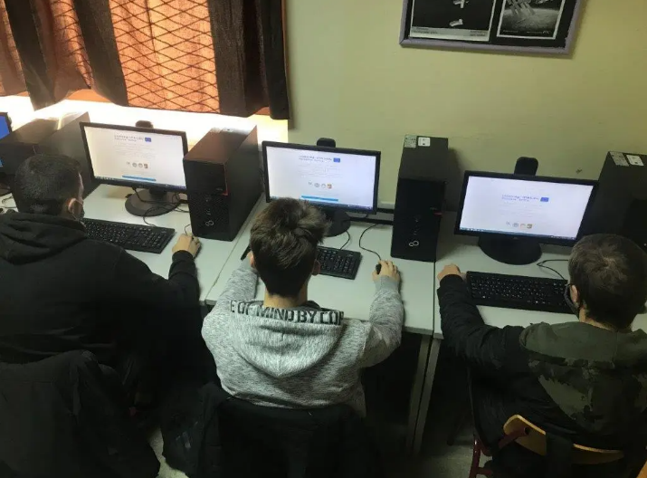
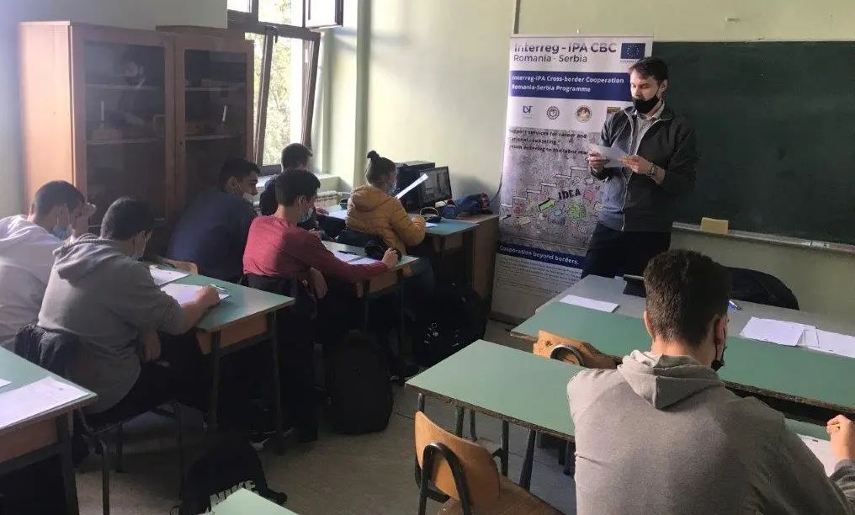
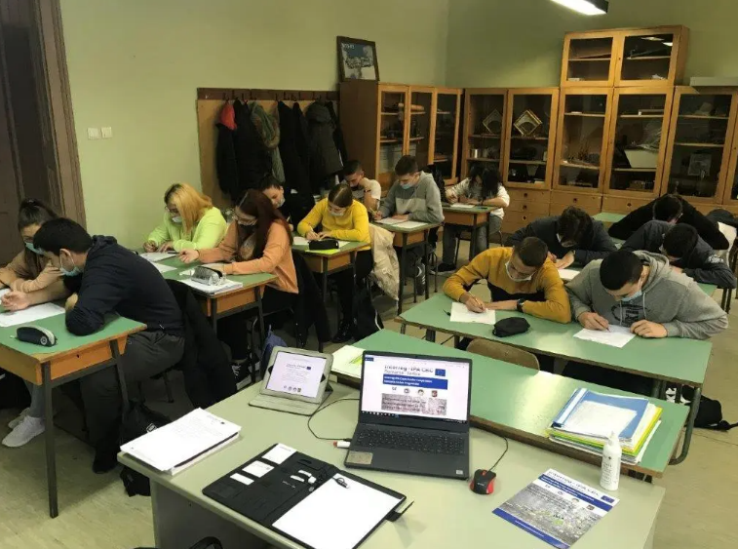
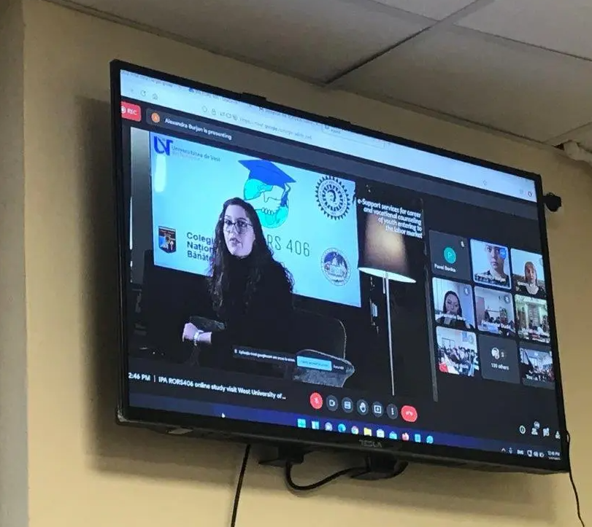

the implementation period (including extensions)
total funds spent/total funds contracted *100
indicators and level of achievement against targets set

