Project information
CALL FOR PROPOSALS | 2
e-MS Code: | RORS-393
PRIORITY AXIS: | 2 Environmental protection and risk management
OBJECTIVE: | 2.1 Environmental protection and sustainable use of natural resources
PROJECT TITLE: | ECO - EDU BANAT
ACRONYM: | EEB
DURATION: | 02.08.2019 – 30.11.2020 (15 months and 29 days)
Interreg-IPA  FUNDS CONTRACTED: | €271.989,37
TOTAL FUNDS CONTRACTED: | €319.987,50
ABSORPTION RATE (%): | 94,48 %
PROJECT OBJECTIVE(S): | The main overall objective was to establish conditions for environment protection in the Banat region through creating a cross-border network for joint training. It was an awareness project for our children in order to help protect the environment through early education.
SHORT DESCRIPTION OF THE PROJECT: | Pre-school children, elementary school children and high school youth were involved in trainings on environment protection, consisting of not only theory, but also of interactive practical activities. In accordance with their age, some of them used colour books or learned through educative stories, adapted to their age in which trainers taught them how to embrace, respect and save the environment, others developed and analysed surveys, another group was involved in planting trees, and the oldest group was engaged in competitions and trainings on first aid, reacting in the fire emergency and responding in emergency situations. Bird watchers, sport fishermen and eco-tourists were also involved in the project. The project took place in Pancevo (Serbia) and Timisoara (Romania).
DEGREE OF ACHIEVEMENT OF INDICATORS: | Infrastructure, equipment built/ installed/ modernized in the field of cross border services for environmental protection: 100%.  Participants to project initiatives and events for information and awareness rising: 100%.  Studies in the field of environmental protection and emergency management. (technical and scientific studies, researches in the relevant fields): 100%.  Participants to capacity building initiatives: 100%.
RESULTS ACHIEVED: | 508 Providing of equipment 100%  3 supporting project activities 100%  450 children and youth educated in applied ecology and the basis of emergency situations reaction 100%  1 Guidelines for applied ecology 100 %  100 Participation in the outdoor activities 100 %
Partnership information
 |  | COUNTRY | COUNTY/DISTRICT | BUDGET(EURO) | CONTACT DETAILS
LEAD PARTNER: | Miltonia Association | Romania | Timis | 168.525,00 | Constructorilor, no 5, Dumbravita, Timis  Tel: +40742838571  E-mail: miltoniaassociation@gmail.com
PARTNER 2: | Centre of volunteers’ and nature conservation movement of Pančevo | Serbia | Južnobanatski | 151.462,50 | Svetog Save, no. 10, Pancevo  Tel: +381640053663  E-mail: sandrakonevski@hotmail.com

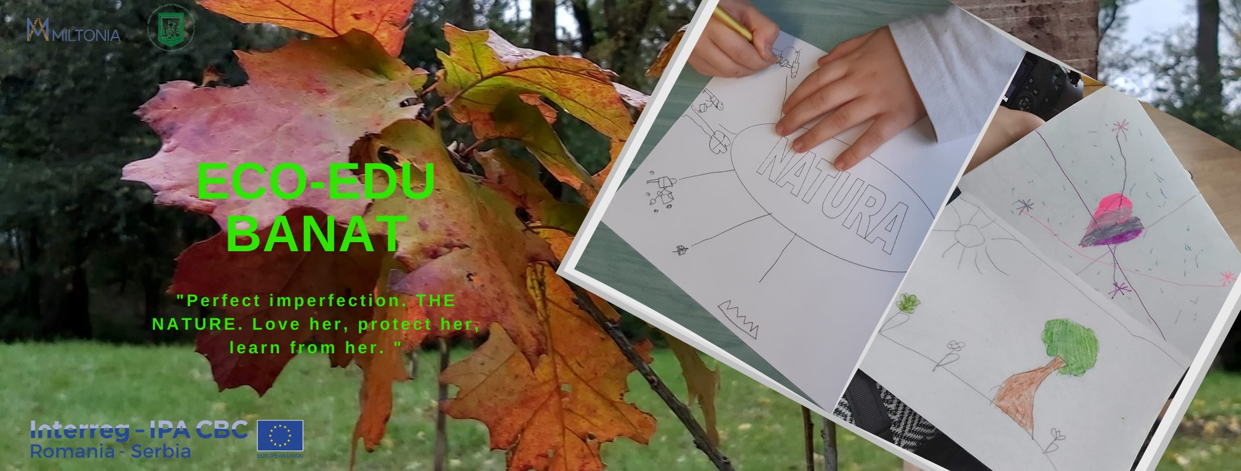
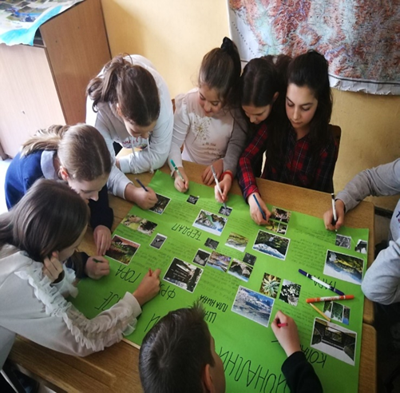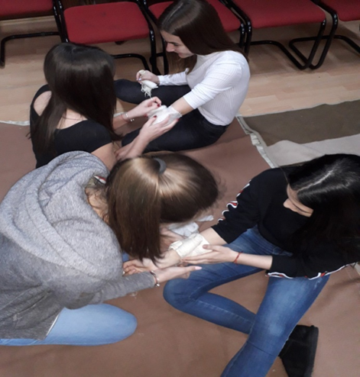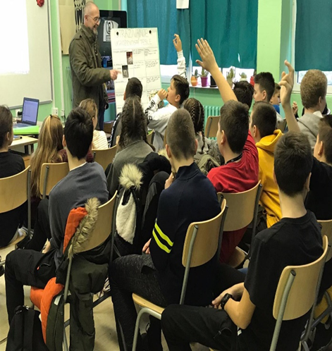

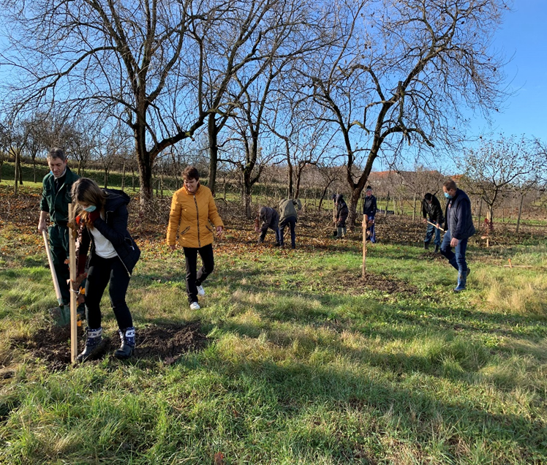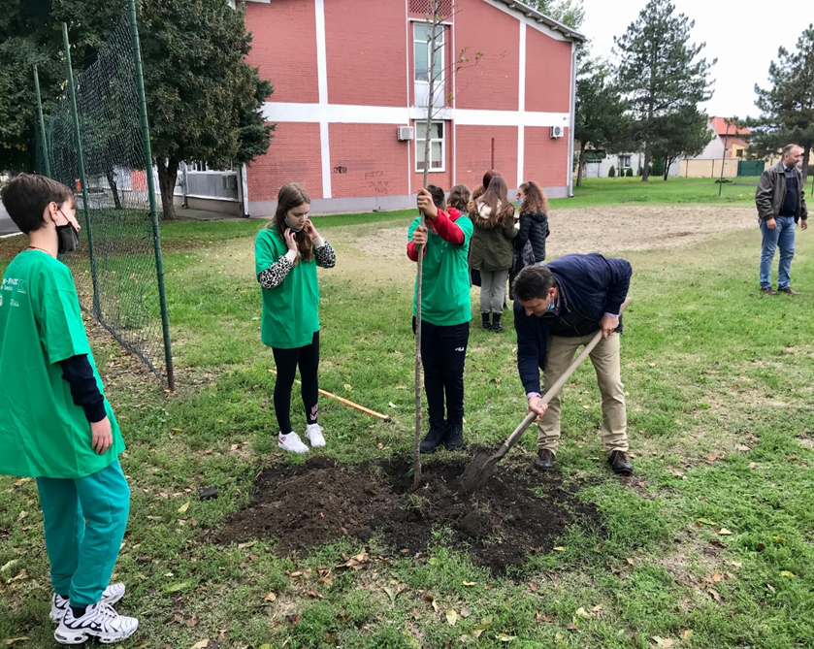

the implementation period (including extensions)
total funds spent/total funds contracted *100
indicators and level of achievement against targets set

