Project information
CALL FOR PROPOSALS | 1
e-MS Code: | RORS-39
PRIORITY AXIS: | 4 Attractiveness for sustainable tourism
OBJECTIVE: | 4.1 Investments for the growth of the demand of local tourism networks and promotion of innovative tourism activities
PROJECT TITLE: | Eco Tamis (Timis) – new tourism product
ACRONYM: | Eco Tamis (Timis) tourism
DURATION: | 14.06.2017 - 13.09.2019 (27 Months)
Interreg-IPA  FUNDS CONTRACTED: | €901.814,55
TOTAL FUNDS CONTRACTED: | €766.542,35
ABSORBTION RATE (%): | 82,45 %
PROJECT OBJECTIVE(S): | Define precisely and develop in detail new touristic product “Eco-Tamis”.  Improve existing and established new product infrastructure and increase capacity building of stakeholders.  Promote and market new touristic product.
SHORT DESCRIPTION OF THE PROJECT: | The area targeted by the project`s activities, Tamis (Timis) river valley, is a “backbone” of the Banat region and it is 359 km long, 241 km in Romania and 118 in Serbia. This unique and continuous touristic area is covered with eco-touristic services: hiking and biking paths, canoeing routes, bird watching and sport fishing places. The institutionalized network of stakeholders manages them.  The overall objective of the project was to contribute to the economic and social development in the Tamis (Timis) River valley, backbone of Banat region, through the development of a new joint tourism product.  A general survey and maps made during the project provide tourists with bike trails that follow natural paths that cross the forests near Timisoara and the hills and mountains of Timis and Caras-Severin counties in Romania and in Serbia also; They can also find canoe rides, fishing and beaches equipped with tables, benches and shade throughout the Timis river, at fixed locations along with fishing associations and local government units in the county.
DEGREE OF ACHIEVEMENT OF INDICATORS: | 16 cross border cooperation structures/ initiatives supported in the field of tourism. 225%  1 study related to the implementation of selected projects or research and studies in the field of natural and cultural resources.193,75%  400 participants attending training initiatives. 172,75%  4432 joint actions and communication instruments created. 131,97%  1 partnerships for the exchange of good practices and the promotion of joint initiatives established. 100%
ACHIEVED RESULTS: | 5 Hike, bike and boat paths and bird watching and sport fishing places developed.  1 Eco Tamis guide elaborated.  1 Study about new tourism product elaborated.  4432 units of small infrastructure posted or procured (1270 signposts, 1270 waste bins, 650 benches, 326 tables, 57 shades, 30 wooden bridges, 735 info board, 5 watching places, 2 catamarans, 20 canoes and 50 bicycles).  1 web portal realized: http://eco-tamis.com/  - Promo regatta on the Tamis River organized.  - Promo tours for media and tour operators organized.  16 Promo events for media organized.  - Production of touristic film about Eco Tamis (Timis) tourism.  - Network of Tamis (Timis) tourism stakeholders established.

Partnership information
 |  | COUNTRY | COUNTY/DISTRICT | BUDGET(EURO) | CONTACT DETAILS
LEAD PARTNER: | Centre of volunteers’ and nature conservation movement of Pancevo | Serbia | South Banat | 216.830,25 | Svetog Save 10  26000 Pancevo  Tel: 013/333-201  Email: pagorani@gmail.com
PARTNER 2: | Chamber of Commerce and Industry of Serbia - Regional Chamber of Commerce and Industry of South Banat District | Serbia | South Banat | 199.888,50 | Zmaj Jovina 1а, 26000 Pancevo  Tel: 38113/343-255  e-mail: rpkpancevo@pks.rs
PARTNER 3: | Miltonia Association | Romania | Timis | 180.816,30 | 5 CONSTRUCTORILOR Street, 307160, DUMBRAVITA  Email: mari_faur@yahoo.com
PARTNER 4: | Association for the Promotion and Development of Tourism in Timis | Romania | Timis | 304.279,50 | Bd. 1989 Revolution No.17  Timisoara, Romania  (+4) 0256 406 470  E-mail:office@turismtimis.ro

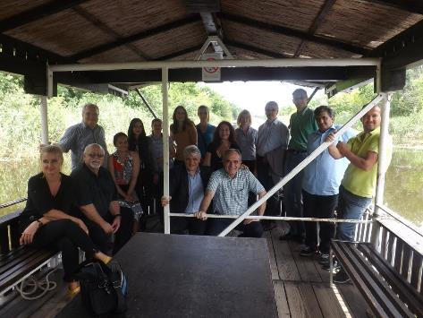
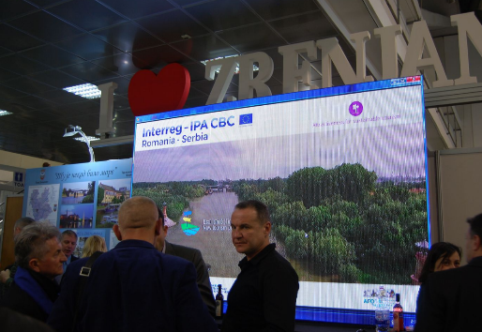
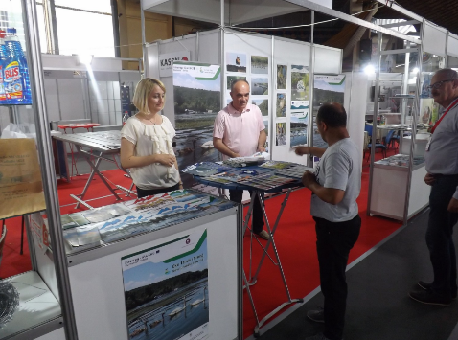
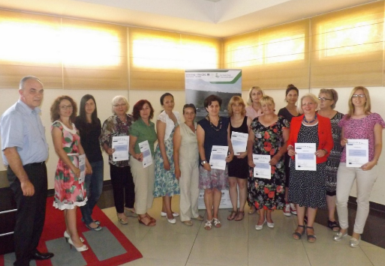
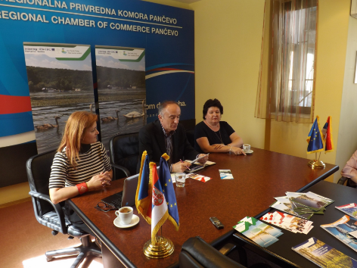
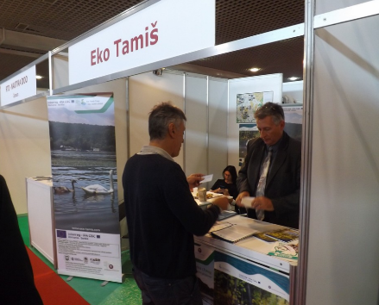

the implementation period (including extensions)
total funds spent/total funds contracted *100

