Project information
CALL FOR PROPOSALS | 2
e-MS Code: | RORS-380
PRIORITY AXIS: | 2 Environmental protection and risk management
OBJECTIVE: | 2.1 Environmental protection and sustainable use of natural resources
PROJECT TITLE: | Integrated management of relationship climate - insect migration in Srednjebanatski District and Timis County
ACRONYM: | CLINSIM
DURATION: | 28.06.2019 – 30.06.2021* (21 months and 8 days)
Interreg-IPA  FUNDS CONTRACTED: | €371.622,72
TOTAL FUNDS CONTRACTED: | €437.203,20
ABSORPTION RATE (%): | 80,40%
PROJECT OBJECTIVE(S): | To develop a specific monitoring system and cross-border network.  To educate and train people in using and improving the monitoring system.  To increase the capacity for emergency interventions by informing people about the availability of the monitoring system.
SHORT DESCRIPTION OF THE PROJECT: | The Romania-Serbia cross-border area mainly offers identical environmental conditions and challenges regarding its dynamics and preservation. There is also the risk caused by different environmental aspects, on both sides, especially for climate, insect migration, water (floating and groundwater) and soil quality. Information on the quality of water, insect migration, and soil quality are vital for a growing population.  An integrated approach to analysing climate, insect migration and soil helped understand this issue and provided a basis for future solutions applied by local stakeholders.  The team set up an online monitoring system for the relationship between climate and insect migration. They analysed the data and included their findings in research papers.  They grew a network of specialists, public administrations, stakeholders and citizens interested in the subject because they wanted to present their research. The people in the network have the power to use the information obtained by researchers.  Education and knowledge are vital to fighting climate change.
DEGREE OF ACHIEVEMENT OF INDICATORS: | Infrastructure, equipment built/ installed/ modernized in the field of cross border services for environmental protection. 100%  80 participants to project initiatives and events for information and awareness raising. 100%  2 studies obtained in the field of environmental protection and emergency management. (technical and scientific studies, researches in the relevant fields). 100%  580 participants to capacity building initiatives. 100%  1 monitoring system established/ extended/ modernized in the eligible area in the field of environmental protection and emergency management. 100%
RESULTS ACHIEVED: | 1 cross-border integrated monitoring system was used for the relationship between weather conditions, insect migration and soil.  1 conference volume including research papers was prepared.  1 study regarding relationship between climate, soil condition and insect migration in cross-border area was elaborated.  500 people were informed about the integrated monitoring system.

Partnership information
 |  | COUNTRY | COUNTY/DISTRICT | BUDGET(EURO) | CONTACT DETAILS
LEAD PARTNER: | City of Zrenjanin | SERBIA | Central Banat | 270 215.40 | 10 Trg slobode, 23101 Zrenjanin
PARTNER 2: | Politehnica University Timisoara | ROMANIA | Timis | 212 284.80 | 2 Piata Victoriei, 300006 Timisoara  nicolae.lontis@upt.ro
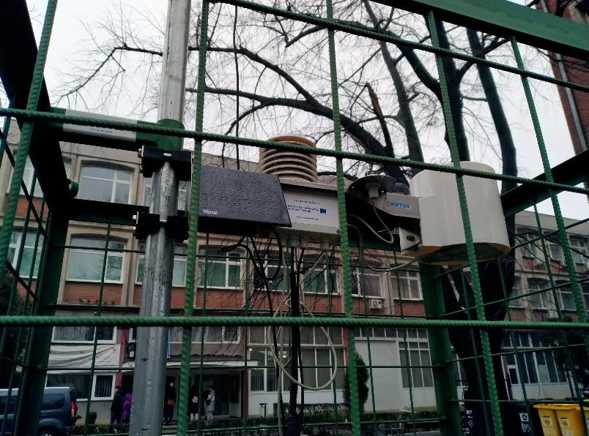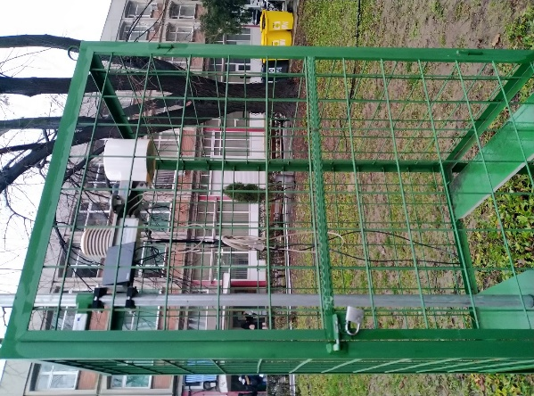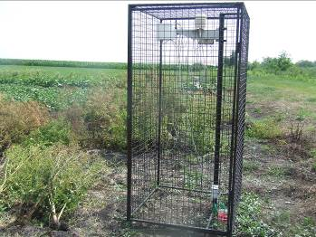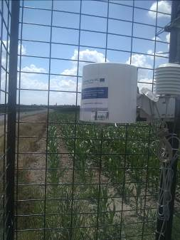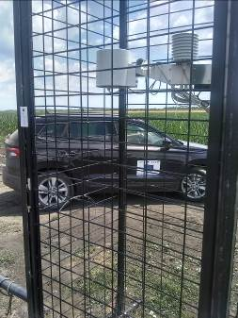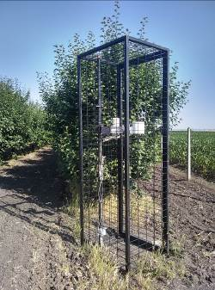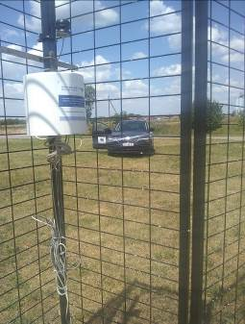

the implementation period (including extensions and one suspension)
total funds spent/total funds contracted *100

