Project information
CALL FOR PROPOSALS | 2
e-MS Code: | RORS-379
PRIORITY AXIS: | 4 Attractiveness for sustainable tourism
OBJECTIVE: | 4.1 Investments for the growth of the demand of local tourism networks and promotion of innovative tourism
PROJECT TITLE: | Banat touristic cycling route connection
ACRONYM: | BanatBike
DURATION: | 29.12.2020 – 28.09.2022 (21 months)
Interreg-IPA  FUNDS CONTRACTED: | €253.291,50
TOTAL FUNDS CONTRACTED: | €297.990,00
ABSORPTION RATE (%): | 89.61%
PROJECT OBJECTIVE(S): | The project's main objective was to enhance demand for cross-border tourist regions by developing a thematic cycling route package and through joint branding and marketing activities. Thematic routes, integrated tourism stakeholders and marketing increase the region's attractiveness for domestic and foreign tourists. Banat Bike focused on creating thematic routes to merge natural, historical and cultural heritages along the Bega cycling path from Timisoara to Zrenjanin.
SHORT DESCRIPTION OF THE PROJECT: | The project focused on common territorial challenges and intended to tackle the connectedness of the two regions, to facilitate better communication and cooperation between the population and communities on both sides of the border.  Considering the region's rural nature, it abounds in various natural and cultural sites, built heritages, landscapes, religious monuments, traditional buildings and settlements, historical and archaeological sites, etc. The assistive tourist services largely need to catch up to their potential and are built haphazardly onto the tourist attractions. Between tourism stakeholders, the partnership and cooperation initiatives needed to be improved. Due to this disorganization, joint touristic packages and the inherent turnover growth need to be included.  The shortcoming was that the tourist services did not follow the achievements of the IT field and were not in accordance with the expectations and requirements of modern tourists and travellers.  The project sustained an innovative solution for raising touristic demand for natural and cultural attractions in the border region. It combined in a unique way two approaches. One was to focus the attention on cycling routes, like Timișoara - Zrenjanin, which attracted those committed to travelling freely in the open air. This was the environmental feature of the project, including the promotion of healthy living. The second, a thematic route, was created, which merges all natural, historical and cultural heritages on the path. In that way, it offers a joint package to tourists and visitors of the region.  The project treated the cross-border territory as a coherent area. Many landmarks, sites and other attractions are linked to each other. The integrated approach was needed to develop a joint tourism image and create a thriving network between key regional actors.  The touristic cycling route package (eco, ethnic, cultural, gastro and leisure) created will foster the recognition and sustainable utilization of tourist attractions in the region. This touristic cycling route presents a common touristic product that integrates the major touristic potentials in the cross-border area.
DEGREE OF ACHIEVEMENT OF INDICATORS: | 1 established CBC structure in the field of tourism between Romanian and Serbian stakeholders – 100%  1 touristic software developed - ROUTE PLANNER based on the efforts of established network – 100%  1 established partnership between cross-border tourism organizations/institutions, and operators – 100%
RESULTS ACHIEVED: | Touristic cycling route package (eco, ethnic, cultural, gastro, and leisure) created (which fosters the recognition and sustainable utilization of tourist attractions in the region). This touristic cycling route presents a common touristic product that integrates the major touristic potentials in the cross-border area.  1 website created - https://www.banatbike.rs/

Partnership information
 |  | COUNTRY | COUNTY/DISTRICT | BUDGET(EURO) | CONTACT DETAILS
LEAD PARTNER: | Municipality of Senta | SERBIA | Northern Banat | 194.145,00 | 1, Glavni Trg, 24400,Senta, info@sentainfo.org
PARTNER 2: | Otelek Hungarian for Hungarians Association | ROMANIA | Timis | 103.845,00 | 373A, Pardani, 307447, Otelec

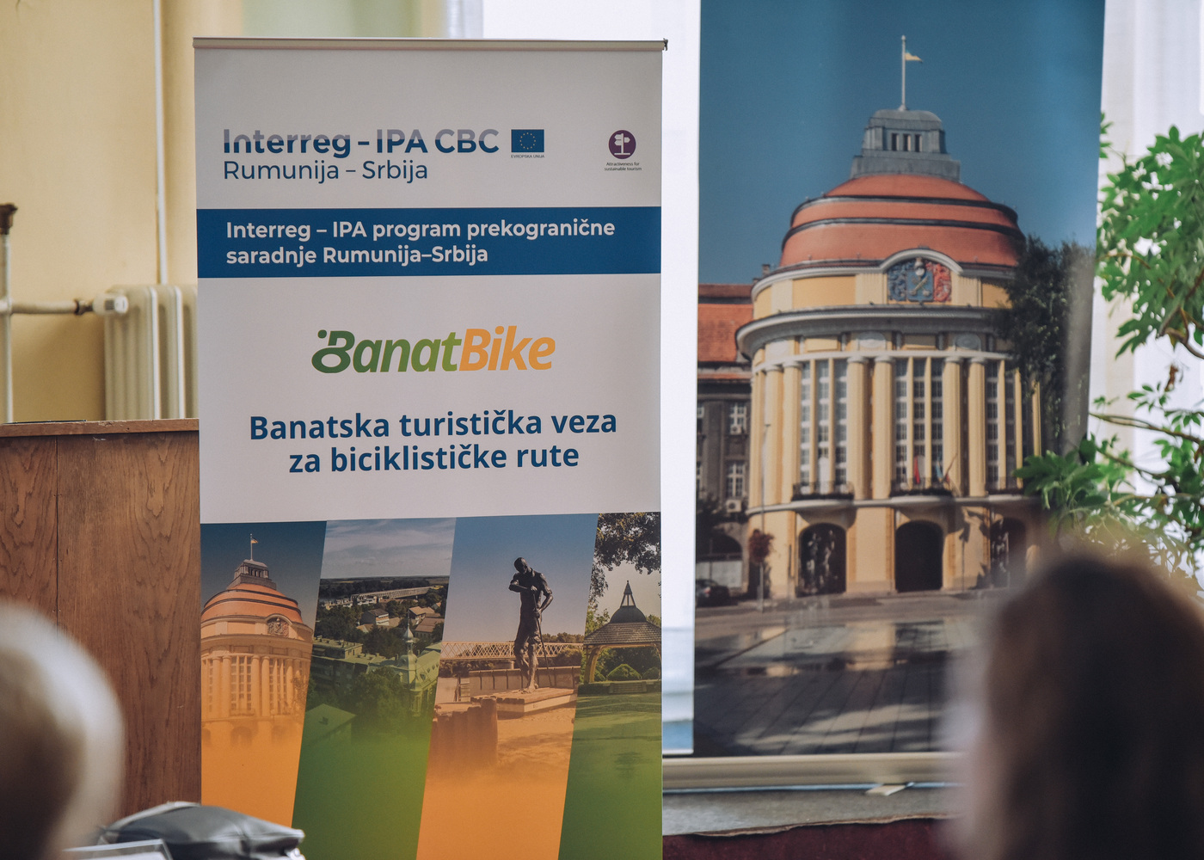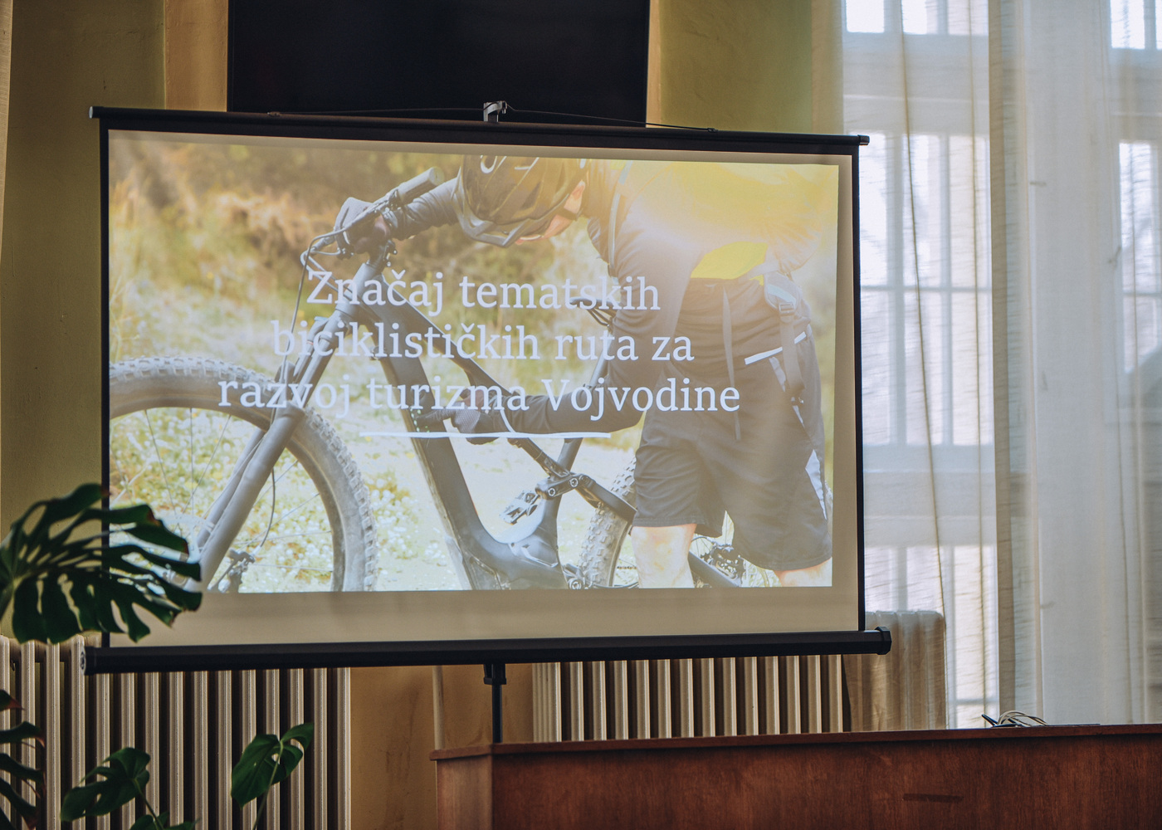
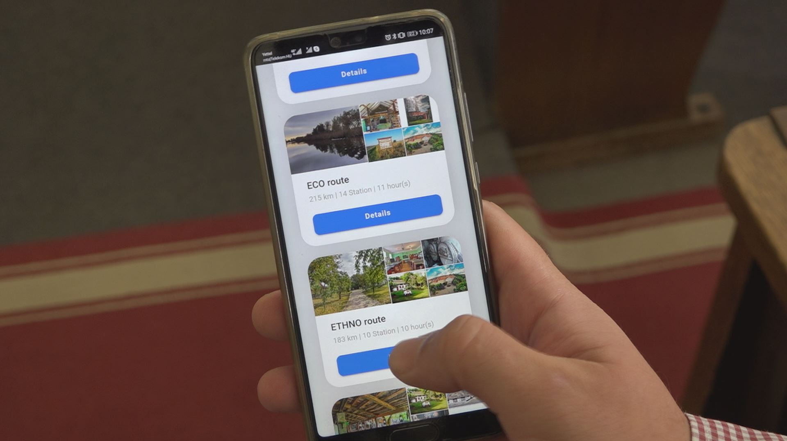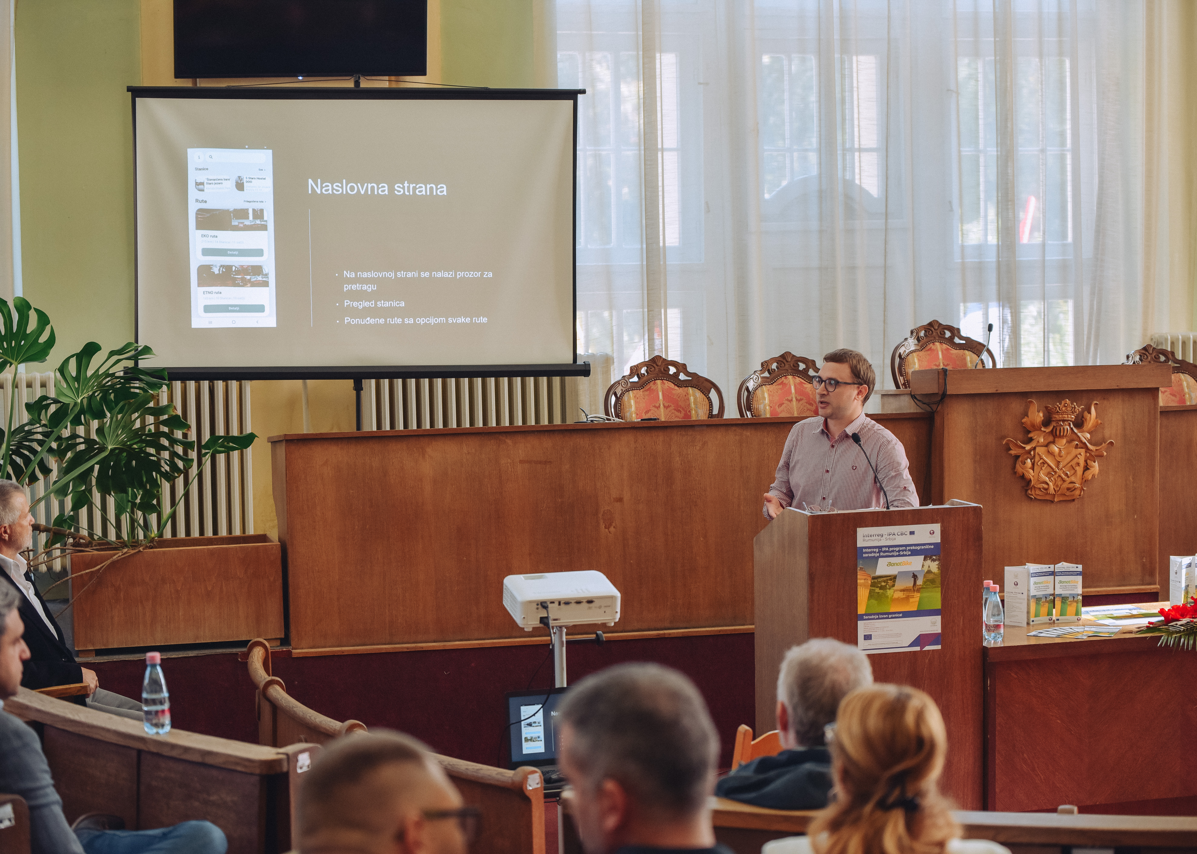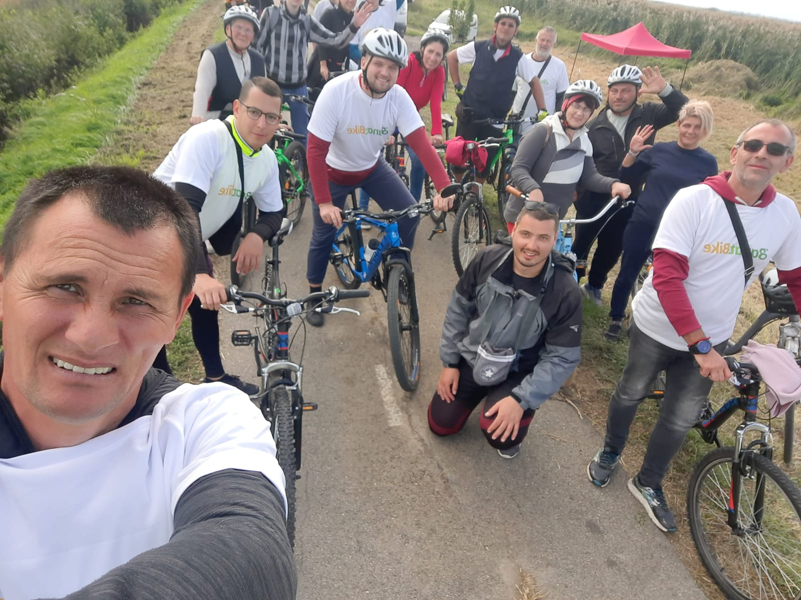

the implementation period (including extensions)
total funds spent/total funds contracted *100
indicators and level of achievement against targets set

