Project information
CALL FOR PROPOSALS | 2
e-MS Code: | RORS-375
PRIORITY AXIS: | 2 Environmental protection and risk management
OBJECTIVE: | 2.1 Environmental risks management and emergency preparedness
PROJECT TITLE: | Firefighting service in cross-border cooperation
ACRONYM: | FSCBC
DURATION: | 20.09.2019 - 19.09.2021 (24 months)
Interreg-IPA  FUNDS CONTRACTED: | €1 467.017,72
TOTAL FUNDS CONTRACTED: | €1 725.903,21
ABSORPTION RATE (%): | 92%
PROJECT OBJECTIVE(S): | The project's overall objective was to protect the area in the cross-border region from natural disasters and reduce the impact in case such a disaster occurs by enhancing awareness of the environmental risks, acting on the basis of an accurate strategy and using efficient tools.
SHORT DESCRIPTION OF THE PROJECT: | Firefighting service in cross-border cooperation - was a project that stressed the main problems the two cross-border partners involved confront regarding natural disasters. The project focused on the measures that need to be undertaken in order to prevent such disasters by developing and implementing an effective Plan. This document described the situation then and identified the risk areas by leading a campaign informing the inhabitants regarding natural disasters. The campaign increased public awareness of environmental risks. Another measure was to purchase innovative systems, tools and equipment to minimize the adverse effects of floods, fires, earthquakes, landslips etc.  The project brought together two cross-border partners: the city of Bor - the administrative centre of the Bor District in eastern Serbia, and from the Romanian side: Giarmata - a commune in Timiș County. The reason for developing these partnerships resides in the partners' similarities regarding climate, land, vegetation, culture, the inhabitant's desire to protect the environment, and, most importantly, both partners are confronting the same significant common challenges regarding the environmental risks and emergency situation.  The actions taken during this project protected the environment and the people using this equipment, who endangered their lives to save others.  Cooperation is necessary through a joint commitment based on a shared vision and a common set of measures to protect the project area efficiently.
DEGREE OF ACHIEVEMENT OF INDICATORS: | 7 infrastructure, equipment built/ installed/ modernized in the field of cross border services for environmental protection. 100%  1.200 participants attended project initiatives and events for information and awareness rising. 100%  1 study elaborated in the field of environmental protection and emergency management (technical and scientific studies, researches in the relevant fields). 100%  1 monitoring system established/ extended/ modernized in the eligible area in the field of environmental protection and emergency management. 100%  6.502 population members benefitted from flood protection measures. 100%
RESULTS ACHIEVED: | 7 equipment built/ installed/ modernized in the field of cross border services for environmental protection. 100%  1.200 participants attended project initiatives and events for information and awareness raising. 100%  1 study regarding the environmental protection and emergency management elaborated.100%  1 monitoring system for the climate set up in the project area. 100%  6.502 people benefitted from flood protection measures. 100%

Partnership information
 |  | COUNTRY | COUNTY/DISTRICT | BUDGET(EURO) | CONTACT DETAILS
LEAD PARTNER: | MUNCIPALITY of BOR | SERBIA | Borski | 884.215,71 | Mose Pijade no. 3, 19210, Bor  officegroup83@gmail.com
PARTNER 2: | Giarmata Commune | ROMANIA | Timis | 841.687,50 | Principală no. 445, 307210, Giarmata  primaria.giarmata@yahoo.com

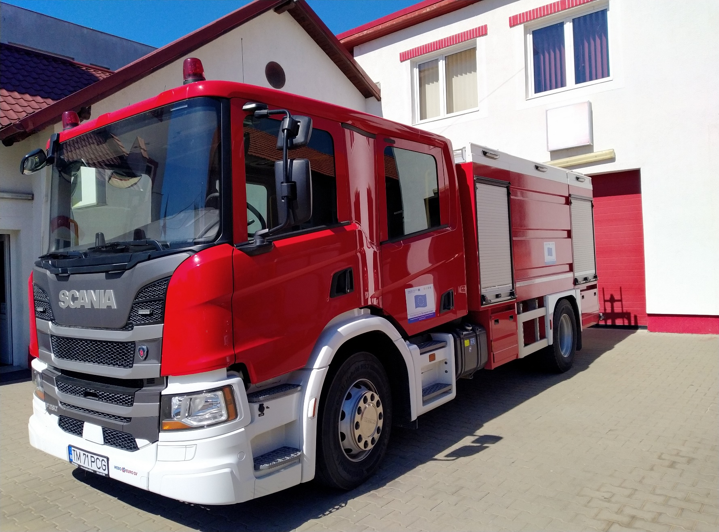
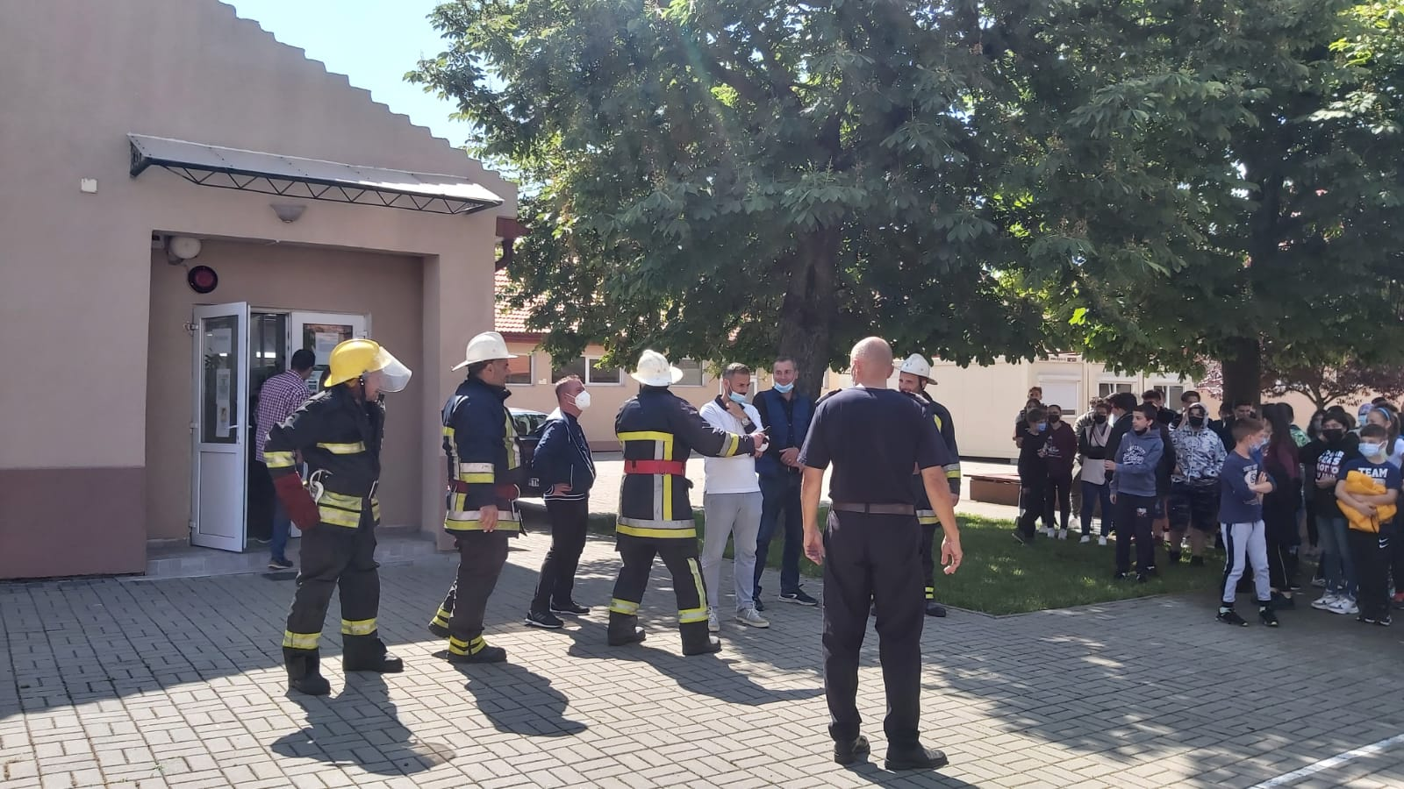
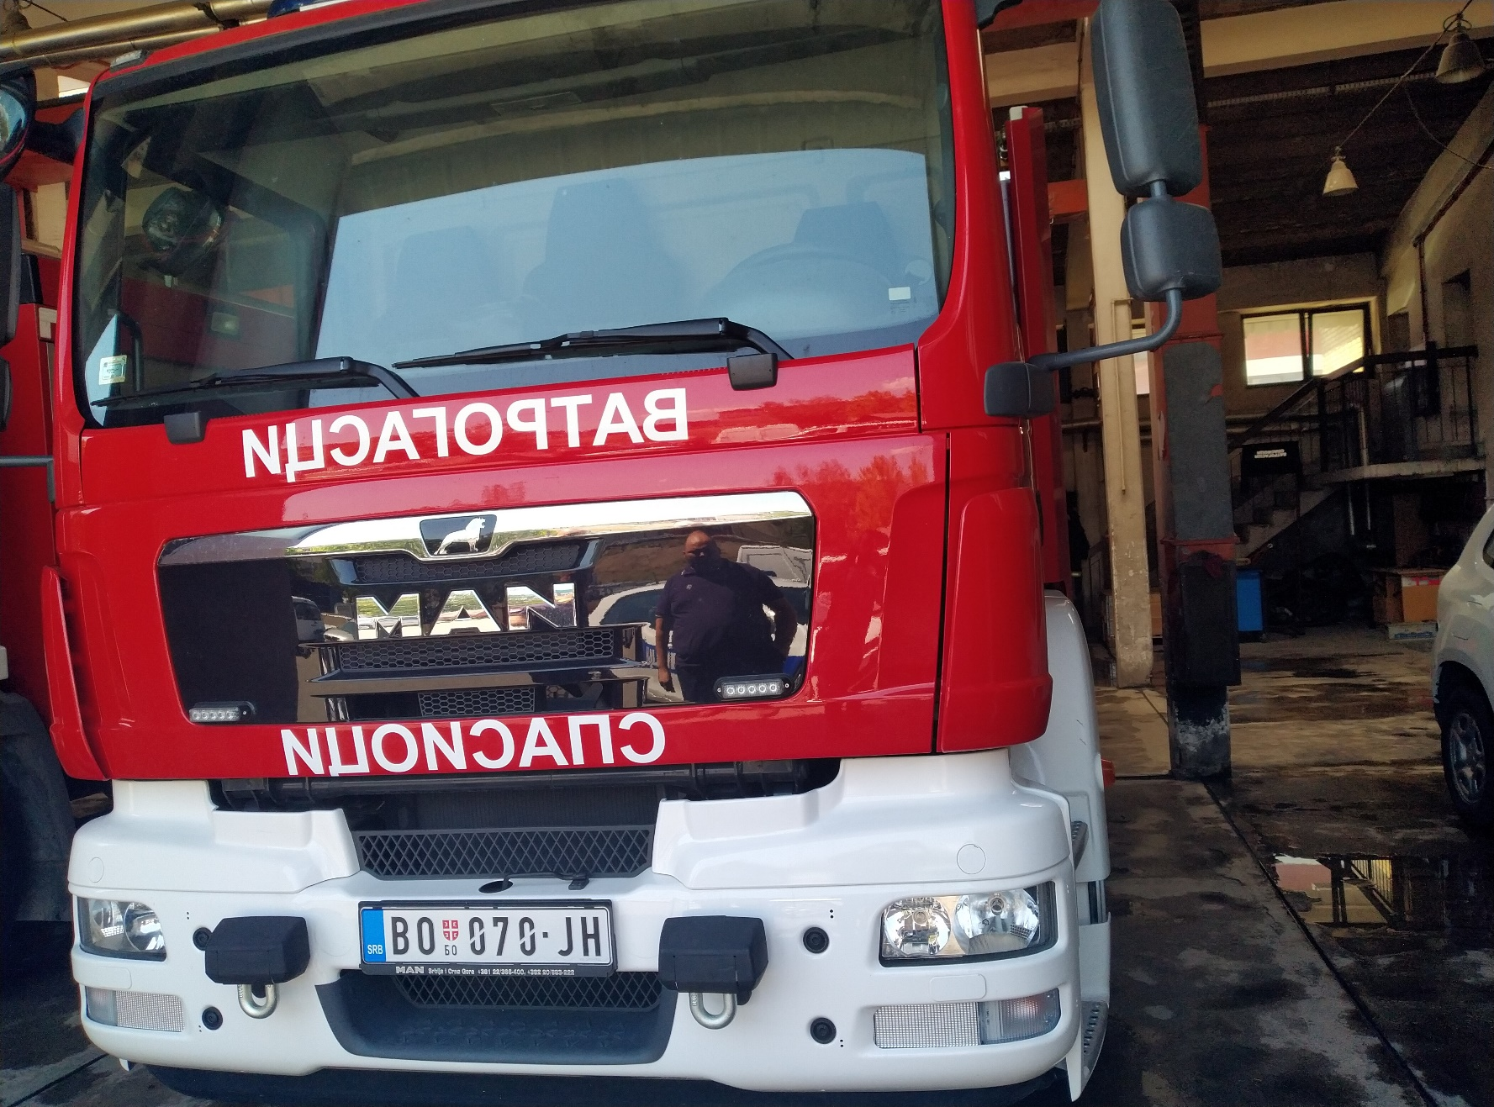
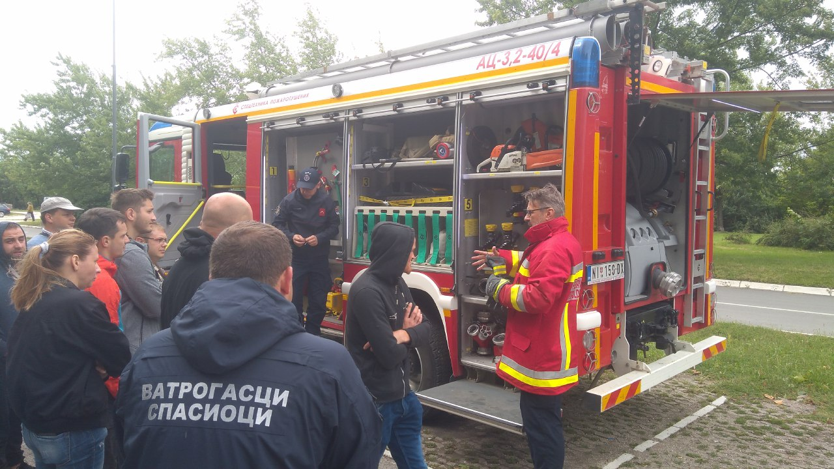
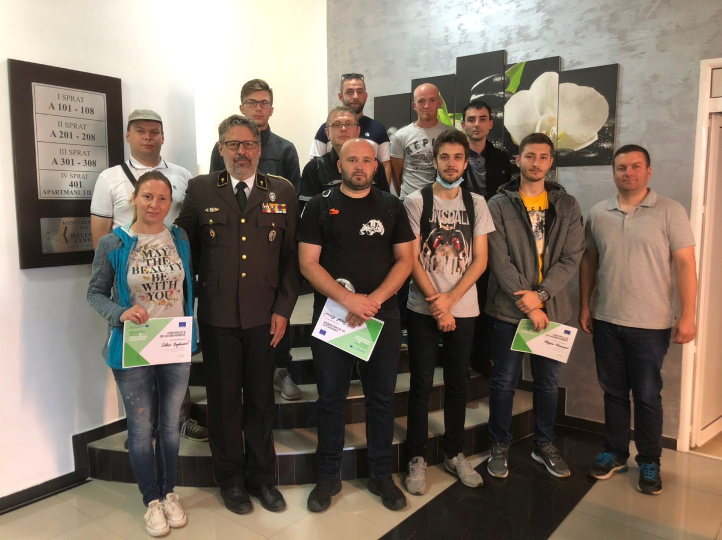

the implementation period (including extensions)
total funds spent/total funds contracted *100
indicators and level of achievement against targets set

