Project information
CALL FOR PROPOSALS | 2
e-MS Code: | RORS-373
PRIORITY AXIS: | 2 Environmental protection and risk management
OBJECTIVE: | 2.1 Environmental protection and sustainable use of natural resources
PROJECT TITLE: | Ecosystems Rehabilitation and Preservation of Natural Values in Jimbolia and Kikinda
ACRONYM: | ECOLAKES
DURATION: | 03.04.2021 – 02.08.2023 (28 Months)
Interreg-IPA  FUNDS CONTRACTED: | €669.576,42
TOTAL FUNDS CONTRACTED: | €787.736,97
ABSORPTION RATE (%): | 98,53%
PROJECT OBJECTIVE(S): | The ECOLAKES project’s main objective was to enhance environmental protection and sustainability in the cross-border region by rehabilitating environmental sites and raising ecological awareness.
SHORT DESCRIPTION OF THE PROJECT: | The Old Lake of Kikinda is a beautiful natural space and a favourite place to rest and relax. Some time ago, the local public authorities decided to improve the condition of this natural oasis within the municipality. Kikinda joined forces with their neighbours from Jimbolia to rehabilitate the ecological sites within a cross-border project.  The Lakes in Jimbolia and Old Pond in Kikinda went through rehabilitation works that contained the greening of lake areas, installation of water purifiers, and development of a social area for inhabitants.  The team organized an awareness raising campaign for the inhabitants of the two localities. The campaign's objective was to raise the level of knowledge on topics related to environmental protection. It targeted different groups, from preschool kids to adults.  Radio Ami Kikinda and Gradski online news site covered this story. Here: https://bit.ly/34MyGkl and here: https://bit.ly/3CQlibA  Children from Kikinda and Jimbolia had also something to say through their drawings about the environment and cooperation:  https://www.facebook.com/100075847171554/videos/1416827812168064  As part of the "Ecolakes" project, the Municipality of Jimbolia organized an exhibition of art works created by preschool children from Kikinda and Jimbolia. The exhibition was held on the 7th of June 2022 and it was a continuation of exhibition held in Kikinda two weeks before.
DEGREE OF ACHIEVEMENT OF INDICATORS: | 1 of 4 Infrastructure, equipment built/ installed/ modernized in the field of cross border services for environmental protection (25%)  330 participants to project initiatives and events for information and awareness rising 100%  2 studies in the field of environmental protection and emergency management. (technical and scientific studies, researches in the relevant fields)  8 participants to capacity building initiatives
RESULTS ACHIEVED: | 1 landscaped Old pond in Kikinda.  1 rehabilitation of lakes in Jimbolia.  2 of 2 purchased equipment (bird watching equipment in Jimbolia) (100%)  350 participants gained knowledge about the environmental protection through educative events. (106%)  2 scientific assessments carried through environmental studies/technological design: The role of the ring canals HCN232 and HCN305 of Jimbolia as potential factors in the protection and conservation of the aquatic habitats within the lakes area in Jimbolia and Technological design of the water purification in the peripheral channel and in the Old Lake.  8 institutions participating in an environmental network on municipal administration level.  https://ecolakes.rs/

Partnership information
 |  | COUNTRY | COUNTY/DISTRICT | BUDGET(EURO) | CONTACT DETAILS
LEAD PARTNER: | Municipality of Jimbolia | Romania | Timis | 374.659,85 | 81 Tudor Vladimirescu street, 305400, Jimbolia  primar.postelnicu@jimbolia.ro
PARTNER 2: | City of Kikinda | Serbia | Northern Banat | 413.077,12 | 12 Trg srpskih dobrovoljaca, 26300, Kikinda  predsednik@kikinda.org.rs

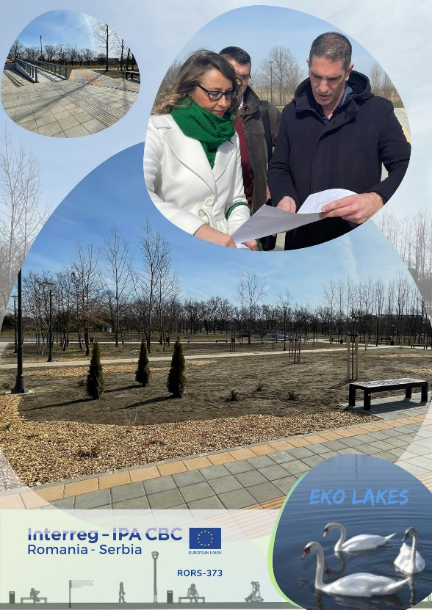
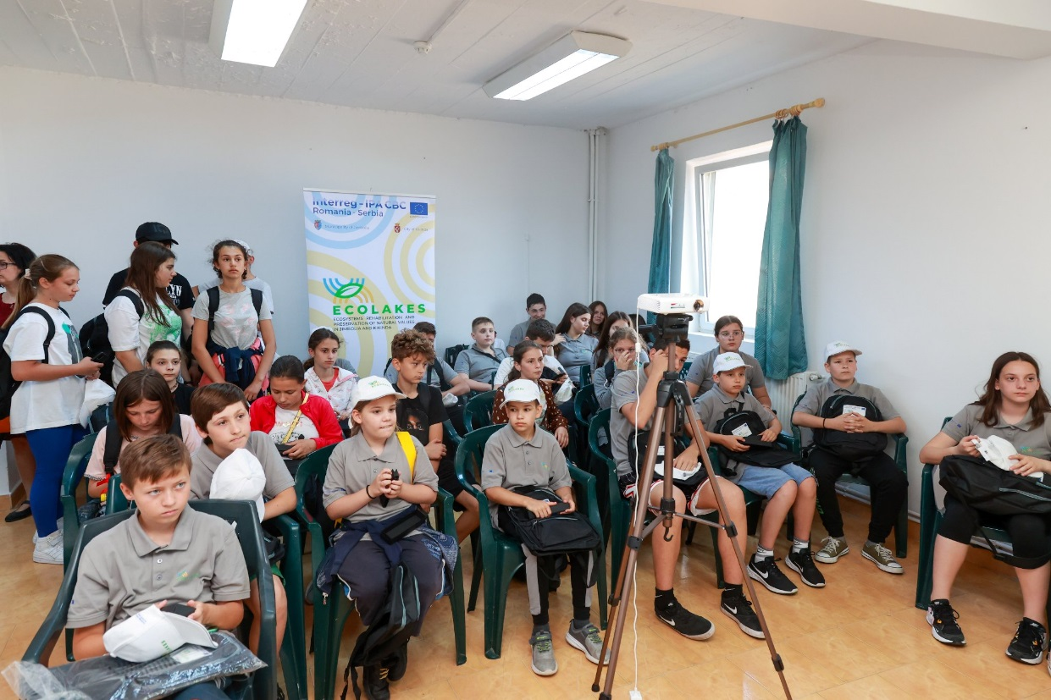
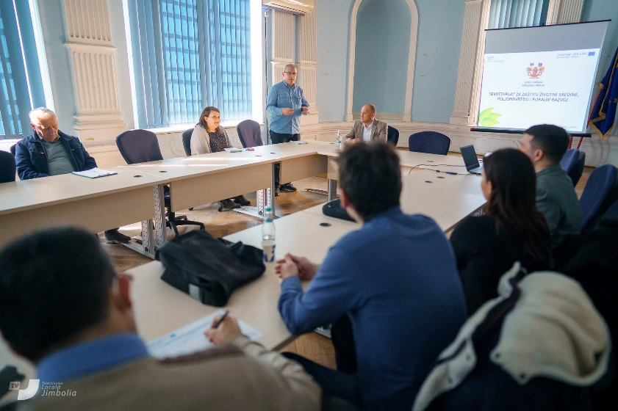

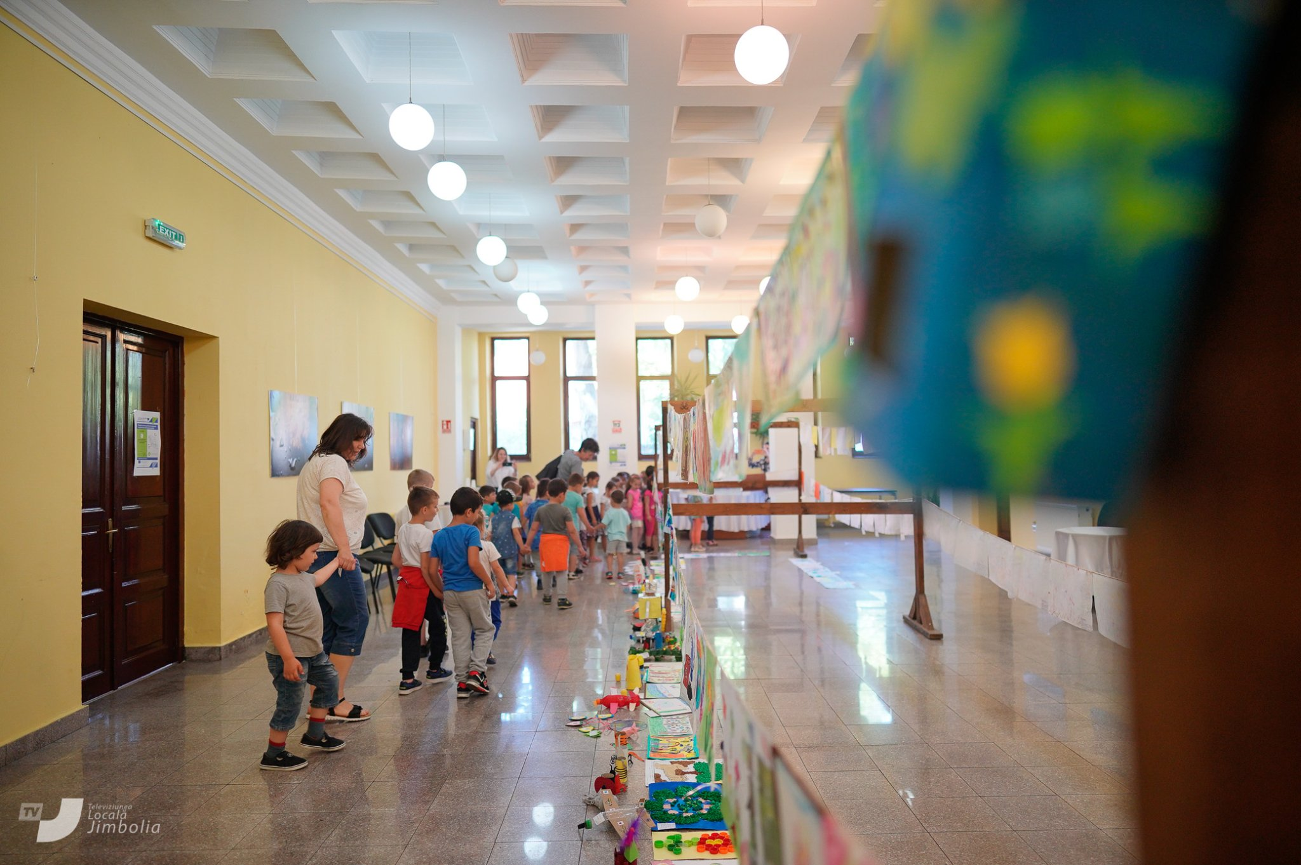

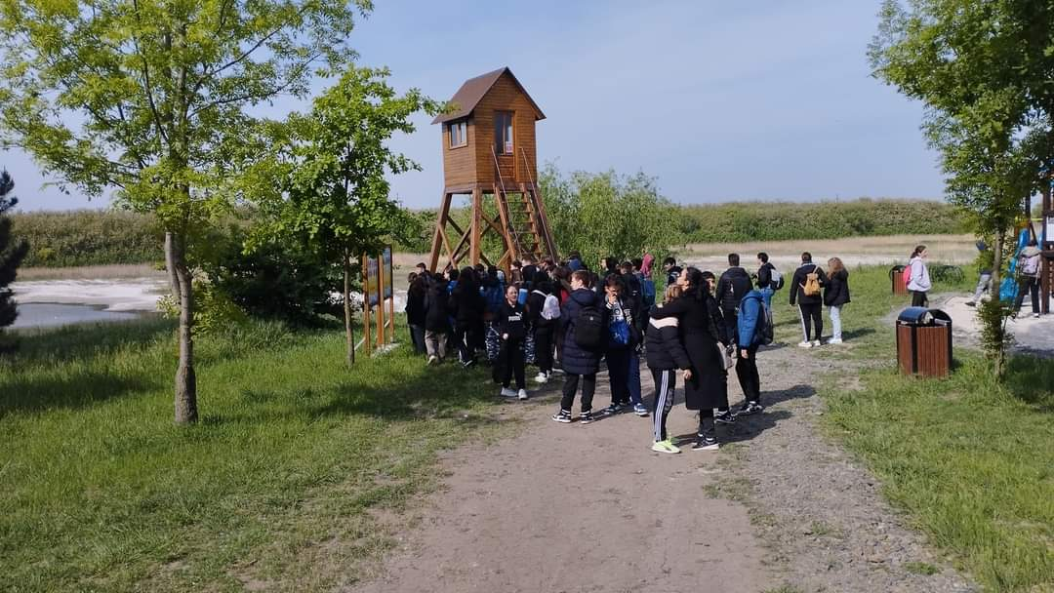
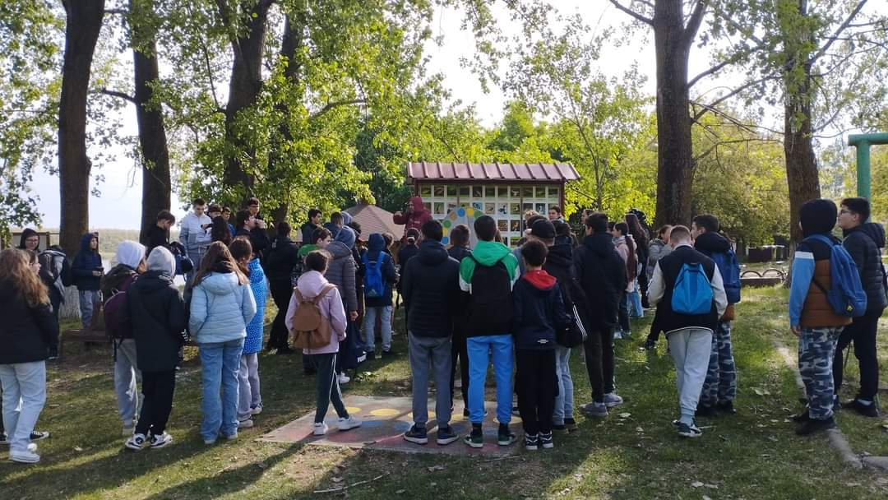
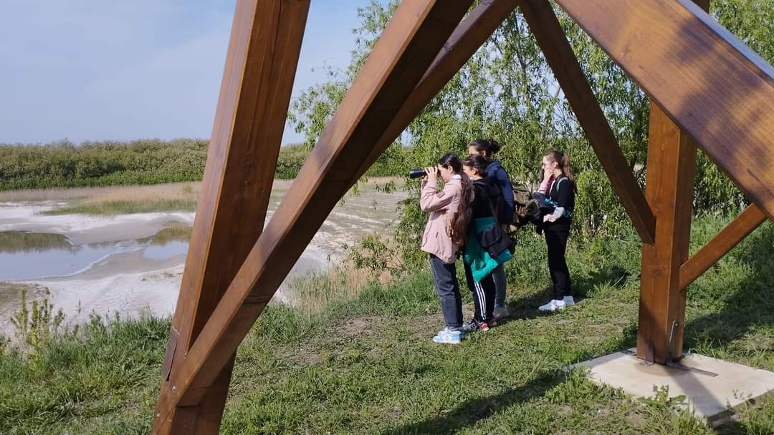
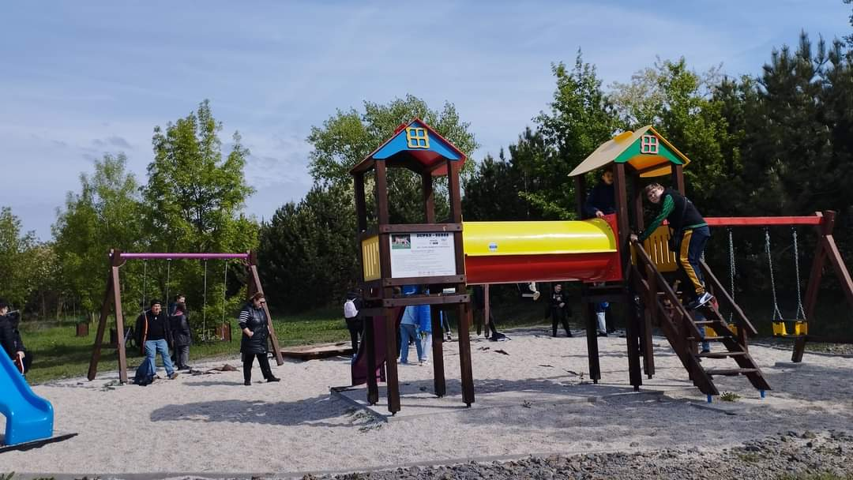
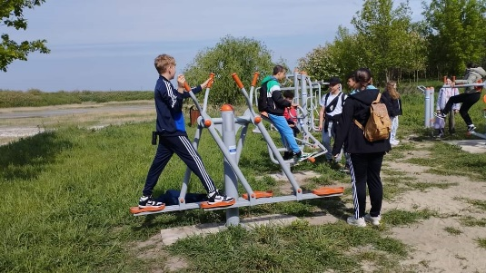
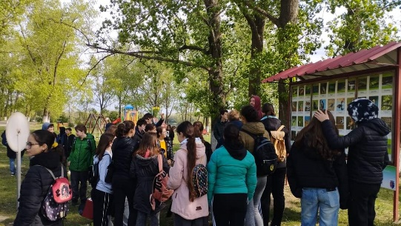
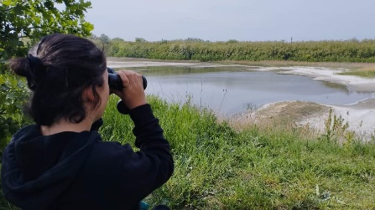

the implementation period (including extensions)
total funds spent/total funds contracted *100
indicators and level of achievement against targets set

