Project information
CALL FOR PROPOSALS | 2
e-MS Code: | RORS-365
PRIORITY AXIS: | 2 Environmental protection and risk management
OBJECTIVE: | 2.1 Environmental protection and sustainable use of natural resources
PROJECT TITLE: | Modern technologies for monitoring land covered with waste in order to restore their initial use
ACRONYM: | EnvDron
DURATION: | 18.09.2019 – 17.06.2021 (21 Months)
Interreg-IPA  FUNDS CONTRACTED: | €839.838,92
TOTAL FUNDS CONTRACTED: | €988.045,80
ABSORPTION RATE (%): | 85,95 %
PROJECT OBJECTIVE(S): | The main objective of the project was to identify and remediate the illegal landfill of waste in the cross-border area in order to restore the initial land use. For this purpose, drones equipped with state-of-the-art modern technology for the detection of illegal waste dumps was used, and after the sanitation was carried out, analyses of the soil and water health if contamination was suspected was carried out. The common challenge within the project was to locate, sanitize and maintain the sanitary land in the cross-border area in order to maintain a protected and healthy environment.
SHORT DESCRIPTION OF THE PROJECT: | The most important challenge of the project was to find illegally located waste in the cross-border area, to eliminate them, to assess the possible contamination of soil and water in order to restore the land to its initial use. This extensive project aimed to protect the environment by restoring the land in the border area, and help improve compliance with EU waste legislation in order to meet the EU targets. The project strengthened the local administrative capacity of Moldova Noua and Zrenjanin in order to improve the coordination and implementation of EU legislation, especially with regard to waste management and environmental protection.
DEGREE OF ACHIEVEMENT OF INDICATORS: | 51 monitoring systems established/ extended/ modernized in the eligible area in the field of environmental protection and emergency management. 100%
RESULTS ACHIEVED: | 12 land sanitation rendered to initial use. 100%  8 machinery and equipment 100%  10 equipment pieces. 100%  5 equipment accessories and specific consumables for chemical analysis. 100%  5 specific consumables for microbiology 100%  11 office equipment 100%
Partnership information
 |  | COUNTRY | COUNTY/DISTRICT | BUDGET(EURO) | CONTACT DETAILS
LEAD PARTNER: | Branch of Agricultural Mechanical Engineers in Romania BAMER Timisoara | Romania | Timis | 144.528,30 | 1989 Revolution avenue, no.15A, Timisoara  Tel: + 40256499336  E-mail: inmatm_caba@yahoo.com
PARTNER 2: | Public utility company “ Cleanliness and greenery”, Zrenjanin, Republic of Serbia | Serbia | Srednjebanatski | 473.203,50 | Beogradska no. 17, Zrenjanin  Tel: + 38123522350  E-mail: bojana.savic@jkpciz.co.rs
PARTNER 3: | Moldova Nouă City | Romania | Caraş-Severin | 202.944,00 | Nicolae Bălcescu, no. 26, Moldova Nouă  Tel: + 40786879303  E-mail: proiecteeuropene@moldovanoua.com
PARTNER 4: | University of Agricultural Sciences and Veterinary Medicine of Banat "King Mihai I of Romania" from Timisoara | Romania | Timis | 167.370,00 | Calea Aradului, no. 119, Timisoara  Tel: + 40742139774  E-mail: pirvulescu_l@yahoo.com

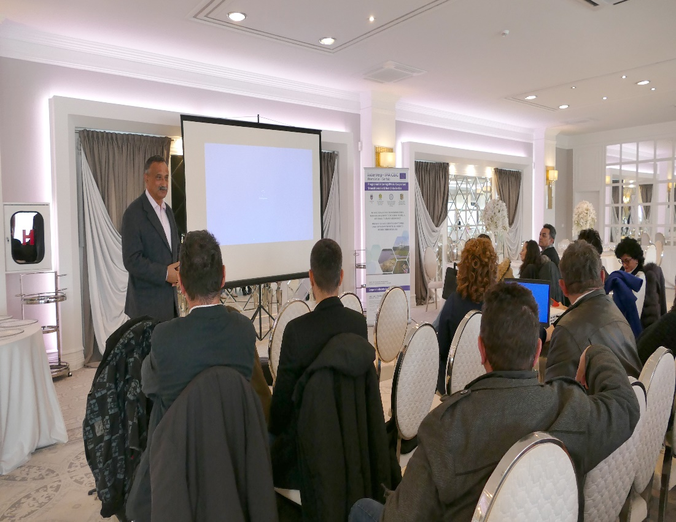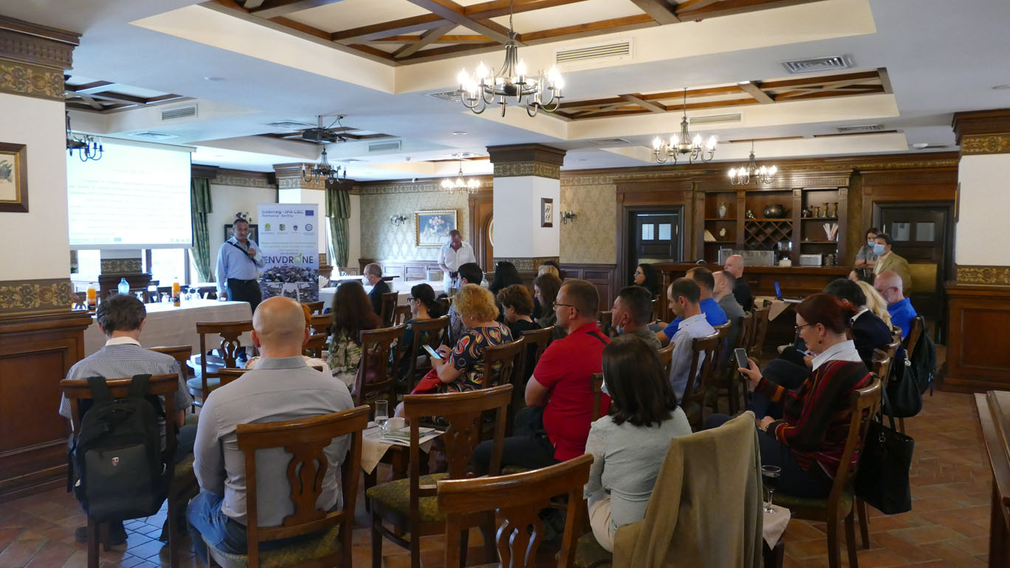

the implementation period (including extensions)
total funds spent/total funds contracted *100
indicators and level of achievement against targets set

