Project information
CALL FOR PROPOSALS | 2
e-MS Code: | RORS-363
PRIORITY AXIS: | 2 Environmental protection and risk management
OBJECTIVE: | 2.1 Environmental protection and sustainable use of natural resources
PROJECT TITLE: | Green economy for greener local communities in Danube area
ACRONYM: | The greener Danube
DURATION: | 28.08.2019 – 27.08.2021 (24 Months)
Interreg-IPA  FUNDS CONTRACTED: | €504.378,00
TOTAL FUNDS CONTRACTED: | €428.721,30
ABSORPTION RATE (%): | 70%
PROJECT OBJECTIVE(S): | The project established a strategic framework for increasing the competitiveness of the local economy, based on the use of sustainable energy and a joint cross-border platform for using renewable energy in the municipalities Dobreta-Turnu Severin and Kladovo.  The project established a partnership mechanism for joint capacity building and joint actions of public, business and civil sectors from the Municipality of Dobreta - Turnu Severin and Municipality of Kladovo in sustainable energy development.
SHORT DESCRIPTION OF THE PROJECT: | Global warming and high temperatures have unprecedented consequences in our lives. By using energy from renewable sources, we can combat climate change and reduce greenhouse gas emissions.  The project supported using renewable energy sources (RES), reduction emission of greenhouse gasses (GHG), environment protection and employment and innovation through an energy hub and cross-border cooperation.  Therefore, the project improved the use of renewable energy sources and reduced the emission of greenhouse gasses through the establishment of a strategic framework, the installation of solar systems and the modernization of the public lighting system in the municipalities of Dobreta-Turnu Severin and Kladovo. The two neighbouring cities set up a more sustainable future for their youngest citizens, using an alternative power supply for the public buildings selected to be part of a Romanian-Serbian cross-border project.
DEGREE OF ACHIEVEMENT OF INDICATORS: | 111 infrastructure, equipment built/ installed/ modernized in the field of cross border services for environmental protection. 100%  663 participants attended project initiatives and events for information and awareness rising. 110%  23 studies in the field of environmental protection and emergency management elaborated (technical and scientific studies, researches in the relevant fields). 100%  90 participants attended capacity building initiatives. 100%  41 monitoring systems established/ extended/ modernized in the eligible area in the field of environmental protection and emergency management. 100%
RESULTS ACHIEVED: | 40 participants attended two two-day workshops for the development of joint tools and techniques to encourage sustainable use of natural resources. 100%  1 document “Joint tools and techniques to encourage sustainable use of natural resources” elaborated. 100%  1 cross-border network of information and communications built for the identification and transfer of local innovation in the use of renewable energy with minimum 10 members. 100%  5 identified local innovative initiatives in the use of renewable energy. 100%  2 offices equipped as communication points. 100%  3 workshops organized for the preparation the Sustainable Energy Action Plan and 1 Sustainable Energy Action Plan made. 100%  1 study made about the available wooden biomass energy potential in the region of Drobeta Turn Severin and Kladovo. 100%  1 feasibility study and technical documentation prepared for using wooden biomass collected in dump of hydropower “Djerdap I” for heating. 100%  5 technical documentations for using renewable energy (heat pumps) in public institutions prepared. 100%  15 energy passports for public buildings in Drobeta Turn Severin and Kladovo Municipality made. 100%  12 public locations from the project area equipped with solar energy collectors (6 in Kladovo and 6 in Drobeta Turnu Severin). 100%  120 LED lamps installed for public lighting in Kladovo. 100%  - Energy Hub established. 100%  40 unemployed persons trained about green energy and self-built Solar Collectors. 100%  60 young people participated in a joint eco camp for youth about nature protection, sustainable energy and reduction of greenhouse gas (GHG) emissions. 100%

Partnership information
 |  | COUNTRY | COUNTY/DISTRICT | BUDGET(EURO) | CONTACT DETAILS
LEAD PARTNER: | Municipality of Kladovo | Serbia | Borski | 407.421,00 | Kralja Aleksandra 35, 19320, Kladovo  Phone: +38119808066  E-mail: opstina@kladovonet.com
PARTNER 2: | Municipality of Drobeta Turnu Severin | Romania | Mehedinti | 96.957,00 | Maresal Averescu street no 2, 220131 Drobeta Turnu Severin

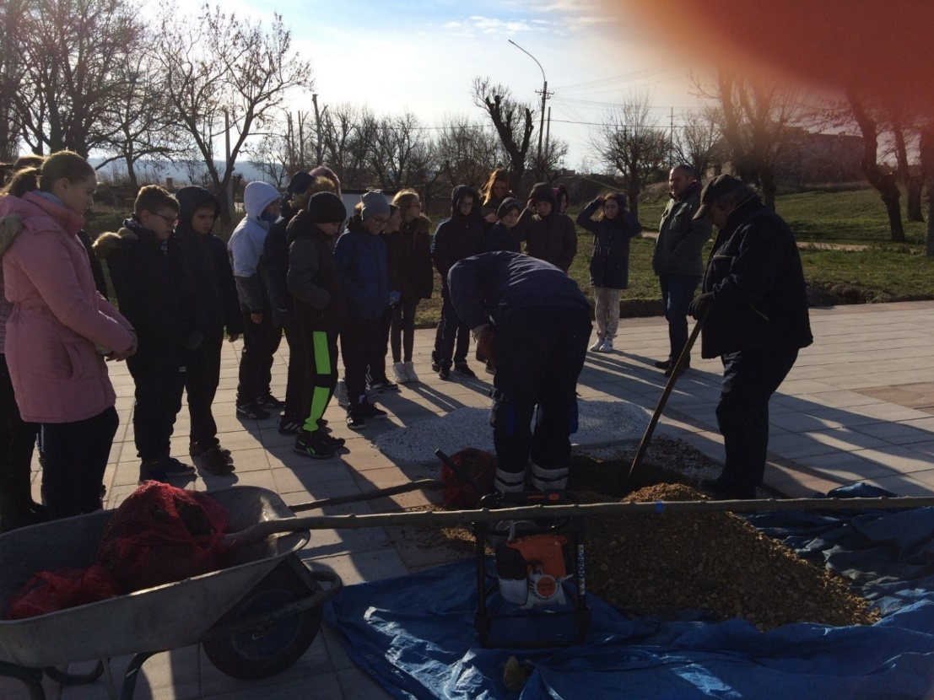
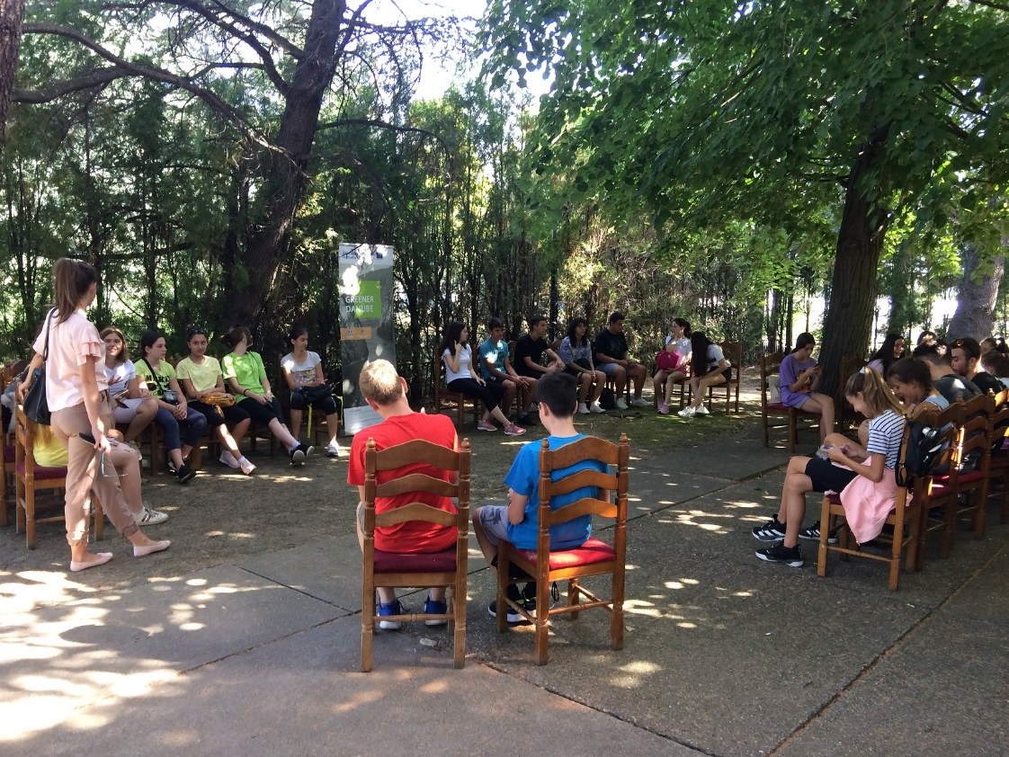

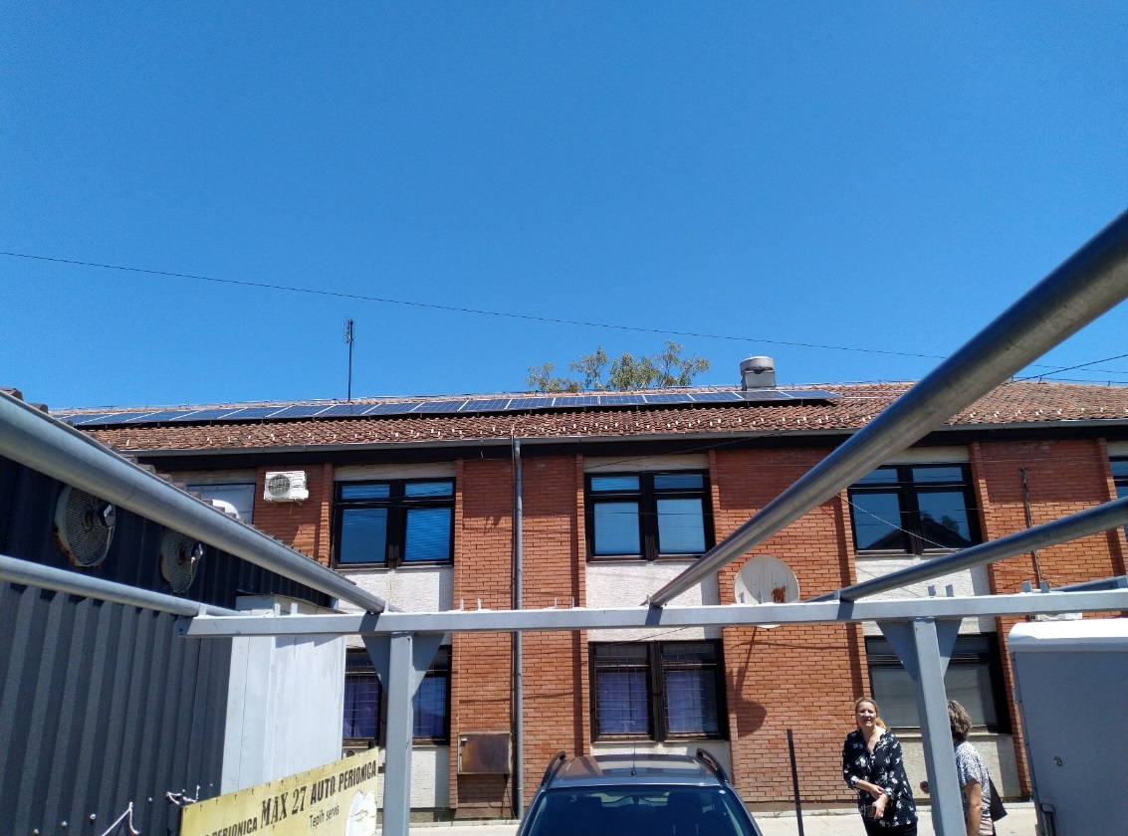
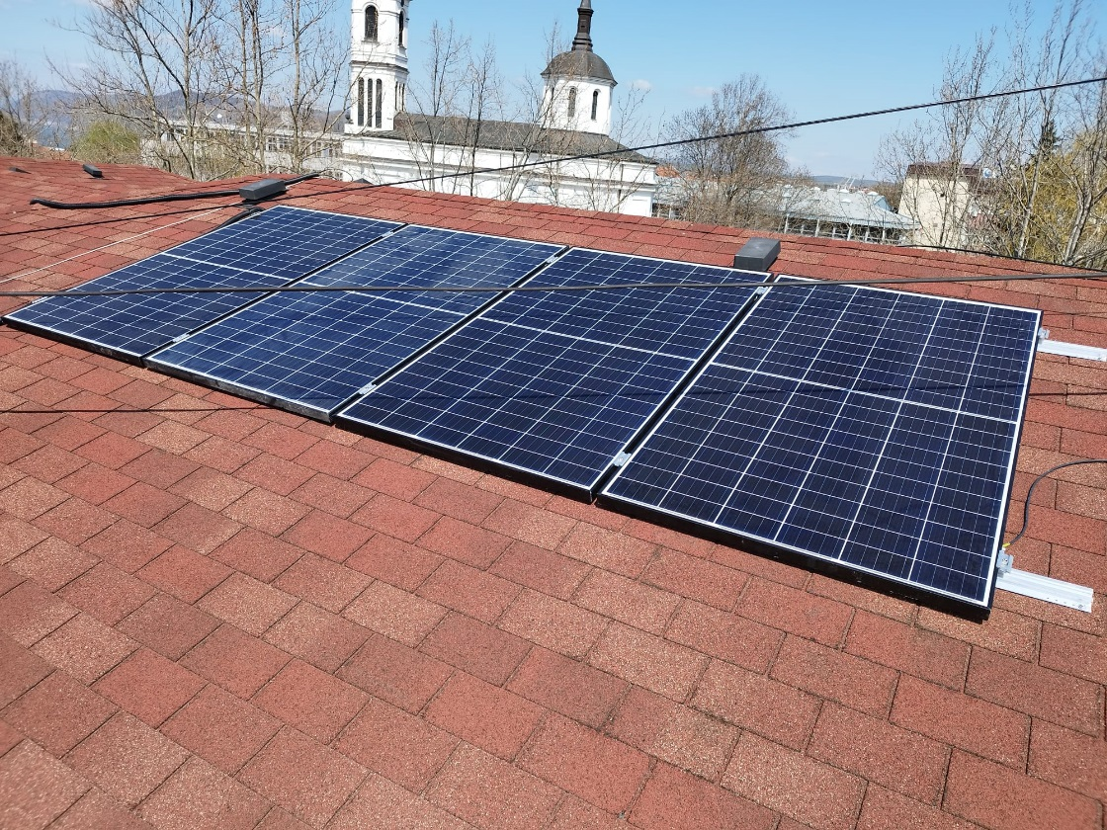

the implementation period (including extensions)
total funds spent/total funds contracted *100
indicators and level of achievement against targets set

