Project information
CALL FOR PROPOSALS | 1
e-MS Code: | RORS-36
PRIORITY AXIS: | 3 Sustainable mobility and accessibility
OBJECTIVE: | 3.2 Public utilities infrastructure
PROJECT TITLE: | Smart Urban Services Through Homogenous Quality Standard in Public Infrastructures for Higher Energy Efficiency
ACRONYM: | BANATSMART
DURATION: | 14.07.2017 - 13.10.2019 (27 months)
Interreg-IPA  FUNDS CONTRACTED: | €1.386.780,77
TOTAL FUNDS CONTRACTED: | €1.631.506,80
ABSORPTION RATE (%): | 86,48 %
PROJECT OBJECTIVE(S): | Ensuring high quality and homogenous public lighting infrastructure both in Romania and Serbia.  Reduction of the energy consumption in the public lighting system and the global energy expenditure of the municipalities.  Raising awareness about energy savings and usage of renewable energy sources in the cross-border area.
SHORT DESCRIPTION OF THE PROJECT: | In Europe, street lighting consumes a significant amount of electricity: more than 56 million street lighting luminaires are in operation, with an estimated electricity consumption of 35 TWh. For municipalities with older, inefficient systems, street lighting can account for 30-50% of their total electricity consumption. However, the savings potential is enormous: 30-70% of energy savings are generally possible with current technologies. This savings potential has been recognized and incorporated into European policies. EC Regulation 245/2009 sets phasing out requirements for various frequently used street lamp types between 2012 and 2017. Phasing out means that these product groups will no longer be placed on the market or available for purchase. The recent market introduction of LED technology for street lighting offers high savings with comparatively short pay-back times. LED technologies have developed very rapidly, especially in the last few years. Today, with cost reduction potentials of over 50%, LED lighting is already an economically exciting option for street lighting refurbishment. Moreover, street lighting refurbishment presents a unique opportunity for the uptake of guaranteed energy services in the form of energy performance contracts (EPC):  - Phasing out is placing municipalities under pressure to act: nearly 80 % of all currently used lamps types will not be available after 2017,  - Street lighting refurbishment, especially with the availability of LED and other innovative solutions that are economically attractive and offer a relatively low level of complexity, presents a low-risk entry point into the provision of EPC services for SMEs.  Since Romania is a member of the EU and Serbia is a candidate country, this is the opportunity to show other regions that joint cross-border work in this field is possible and sustainable, especially when discussing energy savings and environmental protection. Also, having in mind that Romania has to apply EU regulation, in the following years, the same regulations will have to be obtained and respected by Serbia. The Municipality of Plandiste and the Municipality of Recas are very similar. They share approximately the same number of inhabitants; both are agricultural municipalities and have the same possibilities regarding renewable energy (thermal waters, wind energy, and the opportunity to use power from biogas).
DEGREE OF ACHIEVEMENT OF INDICATORS: | Cross-border cooperation structures supported in the field of transport and public utilities - 100 %  Investments in transport and utilities infrastructure, including improvement, enhancement of existing infrastructure – 100 %  Participants to information/ training/ awareness raising initiatives in the field of transport and public utilities – 151 %
RESULTS ACHIEVED: | 1 Energy Efficiency System implemented;  1 Public Lighting System installed in Recas, including a monitoring system;  2 Public Lighting Systems installed in Plandiste, including a monitoring system;  234 participants to the Round tables and Seminars.

Partnership information
 |  | COUNTRY | COUNTY/DISTRICT | BUDGET(EURO) | CONTACT DETAILS
LEAD PARTNER: | Municipality of Plandiste | Serbia | Juznobanatski | 667.663,50 | 38 Vojvode Putnika Street, 26360, Plandiste  office@plandiste-opstina.rs
PARTNER 2: | Municipality of Recas | Romania | Timis | 779.841,30 | 86 Calea Timisoarei Street, 307340, Recas  primariarecas@yahoo.com
PARTNER 3: | Timis County Energy Management Association | Romania | Timis | 131.334,00 | 17 Revolutiei din 1989 Blvd, 300034, Timisoara  adrian.balaci@amet.ro
PARTNER 4: | Regional Agency for Socio – Economic Development – Banat Ltd | Serbia | Srednjebanatski | 52.668,00 | 1 Čarnojeviceva Street, 23000, Zrenjanin  office@rcrbanat.rs

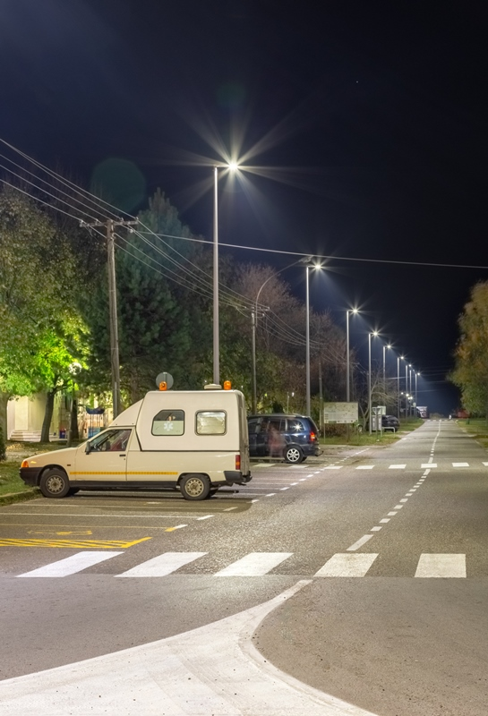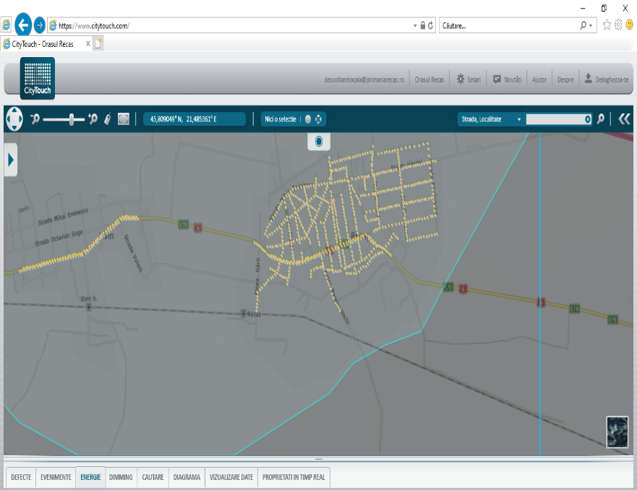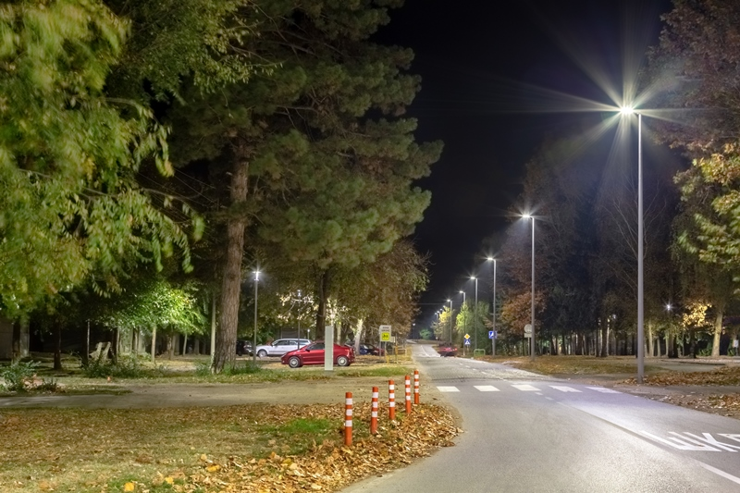

the implementation period (including extensions)
total funds spent/total funds contracted *100
indicators and level of achievement against targets set

