Project information
CALL FOR PROPOSALS | 2
e-MS Code: | RORS-353
PRIORITY AXIS: | 1 Employment promotion and services for an inclusive growth
OBJECTIVE: | 1.2 Health and social infrastructure
PROJECT TITLE: | Mental health care for the inclusive community growth
ACRONYM: | -
DURATION: | 19.06.2019 – 18.06.2021 (24 months)
Interreg-IPA  FUNDS CONTRACTED: | €645.143,62
TOTAL FUNDS CONTRACTED: | €758.992,50
ABSORPTION RATE (%): | 85,27%
PROJECT OBJECTIVE(S): | Community involvement to increase the access to improved mental health care and education for children in risk or with mental health disorders in the border area of Timis county, Romania and South Banat, Serbia.  Preventing the occurrence of mental health disorders or remedy their consequences by developing and delivering specialized intervention and support services for minimum 500 children and their families in the Timis-Plandiste area.
SHORT DESCRIPTION OF THE PROJECT: | The project aimed to increase the quality of life by implementing an integrated set of regional policies and effective prevention, intervention and compensation measures in cases of risk or mental health disorder in children in the Timis-Plandiste area. The usual practice of public institutions, kindergartens, schools, and even parents in rural areas (the entire border area Romania-Serbia) is to ignore the children`s needs, making diagnosis and intervention more delayed until the disorders become clinical. Unfortunately, the system remains focused on hospitals, with little primary and outpatient care, resulting in obsolete and ineffective care services. (European Commission,2016)  The project contributed to changing these systemic issues by setting up 2 Mental health Intervention and Support Centres, reachable and accessible in the community, for the community.  Based on the real needs of the community, the shortcomings of the public mental health system for children, and segregated practices in addressing the need of every child at risk or with mental health disorders, the three partners proposed an innovative model for addressing mental health problems in children by providing integrated support covering their immediate needs to overcome the challenging situation, informing the community and parents about mental health disorders and integrated multidisciplinary support, customized, according to the need of each child.  2 Mental health Intervention and Support Centers were established and became fully operational for the community. We organized workshops/training sessions for stakeholders, parents, teachers, and community members to meet information needs and raise awareness of the complex needs of children at risk or with mental health disorders and smart (green) growth opportunities (including 100 parents). Over 800 children had their mental health status assessed. Preventive measures (psychosocial activities/after-school educational activities) for 500 children and 250 parents and specialized intervention (medicine, clinical psychology, speech therapy, ergotherapy, kinetotherapy) for 100 children were provided.
DEGREE OF ACHIEVEMENT OF INDICATORS: | 550 citizens involved in project activities in cultural, social health care services. 117,45%  Investment in health care and social services infrastructure. 100%  Joint action targeting vulnerable groups (youth, women, disabled, ethnic minorities) established for the prevention of early school leaving, for cultural inclusion 100%  Joint actions targeting smart (green) growth opportunities 100%  500 people covered by improved health services 169,80%
RESULTS ACHIEVED: | One Mental health intervention and support centre with 4 cabinets compartmentalised appropriately to carry out preventive and specialized intervention activities. 100%  Establishment, development and modernization of 2 mental health care units (Mental Health Intervention and Support Centres) for the children in risk or with mental health disorders. 100%  A special interest group created to support the access to mental health care, educational and social services. 100%  Children at risk or with mental health disorders covered by improved and accessible mental health care services and smart growth activities. 104%  Parents of children at risk or mental health disorders involved in project activities in social, mental health care services and smart growth activities. 187%

Partnership information
 |  | COUNTRY | COUNTY/DISTRICT | BUDGET(EURO) | CONTACT DETAILS
LEAD PARTNER: | Rehabilitation Foundation Speranta | ROMANIA | Timis | 410.623,50 | Aurel Popovici no. 17, 300050, Timisoara  sebastian.bilanin@gmail.com
PARTNER 2: | Save The Children Timis Branch | ROMANIA | Timis | 169.554,00 | 1 Blv. Republicii, 300005 Timisoara  bajireanud@gmail.com
PARTNER 3: | Municipality of Plandiste | SERBIA | Juznobanatski | 178.815,00 | 38 Vojvode Putnika, 26360, Plandiste  rodika.grujesku@plandiste-opstina.rs

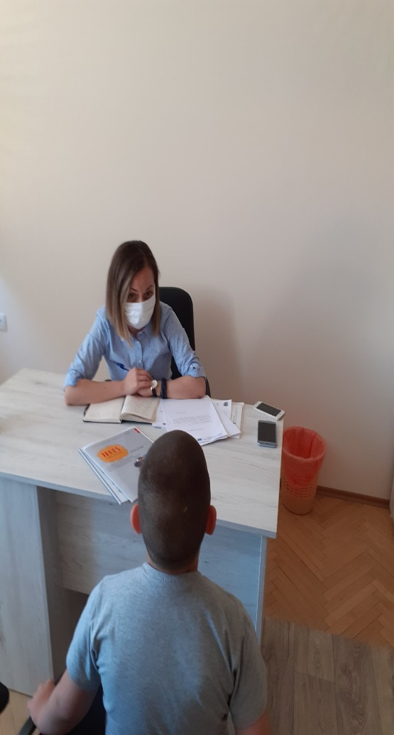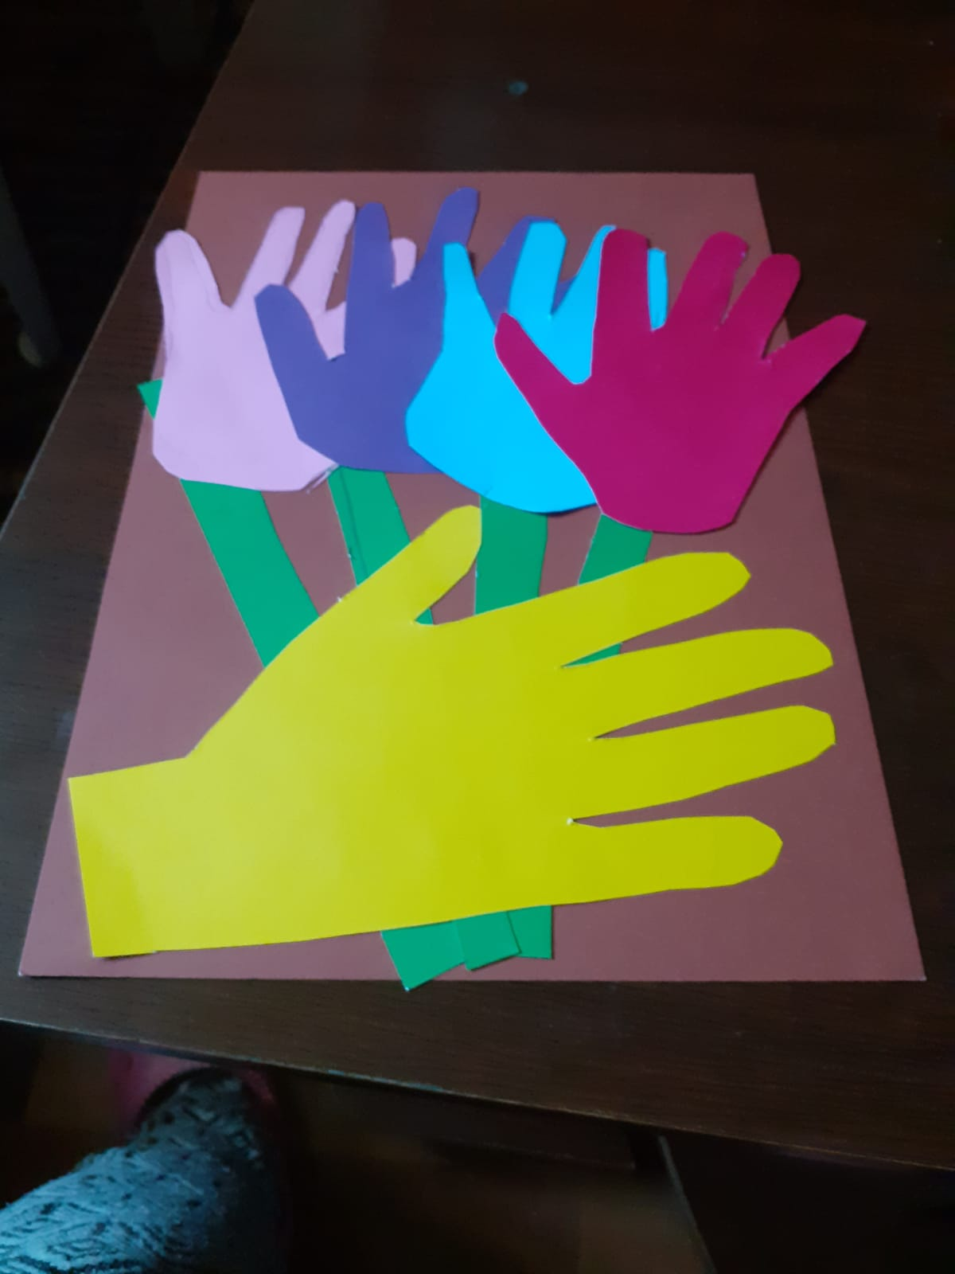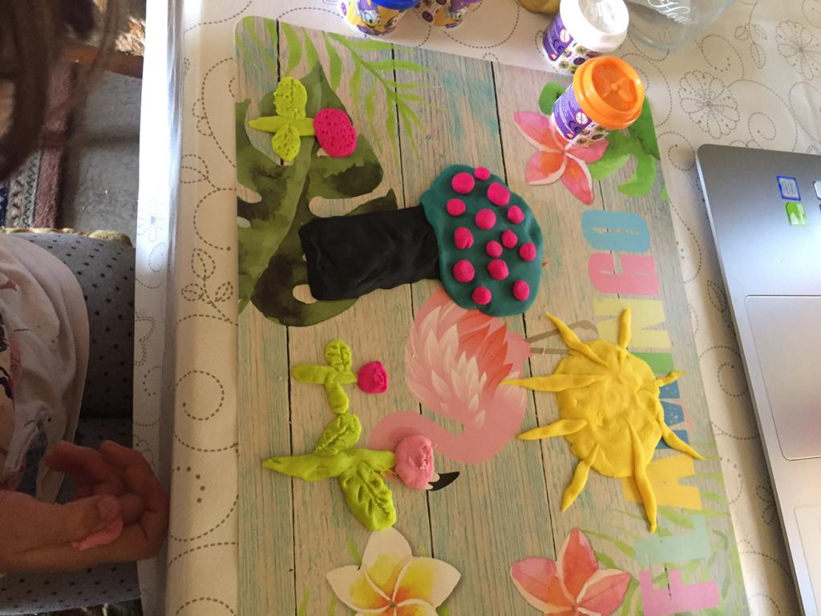

the implementation period (including extensions)
total funds spent/total funds contracted *100
indicators and level of achievement against targets set

