Project information
CALL FOR PROPOSALS | 2
e-MS Code: | RORS-350
PRIORITY AXIS: | 1 Employment promotion and services for an inclusive growth
OBJECTIVE: | 1.2 Health and social infrastructure
PROJECT TITLE: | Common approaches to enhanced early diagnosis and treatment of thyroid cancer in the population of partner areas
ACRONYM: | THYRO-SCREEN
DURATION: | 13.08.2019 – 12.02.2022 (30 Months)
Interreg-IPA  FUNDS CONTRACTED: | €882.559,93
TOTAL FUNDS CONTRACTED: | €1.038.305,80
ABSORPTION RATE (%): | 92.08%
PROJECT OBJECTIVE(S): | The project improved the quality of life for the people of the partner regions by jointly providing early, modern diagnosis and treatment of thyroid cancer. Early diagnosis and treatment reduce thyroid cancer's mortality and morbidity rate and the costs associated with medical services. Thus, the people in our communities remain active and healthy socially and economically.
SHORT DESCRIPTION OF THE PROJECT: | Thyroid cancer records a significant increase in new cases diagnosed worldwide. The incidence varies amongst geographical regions, the programme area being recognized as endemic for both benign and malignant thyroid pathology. The common challenge of this project was that the population's low level of medical education, as well as the common habits and socio-economic structures, imply, in most cases, a late diagnosis of thyroid cancer, along with a poor prognosis, requiring sustained efforts and increased healthcare costs. The early diagnosis and treatment of this pathology increase the quality of life and patient survival, as well as decrease medical expenditure and maintain a socially apt and economically active individual. The overall objective of the project was to offer residents an enhanced preventive care service through the primary medicine segment. The main outputs were: a cross-border platform for the early diagnosis and treatment of thyroid cancer; modernization of healthcare centres; improved quality of primary healthcare and increased access to specialized medical services; raised awareness of the general population regarding thyroid pathology; furthering of current medical knowledge by dissemination of the project results. The approach of this project was based on a three-level system. The first level involved the general practitioners who selected from the general population only those patients presenting known risk factors for developing thyroid cancer. Subsequently, general practitioners evaluated this group through cervical ultrasound and based on a novel scoring system, they assessed the need for a specialized consult. The second level was represented by endocrinologists who decided the patients' risk of thyroid cancer and whether they should be monitored or treated. Surgeons who offered surgical therapy in selected cases were at the third level, allowing for a definitive diagnosis through a histopathological analysis. Although the populations of the project area share a similar background and risk factors, the medical systems differ significantly. A cross-border approach reduced the bias and validated the proposed method of early diagnosis of thyroid cancer. The joint effort increased the quality of medical services and enabled sharing of knowledge and experience. Although the general practitioner is the first to come in contact with a patient, the medical systems of the partner areas need to encourage a complete primary diagnosis. The novelty lies in that this project furthers and supports the role of the general practitioner in early diagnosis and patient management, allowing for specialized secondary diagnosis and treatment of thyroid cancer.  In the screenings performed, the results showed that 57% of the conditions were benign and 25% malignant. Following histopathological tests, thyroid cancer was diagnosed in 35 % of cases.  https://www.facebook.com/profile.php?id=100063710237584  https://thyroscreen.ro/despre-proiect-2/
DEGREE OF ACHIEVEMENT OF INDICATORS: | 2270 citizens involved in project activities in cultural, social health care services (113,50%)  24 investments in health care and social services infrastructure (100%)  1 joint action targeting smart (green) growth opportunities (100%)  8356 - population covered by improved health services (298,43%)
RESULTS ACHIEVED: | 2270 citizens from the cross-border area benefited of early diagnosis and treatment of thyroid pathologies (113,50%)  5 regional healthcare centres involved in the diagnosis and treatment of thyroid pathologies modernized (100%)  14 pieces of medical equipment for Emergency Municipal Clinical Hospital Timisoara (100%)  5 pieces of medical equipment for Health Centre Veliko Gradiste (100%)  1 regional registry for thyroid pathology created (100%)  8356 people benefitted from the modernization of regional healthcare centres involved in the diagnosis and treatment of thyroid pathologies (298,43%)

Partnership information
 |  | COUNTRY | COUNTY/DISTRICT | BUDGET(EURO) | CONTACT DETAILS
LEAD PARTNER: | Emergency Clinical Municipal Hospital Timisoara | Romania | Timis | 891.949,80 | Hector Street, no. 1, postal code 300041, secretariat@smtm.ro
PARTNER 2: | Health Center Veliko Gradiste | Serbia | Branicevski | 146.356,00 | Vojvode Putnika street, no. 1, postal code 12220, domzvg@mts.rs

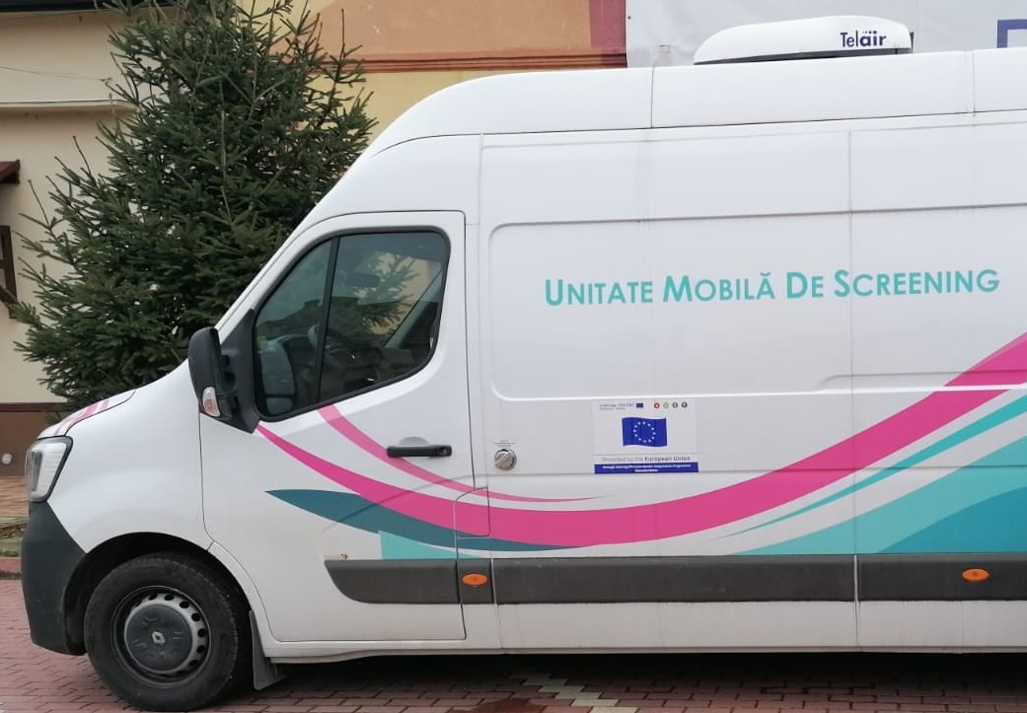
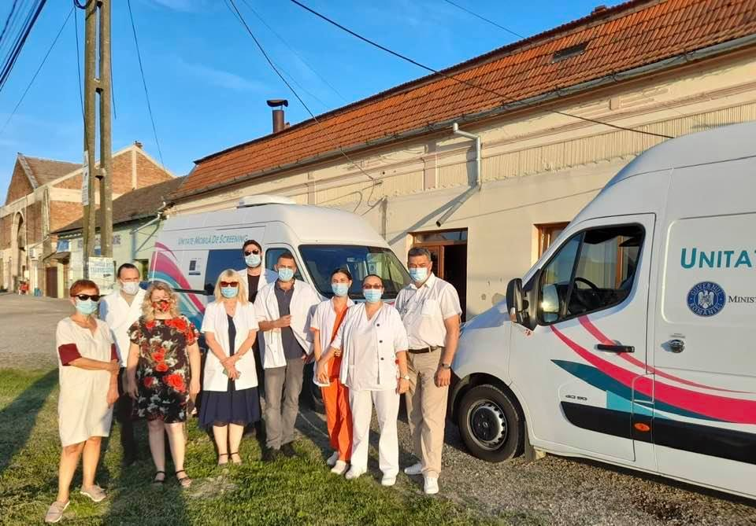

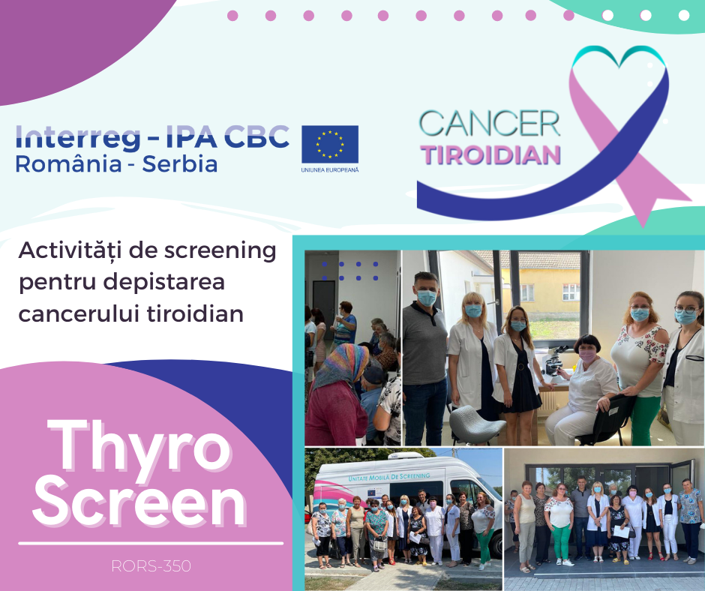
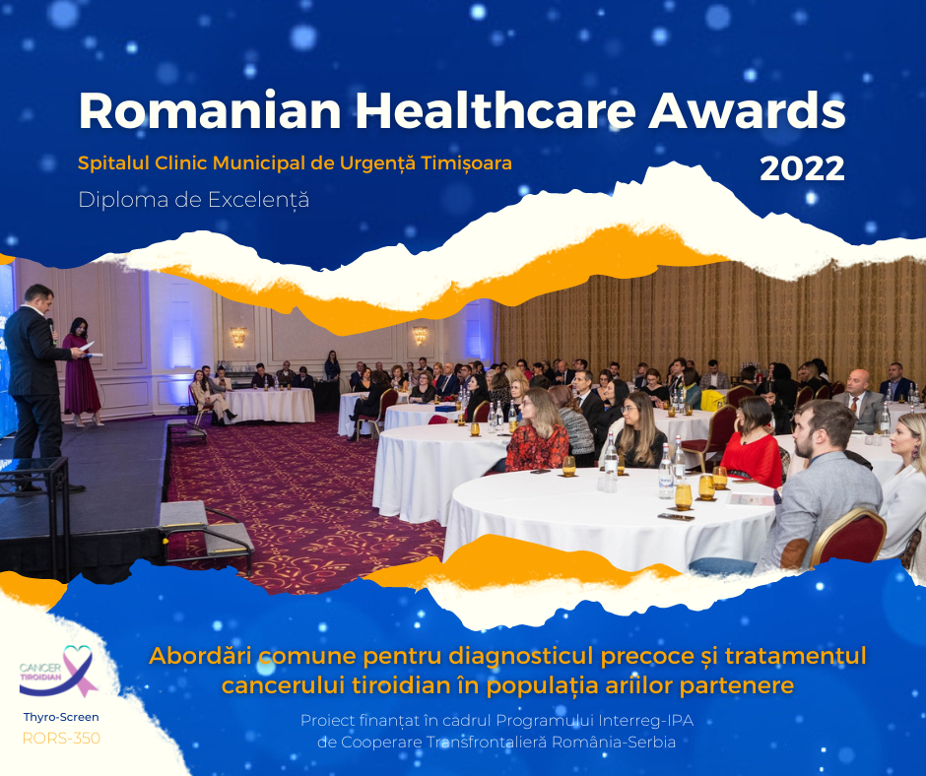
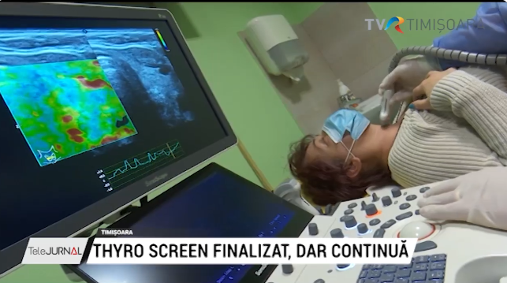
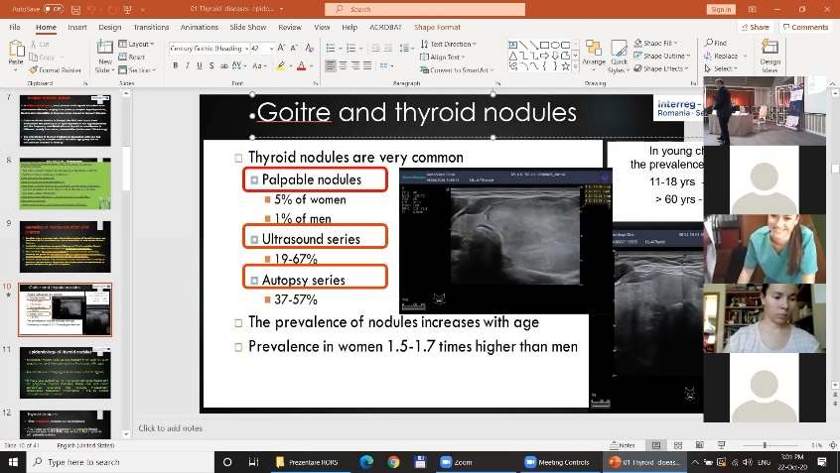
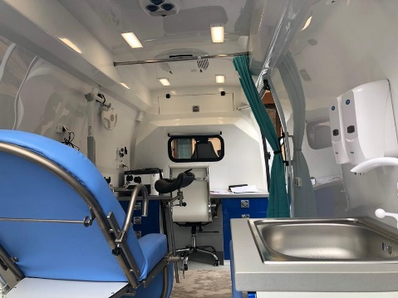

the implementation period (including extensions)
total funds spent/total funds contracted *100
indicators and level of achievement against targets set

