Project information
CALL FOR PROPOSALS | 1
e-MS Code: | RORS-35
PRIORITY AXIS: | 4 Attractiveness for sustainable tourism
OBJECTIVE: | 4.1 Investments for the growth of the demand of local tourism networks and promotion of innovative tourism activities
PROJECT TITLE: | Religious music - Establishment of Cross-border Touristic Routes
ACRONYM: | Music routes
DURATION: | 10.06.2017 - 09.06.2019 (24 Months)
Interreg-IPA  FUNDS CONTRACTED: | €676.947,57
TOTAL FUNDS CONTRACTED: | €796.408,92
ABSORPTION RATE (%): | 95,09 %
PROJECT OBJECTIVE(S): | Improving the attractiveness of the cross-border ecumenical tourism.  Elaborating thematic tourism packages.
SHORT DESCRIPTION OF THE PROJECT: | Our objective being the promotion of transnational ecumenical tourism, we elaborated our project`s idea and its activities in such way that it will bring a major contribution to the sustainable use of the cultural heritage and to bring contribution to the development of the tourism in this border region. By elaborating a whole tourist package concerning religious music – choirs, concerts, expositions, tourist routs – we are elaborating an innovative tourism attraction. By the construction of a modern concert hall and the renovation of a church that is on the cultural heritage list, we are improving the attractiveness of the cross-border tourism. Beside the constructed concert hall within the building complex of the Reformed Centre in Timisoara (Romania) and the renovated church in Senta (Serbia), our main outputs are the tourism promoting website and the brochures promoting the tourism routes, the elaborated study in the field of clerical music and the 45 thematic events organized during the implementation of the project.  Built on the idea that modern tourist routes have a richer offer and are more attractive for tourists if they cross the state border, we elaborated the whole project idea in this spirit. Our project objectives, the activities and the outputs all have a cross-border character, some of them can be achieved only using a cross-border approach. By means of the project 45 events were organized with the purpose to initiate and further promote tourism in the field of religious music. These events are 11 concerts, 3 high masses, 12 organ demonstrations, 6 choir meetings, 3 chapel master reunions, 6 expositions, 2 conferences and 2 trips. The main locations were Timisoara and Senta, but for further intensification of the impact, some of the events took place in Vrsac, Zrenjanin, Sannicolau Mare, Deta and Tormac.  An asset study about the region’s touristic attraction in the field of religious music was also elaborated. By means of this study, thematically designed tourist routes were elaborated, which were also included in the promotional brochures. The website has a cross-border tourism promoter portal role, it presents the identified constructed cultural heritages in the field, photo illustrations, presentation of the music achievements and activities, the joint music event calendar from the whole region of Banat in Serbia and Timis county from Romania.
DEGREE OF ACHIEVEMENT OF INDICATORS: | 2 cross-border cooperation structures/ initiatives supported in the field of tourism. 100 %  1 study related to the implementation of selected projects or research and studies in the field of natural and cultural resources. 100 %
RESULTS ACHIEVED: | 45 events organized with the purpose to initiate and further promote tourism in the field of religious music: 11 concerts, 3 high masses, 12 organ demonstrations, 6 choir meetings, 3 chapel master reunions, 6 expositions, 2 conferences and 2 trips.  1 Construction of the concert hall in Timisoara.  1 Modernised church in Senta.  Website: www.musicroutes.eu

Partnership information
 |  | COUNTRY | COUNTY/DISTRICT | BUDGET(EURO) | CONTACT DETAILS
LEAD PARTNER: | Reformed Centre Timisoara | Romania | Timis | 490.058,96 | 1 b Splaiul Morarilor, Timisoara, Timis County, Romania  ujezredev@yahoo.com
PARTNER 2: | Senta Municipality | Serbia | Severnobanatski | 263.481,80 | 1 Glavni Trg, 24400, Senta, Serbia  naplata@zenta-senta.co
PARTNER 3: | Cor Jesu Foundation | Serbia | Severnobanatski | 42.868,16 | 3 Madač Imre, 24400, Senta, Serbia  borzorg@gmail.com
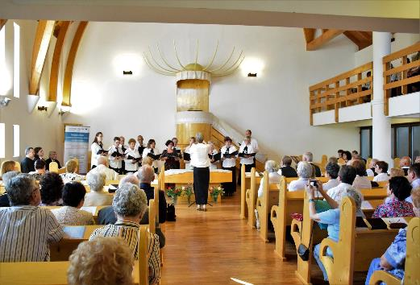
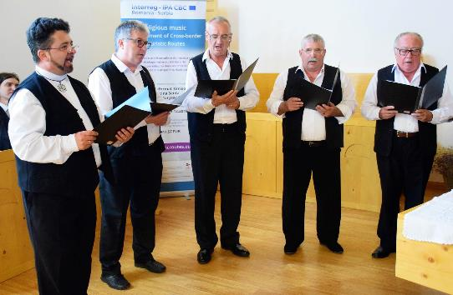
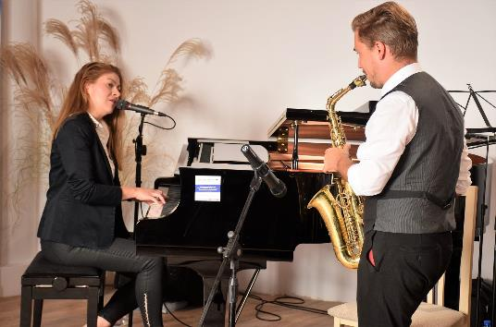

the implementation period (including extensions)
total funds spent/total funds contracted *100

