Project information
CALL FOR PROPOSALS | 1
e-MS Code: | RORS-34
PRIORITY AXIS: | 3 Sustainable mobility and accessibility
OBJECTIVE: | 3.2 Public utilities infrastructure
PROJECT TITLE: | Expansion of the AgriCO network in the cross-border region Oravita - Bela Crkva
ACRONYM: | AgriCO 2
DURATION: | 13.06.2017 - 12.12.2021 (54 Months)
Interreg-IPA  FUNDS CONTRACTED: | €1.968.955,85
TOTAL FUNDS CONTRACTED: | €2.316.418,65
ABSORPTION RATE (%): | 92,69 %
PROJECT OBJECTIVE(S): | To increase the accessibility of at least 387 small farmers and producers and other goods sellers from Oravita City (Romania) and Bela Crkva (Serbia).  To create 2 new economic public utilities infrastructures – food and goods marketplaces at cross-border level.  To promote and to support the public services of the existing AgriCO cross-border network by organizing at least 5 initiatives focusing of agriculture sector during the project implementation period of the last 6 months.
SHORT DESCRIPTION OF THE PROJECT: | The cross-border area is characterized by similar agricultural and economic assets, especially by a need for more competitiveness, including entrepreneurship and business activity, and by reduced cooperation and contacts between local communities on both sides of the border. Both partners did not have an appropriate economic public infrastructure where the 36 farmers and small producers from Oravita and the 1.707 farms, processing companies, and small producers from Bela Crkva could sell agricultural products and other large consumer goods, even if the consumer population of Oravita City resumes to 11.382 inhabitants and Bela Crkva Municipality, 17.367 inhabitants. Both initial markets have opened places with poor quality and quantity structuring places, far less than the needs of the area they served, without a clear tie between sections, without heating, cooling and ventilation, storage and cold warehouses, sanitary facilities, and administrative spaces. There needed to be more communication between the two localities across borders since about 34.000 Romanian and Serbian crossed the border to purchase various agricultural products and goods from Oravita and Bela Crkva. The AgriCO 2 project improved access for the small farmers, producers and the cross-border consumer population to a modern, appropriate and efficient marketplace built at European quality standards for economic public infrastructures for essential selling services like food and goods in the cross-border area where the AgriCO network is active and has potential to grow.
DEGREE OF ACHIEVEMENT OF INDICATORS: | 2 cross-border cooperation structures supported in the field of transport and public utilities. 100%  2 investments in transport and utilities infrastructure, including improvement, enhancement of existing infrastructure. 100%  387 participants to information/ training/ awareness raising initiatives in the field of transport and public utilities. 187,59%
RESULTS ACHIEVED: | Registering in the AgriCO network. 100 %  Creation of a centre for fruits and honey collecting, storing and selling. 100 %  1 seminar Fruits standards – growing, pests, collecting and processing process organized. 100%  1 seminar The new European standards for animal husbandry organized. 100%  Construction of two public utilities infrastructures, one in Oravita and one in Bela Crkva.100%

Partnership information
 |  | COUNTRY | COUNTY/DISTRICT | BUDGET(EURO) | CONTACT DETAILS
LEAD PARTNER: | City of Oravita | Romania | Caras-Severin | 1.362.598,65 | 1 Decembrie 1918 street, no. 60, 325600, Caras-Severin County, Romania  stangur@yahoo.com
PARTNER 2: | Municipality of Bela Crkva | Serbia | Juznobanatski | 953.820,00 | 2 Mileticeva, 26340, Bela Crkva, Serbia  aleksandarcirin@gmail.com
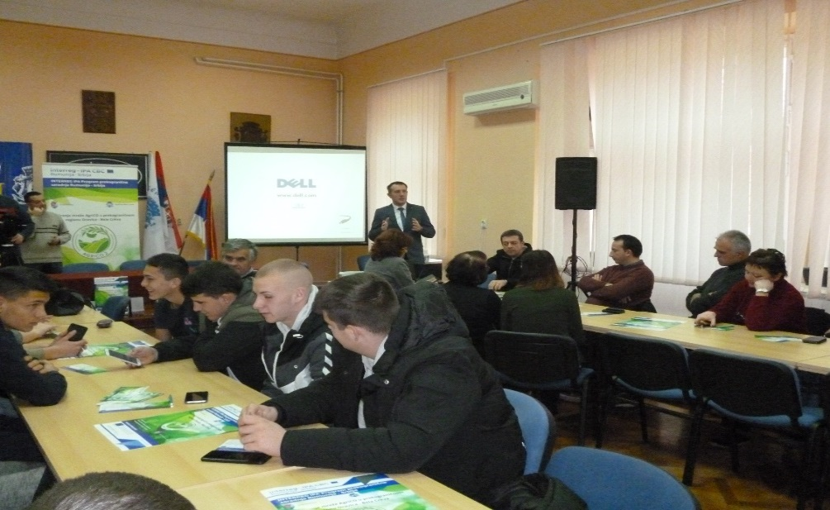
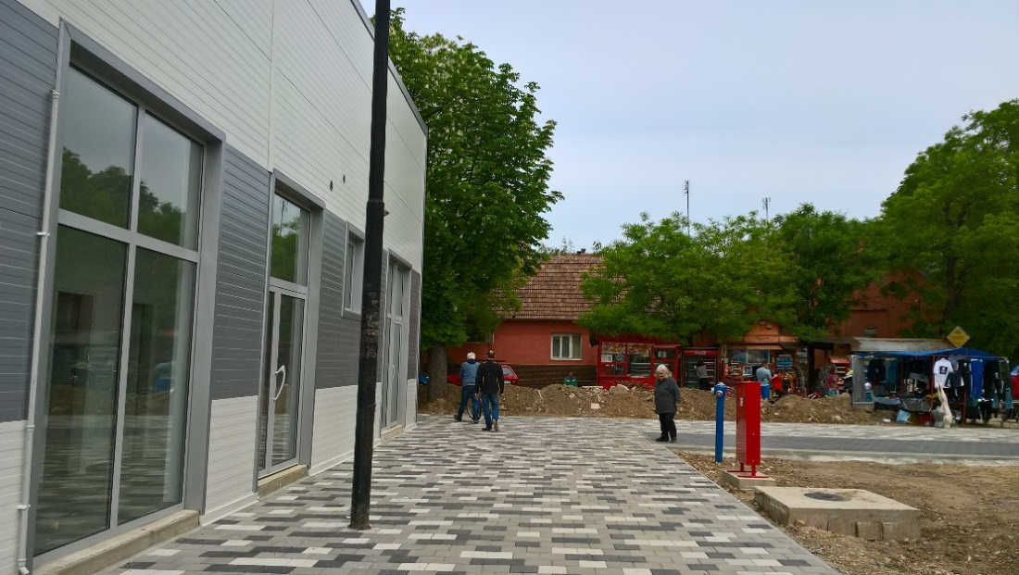
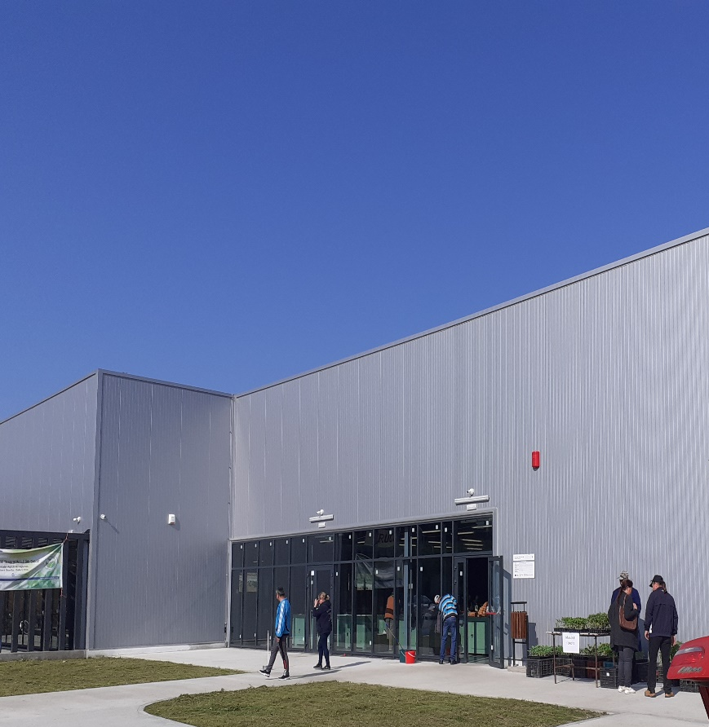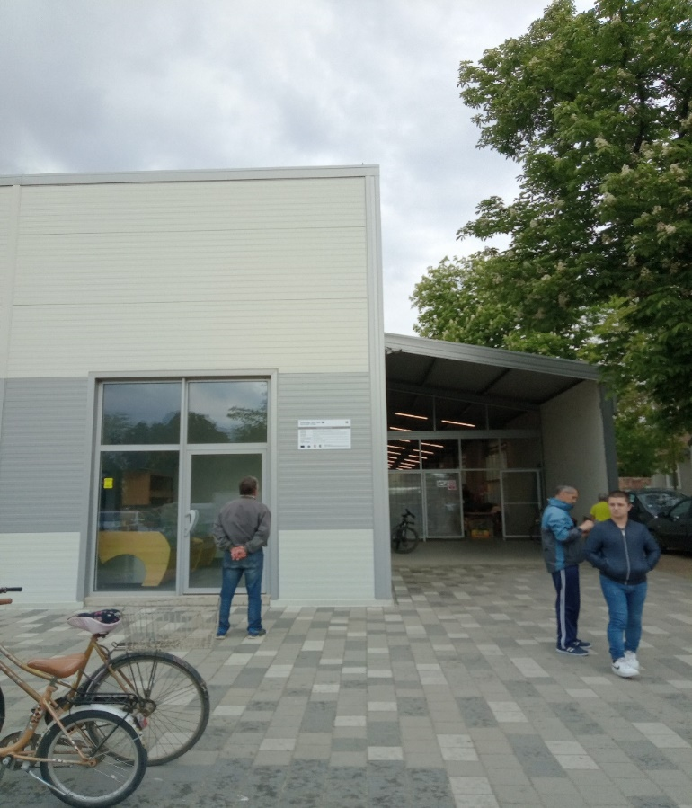

the implementation period (including extensions)
total funds spent/total funds contracted *100
indicators and level of achievement against targets set

