Project information
CALL FOR PROPOSALS | 2
e-MS Code: | RORS-309
PRIORITY AXIS: | 4 Attractiveness for sustainable tourism
OBJECTIVE: | 4.1 Investments for the growth of the demand of local tourism networks and promotion of innovative tourism activities
PROJECT TITLE: | Secrets of the Iron Gate`s medieval fortresses
ACRONYM: | Secrets of the medieval fortresses
DURATION: | 09.07.2019 – 08.07.2021 (24 Months)
Interreg-IPA  FUNDS CONTRACTED: | €646.409,76
TOTAL FUNDS CONTRACTED: | €760.482,08
ABSORPTION RATE (%): | 78%
PROJECT OBJECTIVE(S): | It provided meaningful experiences for visitors and tourists, through discovering the secrets of the medieval fortress of Severin (Romania) and Fetislam (Serbia);  It improved the quality and the accessibility of the tourist offer of the Fetislam and Severin fortresses;  It improved the capacities of local stakeholders for valorisation and promotion of the new brand on the “sustainable tourism” principles and further similar brands;
SHORT DESCRIPTION OF THE PROJECT: | Various civilisations have left a significant mark on the area of the Iron Gates, ranging from prehistoric times through the Roman Empire and medieval cultures to modern times. All these civilisations have left a significant cultural and historical heritage.  Among the most significant legacies of past civilisations in the area of ​​the Municipality of Kladovo and Drobeta Turnu-Severin are certainly the defences from the Roman and medieval periods, of which the fortresses "Severin" and "Fetislam" definitely stand out.  The project established a new, joint, cross-border tourism brand, "Secrets of the medieval fortresses", which was based on the integration of the fortresses "Severin" and "Fetislam" in a unique tourist offer, as well as on the tourism valorisation of all the "stories" and "secrets" that are related to these two fortresses. The team analysed the visitors' needs in order for the newly established brand to match their expectations. The adaptation of promotions (messaging, marketing strategy, channels) to the needs of the target groups significantly facilitates potential visitors to make a decision about the trip, which produces a greater number of visitors.
DEGREE OF ACHIEVEMENT OF INDICATORS: | 4 cross border cooperation structures/ initiatives supported in the field of tourism. 100%  6 studies related to the implementation of selected projects or research and studies in the field of natural and cultural resources. 100%  28 participants attending training initiatives. 100%  3 joint actions and communication instruments created. 100%  1 partnership for the exchange of good practices and the promotion of joint initiatives established. 100%
RESULTS ACHIEVED: | A Revitalized “Small town” inside the Fetislam fortress in Kladovo. 100%  “Brand development strategy” prepared. 100%  1000 books about “Secrets of the medieval fortresses” printed. 100%  50 street signs installed to direct the visitors to the fortresses. 100%  8 Info boards installed to inform visitors about “Secrets of the medieval fortresses”. 100%  200 medieval costumes for ladies, knights, guard, medieval instruments purchased. 100%  100 models of the Fetislam fortress soldiers, inhabitants and fortress equipment purchased. 100%  2 “Medieval Feasts” organized with 5000 participants. 100%  Joint scientist symposium “Cultural-historical heritage in the Iron Gate” with 200 participants organized. 100%  20 young people and women trained for handcraft production. 100%  8 civil servants trained for the proper promotion of the new tourism brand. 100%  200 pieces of the electronic guide developed and distributed to other stakeholders. 100%  Memorandum on further cooperation signed. 100%

Partnership information
 |  | COUNTRY | COUNTY/DISTRICT | BUDGET(EURO) | CONTACT DETAILS
LEAD PARTNER: | Municipality of Kladovo | Serbia | Borski | 569.529,08 | Kralja Aleksandra 35, 19320, Kladovo  Phone: +38119808066  E-mail: opstina@kladovonet.com
PARTNER 2: | Municipality of Drobeta Turnu Severin | Romania | Mehedinti | 190.953,00 | Maresal Averescu street no 2, 220131 Drobeta Turnu Severin
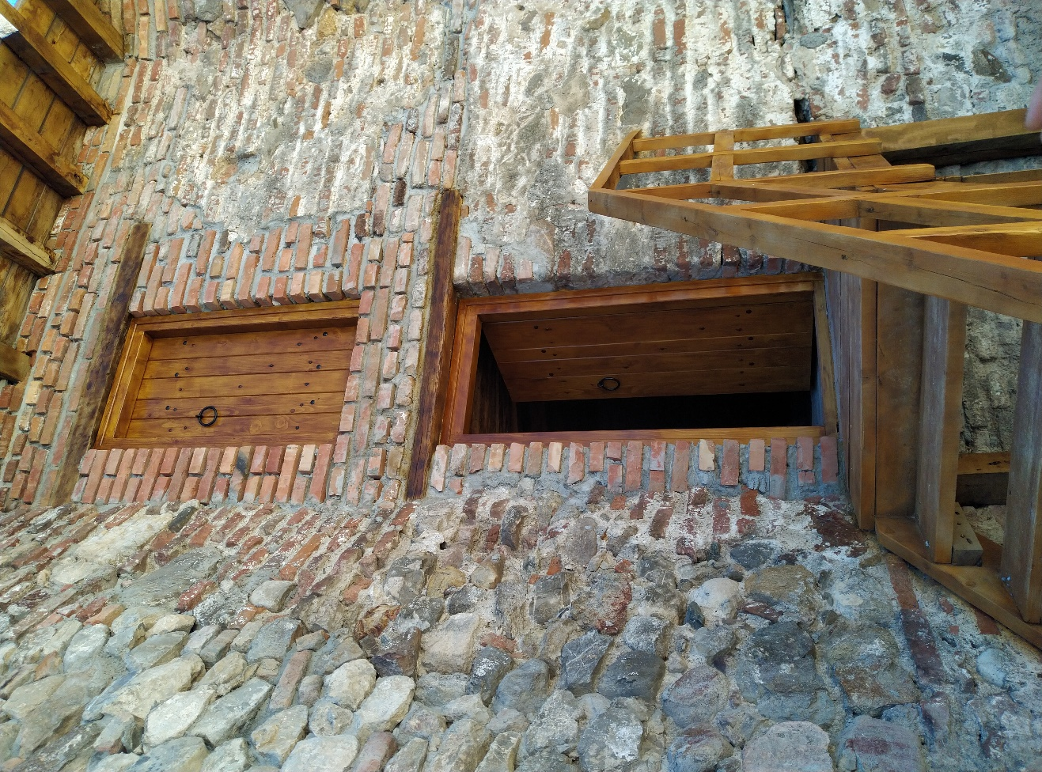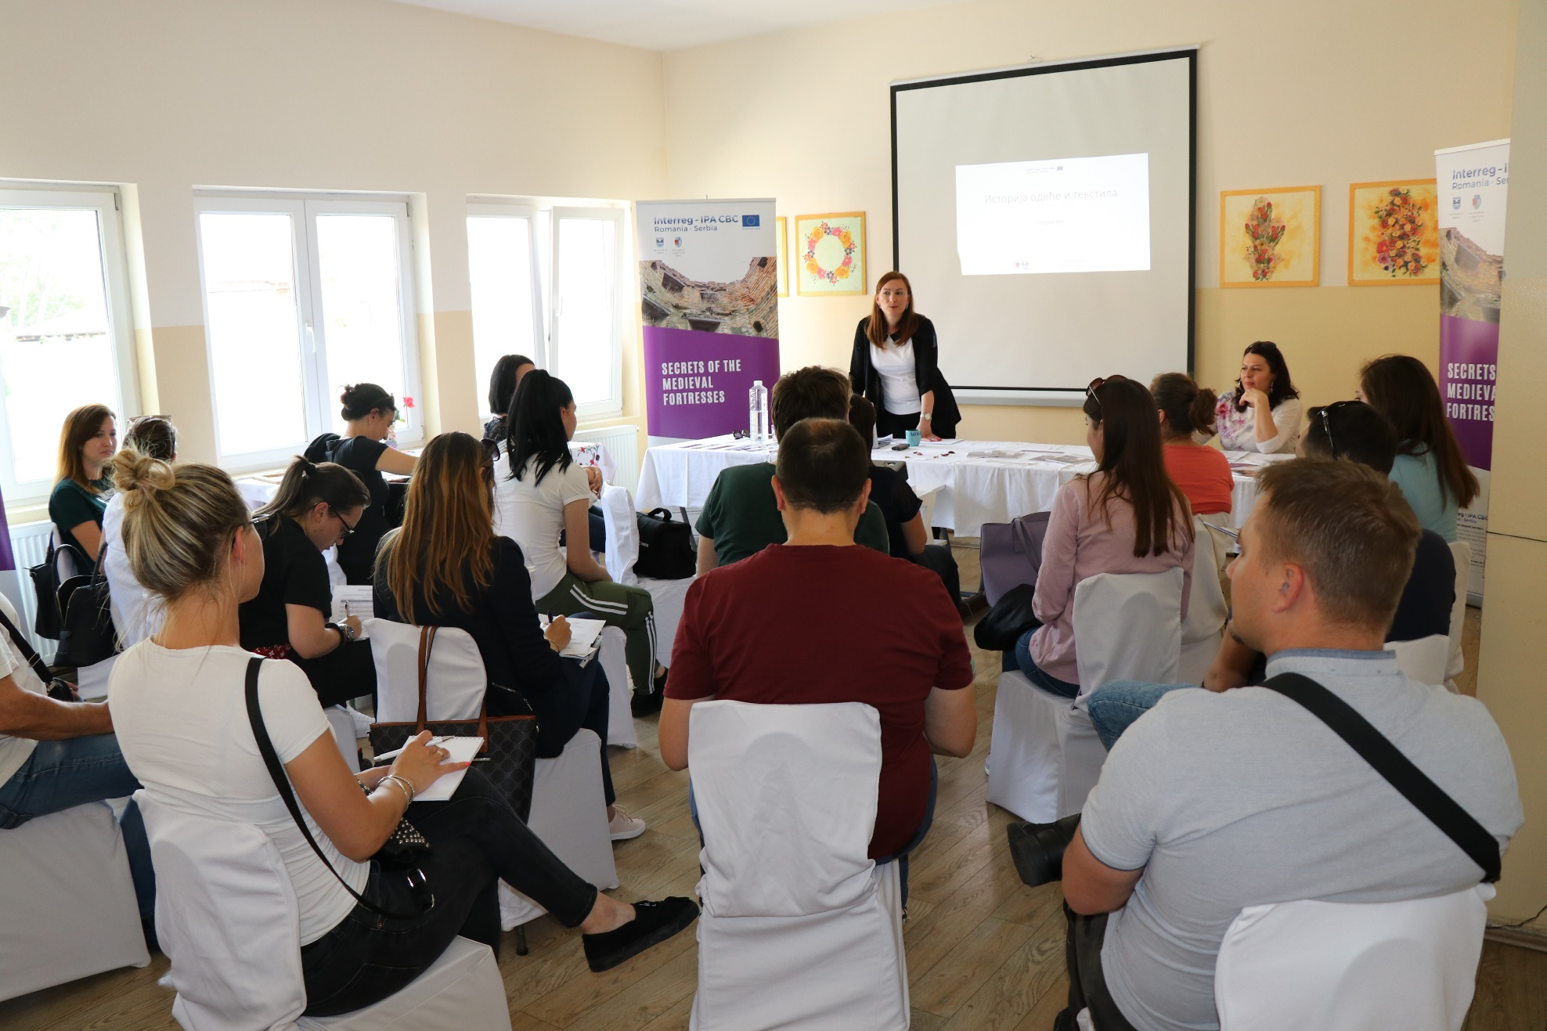
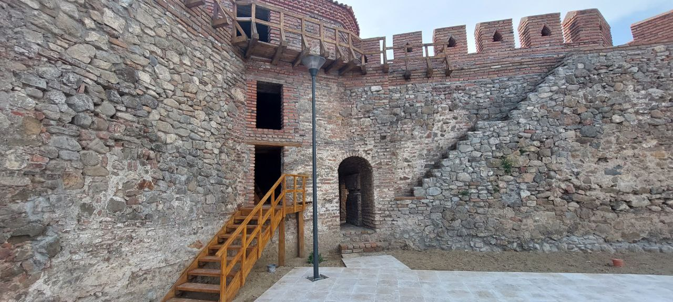

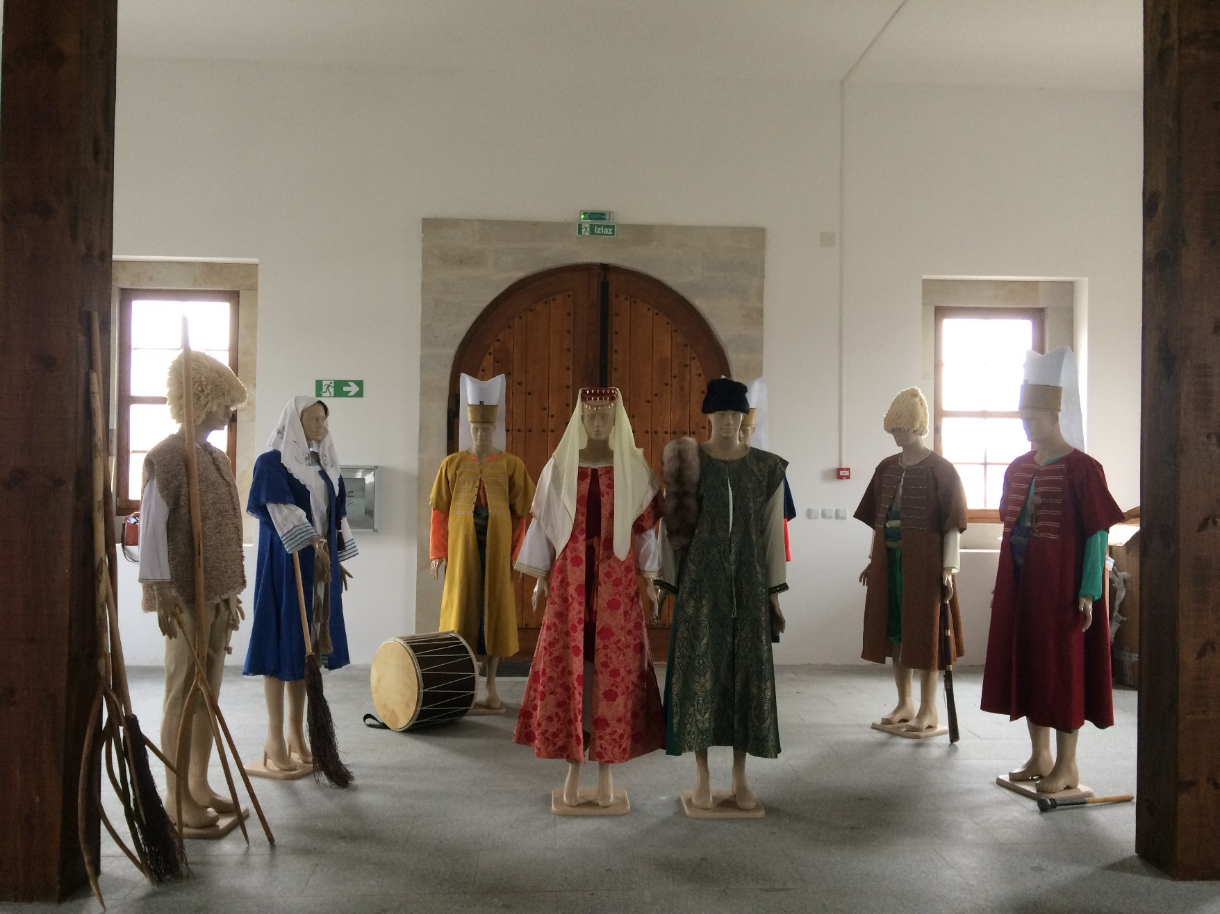

the implementation period (including extensions)
total funds spent/total funds contracted *100
indicators and level of achievement against targets set

