Project information
CALL FOR PROPOSALS | 2
e-MS Code: | RORS-308
PRIORITY AXIS: | 2 Environmental protection and risk management
OBJECTIVE: | 2.1 Environmental protection and sustainable use of natural resources
PROJECT TITLE: | Forming of network for enhancing environmental protection from pollutants of mining cross border areas
ACRONYM: | NETMIN
DURATION: | 13.06.2019 – 11.12.2020 (17 Months and 29 Days)
Interreg-IPA  FUNDS CONTRACTED: | €257.607,62
TOTAL FUNDS CONTRACTED: | €303.067,80
ABSORPTION RATE (%): | 90,80 %
PROJECT OBJECTIVE(S): | To establish advanced research and educational network in the field of environmental protection.  Increased people-to-people exchange in environmental education, improved their knowledge of different environmental-friendly approaches and implementation of national and EU environmental legislative framework.  To increase the visibility of the network at the European level through actions of dissemination of the results obtained.
SHORT DESCRIPTION OF THE PROJECT: | In the border regions of Romania and Serbia, there are significant environmental challenges concerning the treatment of the soil contaminated with heavy metals due to mining activities. But it is often problematic to identify the extent of the damage considering that the research was limited.  Could a multi-inter-trans disciplinary approach in the field of environmental research help?  We established a research-educational network for environmental protection and sustainable use of natural resources between the Politehnica University Timisoara (UPT) in Romania and Mining and Metallurgy Institute Bor (MMI Bor) in Serbia to broaden and complement the knowledge and experience of both partners.  We started by organizing training sessions for our students. Together, we organized awareness raising campaigns for the general public. Another result of this partnership was the STUDY regarding the pollution with heavy metals and arsenic in mining areas and methods of remediation.
DEGREE OF ACHIEVEMENT OF INDICATORS: | 7200 participants to project initiatives and events for information and awareness raising. 172%  1 study elaborated in the field of environmental protection and emergency management (technical and scientific studies, researches in the relevant fields). 100%
RESULTS ACHIEVED: | 1 network for advanced research and education in the field of environmental protection established. 100%  200 participants to informative and educational activities, from target groups and outside target groups.251,50%  7000 promotional materials for informative and educational activities, inside and outside target groups were distributed. 169,72%  1 Study regarding the pollution with heavy metals and arsenic in mining areas and methods of remediation was accomplished. 100%

Partnership information
 |  | COUNTRY | COUNTY/DISTRICT | BUDGET(EURO) | CONTACT DETAILS
LEAD PARTNER: | Politehnica University Timisoara | ROMANIA | Timis | 154.451,85 | 2 Piata Victoriei, 300006 Timisoara  cornelia.muntean@upt.ro
PARTNER 2: | Mining and Metallurgy Institute Bor | SERBIA | Borski | 148.615,95 | 35 Zeleni bulevar, 19210, Bor  daniel.krzanovic@irmbor.co.rs

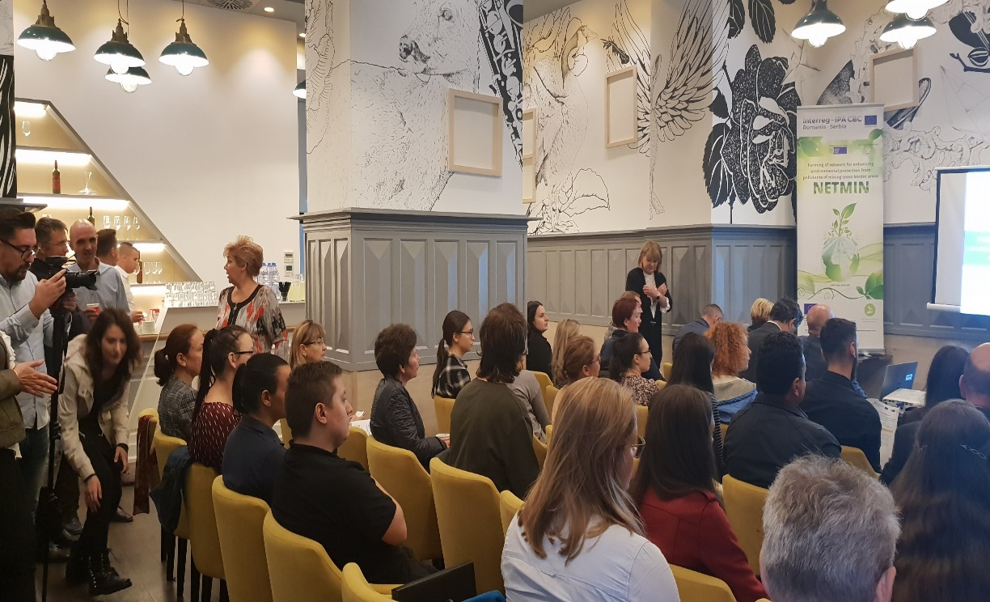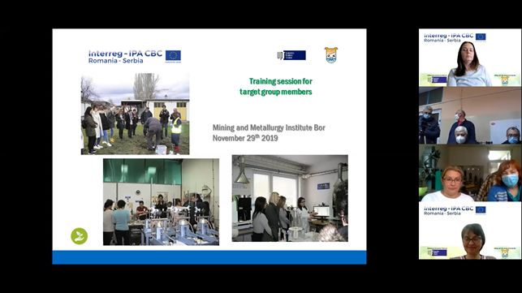

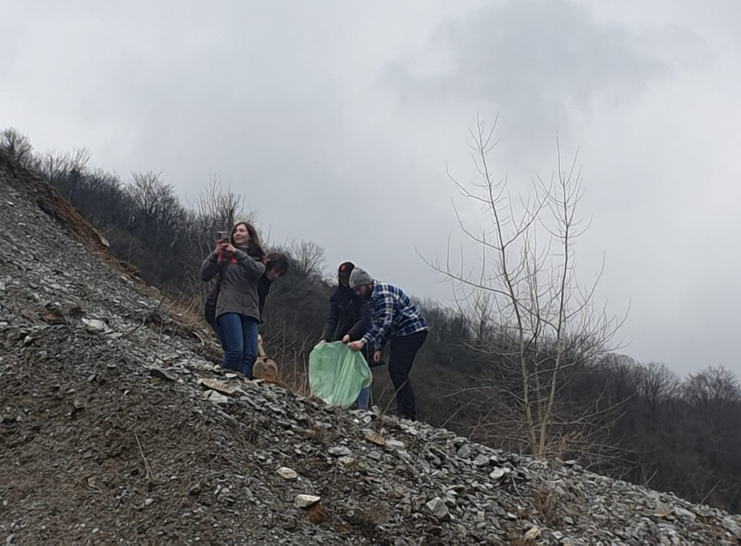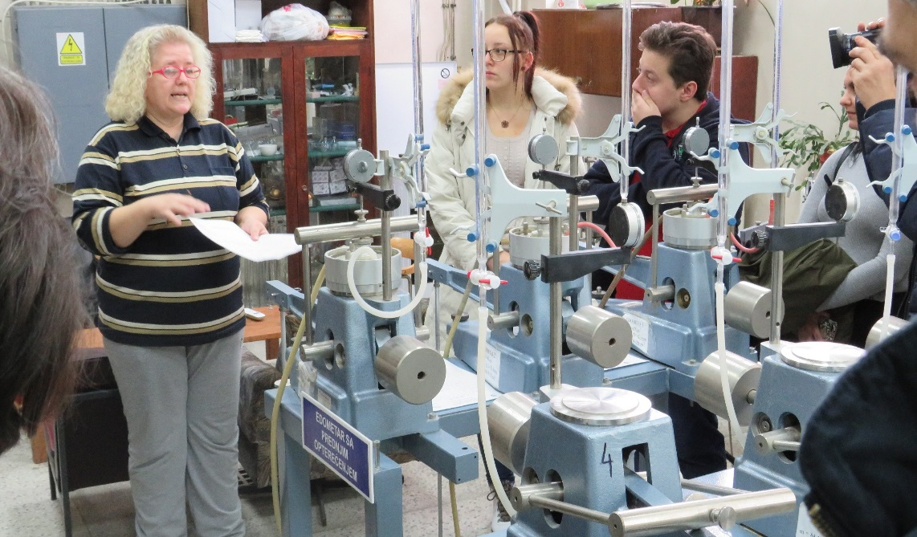

the implementation period (including extensions)
total funds spent/total funds contracted *100
indicators and level of achievement against targets set

