Project information
CALL FOR PROPOSALS | 2
e-MS Code: | RORS-300
PRIORITY AXIS: | 2 Environmental protection and risk management
OBJECTIVE: | 2.1 Environmental protection and sustainable use of natural resources
PROJECT TITLE: | Smart And Sustainable Energy Consumption
ACRONYM: | SASEC
DURATION: | 14.06.2019 – 13.03.2021 (21 Months)
Interreg-IPA  FUNDS CONTRACTED: | €724.201,27
TOTAL FUNDS CONTRACTED: | €852.001,51
ABSORPTION RATE (%): | 93,78
PROJECT OBJECTIVE(S): | Establishment of a sustainable energy management system in the cross-border region, through the setting up of a plan framework and institutional support in the field of energy efficiency and renewable energy sources.  Improvement of capacities and awareness raising of local communities on the importance of an energy efficient way of producing and using energy with as little harmful impact on the environment as possible.
SHORT DESCRIPTION OF THE PROJECT: | The project promoted energy sustainability in the local communities of the cross-border region by improving their capacity to plan and manage integrated energy-saving and renewable energy generation actions. The project established institutional support for sustainable energy development and the application of energy efficiency principles in the cross-border region; improved the capacities of competent bodies; promoted cross border network for education and studies on environmental resources; raised awareness among the population about the importance of energy savings and use of renewable sources in energy production - development of an energy-sustainable society.
DEGREE OF ACHIEVEMENT OF INDICATORS: | 2 infrastructure, equipment built/ installed/ modernized in the field of cross border services for environmental protection.  4.956 participants in project initiatives and events for information and awareness raising.  5 studies done in the field of environmental protection and emergency management (technical and scientific studies, researches in the relevant fields).  724 participants to capacity building initiatives.  1 monitoring system established/ extended/ modernized in the eligible area in the field of environmental protection and emergency management.
RESULTS ACHIEVED: | 1 building rehabilitated, the first “Smart building” in the Serbian Banat region with “demo room” – where the Regional Centre for Energy Efficiency Banat functions (100%).  1 established and functioning Regional Centre for Energy Efficiency Banat (100%).  1 Sustainable Energy Action Plan (100%).  3 green pilot research actions (100%).  1 Guidebook for best practices in Energy Efficiency (100%).  724 participants of target groups acquired knowledge in the field of energy efficiency and sustainable use of natural resources (111%).  1 Energy Efficiency Platform (100%).

Partnership information
 |  | COUNTRY | COUNTY/DISTRICT | BUDGET(EURO) | CONTACT DETAILS
LEAD PARTNER: | City of Zrenjanin | SERBIA | Srednjebanatski | 501.771,90 | 10 Trg Slobode, 23000 Zrenjanin  jovan.vukanovic@grad.zrenjanin.rs
PARTNER 2: | Municipality of Timisoara | ROMANIA | Timis | 79.598,40 | 1 Bd. C.D. Loga, 300030, Timisoara  iudit.bere@primariatm.ro
PARTNER 3: | Regional Agency for Socio–Economic Development – Banat Ltd | SERBIA | Srednjebanatski | 180.497,10 | 1 Carnojiceva, 23000, Zrenjanin  branislav.milosav@rcrbanat.rs
PARTNER 4: | Romanian Sustainable Energy Cluster ROSENC | ROMANIA | Timis | 90.134,10 | 9 Republicii Blvd, room 1, 300001, Timisoara  contact@rosenc.ro

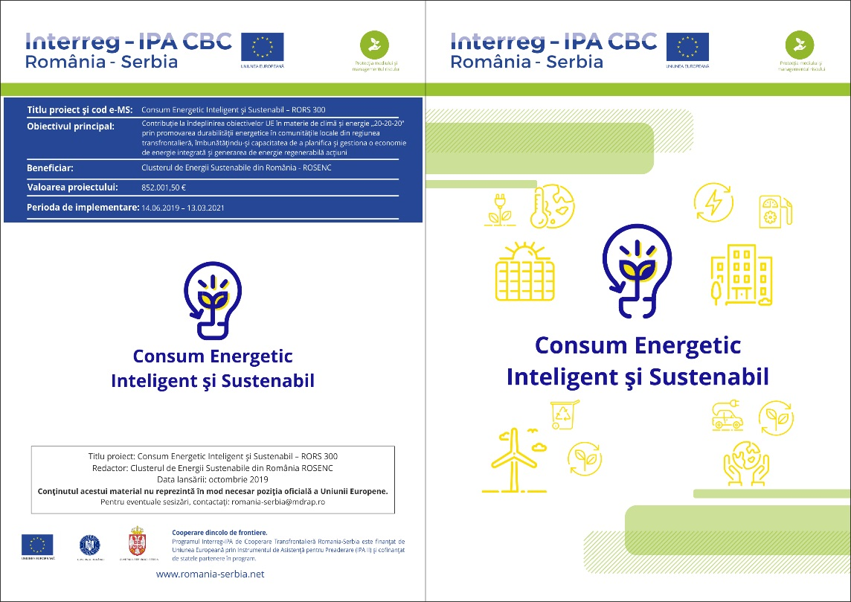
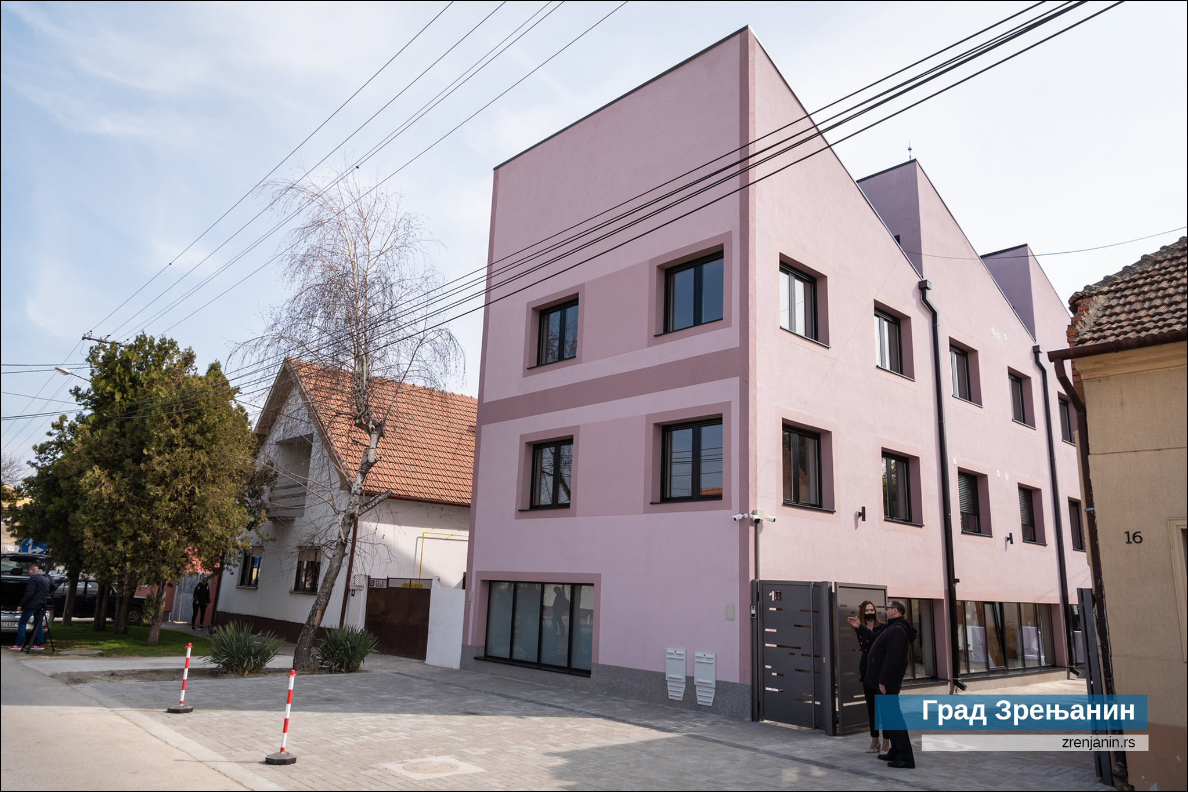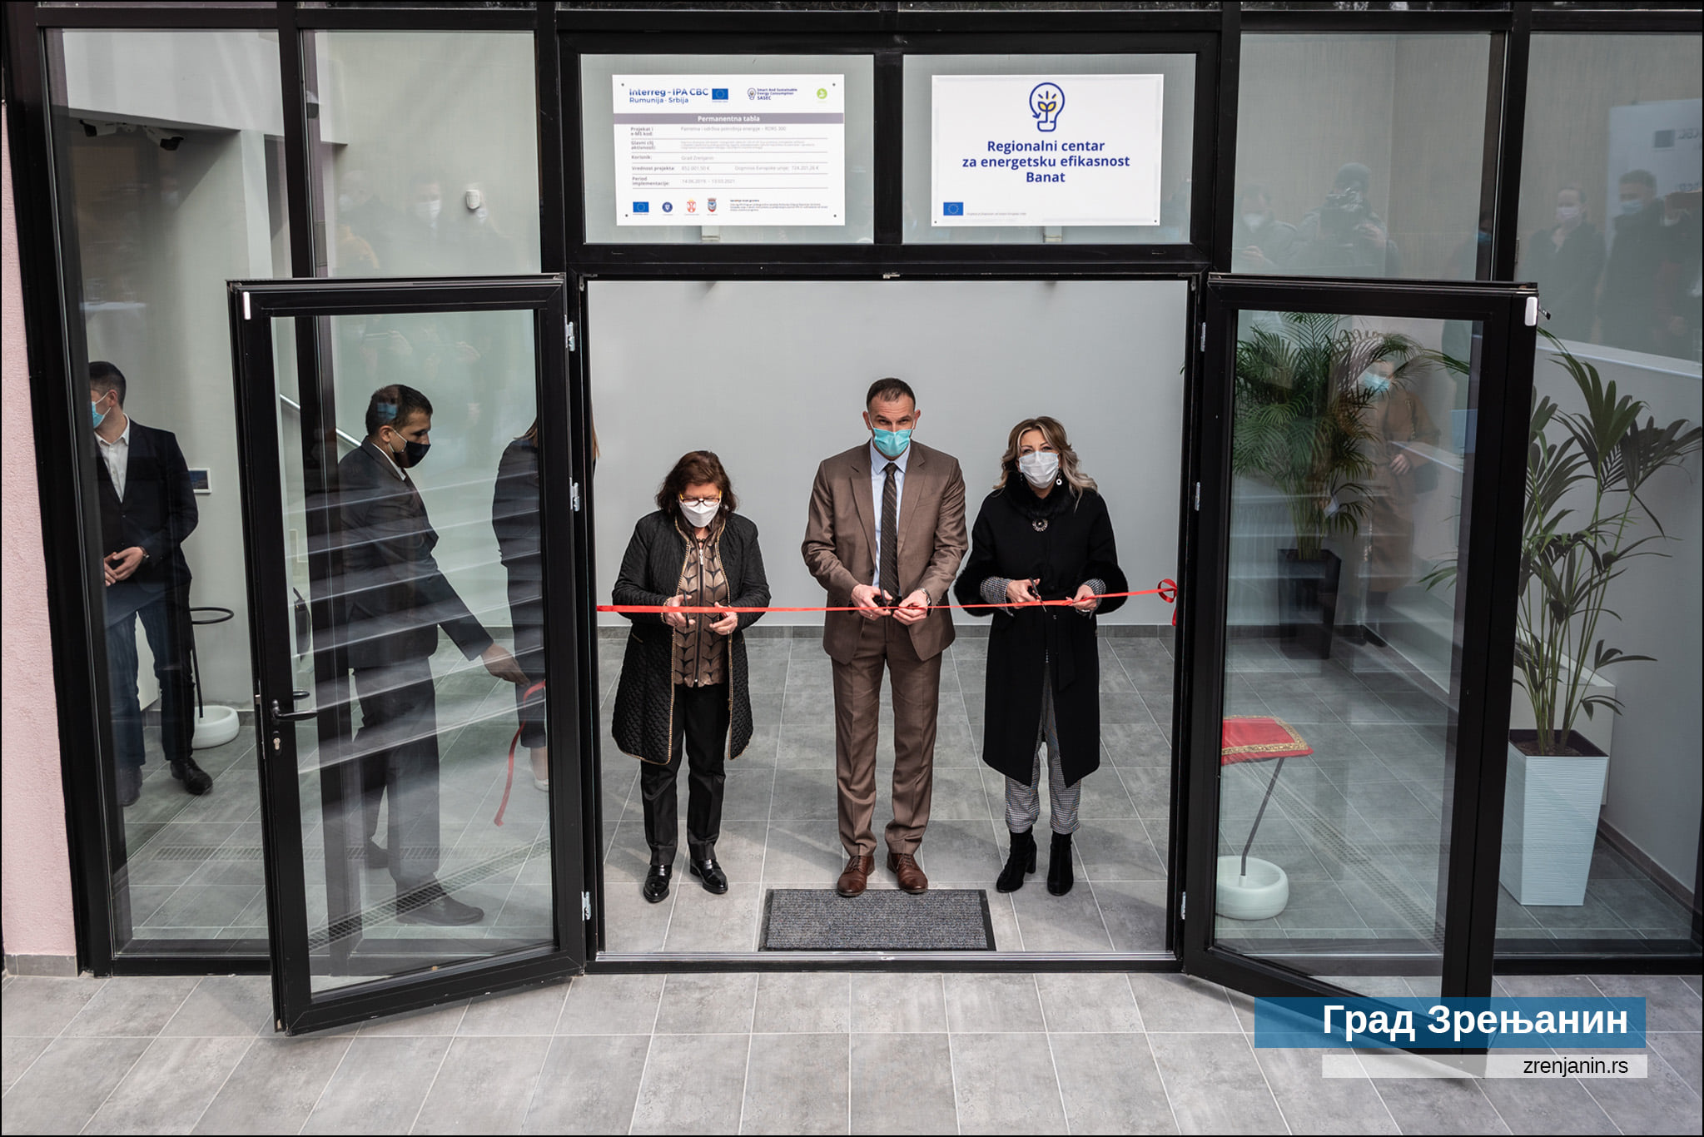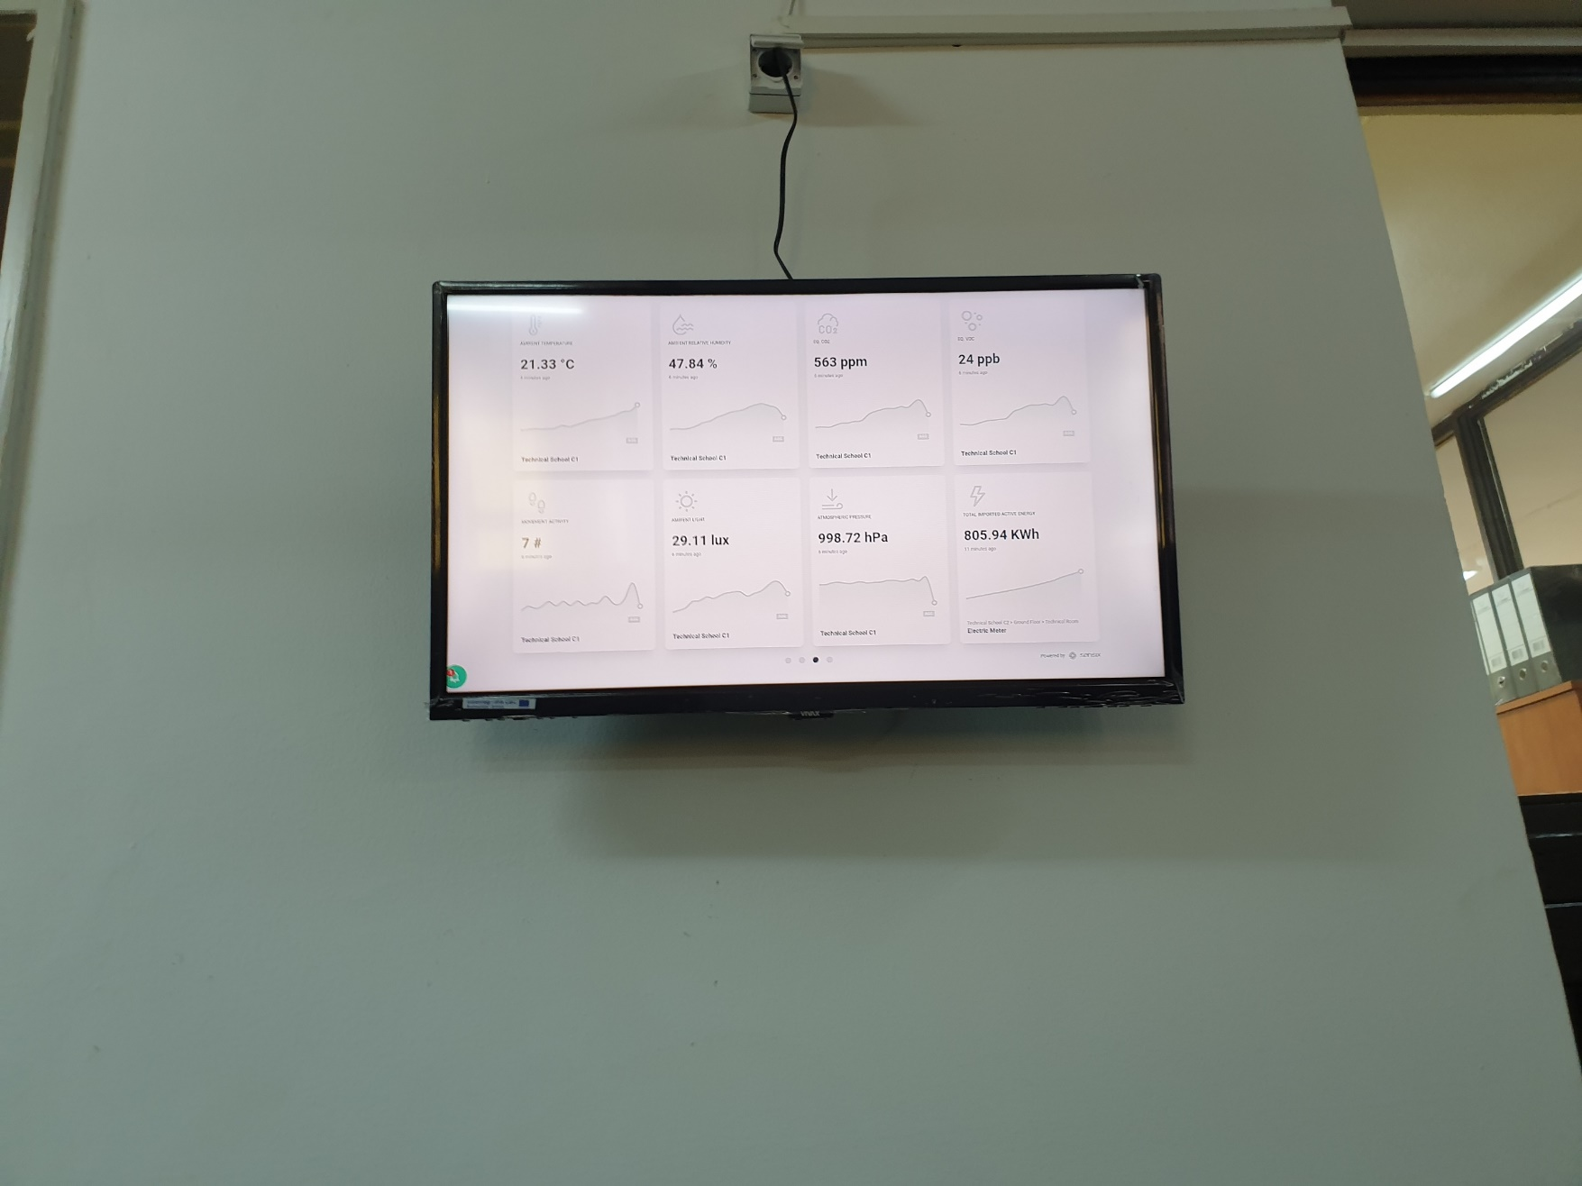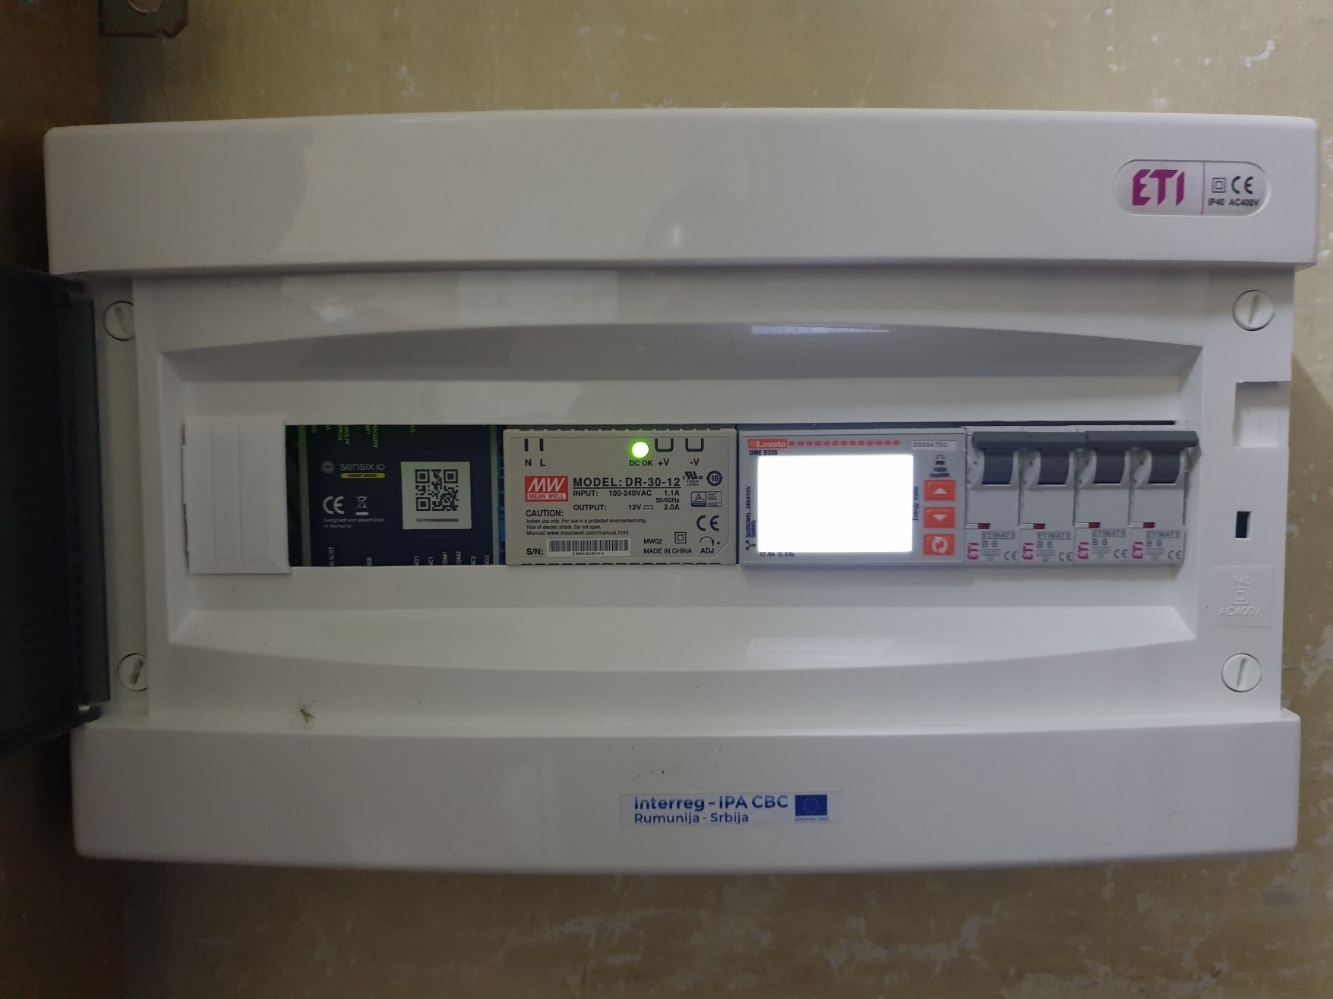

the implementation period (including extensions)
total funds spent/total funds contracted *100

