Project information
CALL FOR PROPOSALS | 1
e-MS Code: | RORS-30
PRIORITY AXIS: | 4 Attractiveness for sustainable tourism
OBJECTIVE: | 4.2 Capacity building initiatives for the improvement of quality and innovation of tourism services and products
PROJECT TITLE: | Carpathians Connects
ACRONYM: | Carpathians Connects
DURATION: | 13.07.2017 – 12.01.2019 (18 Months)
Interreg-IPA  FUNDS CONTRACTED: | €192.735,37
TOTAL FUNDS CONTRACTED: | €226.747,50
ABSORBTION RATE (%): | 91,79%
PROJECT OBJECTIVE(S): | To support development of local tourism businesses and sustainable use of natural and cultural heritage by providing framework, guidelines and trainings for new touristic product of cross-border mountain tourism.
SHORT DESCRIPTION OF THE PROJECT: | The project contributed to the sustainable use of natural and cultural resources in the mountain region of the cross-border area. The Southern Carpathians Mountains (spread in Caras-Severin and Mehedinti counties in Romania and Bor district in Serbia) are attracting more and more visitors and a comprehensive framework and guidelines of sustainable tourism development was needed. People living in Caras-Severin and Mehedinty counties as well as in Bor district are aware of the great tourism potential the Carpathian Mountains have. As mountainous area, this region is fully related to the Carpathians, its resources and its particularities. Carpathians` natural and cultural values can be harmed by uncontrolled development of tourism, thus making tourism development unsustainable and a short-term business activity. This will lead to unsustainable usage of natural and cultural resources and will harm income generators of the business sector in the region.  Development of sustainable mountain tourism with a cross-border approach empowered stakeholders in tourism and environmental sectors and provided long-lasting tourism products based on smart usage of heritage, making the Romania-Serbia Carpathian cross-border area a unique mountain destination.  The tourism industry generates significant amounts of profits. Thus, stakeholders are sensitive and proactive when new ideas on tourism business appear. The project established a cross-border sustainable tourism product that will ensure long-lasting tourism activities, with minimized chances for fast destruction of key attractors (natural and cultural heritage) of the area. Projects target groups were: business sector dealing with tourism in the Romania-Serbia Carpathian cross-border area, public authority representatives, institutions and organisations operating in the field of environment and tourism, professionals dealing with sustainable tourism and related sectors, inhabitants of the cross-border area with ages between 20-59 years.
DEGREE OF ACHIEVEMENT OF INDICATORS: | 204 Studies related to the implementation of selected projects or research and studies in the field of natural and cultural resources – 113,23%  165 participants attending training initiatives – 109,09%  1 Partnership for the exchange of good practices and the promotion of joint initiatives established – 100%
RESULTS ACHIEVED: | Increased capacities for development of sustainable mountain tourism in Romania-Serbia Carpathian cross-border area among stakeholders by:  1) Training on introducing sustainable mountain tourism in RO-SER Carpathian cross-border area - performed;  2) Training on identification of cross-border projects on sustainable mountain tourism in Romania-Serbia Carpathian cross-border area - performed.  Introduced cross-border sustainable mountain tourism as a new touristic product contributing to sustainable use of natural resources in Romania-Serbia Carpathian cross-border area by:  1) Elaboration of Research „State of the art of mountain tourism in Romania-Serbia Carpathian cross-border area”;  2) Elaboration of „Study on development of sustainable mountain tourism in Romania-Serbia Carpathian cross-border area”;  3) Elaboration of Manual „Identifying cross-border projects on sustainable mountain tourism initiatives”,  4) Established cross-border partnership for exchange of practises and for implementation of joint initiatives by “Stakeholder’s cross-border network on Mountain tourism development”.  All materials are published on the project website: http://www.carpathiansconnects.com/

Partnership information
 |  | COUNTRY | COUNTY/DISTRICT | BUDGET(EURO) | CONTACT DETAILS
LEAD PARTNER: | RARIS - Regional Development Agency Eastern Serbia | Serbia | Borski | 129.286,50 | Trg oslobođenja bb  19000 Zaječar  tel/fax: +381 (0)19 426 376  tel/fax: +381 (0)19 426 377  web: www.raris.org  e-mail: office@raris.org
PARTNER 2: | Romanian Association for Technology Transfer and Innovation – Mehedinti Branch | Romania | Mehedinti | 97.461,00 | 25 Crisan Street, 27-28 offices, Drobeta Turnu Severin, Romania
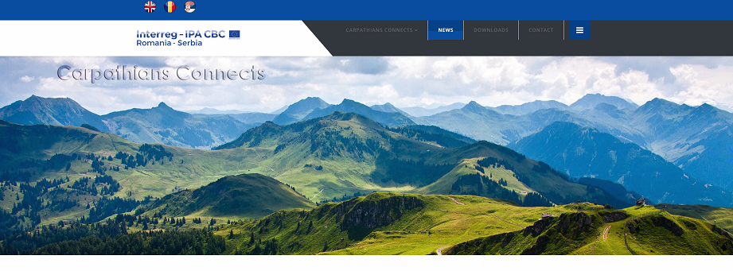
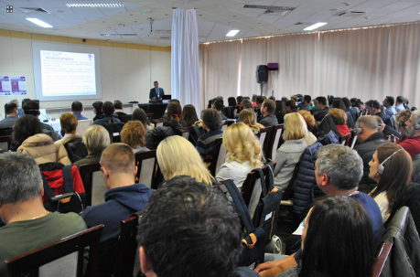
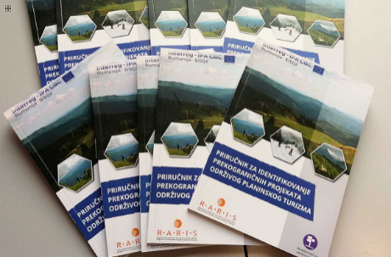
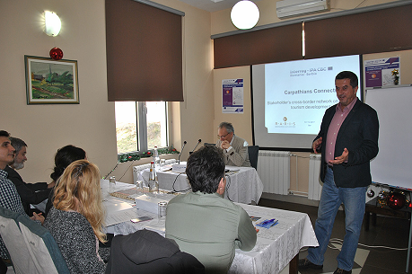
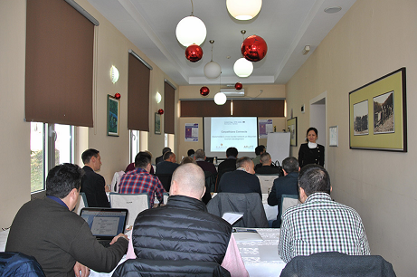
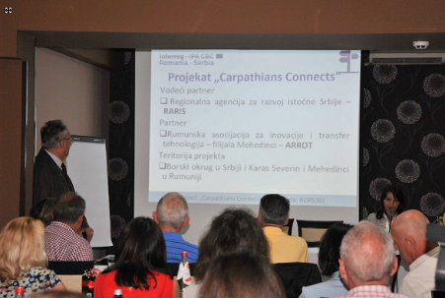

the implementation period (including extensions)
total funds spent/total funds contracted *100
indicators and level of achievement against targets set

