Project information
CALL FOR PROPOSALS | 2
e-MS Code: | RORS-283
PRIORITY AXIS: | 2 Environmental protection and risk management
OBJECTIVE: | 2.2 Environmental risks management and emergency preparedness
PROJECT TITLE: | Sustainable Joint Network of the Emergency Situations in Banat
ACRONYM: | JNEB
DURATION: | 06.08.2019 – 05.08.2021 (24 Months)
Interreg-IPA  FUNDS CONTRACTED: | €1.268.664,64
TOTAL FUNDS CONTRACTED: | €1.492.546,64
ABSORPTION RATE (%): | 94,49%
PROJECT OBJECTIVE(S): | The project objective was to strengthen local authorities' operational and institutional capacity in an emergency, in disaster prevention, mitigation, and prevention of environmental accidents and emergency reactions.
SHORT DESCRIPTION OF THE PROJECT: | Weather phenomena have cross-border implications. Through joint preparation, partners identified common needs and found complementary solutions.  Climate change and events of the last 15 years have developed a history of natural disasters in the project area (Caraş-Severin, Timis counties in Romania, South Banat district of Serbia). Floods affect the common hydrographic basins, forest and dry vegetation fires, earthquakes, erosion and water scarcity, accidental air/water pollution, epidemics, and storms/blizzards frequently cross borders. The frequency and severity of those are significant challenges. Floods affect the environment and cause economic damage and loss of life. The 2017 events in Romania and Serbia demonstrated that emergency needs are not covered, and the necessity of solving equipment needs, warning systems, and awareness campaigns for the population in emergencies was vital. Common risks lead authorities to jointly strengthen prevention, protection, population awareness, and emergency response capabilities.
DEGREE OF ACHIEVEMENT OF INDICATORS: | 140 infrastructure, equipment built/ installed/ modernized in the field of cross border services for environmental protection (100%)  28.165 participants attended project initiatives and events for information and awareness raising. (146,62%)  1 study in the field of environmental protection and emergency management was elaborated (technical and scientific studies, researches in the relevant fields). (100%)  728 participants attended capacity building initiatives. (132,36%)  1 monitoring system was established/ extended/ modernized in the eligible area in the field of environmental protection and emergency management. (100%)  219.107 people benefitted from flood protection measures. (182,58%)
RESULTS ACHIEVED: | 140 pieces of emergency equipment delivered and installed in Romania and Serbia. (100%)  4.833 Green IT Platform Warning Joint Network E-Emergency System installed. (120,83%)  234 participants to round tables organized on horizontal themes. (111,43%)  23.098 people attended the population awareness campaign on risk factors organized. (153,99%)  1 research study for emergency and environmental risks in the project area was developed. (100%)  312 tactical exercise sessions were held in Romania and Serbia. (124,80%)  82 training for interventions personnel and territorial administrative units personnel were organized. (136,66%)  195 Establishing the joint intervention frame, at least 4 common methodologies for intervention and RO–SE Collaboration Agreement (162,50%)  139 people attended the Joint interregional Working Group. (115,83%)  1 Green IT Platform Warning Joint Network E-Emergency System installed. (100%)  219.099 Population awareness campaign on risk factors (182,59%)  8 Divers who finished a special course. (100%)

Partnership information
 |  | COUNTRY | COUNTY/DISTRICT | BUDGET(EURO) | CONTACT DETAILS
LEAD PARTNER: | CARAS-SEVERIN COUNTY COUNCIL | Romania | Caras-Severin | 161.377,65 | 1 Piata 1 Decembrie 1918, 320084, Resita  cjcs@cjcs.ro
PARTNER 2: | Caras-Severin County Inspectorate for Emergency Situations „Semenic” | Romania | Caras-Severin | 696.331,00 | 123 Castanilor street, 320030, Resita,  contact@isusemenic.ro
PARTNER 3: | CITY OF VRSAC | Serbia | Southern Banat | 574.557,99 | 1 Trg pobede, Vrsac 26300, kabinet@vrsac.org.rs
PARTNER 4: | Inter-community Development Association for the Management of Emergency Situation - ADIVEST | Romania | Timis | 60.280,00 | 17 Blv. Revoluției din 1989, 300034Timișoara  officeadivest@gmail.com

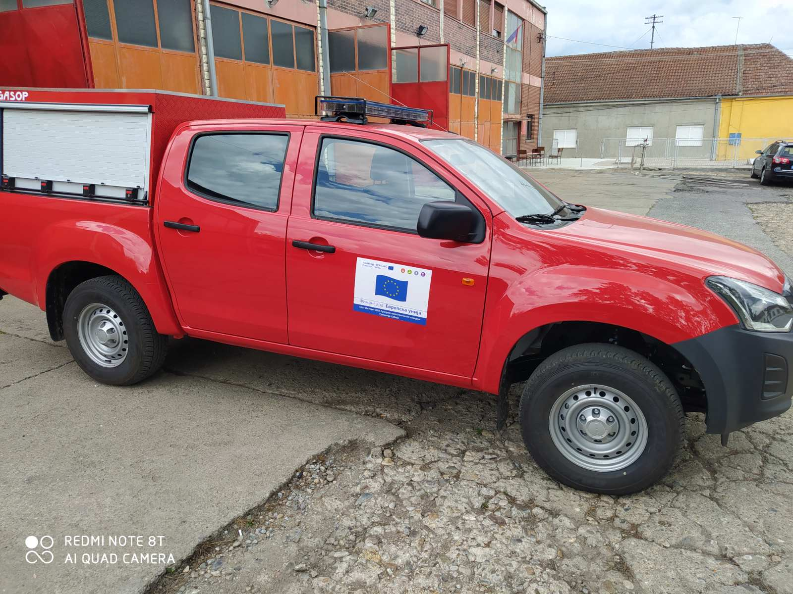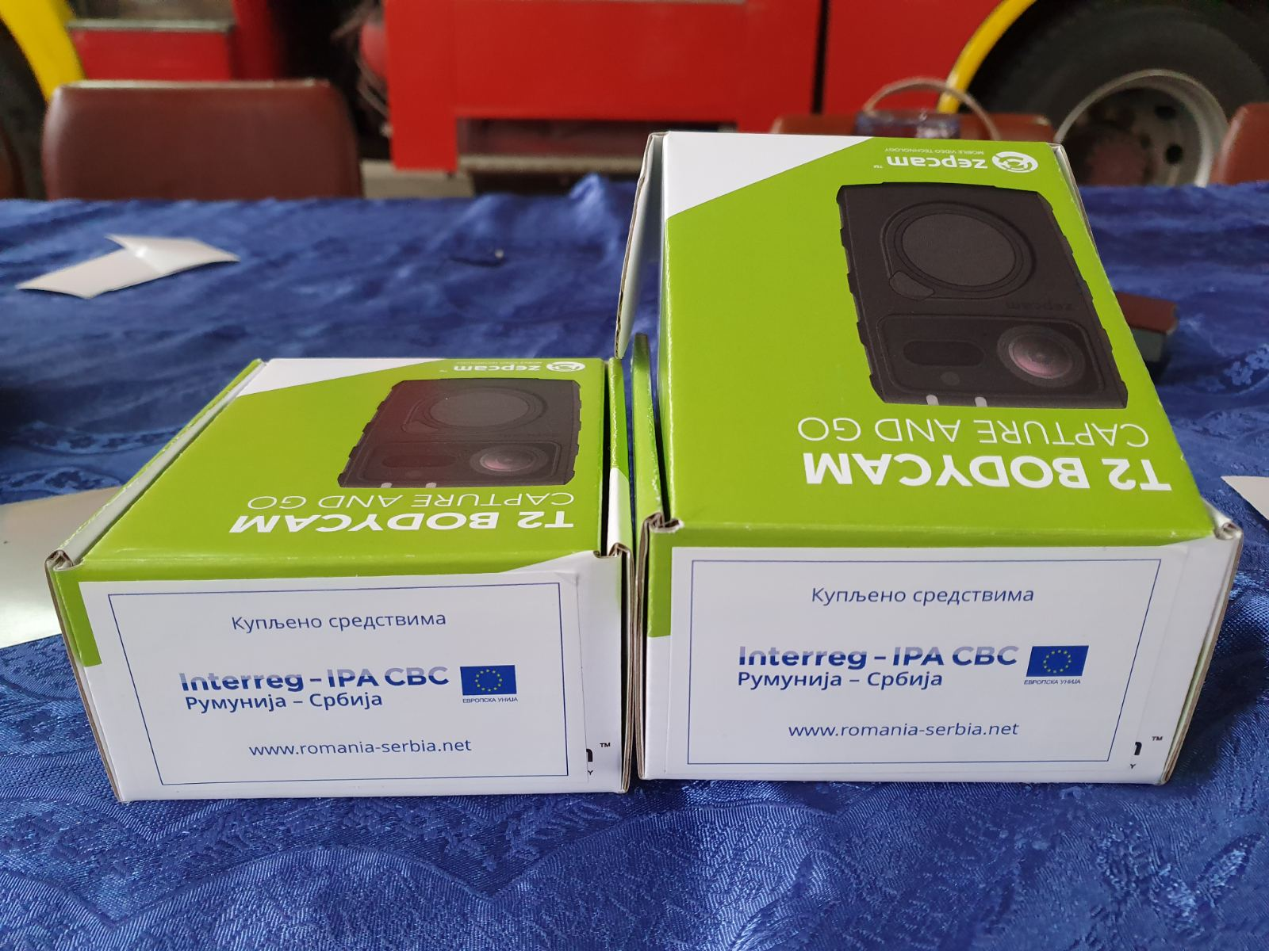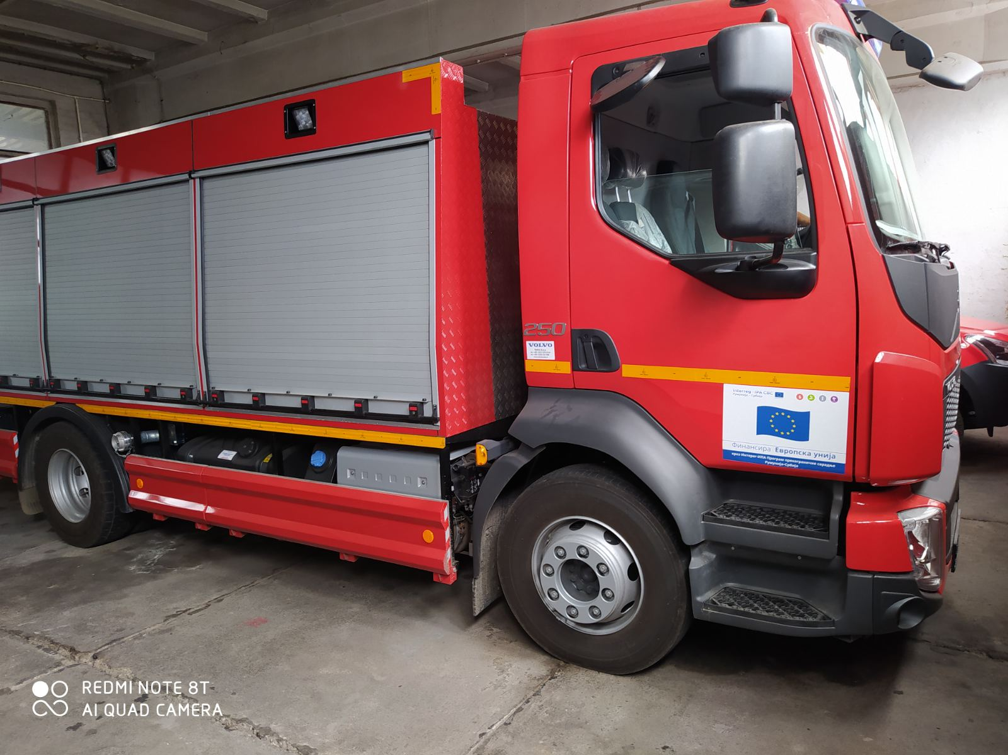
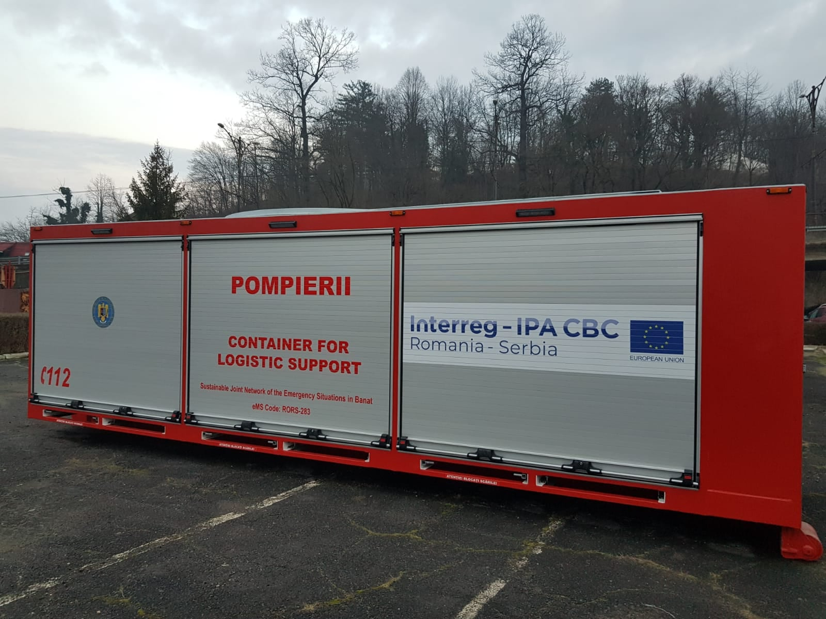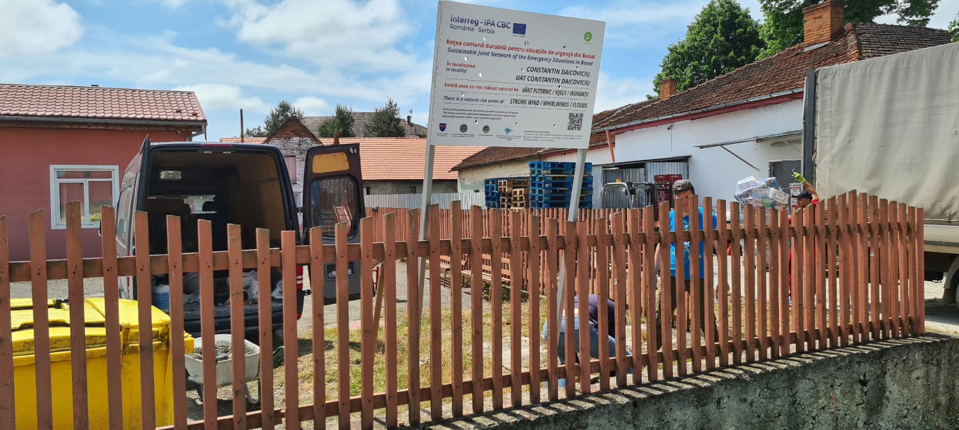
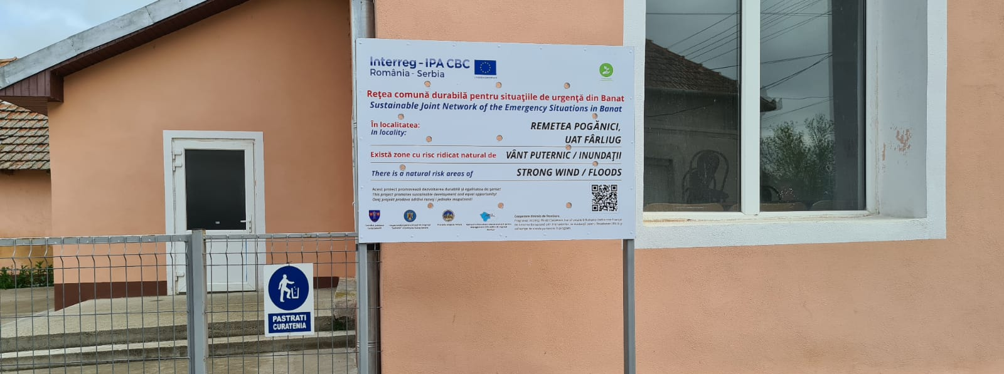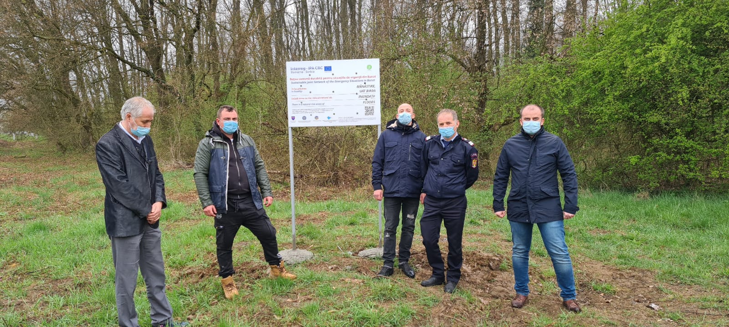

the implementation period (including extensions)
total funds spent/total funds contracted *100

