Project information
CALL FOR PROPOSALS | 1
e-MS Code: | RORS-28
PRIORITY AXIS: | 2 Environmental protection and risk management
OBJECTIVE: | 2.2 Environmental risks management and emergency preparedness
PROJECT TITLE: | Efficiency in emergency situations management
ACRONYM: | EESM
DURATION: | 30.06.2017 – 29.06.2019 (24 Months)
Interreg-IPA  FUNDS CONTRACTED: | €717.942,18
TOTAL FUNDS CONTRACTED: | €844.637,86
ABSORBTION RATE (%): | 98
PROJECT OBJECTIVE(S): | Modernizing of emergency situation services provided by the local public administrations from Romania and Serbia.
SHORT DESCRIPTION OF THE PROJECT: | Climate change, environmental accidents, crises caused by humans, are the major challenges of our century - a complex area that must improve our knowledge and understanding to take immediate measures to address efficient and fair, in terms cost, the challenges of emergency situations, the precautionary principle.  The project is focused on one of the key challenges of the border region, namely the common challenges in the environment and specific aspect of local preparedness in relation to cross-border emergency situations. Thus, both partners who are facing limited budgets and common needs can share experience and create premises for cross-border cooperation (CBC) interoperability in emergency situations.  The project aims to improve the capacity of intervention of local public administration in emergency situations, having impact on local communities and volunteer services members of Sisesti and Mosna.
DEGREE OF ACHIEVEMENT OF INDICATORS : | 26 Participants to capacity building initiatives – 100%;
RESULTS ACHIEVED: | 1 Emergency Situation Management Centre established;  10 Equipment for the project management purchased;  6 Specific intervention equipment and vehicles purchased;  3 Workshops/training sessions on emergency situations organized;  1 Common action plan elaborated;  5 IT equipment for the multifunctional conference hall of the Emergency Centre purchased;

Partnership information
 |  | COUNTRY | COUNTY/DISTRICT | BUDGET(EURO) | CONTACT DETAILS
LEAD PARTNER: | Sisesti Commune | Romania | Mehedinti | 319.263,53 | Sisesti Commune, 227455  primariasisestimh@yahoo.com
PARTNER 2: | Local Community of Mosna | Serbia | Borski | 525.374,33 | Mosna, 19220

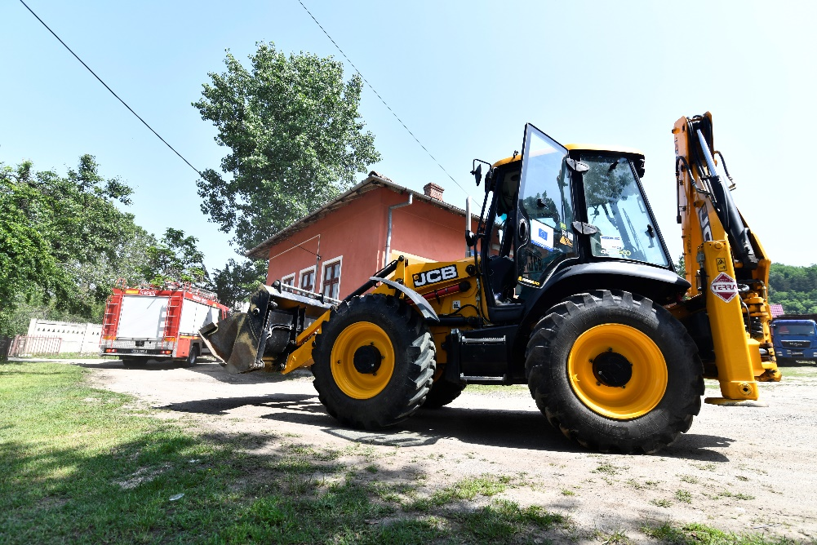
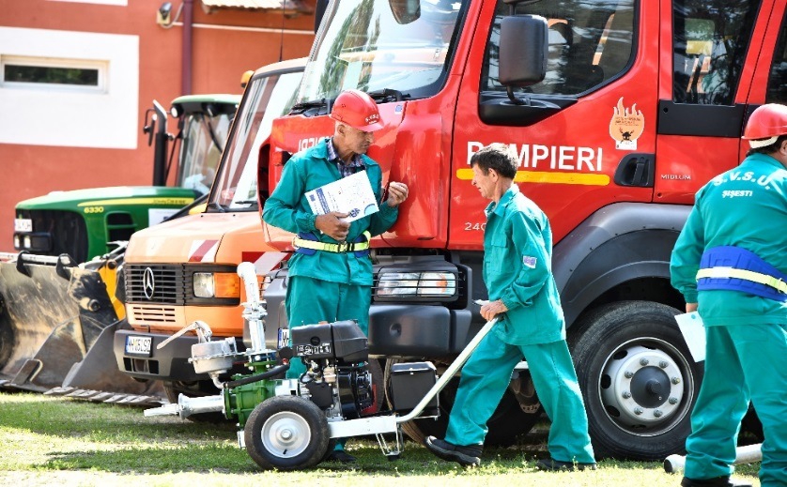
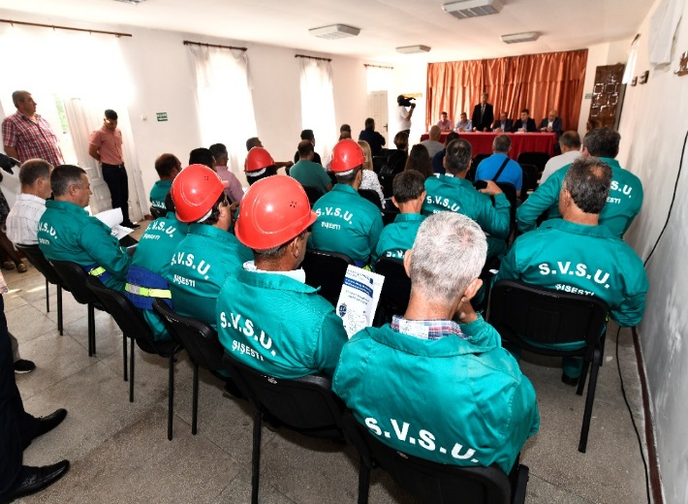
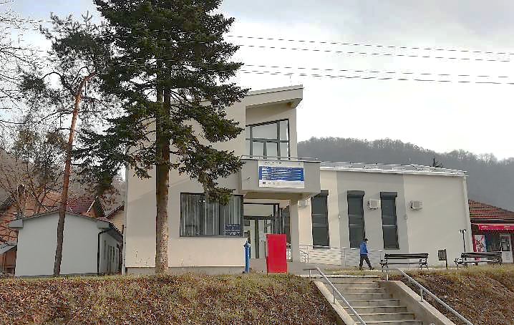

the implementation period (including extensions)
total funds spent/total funds contracted *100
indicators and level of achievement against targets set

