Project information
CALL FOR PROPOSALS | 2
e-MS Code: | RORS-273
PRIORITY AXIS: | 1 Employment promotion and services for an inclusive growth
OBJECTIVE: | 1.1 Employment and labour mobility
PROJECT TITLE: | Regional Employment Center
ACRONYM: | REC
DURATION: | 30.07.2019 – 28.10.2020 (11 months and 29 days)
Interreg-IPA  FUNDS CONTRACTED: | €310.732,80
TOTAL FUNDS CONTRACTED: | €365.568,00
ABSORPTION RATE (%): | 89%
PROJECT OBJECTIVE(S): | To create the environment for joint initiatives, cooperation and coordination for removing obstacles to keeping youth in the rural area of the cross-border region Romania – Serbia, by practical usage of Nudge theory.  Hardly employable categories in rural areas (young people without university degrees, women over 50 years of age, and people with disabilities) are enabled to start new jobs using IT technologies.  Pre-conditions for employment opportunities in the rural area of cross-border region Romania – Serbia through setting up services to promote employment, implement vocational training, and raise entrepreneurial initiatives are established.
SHORT DESCRIPTION OF THE PROJECT: | For decades, young people have been migrating from rural to urban areas in Serbia. However, for the last ten years, there has been a large number of youths who are leaving the country, searching for better jobs. The same situation is in Romania, where young people leave their country, especially rural areas, and move to more developed European countries or even the USA and Canada. Through this project, both partner municipalities expect to provide necessary conditions for youth to stay in their birthplaces, establish their businesses, and build their families there. Also, to enable other unemployed (women, other difficult to employ categories) to start some businesses as primary or additional jobs. Dealing with the outflow of the population is not a new story, but the way we were dealing with it is innovative.  Instead of forbidding young people to leave, we will offer them excellent conditions for staying – access to well-paid jobs, education, and necessary infrastructure. A cross-border approach was planned to achieve the goals. With this approach, Romanian and Serbian institutions, companies, schools and unemployed persons were involved in the mutual goal of establishing pre-conditions for employment opportunities in the rural area of the cross-border region. Municipality of Coka and Municipality of Deta are similar in the number of inhabitants. They are both rural agricultural areas with most of their population acting in this field. Considering that those two municipalities are similar in many ways, it was natural that they have similar problems. The solution was to establish a Regional Employment Center, with offices in both municipalities, to implement several different training sets to provide conditions for new jobs in these municipalities.
DEGREE OF ACHIEVEMENT OF INDICATORS: | 153 cross-border cooperation structures supported in the field of labour market. (107%)  4 investments in health care and social services infrastructure achieved. (100%)  198 disadvantaged persons involved in projects activities. (116%)
RESULTS ACHIEVED: | Coka and Deta inhabitants educated in how to find new job in the IT industry.  20 young, educated people trained in the field of Project Cycle Management.  20 Deta Municipality inhabitants educated in the topic of old crafts.  30 Deta Municipality inhabitants educated in the topic of rural tourism.  20 inhabitants of Coka and Deta educated in web development.  20 inhabitants of Coka and Deta educated in web design.  16 new IT experts involved in the web development/design.  6 meetings with companies organized.  11 persons participated in the Study tour.  2 local REC offices equipped.  Providing transportation for training participants twice.  170 inhabitants of Coka and Deta educated.

Partnership information
 |  | COUNTRY | COUNTY/DISTRICT | BUDGET(EURO) | CONTACT DETAILS
LEAD PARTNER: | Coka Municipality | SERBIA | North Banat | 194.250,00 | Potiska no. 20, 23320, Coka,  nacelnik@coka.rs
PARTNER 2: | Deta Municipality | ROMANIA | Timis | 171.318,00 | Victoriei no. 32, 305200, Deta  neluiiovan@yahoo.com

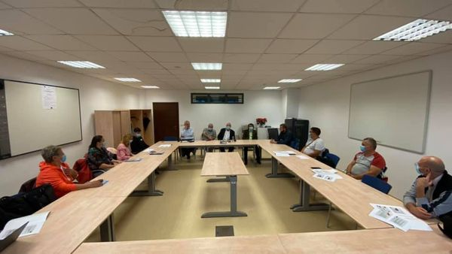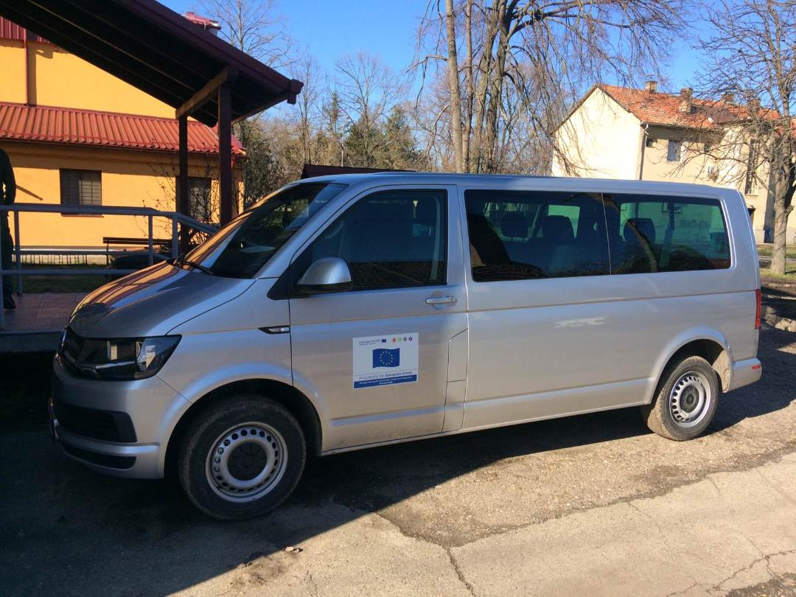

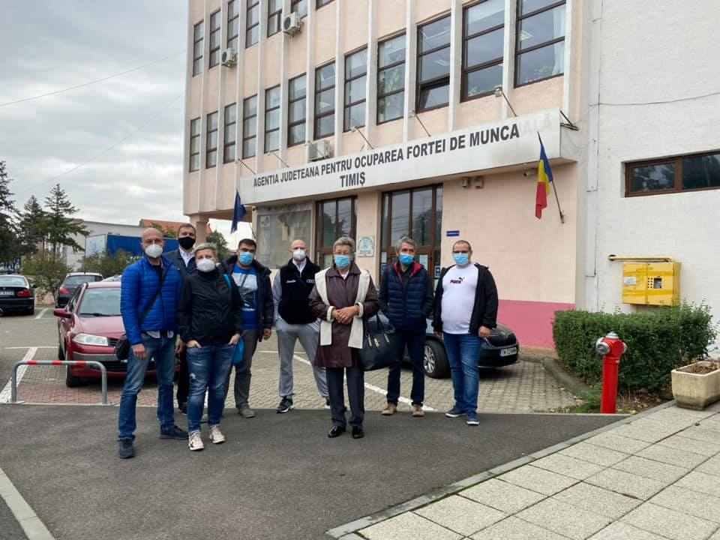
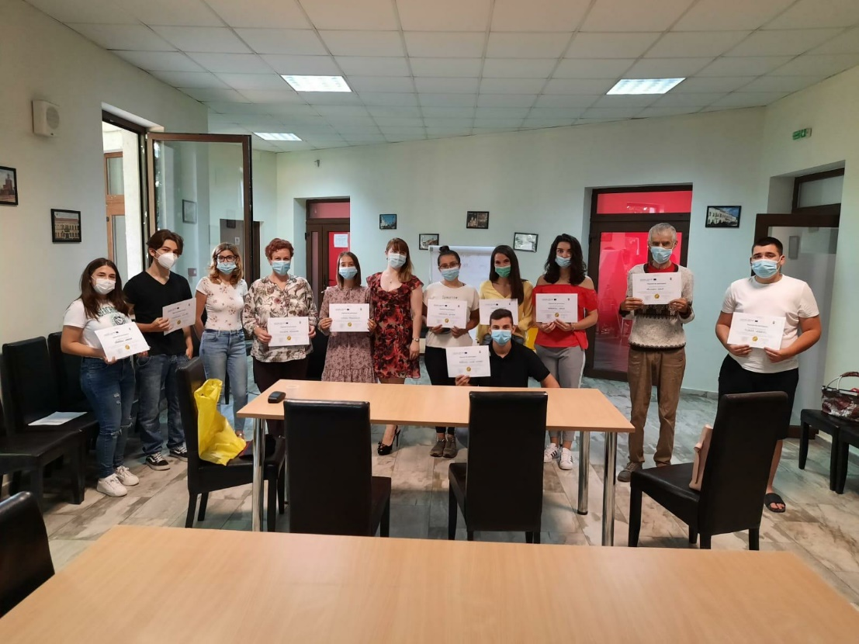

the implementation period (including extensions)
total funds spent/total funds contracted *100
indicators and level of achievement against targets set

